Starting Hadoop Daemons:
shadman@AI02SAM:~$ sudo apt-get update
shadman@AI02SAM:~$ sudo apt-get install openssh-server openssh-client -y
shadman@AI02SAM:~$ sudo service ssh start
shadman@AI02SAM:~$ ssh-keygen -t rsa -P '' -f ~/.ssh/id_rsa
shadman@AI02SAM:~$ cat ~/.ssh/id_rsa.pub >> ~/.ssh/authorized_keys
shadman@AI02SAM:~$ chmod 0600 ~/.ssh/authorized_keys
shadman@AI02SAM:~$ ssh localhost
shadman@AI02SAM:~$ stop-all.sh
shadman@AI02SAM:~$ start-all.sh
shadman@AI02SAM:~$ jps
2096 DataNode
2352 SecondaryNameNode
3043 Jps
1972 NameNode
2568 ResourceManager
2686 NodeManager

Data Load:
shadman@AI02SAM:~$ hdfs dfs -mkdir /amazon/
shadman@AI02SAM:~$ hdfs dfs -put amazon_reviews_us_Digital_Video_Games_v1_00.tsv /amazon/
shadman@AI02SAM:~$ hdfs dfs -ls /amazon/
Found 1 items
-rw-r--r-- 1 shadman supergroup 73154460 2026-09-14 12:22 /amazon/amazon_reviews_us_Digital_Video_Games_v1_00.tsv

Map Reduce
Script Creating:
1. GameStats.java (Task 1: Max Rating, Total Helpful Votes, Total Votes per Product ID)
import java.io.IOException;
import org.apache.hadoop.conf.Configuration;
import org.apache.hadoop.fs.Path;
import org.apache.hadoop.io.*;
import org.apache.hadoop.mapreduce.*;
import org.apache.hadoop.mapreduce.lib.input.FileInputFormat;
import org.apache.hadoop.mapreduce.lib.output.FileOutputFormat;

public class GameStats {
public static class StatMapper extends Mapper<Object, Text, Text, Text> {
public void map(Object key, Text value, Context context) throws IOException, InterruptedException {
String[] cols = value.toString().split("\t");
// Check for valid row and skip header
if (cols.length > 9 && !cols[0].equals("marketplace")) {
// Key: Product ID (col 3), Value: star_rating (7), helpful_votes (8), total_votes (9)
context.write(new Text(cols[3]), new Text(cols[7] + "," + cols[8] + "," + cols[9]));
}
}
}
public static class StatReducer extends Reducer<Text, Text, Text, Text> {
public void reduce(Text key, Iterable<Text> values, Context context) throws IOException, InterruptedException {
float maxRate = 0;
int totalHelpful = 0, totalVotes = 0;
for (Text val : values) {
String[] metrics = val.toString().split(",");
try {
maxRate = Math.max(maxRate, Float.parseFloat(metrics[0]));
totalHelpful += Integer.parseInt(metrics[1]);
totalVotes += Integer.parseInt(metrics[2]);
} catch (NumberFormatException e) { continue; }
}
context.write(key, new Text("MaxRate: " + maxRate + "\tHelpfulVotes: " + totalHelpful + "\tTotalVotes: " + totalVotes));
}
}
public static void main(String[] args) throws Exception {
Configuration conf = new Configuration();
Job job = Job.getInstance(conf, "Game Stats");
job.setJarByClass(GameStats.class);
job.setMapperClass(StatMapper.class);
job.setReducerClass(StatReducer.class);
job.setOutputKeyClass(Text.class);
job.setOutputValueClass(Text.class);
FileInputFormat.addInputPath(job, new Path(args[0]));
FileOutputFormat.setOutputPath(job, new Path(args[1]));
System.exit(job.waitForCompletion(true) ? 0 : 1);
}
}

2. MovingAverage.java (Task 2: Moving Average of Ratings per Product ID)
import java.io.IOException;
import org.apache.hadoop.conf.Configuration;
import org.apache.hadoop.fs.Path;
import org.apache.hadoop.io.*;
import org.apache.hadoop.mapreduce.*;
import org.apache.hadoop.mapreduce.lib.input.FileInputFormat;
import org.apache.hadoop.mapreduce.lib.output.FileOutputFormat;

public class MovingAverage {
public static class AvgMapper extends Mapper<Object, Text, Text, FloatWritable> {
public void map(Object key, Text value, Context context) throws IOException, InterruptedException {
String[] cols = value.toString().split("\t");
if (cols.length > 7 && !cols[0].equals("marketplace")) {
try {
context.write(new Text(cols[3]), new FloatWritable(Float.parseFloat(cols[7]))); // Product ID and Star Rating
} catch (NumberFormatException e) { }
}
}
}
public static class AvgReducer extends Reducer<Text, FloatWritable, Text, Text> {
public void reduce(Text key, Iterable<FloatWritable> values, Context context) throws IOException, InterruptedException {
float sum = 0;
int count = 0;
StringBuilder movingAvgs = new StringBuilder();
for (FloatWritable val : values) {
sum += val.get();
count++;
movingAvgs.append(sum / count).append(",");
}
context.write(key, new Text("Moving Averages: " + movingAvgs.toString()));
}
}
public static void main(String[] args) throws Exception {
Configuration conf = new Configuration();
Job job = Job.getInstance(conf, "Moving Average");
job.setJarByClass(MovingAverage.class);
job.setMapperClass(AvgMapper.class);
job.setReducerClass(AvgReducer.class);
job.setMapOutputKeyClass(Text.class);
job.setMapOutputValueClass(FloatWritable.class);
job.setOutputKeyClass(Text.class);
job.setOutputValueClass(Text.class);
FileInputFormat.addInputPath(job, new Path(args[0]));
FileOutputFormat.setOutputPath(job, new Path(args[1]));
System.exit(job.waitForCompletion(true) ? 0 : 1);
}
}

3. TopReviewer.java (Task 3: Top Customer by Number of Reviews)
import java.io.IOException;
import org.apache.hadoop.conf.Configuration;
import org.apache.hadoop.fs.Path;
import org.apache.hadoop.io.*;
import org.apache.hadoop.mapreduce.*;
import org.apache.hadoop.mapreduce.lib.input.FileInputFormat;
import org.apache.hadoop.mapreduce.lib.output.FileOutputFormat;

public class TopReviewer {
public static class ReviewerMapper extends Mapper<Object, Text, Text, IntWritable> {
private final static IntWritable one = new IntWritable(1);
public void map(Object key, Text value, Context context) throws IOException, InterruptedException {
String[] columns = value.toString().split("\t");
if (columns.length > 1 && !columns[0].equals("marketplace")) {
context.write(new Text(columns[1]), one); // Key: Customer ID
}
}
}
public static class TopReviewerReducer extends Reducer<Text, IntWritable, Text, IntWritable> {
private String bestReviewer = "";
private int maxReviews = 0;
public void reduce(Text key, Iterable<IntWritable> values, Context context) {
int sum = 0;
for (IntWritable val : values) { sum += val.get(); }
if (sum > maxReviews) {
maxReviews = sum;
bestReviewer = key.toString();
}
}
protected void cleanup(Context context) throws IOException, InterruptedException {
context.write(new Text("Best Reviewer ID: " + bestReviewer), new IntWritable(maxReviews));
}
}
public static void main(String[] args) throws Exception {
Configuration conf = new Configuration();
Job job = Job.getInstance(conf, "Top Reviewer");
job.setJarByClass(TopReviewer.class);
job.setMapperClass(ReviewerMapper.class);
job.setReducerClass(TopReviewerReducer.class);
job.setMapOutputKeyClass(Text.class);
job.setMapOutputValueClass(IntWritable.class);
job.setOutputKeyClass(Text.class);
job.setOutputValueClass(IntWritable.class);
FileInputFormat.addInputPath(job, new Path(args[0]));
FileOutputFormat.setOutputPath(job, new Path(args[1]));
System.exit(job.waitForCompletion(true) ? 0 : 1);
}
}

Compilation and MapReduce Execution:
shadman@AI02SAM:~$ export HADOOP_CLASSPATH=$(hadoop classpath)
shadman@AI02SAM:~$ javac -classpath ${HADOOP_CLASSPATH} -d . GameStats.java MovingAverage.java TopReviewer.java
shadman@AI02SAM:~$ jar -cvf amazon_jobs.jar *.class
added manifest
adding: BestYoutuber$TopUploaderReducer.class(in = 2634) (out= 1067)(deflated 59%)
adding: BestYoutuber$UploaderMapper.class(in = 1681) (out= 697)(deflated 58%)
adding: BestYoutuber.class(in = 1583) (out= 842)(deflated 46%)
adding: GameStats$StatMapper.class(in = 2034) (out= 841)(deflated 58%)
adding: GameStats$StatReducer.class(in = 2544) (out= 1110)(deflated 56%)
adding: GameStats.class(in = 1420) (out= 780)(deflated 45%)
adding: MovingAverage$AvgMapper.class(in = 1807) (out= 776)(deflated 57%)
adding: MovingAverage$AvgReducer.class(in = 2384) (out= 1016)(deflated 57%)
adding: MovingAverage.class(in = 1564) (out= 834)(deflated 46%)
adding: TopReviewer$ReviewerMapper.class(in = 1750) (out= 738)(deflated 57%)
adding: TopReviewer$TopReviewerReducer.class(in = 2635) (out= 1062)(deflated 59%)
adding: TopReviewer.class(in = 1578) (out= 836)(deflated 47%)
adding: VideoStats$StatMapper.class(in = 1965) (out= 785)(deflated 60%)
adding: VideoStats$StatReducer.class(in = 2550) (out= 1111)(deflated 56%)
adding: VideoStats.class(in = 1425) (out= 781)(deflated 45%)

shadman@AI02SAM:~$ hadoop jar amazon_jobs.jar GameStats /amazon/amazon_reviews_us_Digital_Video_Games_v1_00.tsv /amazon/output_stats
shadman@AI02SAM:~$ hadoop jar amazon_jobs.jar MovingAverage /amazon/amazon_reviews_us_Digital_Video_Games_v1_00.tsv /amazon/output_avg
shadman@AI02SAM:~$ hadoop jar amazon_jobs.jar TopReviewer /amazon/amazon_reviews_us_Digital_Video_Games_v1_00.tsv /amazon/output_best

Output:
1. GameStats (Maximum rating, total helpful votes, and total overall votes grouped by Product ID)
shadman@AI02SAM:~$ hdfs dfs -cat /amazon/output_stats/part-r-00000 | head -n 20
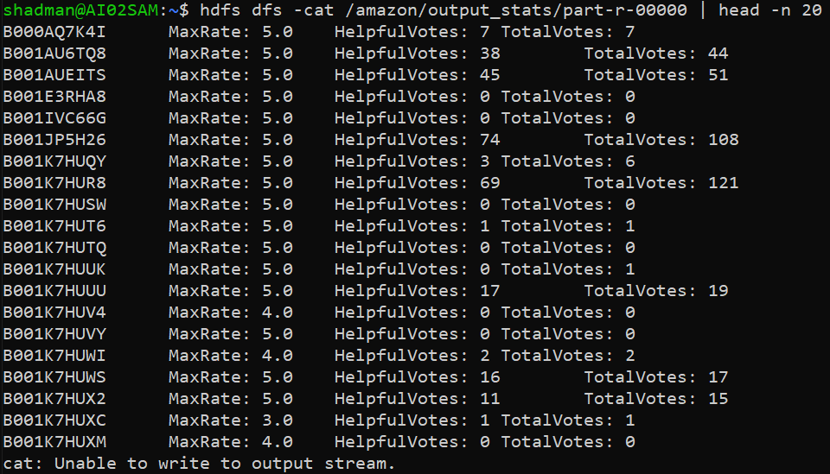

2. MovingAverage (The moving average of star ratings calculated for each Product ID)
shadman@AI02SAM:~$ hdfs dfs -cat /amazon/output_avg/part-r-00000 | head -n 20
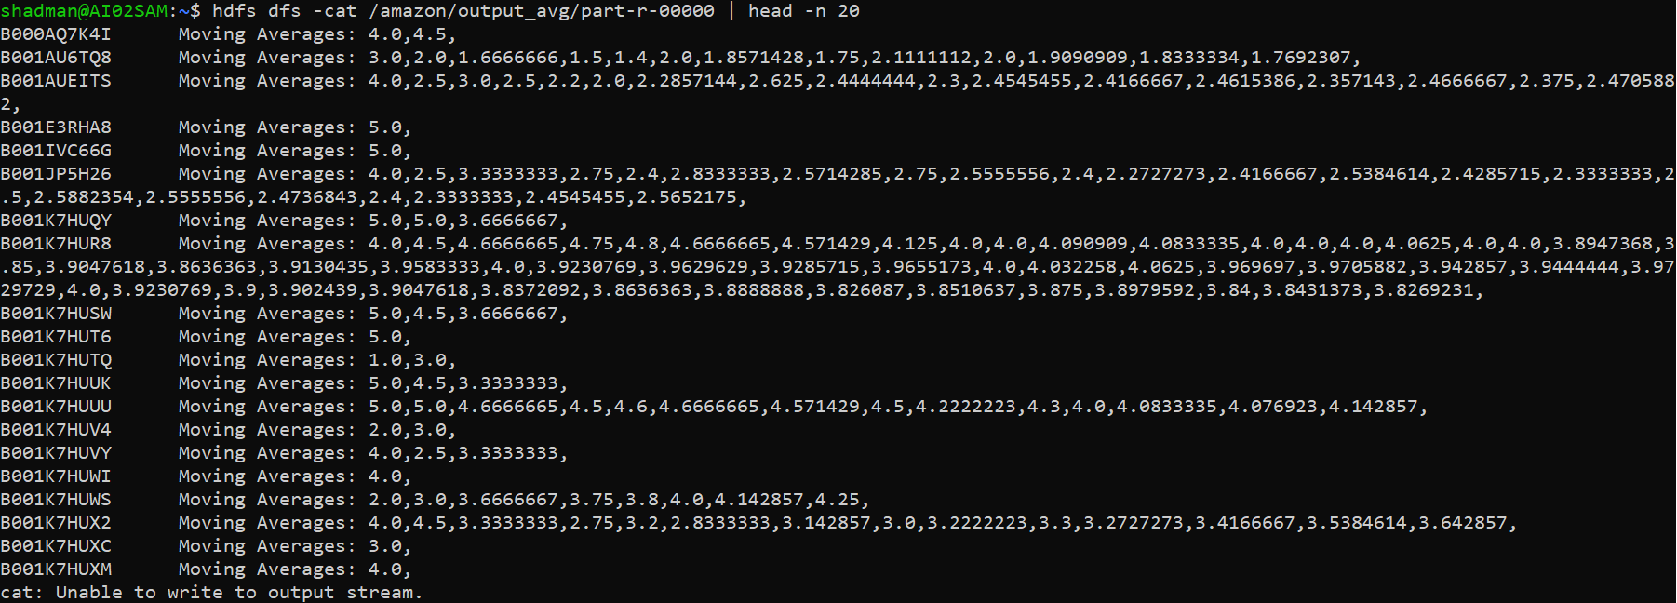
3. TopReviewer (The top reviewer (Customer ID) based on the highest total number of submitted reviews)
shadman@AI02SAM:~$ hdfs dfs -cat /amazon/output_best/part-r-00000

Generating the outputs in text files:
shadman@AI02SAM:~$ hdfs dfs -cat /amazon/output_stats/part-r-00000 > GameStats_Output.txt
shadman@AI02SAM:~$ hdfs dfs -cat /amazon/output_avg/part-r-00000 > MovingAverage_Output.txt
shadman@AI02SAM:~$ hdfs dfs -cat /amazon/output_best/part-r-00000 > TopReviewer_Output.txt

Pig
Creating pig script:
shadman@AI02SAM:~$ nano amazon_pig_analysis.pig
/* 1. Safely remove old output folders */
rmf /amazon/pig_task1;
rmf /amazon/pig_task2;
rmf /amazon/pig_task3;
rmf /amazon/pig_task4;
rmf /amazon/pig_task5;

/* 2. Load and Filter the raw data */
raw_data = LOAD '/amazon/amazon_reviews_us_Digital_Video_Games_v1_00.tsv' USING PigStorage('\t') AS (marketplace:chararray, customer_id:chararray, review_id:chararray, product_id:chararray, product_parent:chararray, product_title:chararray, product_category:chararray, star_rating:float, helpful_votes:int, total_votes:int, vine:chararray, verified_purchase:chararray, review_headline:chararray, review_body:chararray, review_date:chararray);

-- Filter out the header row and any corrupted/null data
clean_data = FILTER raw_data BY (star_rating IS NOT NULL) AND (total_votes IS NOT NULL) AND (marketplace != 'marketplace');

/* -------------------------------------------------------- */
/* TASK 1: Top 5 Game Franchises (Product Parents) by Review Count */
/* -------------------------------------------------------- */
grp_parent = GROUP clean_data BY product_parent;
parent_counts = FOREACH grp_parent GENERATE group AS product_parent, COUNT(clean_data) AS total;
grp_all_1 = GROUP parent_counts ALL;
top_5_parent = FOREACH grp_all_1 GENERATE FLATTEN(TOP(5, 1, parent_counts));
STORE top_5_parent INTO '/amazon/pig_task1' USING PigStorage('\t');
EXEC;

/* -------------------------------------------------------- */
/* TASK 2: Top 10 Rated Individual Reviews */
/* -------------------------------------------------------- */
-- Sort by star_rating (column index 7)
grp_all_2 = GROUP clean_data ALL;
top_10_rated = FOREACH grp_all_2 GENERATE FLATTEN(TOP(10, 7, clean_data));
STORE top_10_rated INTO '/amazon/pig_task2' USING PigStorage('\t');
EXEC;

/* -------------------------------------------------------- */
/* TASK 3: Top 10 Rated Game Franchises */
/* -------------------------------------------------------- */
avg_rate = FOREACH grp_parent GENERATE group AS product_parent, AVG(clean_data.star_rating) AS avg_rating;
grp_all_3 = GROUP avg_rate ALL;
top_10_avg_rate = FOREACH grp_all_3 GENERATE FLATTEN(TOP(10, 1, avg_rate));
STORE top_10_avg_rate INTO '/amazon/pig_task3' USING PigStorage('\t');
EXEC;

/* -------------------------------------------------------- */
/* TASK 4: Top 10 Most Helpful Individual Reviews */
/* -------------------------------------------------------- */
-- Sort by helpful_votes (column index 8)
grp_all_4 = GROUP clean_data ALL;
top_10_helpful = FOREACH grp_all_4 GENERATE FLATTEN(TOP(10, 8, clean_data));
STORE top_10_helpful INTO '/amazon/pig_task4' USING PigStorage('\t');
EXEC;

/* -------------------------------------------------------- */
/* TASK 5: Top 10 Most Interacted Game Franchises (Total Votes) */
/* -------------------------------------------------------- */
sum_votes = FOREACH grp_parent GENERATE group AS product_parent, SUM(clean_data.total_votes) AS total_franchise_votes;
grp_all_5 = GROUP sum_votes ALL;
top_10_sum_votes = FOREACH grp_all_5 GENERATE FLATTEN(TOP(10, 1, sum_votes));
STORE top_10_sum_votes INTO '/amazon/pig_task5' USING PigStorage('\t');
EXEC;

Executing the script:
shadman@AI02SAM:~$ pig -x mapreduce amazon_pig_analysis.pig
Output:
1. Task 1: Top 5 Game Franchises by Volume
shadman@AI02SAM:~$ hdfs dfs -cat /amazon/pig_task1/part-r-00000
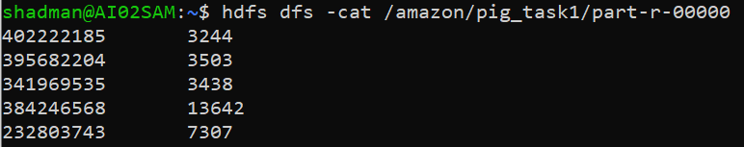

2. Task 2: Top 10 Rated Individual Reviews
shadman@AI02SAM:~$ hdfs dfs -cat /amazon/pig_task2/part-r-00000
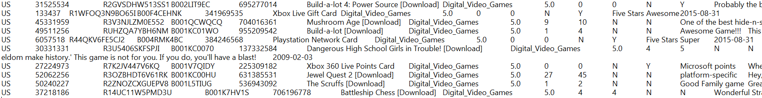
3. Task 3: Top 10 Highest-Rated Franchises
shadman@AI02SAM:~$ hdfs dfs -cat /amazon/pig_task3/part-r-00000
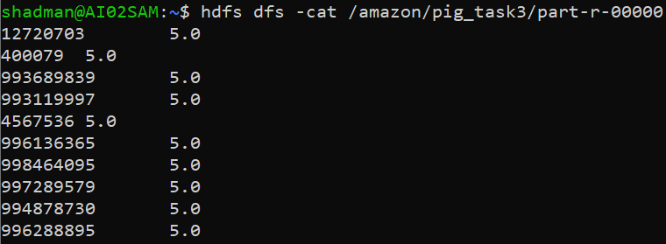

4. Task 4: Top 10 Most Helpful Reviews
shadman@AI02SAM:~$ hdfs dfs -cat /amazon/pig_task4/part-r-00000
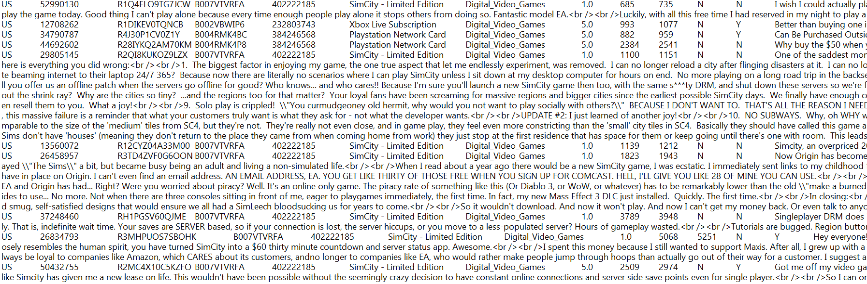
5. Task 5: Top 10 Most Interacted Franchises
shadman@AI02SAM:~$ hdfs dfs -cat /amazon/pig_task5/part-r-00000
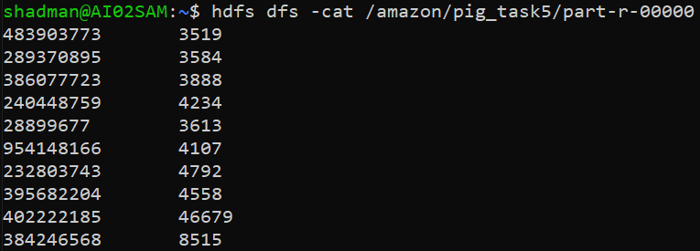

Generating the outputs in text files:
shadman@AI02SAM:~$ hdfs dfs -cat /amazon/pig_task1/part-r-00000 > Pig_Task1_TopFranchises.txt
shadman@AI02SAM:~$ hdfs dfs -cat /amazon/pig_task2/part-r-00000 > Pig_Task2_TopRatedReviews.txt
shadman@AI02SAM:~$ hdfs dfs -cat /amazon/pig_task3/part-r-00000 > Pig_Task3_TopRatedFranchises.txt
shadman@AI02SAM:~$ hdfs dfs -cat /amazon/pig_task4/part-r-00000 > Pig_Task4_MostHelpful.txt
shadman@AI02SAM:~$ hdfs dfs -cat /amazon/pig_task5/part-r-00000 > Pig_Task5_MostInteracted.txt

