| **North South University**  Department of Electrical & Computer Engineering  Course Name: **CSE-311 Lab** Section: **7**  Project Title: **Forum Website** | |
| --- | --- |
| **Shadman Sakib - 2014310042** | Score |
| **Nadia Binte Rahman Peeya - 1731358642** |  |
| Remarks: |

**Description of the Project:**

The primary goal is to create a website than can host a number of threads for public or private group discussions. Users will have to make an account to participate in the threads. To register an account, only a unique Username and password will be required. Public threads will work much like the ones in the popular website Reddit. For private threads, a user will have to host a room with a password that must be shared with other desired users for them to get in. The website will have 3 roles; admin, mod, citizen. Admin will have full control, Mods can drop public threads and cannot view private threads or messages. Citizens can do everything else outside the jurisdiction of Mods.

These are the key goals of the project. Other quality of life features will be added depending on the time left and necessity of the project requirements.

**Sitemap of the Project.**

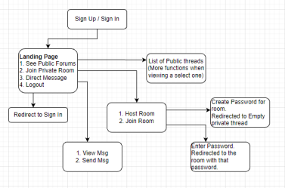

**Gantt chart**

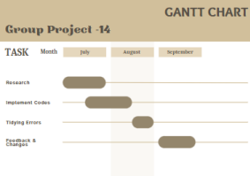

**GitHubLink: https://github.com/ShadmanSakib22/CSE311L_GroupProject/tree/main/Project-Proposal**