ASSIGNMENT #1

Name : Chandra sai krishna,

MIS.NO:112315170,

Group-4.

Q1.

import sys

print(sys.version)



Q2.

import keyword

print(keyword.kwlist)



Q3.

name = input( "Enter  the name : ")

age = int(input("Enter the age : "))

year=2024+100-age

print("The year ",year, name,"will become 100  years")

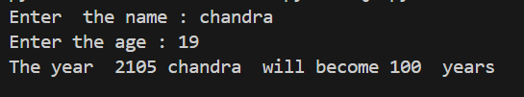

Q4.

import math

r = int(input("Enter the radius of circle : "))

print("The area of circle = ",math.pi*r*r)

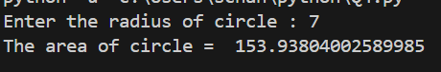

Q5.

x = int(input("Enter any number = "))

if x%2==0 :

    print("The number is Even")

else :

    print("The number is Odd")

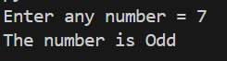

Q6.

sum=0.1+0.2

if sum==0.3 :

    print("The sum is correct")

else:

    print("The sum is incorrect ")

ans=round(0.1+0.2,2)

if ans==round(0.3,2):

    print("This is the correct answer")

else:

    print("This was also incorrect ")

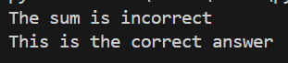

Q7.

str1="ravi"

str2="kiran"

s1=str1[:1]

s2=str2[:1]

newstr1=s2+str1[1:]

newstr2=s1+str2[1:]

print(newstr1,newstr2)

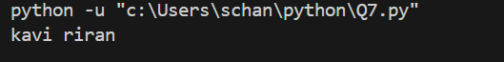

Q8.

str=input("Enter the string : " )

print(str.isidentifier())

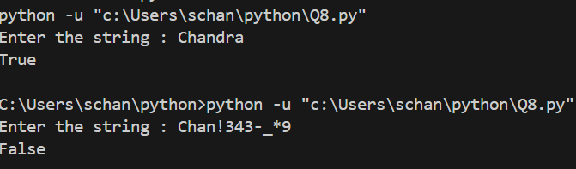

Q9.

string1=input("enter the string  ")

string2=input("enter the second string  ")

l=string1[:1]

s=string2[:1]

h=string1[len(string1)-1:]

d=string2[len(string2)-1:]

new_string1=s+string1[1:len(string1)-1]+d

new_string2=l+string2[1:len(string2)-1]+h

print(new_string1,new_string2,sep=" ")

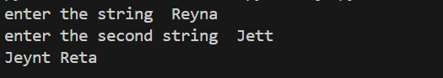

Q10.

str=input("Enter the string : ")

print(str.upper())

print(str.lower())

