Experiment :-
Aim:

Step 1 : Click On New Item select Freestyle Project and click on ok

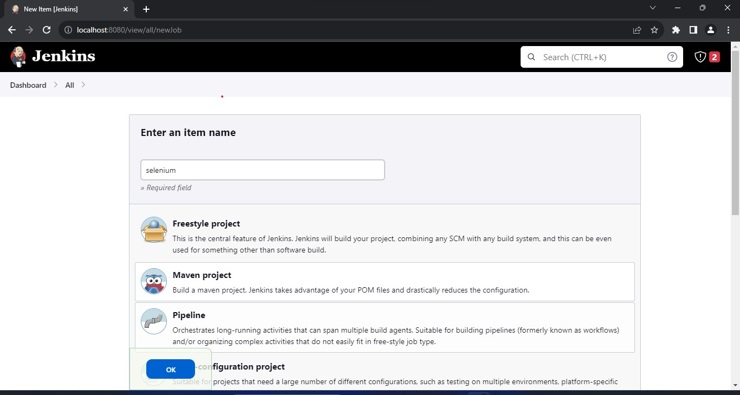

Step 2: In Source Code Management click on Git and enter the url
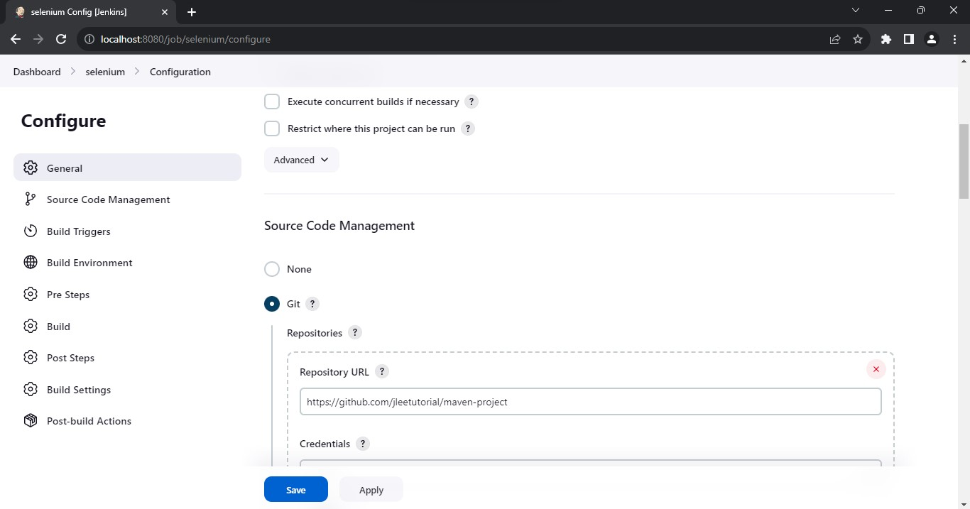
Step 3:In Build Goals and Options write test
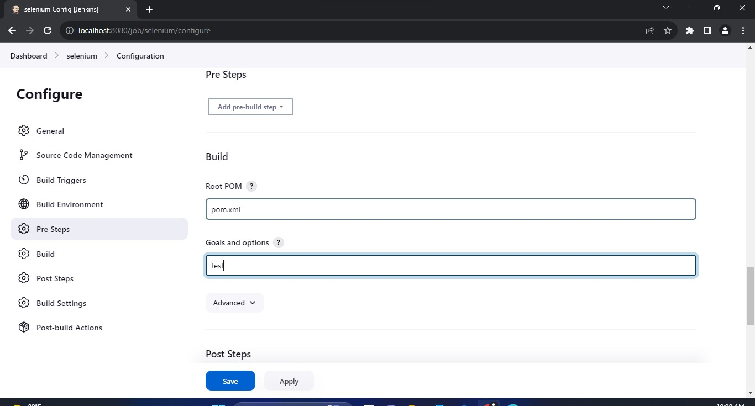

Step 4:In post steps click on Invoke top level management targets click on maven version select maven and it test goals write test
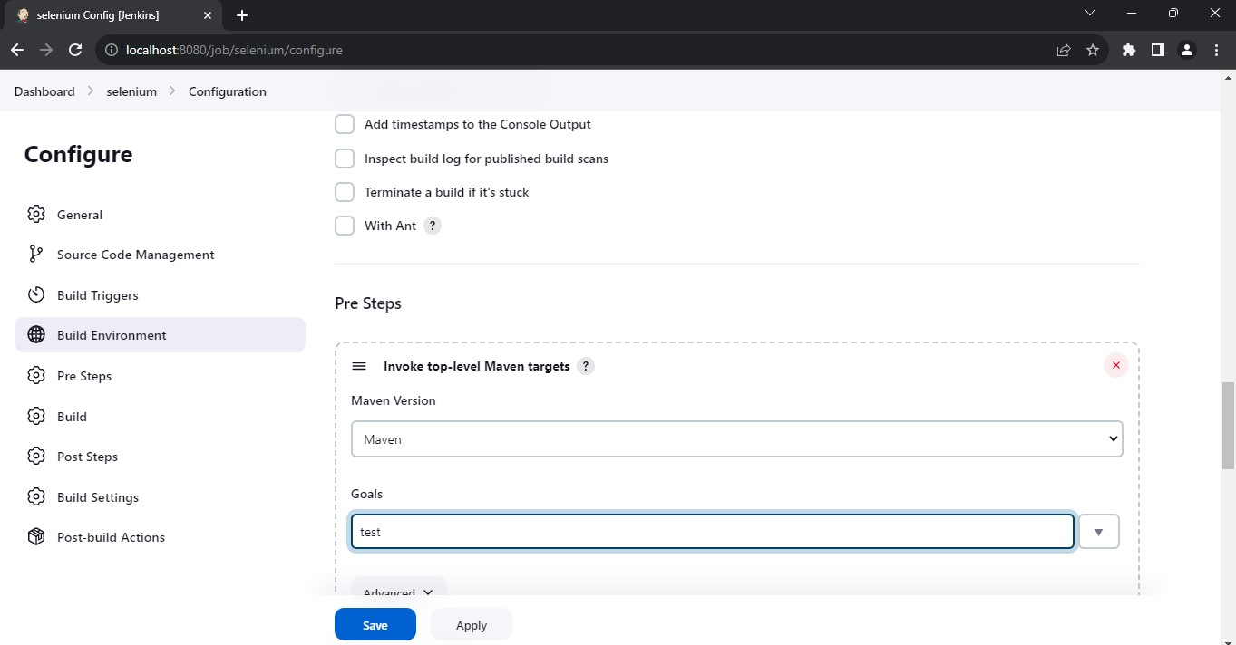
Step 5: Click on Buld Now
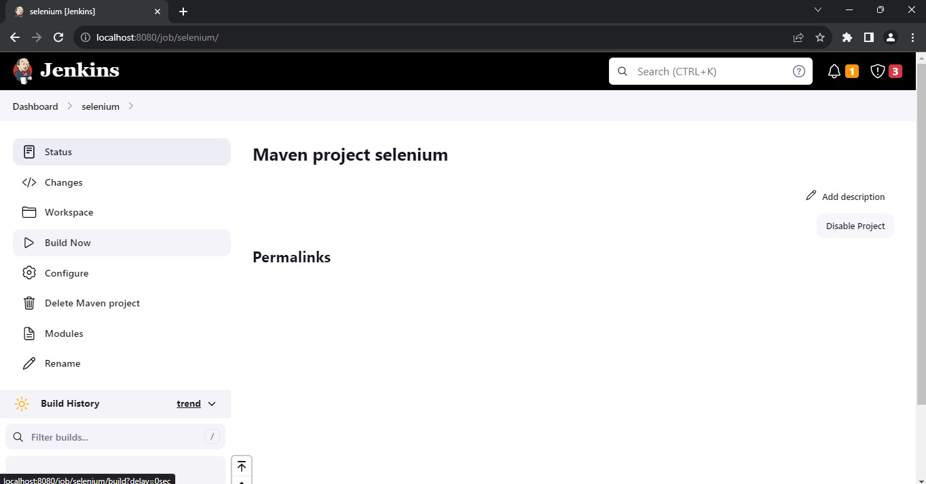
Step 6:Build Successful
