Project Report
MedScope
Aryan Gahlot – S24CSEU0701
Himanshu Kumar Singh – S24CSEU0721
Harshit Gupta – S24CSEU0735

A report submitted in part fulfilment of the degree of
BTech in Computer Science
Supervisor: Dr. Susmita Das

School of Computer Science Engineering and Technology

Date- 13-11-2025

Abstract

- Introduction

- Proposed Works/Methodology

- Data structure and algorithms used.

- Result Analysis

- Conclusion

Introduction

Adverse Drug Reactions is a significant problem in healthcare. Primary issue with current information system is the ‘one fits all’ approach for the side effect on different patients. Generally patients are provided with the list of generic side effect which fails for individual variability.
The risk and severity of an Adverse Drug Reactions are uniquely influenced by personal factors such as age, gender, weight, and other demographic details.
Even World Health Organization aims to reduce severe avoidable medication-related harm globally by 50%. (Medications without harm)
Pharmacovigilance is used to describe the practice of monitoring the effects of medicines with the aim of identifying and evaluating any adverse drug reactions. Aside from ensuring greater safety for individual patients, other benefits of pharmacovigilance include:
- A better understanding of a drug’s safety profile, which can inform a health professional’s decision to prescribe that medication
- The ability to identify any potential issues with a medicine that could lead to its abuse or diversion and ability to identify potential drug causes of serious injury or death, which could prevent future complaints or litigation

FDA Adverse Event Reporting System (FAERS) is a database that contains information on adverse event and medication error reports submitted to Food and Drug Administration(Agency in the US federal government) by patients, healthcare professionals, and manufacturers.
Our project MedScope uses FAERS dataset to predict the Adverse Drug Reactions for individual variability among patients.

Proposed Works/Methodology

Our MedScope Project is a web-interface using Fastapi service which can be easily accessed by the patients.

- Architecture: The backend is built using FastAPI, which provides a high-performance framework for building API in Python and frontend is built using HTML/CSS.
- Routing - The project is organized into routes for different functionalities auth.py (For authentication related endpoints), ml_models.py (For ML models endpoints), user.py (For HTML pages endpoints) and chat.py (For Gemini chatbot endpoint).
- Authentication - Firebase Auth is used for Signup and Login (with email verification and google login). User session is done using HTTP-only cookies.
- Database – We have used Cloud Firestore (Nosql) for saving user database such as user history.
- Frontend – We have rendered frontend using Jinja2 templates.

- Machine Learning Prediction Pipeline: The FDA produces FAERS dataset 4 times each year. We have used the dataset for year 2020.
- Inputs – FAERS Dataset is divided into 6 main smaller dataset (Administrative Information, Drug Information, Reaction Information, Patient Outcome, Sources of the Reports, Drug Therapy Date).
- Cleaning – The total dataset is very large and most of the columns are not significant. After cleaning the columns used in training are: age_group, sex, country, is_health_professional, drug_name, drug_role, route, indication_for_use, dechallenge, outcome, reaction.
- Analysis – Analysed the dataset for better understand of features in the dataset.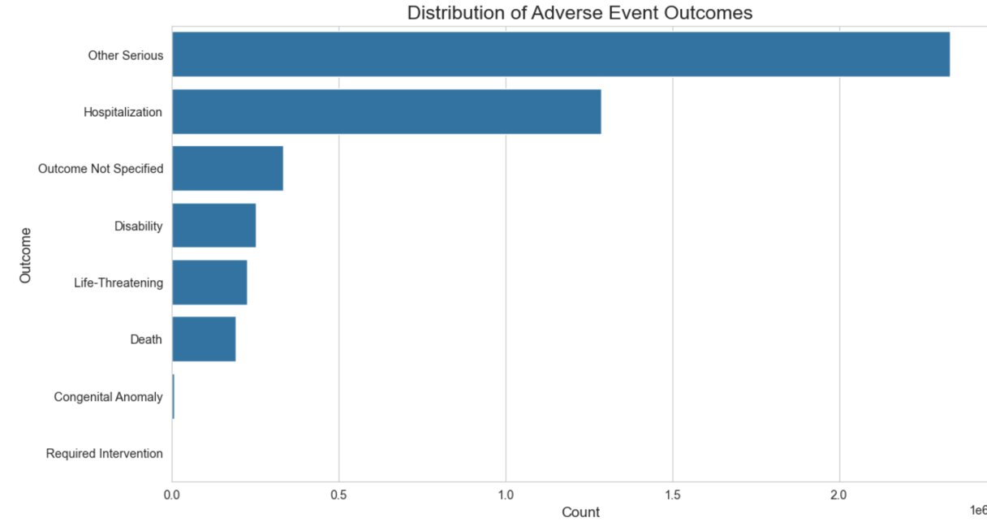
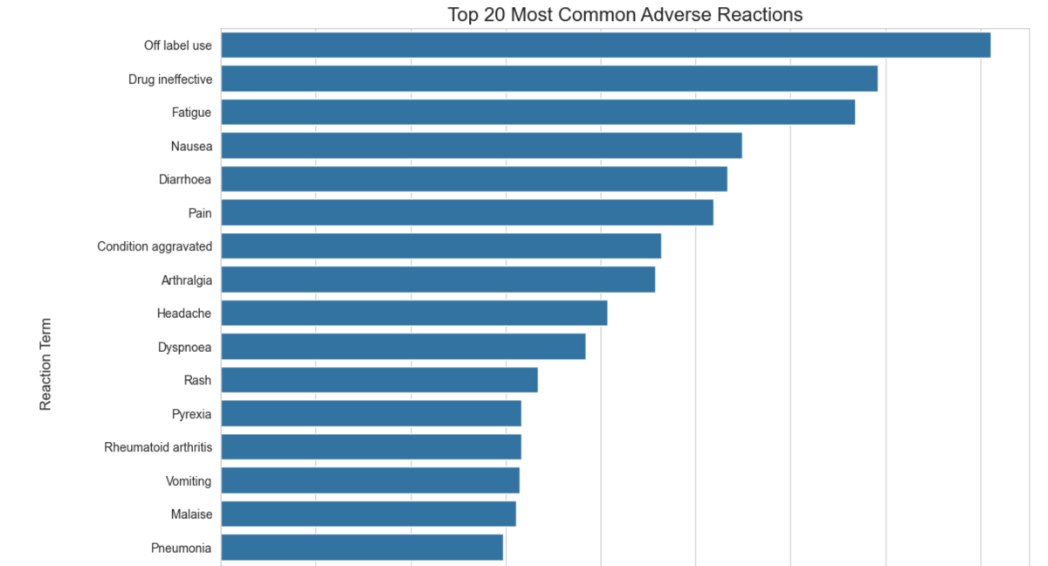

- Preprocessing – Columns like age were in different format like days, months, years which was difficult to understand so after converting them to year we grouped them by age group for better prediction.

Created a new column drug profile by combining name, role, indication and dechallenge to perform TfidfVectorizer to convert combined string into number matrix.

Applied One-Hot-Encoding to encode the text to numeric data.

- Training the Model – We perform test-train split with 80:20 ratio. To train the model we used RandomForestClassifier(n_estimators=15).

- Analysis – To performed it we used standard metrics: Accuracy, Precision, Recall, and F1-Score.

- Drug Alternatives Engine: We have used medicine dataset from Kaggle to suggest alternate medicines. We have converted the dataset to JSON format to easily fetch the result and show them for alternative medicines.
We uses the medical indication and side effect and drug name as input to suggest medicine to avoid the side effect.

- AI Medical Assistant: This act as the brain of the application integrating all services. Chatbot is provided by google-generativeai model(‘gemini-flash-2.5’).
The main methodology is the chatbot ability to use tools: predict_side_effect and find_alternatives.

Data structure and algorithms used
Data Structures
- JSON: This is used for the non-ML parts in the project. It is used to store:
- The drug alternatives database
- Static data for the frontend
- API request and response bodies between the client and the FastAPI server.

- Pydantic Models: These are Python classes that enforce strict data validation and structure for all API inputs and outputs, to prevent invalid data from being processed.

- Pandas DataFrames: DataFrames were the main structure used for data cleaning, preprocessing, feature engineering, and model training.

- Firestore Documents: The Firebase database stores data in documents (JSON-like) organized into collections.

Algorithms

- Machine Learning Classification:
- The Preprocessing Stage: The ColumnTransformer is a tool that applies different preprocessing steps to different columns of our data together.

- The Modeling Stage: Our base algorithm is RandomForestClassifier which is very stable model and best for our prediction and MultiOutputClassifier is a wrapper algorithm takes our RandomForestClassifier and trains one separate copy of it for every single possible side effect.
- Token-Based Authentication: Firebase Authentication uses secure token-based algorithms (like JWTs) to verify a user's identity and manage their session.

- Generative AI: Google's Gemini model which is a transformer-based algorithm. It’s key algorithmic capability here is tool use where the model can call an external API (our ML functions) to receive data and give output based on that.

Result Analysis

Models were trained and evaluated on the pre-processed FAERS dataset. The key performance metrics are:

- Machine Learning Model Performance

- Risk Model:

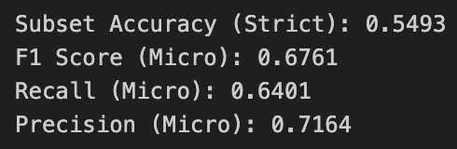
- Reactions Model:

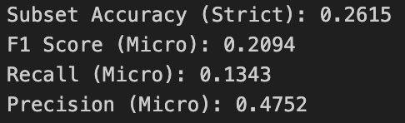

- Qualitative System Analysis

Users receive an immediate easy to understand and personalized risk profile. Instead of a generic warning, they get a specific insight based on their data. The alternative engine provides a search for specific medicine and correctly filters out drugs known for that side effect providing a safer and more targeted list of alternatives. The chatbot successfully integrates all components into a seamless user experience.

Conclusion

Our project successfully demonstrates the design and implementation of an AI-powered medical information service. We have integrated three different technologies: Side-Effect predictive model, Alternative medicine engine and Gemini-powered AI into a web service using Fastapi.

Future work for this project includes:
- Integrating a Drug-Drug Interaction model to add another critical layer of safety using HODDI dataset
- Expanding the datasets for ML training to improve model accuracy and generalizability.
- Using user medical history to achieve even deeper level of personalization in the risk predictions.

