**Name – Aryan Gahlot**

**Roll No- S24CSEU0701**

**Assignment Test**

**Ans 1)** The gates shown in the t question are:

AND Gate using NAND Gate

OR Gate using NOR Gate

TRUTH TABLES:

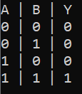 for AND Gate

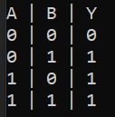for OR Gate

VERILOG CODES:

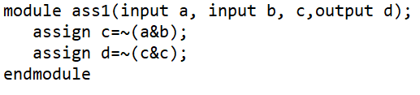for AND Gate

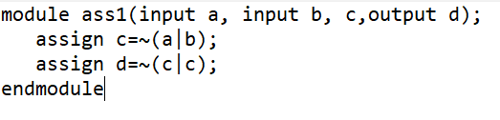for OR Gate

**ANS 2)**

VERILOG CODE AND TESTBENCH:

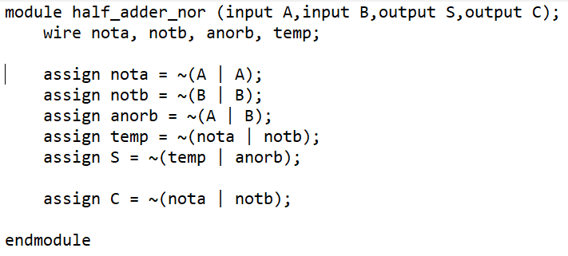

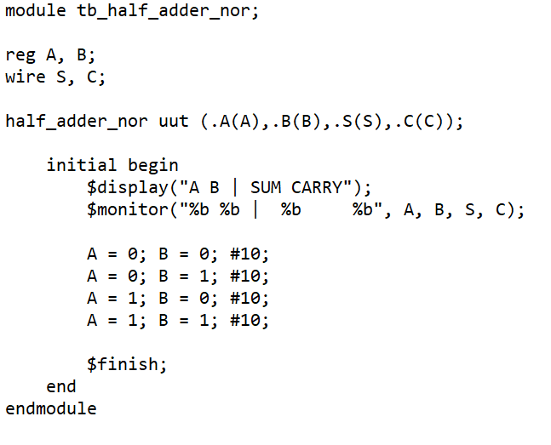

TRUTH TABLE:

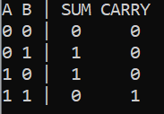

GTKWAVE:

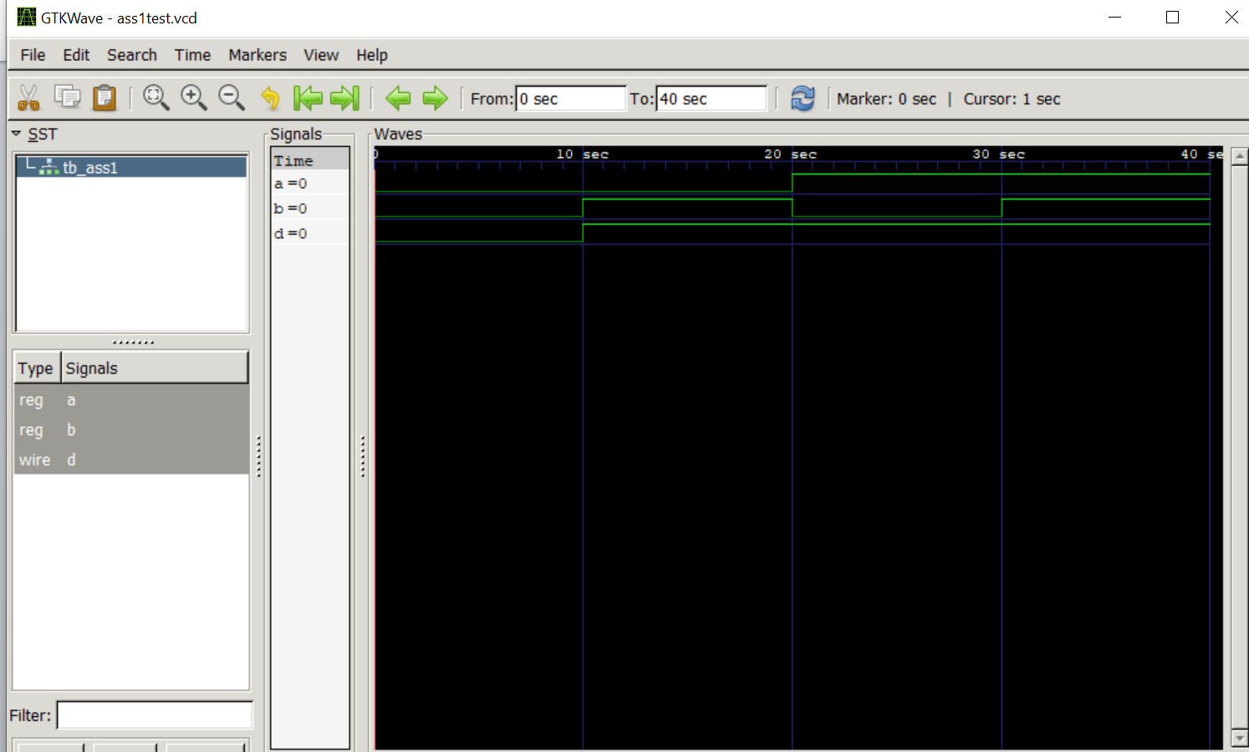

**ANS 3)**

VERILOG CODE AND TESTBENCH:

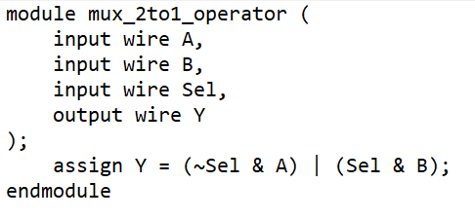

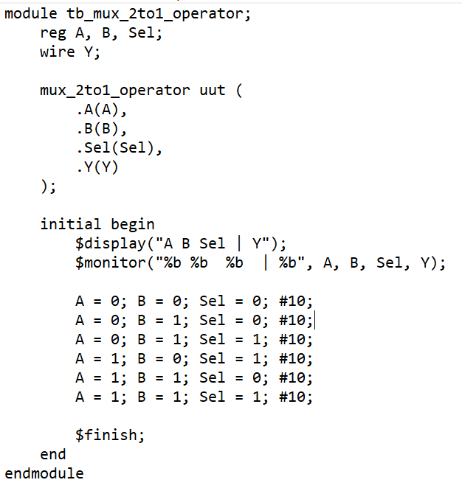

TRUTH TABLE:

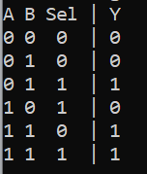

**ANS 4)**

VERILOG CODE AND TESTBENCH:

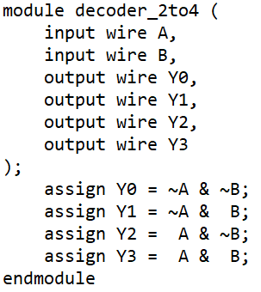

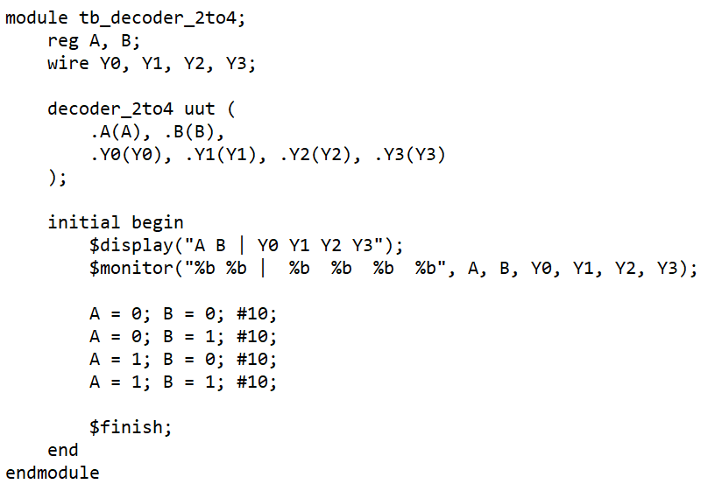

TRUTH TABLE:

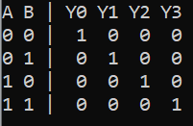

**ANS 5)**

