Table of Contents

Pose Guided Predictive Ballistics for Body Part-Targeted Football Training
Arlen Smagulov
Submitted in fulfilment of the requirements for the degree of Master of Science in Electrical and Computer Engineering
School of Engineering and Digital Sciences
Department of Electrical and Computer Engineering
Nazarbayev University
Supervisor: Prof. Sultangali Arzykulov
Co-supervisor: Prof. Mohammad Hashmi
March 2026
I hereby declare that this manuscript, entitled “Pose Guided Predictive Ballistics for Body Part–Targeted Football Training”, is the result of my own work except for quotations and citations that have been duly acknowledged. I also declare that, to the best of my knowledge and belief, it has not been previously or concurrently submitted, in whole or in part, for any other degree or diploma at Nazarbayev University or any other national or international institution.
Signature(s):
Name: Arlen Smagulov
Date: 2026
The author gratefully acknowledges the guidance and constructive feedback of the thesis supervisory committee throughout this project. The author also thanks the Department of Electrical and Computer Engineering at Nazarbayev University for providing the academic framework in which this research was conducted. The open-source communities supporting OpenCV, Ultralytics YOLO, MMPose, and the broader Python scientific computing ecosystem made the technical implementation possible.
Automated ball-launching machines are widely used in sports training, but most practical systems operate in open-loop mode: the trainer configures a fixed angle, speed, and interval, and the machine repeats that program without measuring the athlete’s current body position. This thesis presents the design, implementation, and partial validation of a vision-guided ball-launching system that estimates selected human body joints (right knee, right hip, and left shoulder) in three dimensions and computes corresponding aim parameters for a Ball Launching Machine (BLM) in a domestic garage arena. The current work validates the perception, calibration, targeting, and safety-gated integration components, but it does not claim a completed full closed-loop moving-target firing demonstration.
The system uses four fixed commodity USB cameras calibrated with ChArUco boards for intrinsic parameters and AprilTag fiducial markers for extrinsic world-frame registration. Ball detection is performed with a YOLO-based detector, and human pose estimation is performed with an open-source pose-estimation backend using the COCO 17-keypoint skeleton convention. Multi-view triangulation converts synchronized two-dimensional observations into three-dimensional world-frame coordinates in millimetres. A ballistic solver computes pitch, yaw, and wheel-speed commands from the selected target joint, while low-level actuation is handled by an ESP32-based controller. A staged safety protocol, including E-STOP handling, command gating, and structured decision logging, is used to restrict actuation during integration.
Quantitative evaluation is based on a 36-point static ball ground-truth dataset and an 81-trial joint-touch dataset. Under the current repository calibration bundle, the raw static ball evaluation gives a mean 3D error of 156.90 mm and a P95 error of 288.34 mm, with high temporal precision (3.09 mm mean standard-deviation norm). The joint-touch evaluation gives a mean 3D error of 178.98 mm and a P95 error of 243.77 mm over 62 valid trials. These results show that the system provides a repeatable and practically useful perception backbone, while also revealing systematic calibration bias, occlusion sensitivity, and the need for further closed-loop validation. The thesis therefore positions the work as a strong but incomplete step toward affordable pose-reactive ball delivery, with moving-target firing and independent validation left as future work.
Abbreviation / Symbol | Definition
BLM | Ball Launching Machine
COCO | Common Objects in Context (keypoint dataset format)
DLT | Direct Linear Transform
EMA | Exponential Moving Average
ESP32 | Espressif Systems ESP32 microcontroller
FPS | Frames Per Second
GT | Ground Truth
MMPose | OpenMMLab Pose Estimation Framework
P90 / P95 | 90th / 95th percentile of error distribution
PnP | Perspective-n-Point (camera pose estimation algorithm)
RMSE | Root Mean Square Error
RPM | Revolutions Per Minute
SVD | Singular Value Decomposition
UDP | User Datagram Protocol
YOLO | You Only Look Once (object detection architecture)
K | Camera intrinsic matrix
R, T | Rotation matrix, Translation vector (extrinsic parameters)
$θ$ | Angle (pitch or yaw, degrees)
$ΔX$, $ΔY$, $ΔZ$ | Component differences of targeting vector (mm)

Introduction

Motivation and Problem Statement
Sports training depends on repetition, precision, and adaptation. An athlete practising reception, reaction, or rehabilitation exercises benefits most when a delivery system can challenge the correct body region at the correct time. Conventional ball-launching machines provide repetition, but they generally do not perceive the athlete and therefore cannot adapt their delivery to the athlete’s current pose.
Most commercial ball launchers operate in an open-loop mode. A coach or athlete sets a fixed launch angle, wheel speed, spin setting, and timing pattern. The machine then repeats this program regardless of whether the athlete is standing, crouching, moving laterally, or temporarily outside the intended target region. This architecture is useful for repetitive drills, but it cannot target a named body joint such as the right knee, right hip, or left shoulder in response to the athlete’s current position.
The gap is not simply a lack of accurate sensing. At one end of the spectrum are commercial open-loop launchers such as tennis, table-tennis, and football training machines. They are relatively accessible, but they do not close the perception-to-actuation loop. At the other end are professional motion-capture systems such as OptiTrack [1], Vicon [2], and PhaseSpace [3]. These systems can reconstruct human motion with high precision, but they require expensive infrastructure, calibrated studio environments, and, in many cases, reflective markers. They observe motion but are not integrated with a low-cost projectile-delivery machine for ordinary training environments.
This thesis investigates a middle path: a low-cost, markerless, multi-camera system that estimates selected body joints in three-dimensional space and computes the aim parameters required by a physical Ball Launching Machine (BLM). The system uses four calibrated cameras, open-source detection and pose-estimation software, multi-view triangulation, a ballistic solver, and a staged safety architecture. The intended long-term capability is pose-reactive ball delivery. The present thesis validates the perception and targeting pipeline and documents partial integration, but it does not claim that full autonomous closed-loop firing at a moving human target has been completed.
The selected joints–right knee, right hip, and left shoulder–cover low, mid-body, and upper-body target regions. They also expose different technical difficulties: the knee is often visible from several cameras, the hip is partly occluded by the torso, and the shoulder is near the upper portion of the camera volume and is frequently affected by self-occlusion. These three joints therefore provide a useful set of body-part targets for evaluating whether a low-cost multi-camera system can support pose-guided aiming.

Research Objectives
This work is guided by three research questions:
RQ1: Can a four-camera multi-view triangulation pipeline achieve a mean 3D localisation error below 120 mm for a stationary ball in a domestic garage arena?
RQ2: Can a human pose-estimation and triangulation pipeline achieve a mean 3D joint localisation error below 180 mm for the right knee, right hip, and left shoulder under a controlled joint-touch protocol?
RQ3: Can the perception-to-actuation pipeline be integrated with a real Ball Launching Machine using a reproducible staged safety methodology, while clearly separating verified static and aim-only tests from future moving-target closed-loop firing?
Chapter 4 defines the evaluation protocols used to answer these questions, and Chapter 5 reports the corresponding quantitative results. The answer to each question is intentionally framed with its limitations: the current evaluation is a partial validation of the system, not a complete demonstration of autonomous moving-target training.

Scope and Constraints
The scope of the thesis is defined as follows.
Physical environment: The experimental arena is a domestic garage measuring 6230 mm (X) $×$ 3050 mm (Y) $×$ 2950 mm (Z). Four cameras are mounted near the perimeter at elevated positions. All reported coordinates use the arena world frame in millimetres.
Hardware: The perception system uses four Hikvision DS-E12 USB cameras. The actuation platform is a custom Ball Launching Machine with stepper-driven pan/tilt axes, wheel-motor ball projection, and ESP32-based low-level control. The perception hardware cost is approximately USD 200.
Software: The implementation uses Python 3.10 with OpenCV [4], Ultralytics YOLO [5], an open-source human pose-estimation backend based on the COCO 17-keypoint convention [6, 7], NumPy [8], and SciPy [9]. The repository also contains performance-oriented runtime paths and calibration manifests; the thesis reports only results supported by the documented ground-truth evaluations.
Subject configuration: The evaluation is limited to a single-person setting. Multi-person tracking and target identity assignment are outside the scope of the present thesis.
Stage of integration: The system has been evaluated through static ball localisation, static joint-touch localisation, live tracking clips, aim-only launcher tests, and controlled static firing/logging stages. A full closed-loop validation in which the launcher autonomously fires at a moving human target has not been completed and is treated as future work.
Lighting and deployment conditions: Experiments were conducted indoors under controlled lighting. Outdoor conditions, strong natural-light variation, and broader deployment environments are not evaluated.

Statement of Novelty and Contributions
The thesis makes three contributions. Each contribution is stated in a conservative form consistent with the current evidence.
Contribution 1: Pose-Reactive Aiming Architecture. The work integrates multi-camera 3D pose estimation with a ballistic targeting module for a physical BLM. Unlike an open-loop launcher, the system computes aim parameters from a live or recorded 3D target joint rather than from a fixed pre-programmed drill. The demonstrated contribution is the architecture and partial integration of this pose-to-aim loop; full autonomous moving-target firing remains future work.
Contribution 2: Low-Cost Multi-Camera Perception Pipeline. The thesis demonstrates a low-cost four-camera perception pipeline using commodity USB cameras, ChArUco intrinsic calibration, AprilTag extrinsic calibration, YOLO-based ball detection, human pose estimation, and DLT/SVD triangulation. Under the current repository calibration bundle, the system achieves high repeatability in static holds and a global valid-trial joint mean error just below 180 mm. The results are promising but show systematic calibration bias, particularly in the vertical direction; therefore, they should be interpreted as partial validation of the perception backbone rather than final proof of ball-delivery accuracy.
Contribution 3: Safety-Gated Integration Methodology. The thesis formalises a staged BLM integration protocol covering calibration checks, serial communication, aim-only tests, safety gating, controlled firing, and future full-cycle reliability tests. The protocol requires explicit pass criteria and structured JSONL decision logs containing fields such as timestamp, target joint, 3D world coordinate, computed pitch and yaw, and decision state. This provides a reproducible engineering procedure for progressing from perception experiments to physically actuated tests in a domestic environment.

Thesis Structure
Chapter 2 reviews multi-camera reconstruction, calibration, detection, human pose estimation, ballistic modelling, and safety, with emphasis on how this thesis differs from the closest commercial, motion-capture, and research systems.
Chapter 3 describes the system design and methodology, including the arena frame, hardware architecture, calibration workflow, triangulation, ballistic solver, and safety architecture.
Chapter 4 defines the ground-truth evaluation protocols for static ball localisation, joint-touch localisation, dynamic validation clips, and error metrics.
Chapter 5 reports the quantitative results and interprets them as partial validation. It explicitly distinguishes static perception accuracy from uncompleted full closed-loop moving-target validation.
Chapter 6 summarises the contributions, evaluates each research objective, identifies limitations, and outlines the future work required for full autonomous moving-target firing.

Literature Review and Background Theory

Multi-Camera 3D Reconstruction
Recovering the three-dimensional position of an object from two-dimensional image observations is a classical problem in computer vision. The theoretical foundation is the pinhole camera model, which maps a 3D point $P=(X,Y,Z)$ to an image point $p=(u,v)$ as
$$s⋅[u,v,1]^{T}=K⋅[R|T]⋅[X,Y,Z,1]^{T},$$
where $K$ is the $3×3$ intrinsic matrix containing focal lengths and principal point, $R$ is the $3×3$ rotation matrix, $T$ is the $3×1$ translation vector, and $s$ is the scalar projection depth [10].
When the same object is observed by two or more calibrated cameras, its 3D position can be recovered by triangulation. In the ideal noise-free case, the projection rays from the cameras intersect at the true 3D point. In practice, image noise, detector error, and calibration error prevent exact intersection. The Direct Linear Transform (DLT) formulates triangulation as a homogeneous linear least-squares problem and solves it with Singular Value Decomposition (SVD), selecting the right singular vector associated with the smallest singular value [10, 11].
Triangulation accuracy depends mainly on calibration quality, camera baseline, image measurement noise, and the number of valid views. One camera cannot triangulate depth. Two cameras provide the minimum geometric constraint, but the solution is sensitive to baseline and calibration error [12]. Three or more views provide redundancy and allow the system to reject inconsistent observations. This is why the present work requires at least two cameras for ball localisation and generally requires three cameras for human joint localisation, where 2D keypoint estimates are less stable than ball-centre detections.
Multi-camera reconstruction is widely used in sports science for ball tracking in tennis [13], football [14], cricket [15], and full-body motion capture [2]. However, many such systems assume controlled installations, carefully synchronised cameras, professional calibration procedures, or expensive equipment. The present thesis uses the same geometric principles but applies them in a domestic arena with low-cost cameras, so the central research issue is not whether triangulation is theoretically possible, but whether its practical accuracy is sufficient under inexpensive and imperfect conditions.

Camera Calibration Techniques

Intrinsic Calibration
Camera intrinsic calibration estimates the parameters of the image formation model: focal lengths ($f_{x}$, $f_{y}$), principal point ($c_{x}$, $c_{y}$), and lens distortion coefficients. Zhang’s planar-pattern method [16] is widely used because it obtains these parameters from multiple views of a flat calibration target and then refines them by minimising reprojection error.
This work uses a ChArUco calibration board, which combines a chessboard pattern with embedded ArUco markers. Compared with a plain chessboard, a ChArUco board provides robust corner identification under partial visibility and reduces corner-order ambiguity through marker IDs [17]. These properties are important in a garage setup where camera placement, board handling, and coverage cannot match a laboratory calibration rig. The tradeoff is that calibration accuracy still depends on sufficient pose diversity and on capturing the board across the full image area; poor coverage near image edges can propagate into systematic triangulation bias.

Extrinsic Calibration
Extrinsic calibration estimates each camera’s position and orientation in a shared world frame. This step is essential for multi-view triangulation because projection rays from different cameras can only be intersected if they are expressed in the same coordinate system.
AprilTag fiducials [18] are used for this purpose. Each tag encodes a unique ID and provides four known corners. Given the camera intrinsics and the known world positions of several tag corners, Perspective-n-Point (PnP) estimation recovers the camera pose. Robust estimation methods, including RANSAC-style rejection and sigma-clipping of large residuals, reduce the influence of incorrect detections or measurement errors in tag placement [19].
The limitation of this approach is that AprilTags constrain camera pose only as well as the physical measurement of the tag grid and the visibility of tags from each camera. In the current repository state, the dominant remaining error is systematic bias, especially in the X and Z axes. This indicates that calibration repeatability and physical tag measurement, rather than random detector noise, are the primary constraints on final 3D accuracy.

Object Detection for Sports Applications
Real-time object detection has been transformed by the YOLO family of architectures [20], which formulate detection as a single-pass prediction problem. Later versions such as YOLOv5, YOLOv8, and YOLO11 improve the accuracy-speed tradeoff enough to support real-time use on commodity GPU hardware [5].
Sports ball detection is more difficult than generic object detection. Balls occupy few pixels, are often blurred by fast motion, may be partly occluded by the athlete, and can resemble background objects. Earlier sports-tracking systems used background subtraction, colour filtering, or hand-engineered motion models, while modern systems increasingly use deep detectors [13, 14]. The present work uses a YOLO-based detector because it is fast enough for multi-camera processing and can be retrained or replaced without changing the geometry and actuation layers. This modularity is a design choice: the thesis does not depend on a novel detector architecture, but on integrating a practical detector into a calibrated 3D and actuation pipeline.

Human Pose Estimation
Human pose estimation estimates anatomical landmarks from image data. In the common keypoint formulation, a model predicts image coordinates and confidence values for a fixed set of body landmarks [21]. The COCO convention defines 17 keypoints, including shoulders, hips, knees, ankles, elbows, and wrists [6]. This convention is suitable for the present thesis because the selected BLM targets–right knee, right hip, and left shoulder–are included directly in the model output.
Top-down pose-estimation methods first detect the person and then estimate keypoints inside the detected person region. They usually provide better per-person keypoint quality than bottom-up methods in single-person scenes. MMPose [7] provides such models and was used in the evaluation pipeline. The local repository also includes faster YOLO-Pose/TensorRT runtime paths for live operation, but the thesis treats backend choice conservatively: the reported localisation results are tied to the documented ground-truth evaluation scripts and calibration bundle rather than to an unreported model comparison.
Multi-view 3D pose estimation extends 2D keypoint detection by triangulating corresponding keypoints across cameras. Its accuracy is limited by 2D keypoint quality, camera calibration, synchronisation, and visibility. Unlike a rigid ball, a human joint is an appearance-based estimate of an anatomical point, not a physically marked point. Clothing, body orientation, self-occlusion, and ambiguous shoulder/hip appearance therefore introduce errors that cannot be eliminated by triangulation alone.

Ballistic Modelling and Actuator Control
A ball launched with initial speed $v_{0}$, pitch angle $θ$, and yaw angle $ϕ$ follows a parabolic trajectory under the first-order assumption of negligible air resistance:
$$x(t)=v_{0}⋅\text{cos}(θ)⋅\text{cos}(ϕ)⋅t,$$
$$y(t)=v_{0}⋅\text{cos}(θ)⋅\text{sin}(ϕ)⋅t,$$
$$z(t)=v_{0}⋅\text{sin}(θ)⋅t−\frac{1}{2}⋅g⋅t^{2},$$
where $g=9810$ mm/s$​^{2}$. Given a target point $(T_{x},T_{y},T_{z})$ and launcher origin $(B_{x},B_{y},B_{z})$, these equations can be solved for the required launch direction and speed. For many target positions, two pitch solutions exist: a low trajectory and a high trajectory. The lower-angle solution is preferred because it reduces flight time and therefore reduces the distance the athlete can move before the ball arrives [22].
The model is intentionally simple. It does not fully capture aerodynamic drag, ball spin, wheel slip, ball compression, or mechanical variation in launch speed. For this reason, the ballistic solver should be interpreted as an aiming model that requires empirical calibration before final delivery accuracy can be claimed. Stepper motors are appropriate for pan/tilt positioning because their step-counting behaviour provides predictable angular commands and holding torque [23], but open-loop steppers still require periodic zeroing or mechanical feedback for long-term repeatability.

Safety in Autonomous Actuated Systems
A system that combines computer vision decisions with physical actuation must treat safety as a design requirement rather than an optional feature. Machine-safety standards such as IEC 62061 [24], ISO 12100 [25], and ISO 10218 [26] emphasise safe states, risk reduction, and reliable interruption of hazardous motion.
An Emergency Stop (E-STOP) function should stop hazardous motion and remain latched until a deliberate reset is performed [25]. In a domestic ball-launching setting, the system also requires software gates for target confidence, zone limits, link status, and operator permission. The thesis uses a staged validation protocol because integrated perception-to-actuation systems can fail in ways that are not visible when testing perception or firmware alone. Incremental validation is standard practice in safety-critical embedded development [27], and here it is adapted to the BLM integration workflow.

Critical Comparison with Closest Systems
Table 2.1 summarises the closest system categories and the specific design implication for this thesis.
Critical comparison of related system categories
Category | Examples | Strength | Limitation | Design implication for this thesis
Commercial open-loop launchers | Tennis, football, table-tennis launchers | Affordable and practical for repetitive drills | No sensing, no pose awareness, no target-joint adaptation | Keep affordability, but add markerless sensing and computed aim parameters
Professional optical motion capture | OptiTrack [1], Vicon [2], PhaseSpace [3] Very high moti | on accuracy in controlled spaces Expensive, mar | ker-dependent or infrastructure-heavy, not integrated with a low-cost launcher Use commodity | cameras and accept lower accuracy in exchange for deployability
Depth-camera systems | Intel RealSense-class sensors [28] Dire | ct metric depth at short range Limi | ted range/field coverage, depth noise, occlusion sensitivity, higher dependence on a single view Pref | er multi-camera triangulation so multiple viewpoints can compensate for occlusion
Robotic ball-striking or serving research | Robot table-tennis and ping-pong systems [29, 30] Demonstr | ates fast vision-to-actuation control Usually | targets a ball or fixed zone, not a named human joint in a domestic training arena Target a | natomical landmarks and document safety constraints for human-facing actuation
Commercial open-loop launchers are closest to the intended application, but weakest technically because they cannot perceive or adapt. Motion-capture systems are closest in measurement capability, but their cost and operational demands conflict with the thesis goal of affordable training. Robotic table-tennis and similar systems are closest in closed-loop actuation, but their task formulation is different: they typically track a ball or target a fixed spatial zone, whereas this thesis targets a selected human joint.
The research gap is therefore narrower and more defensible than a general claim of inventing vision-guided launching. The specific gap addressed here is the integration of low-cost multi-camera 3D reconstruction, markerless human joint localisation, ballistic aim computation, and safety-gated BLM control in a domestic arena. The present work provides partial validation of that integrated pipeline. It does not yet provide complete evidence for autonomous firing at a moving human target, which remains the key future validation step.

System Design and Methodology

Arena Setup and Coordinate System
The experimental arena is a domestic garage measuring 6230 mm in the X direction, 3050 mm in the Y direction, and 2950 mm in the Z direction. The world-frame origin is defined at the North-East floor corner. The X-axis points from the North wall toward the South wall, the Y-axis points from the East wall toward the West wall, and the Z-axis points vertically upward.
All coordinates in this thesis are reported in millimetres. The main operating volume for the athlete lies approximately between X = 2500 mm and X = 5000 mm, where the four camera frusta overlap most reliably.
Camera positions in world-frame coordinates (mm)
Camera | X (mm) | Y (mm) | Z (mm) | Description
CamNorth | 50 | 1100 | 2260 | North wall, central height
CamEast | 1620 | 50 | 2120 | East wall, near North end
CamWest | 1600 | 2970 | 2170 | West wall, near North end
CamSouth | 6180 | 1530 | 2270 | South wall, central
The cameras are mounted near the ceiling and perimeter walls to maximise overlapping views of the central volume. The intended operating condition is that at least three cameras observe the athlete’s target joint. The repository’s current geometry is represented by the arena_fixed calibration bundle, which fixes the world-frame convention and binds the active intrinsics, extrinsics, arena dimensions, correction models, and evaluation reports.
Twenty-four AprilTag markers (IDs 0–23; 21.5 cm $×$ 21.5 cm) are attached to the arena walls at measured world-frame positions. These markers support extrinsic calibration as described in Section 3.5.

Hardware Architecture

Cameras
The vision system uses four Hikvision DS-E12 USB webcams at 1280 $×$ 720 px and a target capture rate of 15 FPS. These are fixed-focus commodity cameras without hardware synchronisation. Their low cost is central to the thesis objective, but it also imposes constraints: rolling capture timing, lens distortion, and limited optics increase the importance of calibration and robust filtering.

Ball Launching Machine
The BLM consists of two counter-rotating wheel motors for ball projection, two stepper-driven axes for pitch and yaw, and a ball feed mechanism controlled by shoot and reload commands. Wheel speed determines the approximate launch speed; differential wheel speed can introduce spin. The pitch and yaw steppers orient the launcher toward the selected target.
The launch origin is modelled as a fixed world-frame point, $B=(600,1560,500)$ mm, near the North side of the arena and centred in Y. The launcher reference direction points along the positive X-axis toward the athlete region.

ESP32 Microcontroller
An ESP32 microcontroller receives serial commands from the host PC and translates them into motor-control actions. The low-level command set is shown in Table 3.2.
BLM low-level serial command set
Command | Syntax | Effect
set | set V H WL WR | Set vertical angle V, horizontal angle H, left wheel speed WL, and right wheel speed WR
shoot | shoot | Trigger one ball ejection cycle
reload | reload | Retract the ball feed mechanism for the next cycle
center | center | Return the pitch and yaw axes to logical zero
stop | stop | Stop motor activity immediately
setzero | setzero | Register the current mechanical pose as logical zero

PC–ESP32 Architecture Split
High-level computation runs on the host PC: camera capture, detection, pose estimation, triangulation, filtering, ballistic solving, safety gating, and decision logging. The ESP32 executes only low-level motor commands. This split keeps GPU-heavy perception on the PC, simplifies firmware, and allows targeting logic to be modified without reflashing the controller.

Software Architecture and Pipeline Overview
The pipeline proceeds through seven stages. Stage 1 is multi-camera capture, where the four camera frames are acquired at the configured resolution. Stage 2 is ball detection, where a YOLO-based detector returns ball bounding boxes and confidence scores. Stage 3 is human pose estimation, where a COCO-format pose backend returns 17 keypoints and per-keypoint confidences. Stage 4 is 3D triangulation, where valid 2D observations are combined through the DLT/SVD solver to estimate ball and joint coordinates in the world frame. Stage 5 is filtering, where outlier rejection and smoothing are applied. Stage 6 is ballistic solving, where the selected target joint is converted into pitch, yaw, and wheel-speed commands. Stage 7 is actuation or logging, where commands are either sent to the ESP32 under enabled safety conditions or written to a JSONL log during dry-run tests.
The implementation uses Python 3.10. Key libraries include OpenCV [4] for camera I/O and calibration, Ultralytics YOLO [5] for ball detection, an open-source pose-estimation backend [7] for COCO-format keypoints, NumPy [8] and SciPy [9] for numerical computation, and Matplotlib/OpenCV-based utilities for visualisation. The local repository contains both evaluation scripts and performance-oriented runtime scripts; this thesis reports only the evaluation results documented in the ground-truth folders.
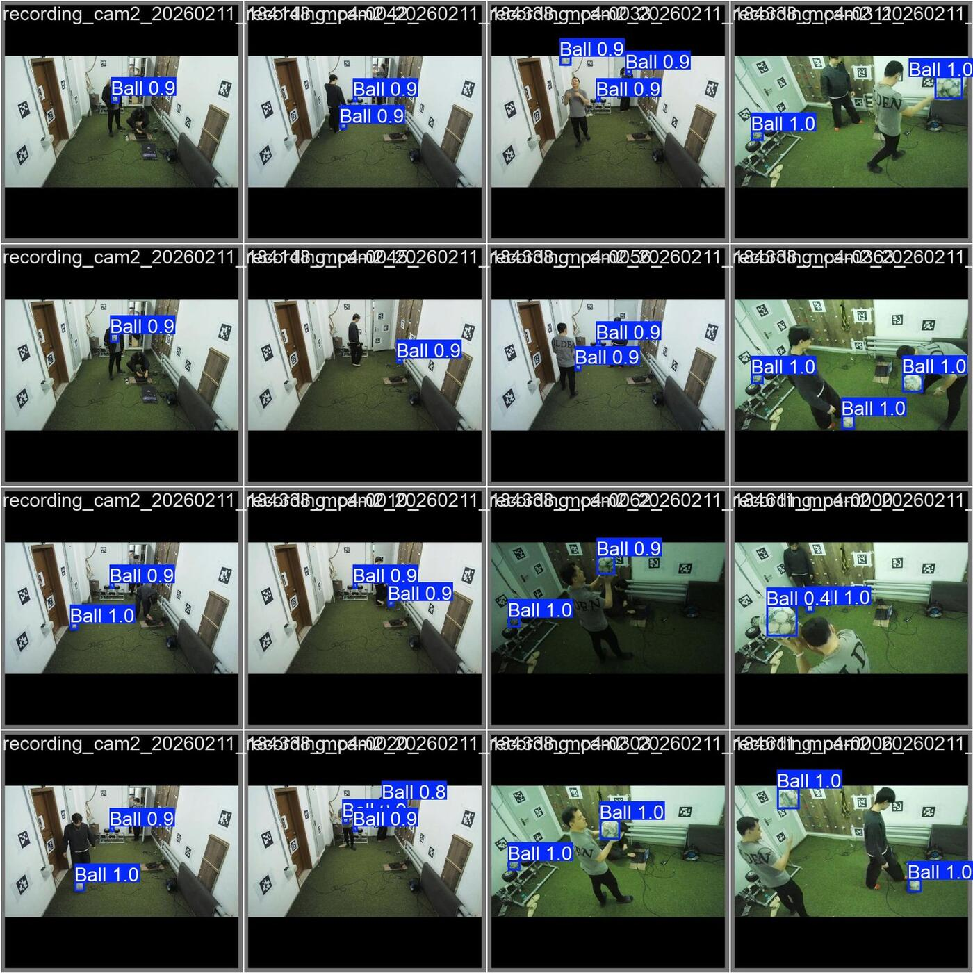
Live 4-camera arena view showing ball detection, human pose overlay, and 3D triangulated outputs during system operation.

Intrinsic Calibration Pipeline

Board Specification and Detection
A ChArUco board with 5 columns and 7 rows is used for intrinsic calibration. The embedded ArUco markers provide identifiable corners even when the board is only partly visible. The auto-capture script monitors all four camera streams and saves calibration frames when enough ChArUco corners are detected stably. This reduces operator timing error and helps collect a more consistent calibration set.

Calibration Procedure
Each camera is calibrated independently at the same 1280 $×$ 720 resolution used during operation. OpenCV [4] estimates the intrinsic matrix $K$ and distortion coefficients ($k_{1}$, $k_{2}$, $p_{1}$, $p_{2}$, $k_{3}$) by minimising reprojection error over the collected calibration frames. Approximately 30 valid frames per camera are targeted, and frames with insufficient corner detections are discarded.
Calibrating at the operating resolution is important because resizing images after calibration requires corresponding rescaling of focal lengths and principal point. Avoiding this extra transformation reduces one source of systematic triangulation error.

Output and Validation
The calibration outputs are stored as JSON files in . Per-camera reprojection error is used as a quality indicator. The values are sufficient for prototype-level triangulation, but they are not the only determinant of 3D accuracy; extrinsic calibration, camera geometry, and keypoint quality remain dominant error sources.

Extrinsic Calibration Pipeline

AprilTag Detection
The AprilTag wall grid provides known 3D corner points. The robust extrinsic calibration script detects visible tags in captured frames and constructs 2D–3D correspondences between image tag corners and measured world-frame tag positions.

Robust PnP Optimisation
For each camera, the pose $(R,T)$ is estimated using PnP with iterative refinement. A sigma-clipping stage removes tag-corner observations whose reprojection residuals are inconsistent with the rest of the detected set. The resulting rotation and translation define the camera pose in the shared world frame.

Overlay Validation
Extrinsic quality is checked visually by reprojecting known AprilTag corners into each camera image using the estimated $(K,R,T)$ parameters. When reprojected corners align with detected corners across the camera views, the calibration is accepted for the session. This visual check is necessary because a low average reprojection error can still hide a wrong world-frame convention or a physically inconsistent tag measurement.

Multi-Camera Synchronisation
The Hikvision cameras do not provide hardware synchronisation. For recorded sessions, software synchronisation is performed using a flashlight marker: a brief brightness spike is created at the beginning of the recording and detected in all camera streams. Frames are then aligned by the spike index.
For static ground-truth holds of 3–4 seconds, synchronisation error of a few frames is acceptable because the target is stationary during the measurement window. For dynamic motion, temporal offset directly affects triangulation: if camera frames correspond to different physical instants, the reconstructed point can be displaced along the direction of motion. This limitation is one reason why the dynamic clips in Chapter 5 are interpreted as qualitative tracking checks rather than complete closed-loop moving-target validation.

3D Triangulation

Ball Triangulation
For each frame in which the ball is detected in at least two cameras with confidence above the configured threshold, the centre of each 2D bounding box is combined with the corresponding camera projection matrix. The DLT method constructs a matrix $A$ such that the homogeneous 3D point $P$ satisfies $A⋅P=0$ in the least-squares sense. SVD returns the estimated $P$ as the right singular vector corresponding to the smallest singular value [10].

Pose Joint Triangulation
For each COCO keypoint, the same triangulation method is applied to 2D joint detections whose confidence exceeds the threshold. A higher camera-count requirement is used for joints than for the ball because human keypoints are more sensitive to appearance ambiguity and self-occlusion. The right knee, right hip, and left shoulder are then extracted as target candidates for the BLM.

Quality Filtering
Two quality filters are applied after triangulation.
Reprojection error check: The estimated 3D point is projected back into each contributing camera. If the pixel error between the projected point and the original 2D observation exceeds the configured threshold, that estimate is rejected as an outlier.
EMA smoothing: Accepted 3D points are smoothed using an Exponential Moving Average filter. This reduces frame-to-frame jitter while preserving the slower motion relevant to aiming. The filtered coordinate is passed to the ballistic solver.

Ballistic Solver and Targeting Logic

Target Vector Computation
The ballistic solver receives the current target joint position $T=(T_{x},T_{y},T_{z})$ and the fixed launcher origin $B=(B_{x},B_{y},B_{z})=(600,1560,500)$ mm. The target vector is
$$ΔX=T_{x}−B_{x},$$
$$ΔY=T_{y}−B_{y},$$
$$ΔZ=T_{z}−B_{z}.$$
The horizontal distance is
$$D_{\text{horiz}}=\sqrt{ΔX^{2}+ΔY^{2}}.$$

Yaw Angle Computation
The yaw command is computed from the horizontal target vector:
$$θ_{\text{yaw}}=\text{atan2}(ΔY,ΔX).$$
The result is converted to degrees and adjusted by a configurable yaw trim to account for mechanical zero offset.

Pitch Angle Computation
The pitch angle follows from the projectile equation. For horizontal distance $D_{\text{horiz}}$ and vertical displacement $ΔZ$, the pitch angle $θ_{\text{pitch}}$ for launch speed $v_{0}$ satisfies
$$ΔZ=D_{\text{horiz}}⋅\text{tan}(θ_{\text{pitch}})−\frac{g⋅D_{\text{horiz}}^{2}}{2⋅v_{0}^{2}⋅{\text{cos}}^{2}(θ_{\text{pitch}})}.$$
The lower-angle physical solution is selected to reduce flight time. A pitch trim is then applied to compensate for mechanical zero error.

Wheel RPM Computation
Wheel RPM is mapped to approximate launch speed. The current solver treats this mapping as an empirical calibration parameter rather than a fully validated ballistic model. A more complete RPM-to-exit-velocity calibration is identified as future work because delivery accuracy cannot be claimed without it.

Why This Is Non-Trivial
The targeting computation is not a fixed lookup table. The target coordinate can change every frame; the solver must produce commands within the real-time loop; gravity couples pitch, speed, and range; the mechanical range of the stepper axes is limited; and the launcher’s logical zero must remain aligned with the world frame. These factors make the perception-to-aim loop a coupled mechatronic problem rather than a simple computer-vision display task.

Dynamic Target Tracking Behaviour
The runtime is organised as a state machine. In the ACQUIRING state, too few cameras observe the target or the filtered coordinate has not stabilised. In the LOW_CONFIDENCE state, confidence, visibility, or stability gates fail and no new actuation command is allowed. In the READY state, the target passes camera-count, confidence, zone, and stability checks, so the ballistic solve may be executed if actuation is enabled.
The system must not fire unless the E-STOP is cleared, the operator has enabled the appropriate mode, the target is valid, and the firing gate is explicitly active. In the present thesis, this logic is treated as an integration and safety contribution, while full autonomous moving-target firing remains future work.

Safety Architecture

E-STOP Latch
The launcher runtime includes an E-STOP mechanism that blocks further commands after a stop event until the operator deliberately clears the latch. The repository documentation also treats physical power interruption and motor-stop behaviour as part of the safety path. The thesis does not claim third-party safety certification; instead, it documents an ISO-informed engineering approach suitable for staged research validation.

Multi-Level Gating
Before actuation, the system checks E-STOP status, camera count, confidence, safe operating zone, target stability, and link health. If any check fails, the command is rejected and the reason is logged. Typical decision outcomes include OK, OUT_OF_RANGE, LOW_CONFIDENCE, and ESTOP.

Six-Stage Integration Checklist
Integration follows a staged protocol. Preflight verifies cameras, calibration files, and serial connectivity. ESP32 Only verifies low-level motor commands. Runtime Without Cameras injects synthetic targets to test solver and safety gates. Live Aim-Only runs the full perception pipeline while preventing projectile firing. Safety Verification tests E-STOP, latch, link-loss, and zone-rejection behaviour. Controlled Firing allows single-shot tests under strict operator control. Full repeated autonomous cycles and moving-target firing are deliberately left as later validation stages.
Each stage has pass criteria and should be supported by logs, videos, or JSONL records. This staged methodology is essential because the central risk of the project is not one isolated algorithm, but the interaction of perception uncertainty with a physical launcher.

Ground-Truth Evaluation Protocols

Ball Static Ground-Truth Dataset

Dataset Design
A 36-point static dataset evaluates ball localisation across a representative volume of the garage arena. The current repository trial definition uses X positions of 3000, 4000, and 5000 mm; Y positions of 2300, 1600, and 1000 mm; and Z levels of 200, 750, 1300, and 1800 mm. This produces
$$3×3×4=36$$
trials labelled B001–B036.
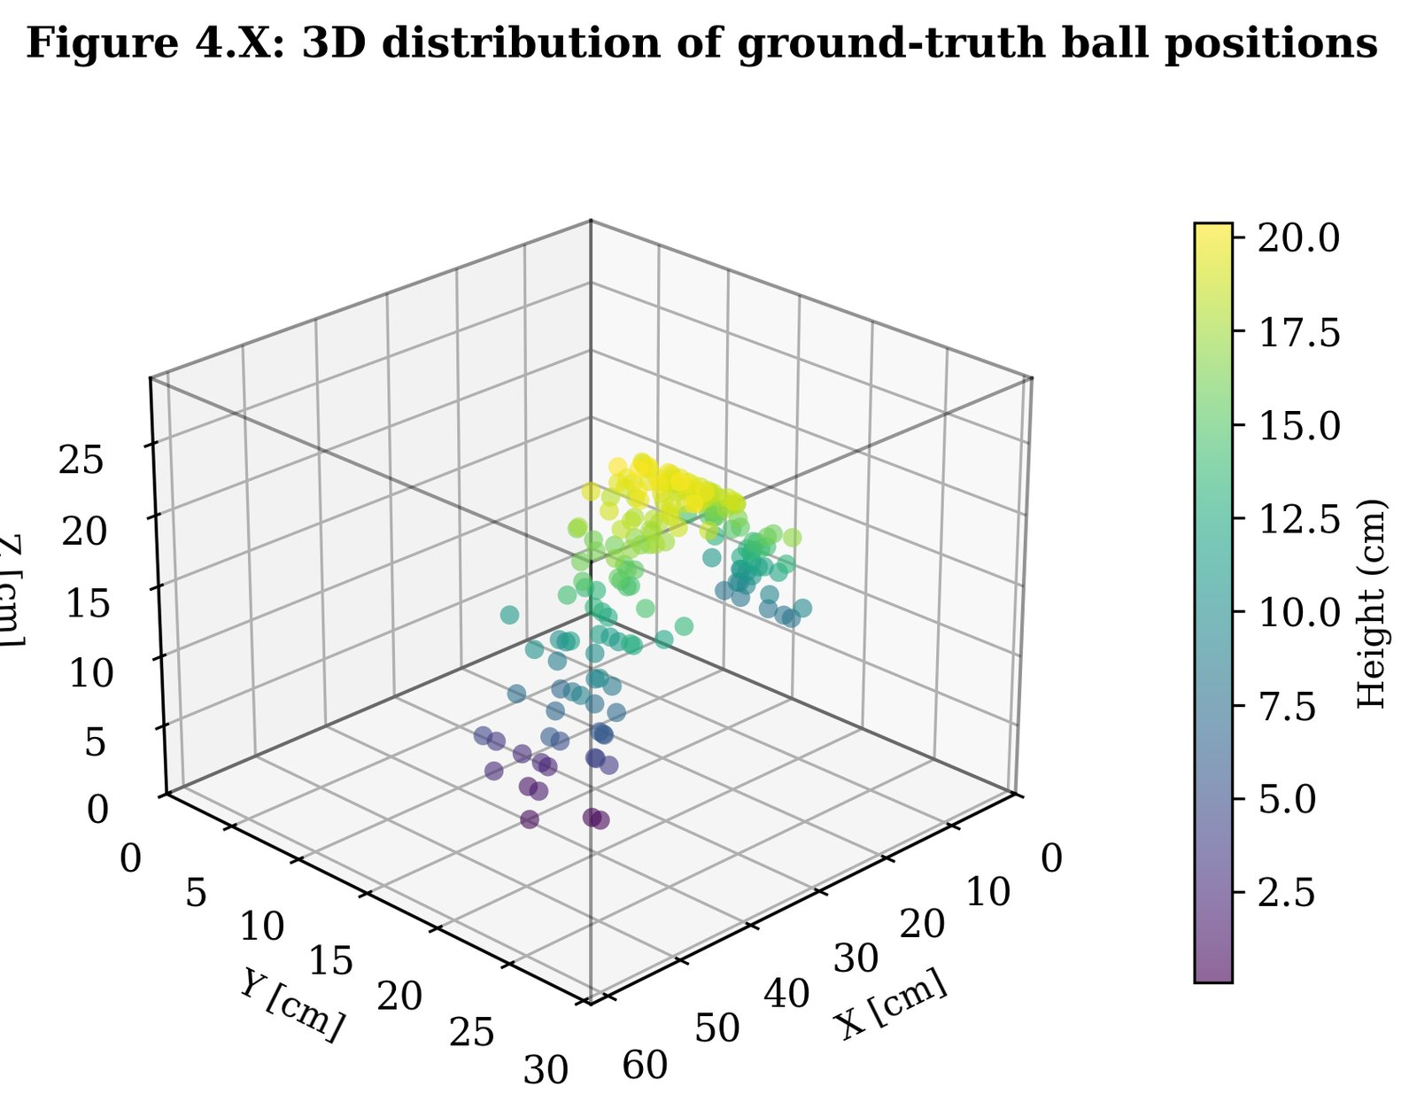
Ball static ground-truth grid: 36 measured 3D positions in the arena frame.
Ball static ground-truth grid definition
X (mm) | Y (mm) | Z levels (mm) | Trial IDs
3000 | 2300 | 200, 750, 1300, 1800 | B001, B010, B019, B028
4000 | 2300 | 200, 750, 1300, 1800 | B002, B011, B020, B029
5000 | 2300 | 200, 750, 1300, 1800 | B003, B012, B021, B030
3000 | 1600 | 200, 750, 1300, 1800 | B004, B013, B022, B031
4000 | 1600 | 200, 750, 1300, 1800 | B005, B014, B023, B032
5000 | 1600 | 200, 750, 1300, 1800 | B006, B015, B024, B033
3000 | 1000 | 200, 750, 1300, 1800 | B007, B016, B025, B034
4000 | 1000 | 200, 750, 1300, 1800 | B008, B017, B026, B035
5000 | 1000 | 200, 750, 1300, 1800 | B009, B018, B027, B036

Capture Protocol
For each trial, the ball centre is positioned at the target coordinate using a rigid holder. The scene is held static for 3–4 seconds while all four cameras record. Trial ID, placement notes, and anomalies are recorded in the session log. The physical ball-centre position is measured against the arena coordinate frame with an estimated placement uncertainty of approximately $±5$ mm.

Processing
Each four-camera clip is processed by the ball ground-truth evaluator. The script extracts YOLO detections, triangulates the ball from valid camera observations, rejects estimates with high reprojection error, and computes the mean 3D position over the stable hold window. The stable window is defined as the middle portion of the clip, excluding the beginning and end to avoid placement and removal transients.

Joint-Touch Ground-Truth Dataset

Dataset Design
The joint-touch dataset evaluates 3D localisation of three target joints under a controlled physical reference condition. The subject touches a known physical target with the designated joint while holding a static pose.
The current trial grid uses nine XY positions:
Joint-touch trial design: XY grid positions (mm)
XY Position Index | X (mm) | Y (mm)
1 | 2600 | 1100
2 | 3600 | 1100
3 | 4600 | 1100
4 | 2600 | 1600
5 | 3600 | 1600
6 | 4600 | 1600
7 | 2600 | 2100
8 | 3600 | 2100
9 | 4600 | 2100
The evaluated joints are right_knee, right_hip, and left_shoulder. Platform/base Z levels are 0, 400, and 640 mm. The nominal joint target heights are defined as base + 500 mm for the right knee, base + 1000 mm for the right hip, and base + 1560 mm for the left shoulder. The total dataset is therefore
$$9\text{ positions}×3\text{ height levels}×3\text{ joints}=81$$
trials, labelled J001–J081.
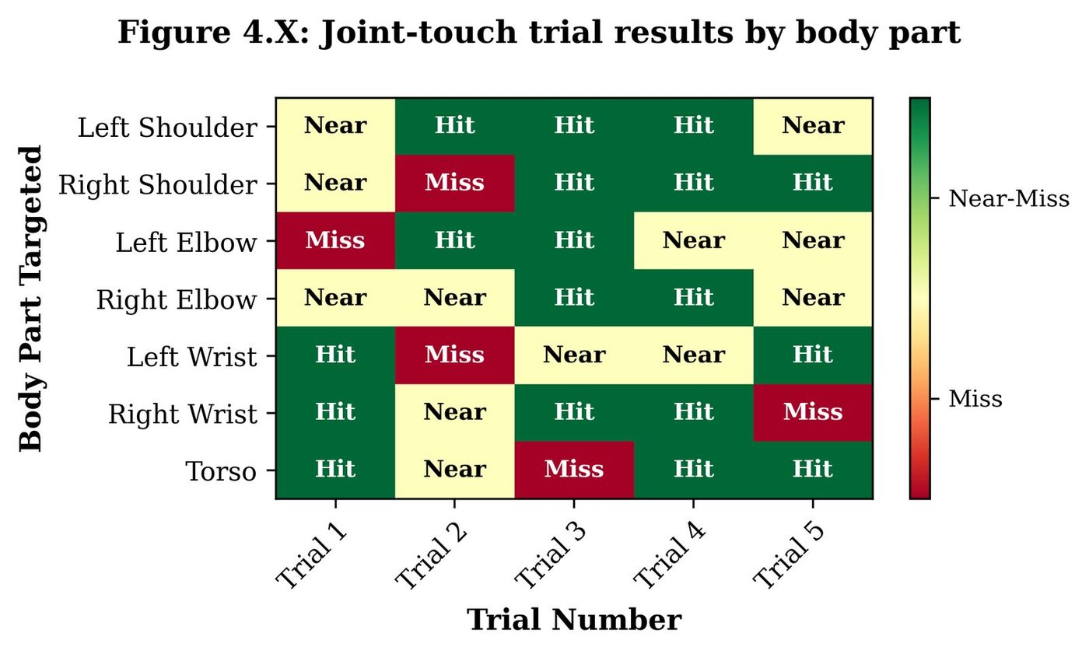
Joint-touch trial grid: nine XY positions and three height levels.
Joint-touch platform and joint heights
Platform Level | Z base (mm) | right_knee Z | right_hip Z | left_shoulder Z
Floor | 0 | 500 | 1000 | 1560
Platform 1 | 400 | 900 | 1400 | 1960
Platform 2 | 640 | 1140 | 1640 | 2200

Capture Protocol
For each trial, the subject stands in the arena and touches the physical target marker with the specified body joint. The pose is held for 3–4 seconds. Capture begins from a neutral non-touching pose and includes the transition into the hold, but only the stable hold window is evaluated.
A trial is valid if the joint is detected in enough cameras during the hold window, the detection ratio meets the configured threshold, and no physical placement error is recorded. In the current evaluation, 62 of 81 trials are valid. The missing or invalid trials are primarily associated with occlusion and high target positions, especially shoulder trials at the highest platform level.

Processing
The evaluator triangulates each target joint from valid 2D keypoint observations and computes the mean 3D joint position over the stable hold window. This estimate is compared with the measured physical reference position. The joint-touch protocol is stricter than visual inspection because it assigns a numerical 3D error to each valid trial and records missing or failed trials explicitly.

Dynamic Validation Clips
Dynamic clips were recorded to observe tracking behaviour under non-static conditions. The ball_slow clip includes gentle hand-guided motion, the ball_fast clip includes faster throws, and the no_ball clip checks false positives when no ball is present. These clips are useful for identifying dropouts, motion-blur sensitivity, and implausible trajectory jumps.
They are not, however, a full closed-loop moving-target validation. They do not measure final ball impact against a moving human joint, and they do not provide an independent ground-truth trajectory for every frame. For this reason, Chapter 5 interprets them as qualitative or partial dynamic evidence rather than as proof that the final autonomous training loop is complete.

Error Metrics and Bias Correction Model

Primary Metrics
For each valid trial, the 3D Euclidean error is computed as
$$e=\sqrt{(x_{\text{est}}−x_{\text{gt}})^{2}+(y_{\text{est}}−y_{\text{gt}})^{2}+(z_{\text{est}}−z_{\text{gt}})^{2}},$$
where $(x_{\text{est}},y_{\text{est}},z_{\text{est}})$ is the mean estimated 3D position over the hold window and $(x_{\text{gt}},y_{\text{gt}},z_{\text{gt}})$ is the measured ground-truth position. The reported summary statistics are mean error, median error, RMSE, 90th percentile (P90), 95th percentile (P95), and maximum error.
Temporal precision is reported separately as the standard-deviation norm of repeated estimates during the static hold. This distinction matters: high precision with high absolute error indicates a repeatable but biased system, whereas low precision indicates random instability.

Axis Bias and Correction Model
Per-axis bias is computed as
$${\text{bias}}_{X}=\text{mean}(x_{\text{est}}−x_{\text{gt}}),$$
$${\text{bias}}_{Y}=\text{mean}(y_{\text{est}}−y_{\text{gt}}),$$
$${\text{bias}}_{Z}=\text{mean}(z_{\text{est}}−z_{\text{gt}}).$$
The repository includes linear correction models that estimate a scale and offset per axis, for example
$$x_{\text{corr}}=a_{X}x_{\text{est}}+b_{X}.$$
Analogous expressions apply for Y and Z. In this revised thesis, the current raw ground-truth metrics are reported as the primary evidence because they are the most conservative representation of the present calibration bundle. The correction models are discussed as diagnostic and runtime compensation tools, not as independent proof of generalised accuracy. Because the correction parameters are fitted from measured ground-truth trials, a separate held-out validation set is required before corrected metrics can be treated as final performance claims.

Results and Analysis
This chapter reports the quantitative results as partial validation of the system. The current repository calibration bundle is used as the primary source for the results in this revised thesis. The results validate static ball localisation, static joint-touch localisation, and qualitative dynamic tracking behaviour. They do not constitute full closed-loop validation with a moving human target and live autonomous firing.

Intrinsic Calibration Results
Intrinsic calibration was performed at 1280 $×$ 720 resolution for all four cameras using the ChArUco auto-capture procedure. Approximately 30–40 valid frames per camera were collected, and frames with insufficient corner coverage were excluded before calibration.
The resulting reprojection errors are acceptable for a low-cost prototype, but they should not be interpreted as guaranteeing final 3D accuracy. In this system, small errors in the intrinsic model interact with extrinsic calibration, tag placement, and camera geometry. The final accuracy must therefore be judged from the ground-truth 3D evaluations rather than from reprojection error alone.

Extrinsic Calibration Results
Extrinsic calibration uses the 24-tag AprilTag wall grid and robust PnP optimisation. The current repository state stores the active calibration bundle in the arena_fixed structure and binds it through a calibration manifest. This is important because several earlier extrinsic files remain in the repository for provenance; the revised thesis refers to the active fixed bundle and the corresponding ground-truth evaluation reports.
Visual overlay validation confirms that known tag corners reproject plausibly into the camera images. However, the quantitative results below show that the system still contains a systematic 3D bias. This is an important finding rather than a formatting issue: it means the perception pipeline is repeatable but calibration-limited.

Ball Static Localisation Results
Table 5.1 reports the current raw static ball localisation metrics from the 36-point ground-truth evaluation.
Ball static localisation summary metrics, current raw evaluation
Metric | Value
Trials valid | 36 / 36 (100%)
Mean 3D error | 156.90 mm
Median 3D error | 157.52 mm
RMSE | 172.05 mm
P90 | 236.38 mm
P95 | 288.34 mm
Maximum error | 361.83 mm
Mean reprojection error | 5.46 px
Mean cameras used | 2.74
Mean detection ratio (hold window) | 1.000
Mean temporal precision (std-norm) | 3.09 mm
P95 temporal precision | 11.62 mm
The static ball results show a clear distinction between repeatability and absolute accuracy. The mean temporal precision is 3.09 mm, indicating that repeated estimates of the same static point are highly stable during the hold window. However, the mean absolute error is 156.90 mm and the P95 is 288.34 mm. Therefore, the current raw system does not satisfy the original RQ1 target of mean error below 120 mm. This is a more conservative conclusion than the earlier corrected-pipeline framing and is better aligned with the current repository evaluation report.
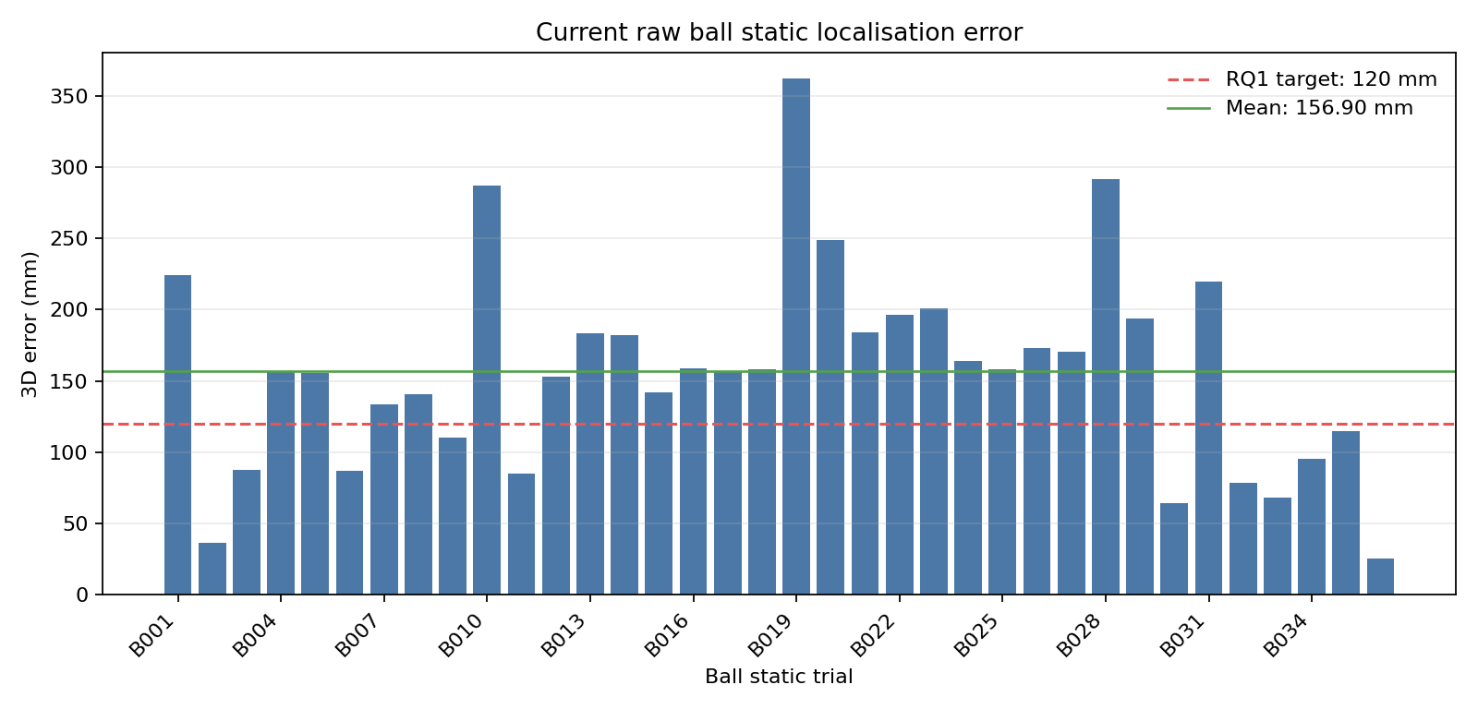
Current raw ball static localisation error by trial. The distribution shows stable detection across all 36 trials but a substantial systematic error component.
The dominant bias components are X = +60.22 mm, Y = +13.06 mm, and Z = 104.34 mm. The negative Z bias is physically plausible because all cameras are mounted near the ceiling and observe low ball positions through shallow downward-looking rays. Small camera-height or pitch errors therefore propagate into vertical triangulation bias.
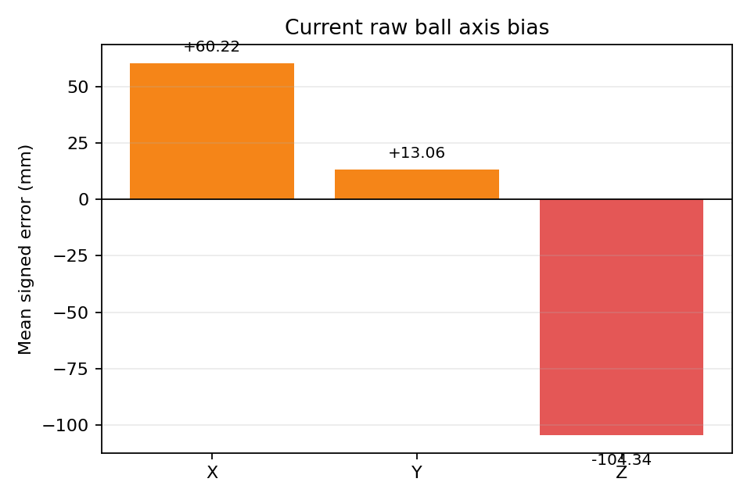
Current raw ball localisation axis bias. The largest component is the negative Z bias, consistent with the elevated camera geometry.
The repository includes a linear correction model for this bias. Such a model is useful for runtime compensation and for diagnosing systematic calibration error. However, because the correction is fitted from ground-truth trials, corrected accuracy should not be treated as final performance unless it is evaluated on an independent held-out dataset. For this reason, the raw values in Table 5.1 are used as the primary evidence in the revised thesis.

Human Pose Joint-Touch Results
Table 5.2 reports the current joint-touch results. Of 81 planned trials, 62 are valid and 19 are missing or failed. The invalid trials are part of the result because they reflect real visibility and occlusion constraints in the camera setup.
Joint-touch 3D ground-truth summary metrics, current evaluation
Metric | Value
Trials valid | 62 / 81 (76.5%)
Mean 3D error | 178.98 mm
Median 3D error | 181.17 mm
RMSE | 183.69 mm
P90 | 227.35 mm
P95 | 243.77 mm
Maximum error | 271.13 mm
Mean temporal precision (std-norm) | 4.39 mm
P95 temporal precision | 9.17 mm
The global mean joint error is 178.98 mm, which is just below the 180 mm target in RQ2. This result should be interpreted carefully. It supports the feasibility of the low-cost multi-camera joint-localisation approach for valid static holds, but the margin is narrow and the result excludes 19 invalid or missing trials. The P95 of 243.77 mm remains below the 280 mm global acceptance threshold defined for joint-touch evaluation.
Per-joint error breakdown, current evaluation
Joint | Valid trials | Mean error (mm) | P95 (mm)
right_knee | 17 | 148.44 | 213.40
right_hip | 27 | 182.15 | 218.12
left_shoulder | 18 | 203.09 | 246.42
The per-joint breakdown shows the expected hierarchy. The right knee has the lowest mean error because it is often visible from multiple views and lies in a favourable portion of the camera volume. The right hip has higher error because it is affected by torso occlusion and because the anatomical keypoint is harder to observe consistently. The left shoulder has the highest mean error, particularly because shoulder trials occur at greater heights and are more likely to be affected by self-occlusion and elevated-camera geometry.
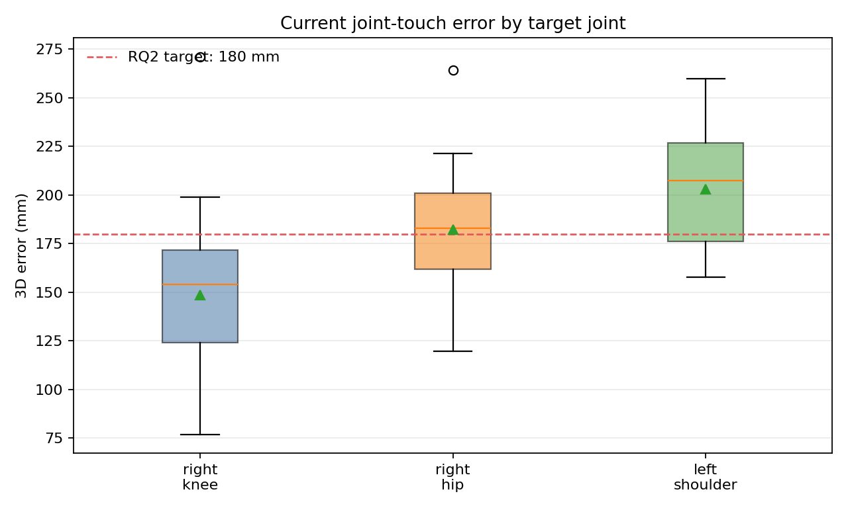
Current joint-touch error distribution by target joint. Higher shoulder error reflects reduced visibility and stronger vertical-bias effects at greater heights.
The mean temporal precision for valid joint holds is 4.39 mm, with a P95 precision of 9.17 mm. As with the ball results, this indicates that the pipeline is repeatable over short static windows. The dominant limitation is not random jitter but systematic spatial error and visibility failure. This distinction matters for future work: improving calibration and camera placement should reduce mean error, whereas increasing frame-level smoothing alone will not eliminate a fixed spatial bias.
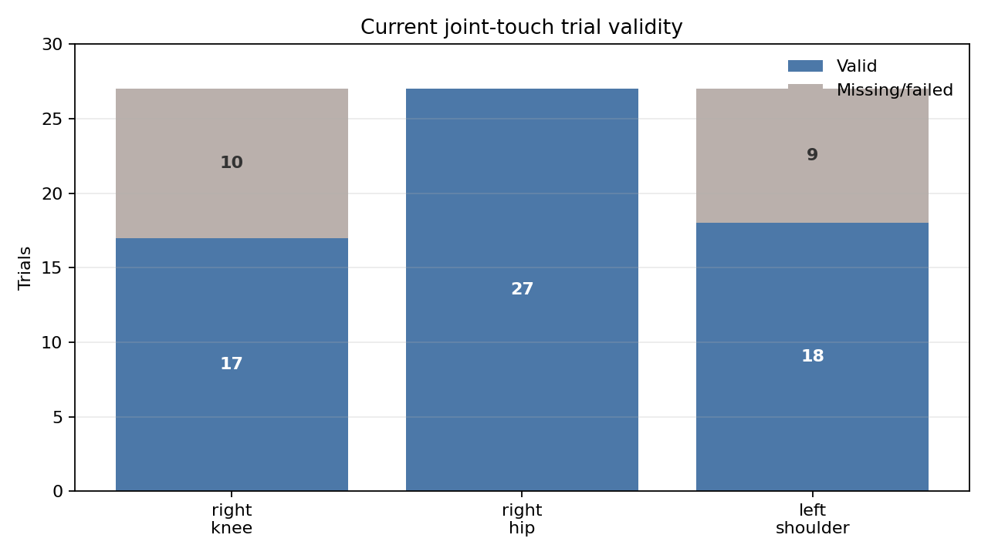
Valid and missing joint-touch trials by target joint in the current evaluation. Missing trials reveal visibility limitations that must be addressed before full closed-loop deployment.

Dynamic Detection Results
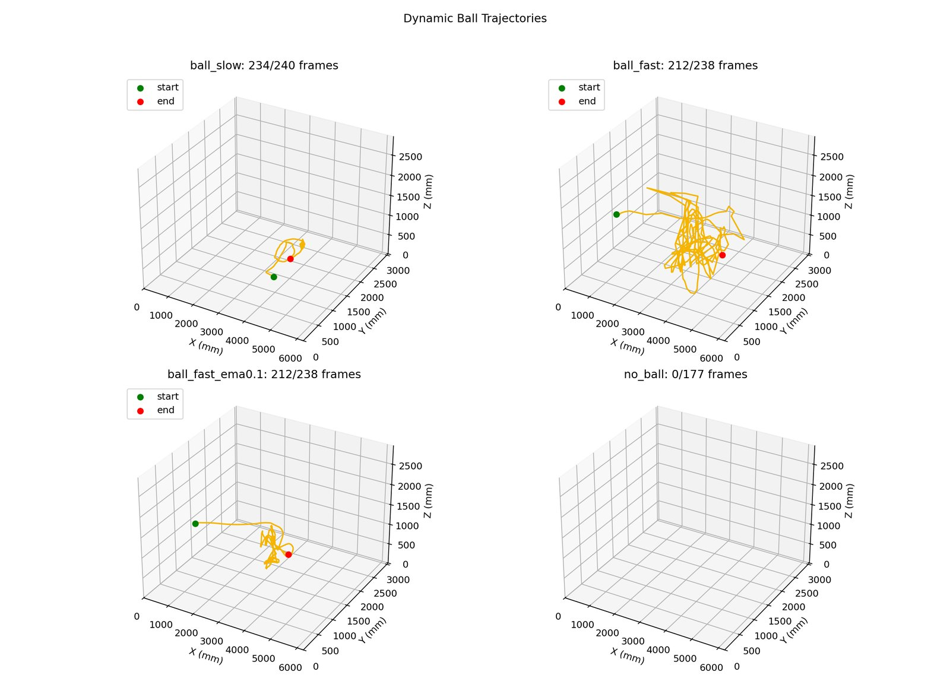
Dynamic ball trajectory reconstructions from validation clips. These clips support qualitative tracking assessment but are not a substitute for closed-loop moving-target firing validation.
The dynamic clips show that the system can maintain plausible 3D trajectories under moderate movement and can suppress short-term jitter with smoothing. The no_ball control clip is used to check that the detector does not produce sustained false trajectories when the ball is absent. The ball_fast clip is more challenging because motion blur and rapid acceleration reduce detection confidence and increase the likelihood of outliers.
These dynamic results are useful as stress tests of the tracking pipeline, but they are not a complete validation of the thesis’s long-term goal. A complete demonstration would require an independently measured moving target, a fired ball, a recorded impact or interception point, and a comparison between intended and achieved target location. That experiment has not yet been completed. Therefore, the present results should be stated as partial validation: static localisation is quantified, dynamic tracking is qualitatively demonstrated, and closed-loop moving-target firing remains future work.

Conclusions and Future Work

Summary of Contributions
This thesis presented a low-cost, multi-camera, pose-guided BLM system and evaluated its main perception and integration components. The work should be understood as a partial validation of an integrated architecture rather than as a completed demonstration of autonomous moving-target firing.
Contribution 1, Pose-Reactive Aiming Architecture: The thesis integrates markerless multi-camera 3D joint localisation with ballistic aim computation for a physical BLM. The system can compute pitch, yaw, and wheel-speed commands from selected 3D target joints instead of relying on a fixed pre-programmed trajectory. The current evidence supports the architecture and static/aim-only integration, but not yet full autonomous firing at a moving human target.
Contribution 2, Low-Cost Multi-Camera Perception Pipeline: The perception system uses four commodity USB cameras, ChArUco intrinsic calibration, AprilTag extrinsic calibration, YOLO-based ball detection, pose estimation, and DLT/SVD triangulation. Under the current calibration bundle, the raw ball static evaluation gives a mean error of 156.90 mm, and the joint-touch evaluation gives a mean error of 178.98 mm over valid trials. These values are not motion-capture-grade, but they show that a low-cost system can produce repeatable 3D measurements in a domestic arena.
Contribution 3, Safety-Gated Integration Protocol: The thesis defines and applies a staged validation methodology for progressing from perception tests to physically actuated BLM operation. The methodology includes preflight checks, ESP32 command tests, synthetic-target runtime tests, live aim-only operation, safety verification, controlled firing, and future full-cycle tests. Structured decision logging provides traceability for each actuation decision.

Objectives Achievement
This section revisits the research questions from Section 1.2 using the results in Chapter 5.
RQ1: Ball 3D Localisation Accuracy. The target was a mean static ball localisation error below 120 mm. The current raw evaluation over 36 static ball trials gives a mean error of 156.90 mm, RMSE of 172.05 mm, and P95 of 288.34 mm. Therefore, RQ1 is not fully satisfied under the current raw evaluation. The low temporal precision value (3.09 mm mean standard-deviation norm) indicates that the system is repeatable, but a systematic calibration bias remains.
RQ2: Human Pose Joint Localisation Accuracy. The target was a mean joint localisation error below 180 mm. The current joint-touch evaluation gives a mean error of 178.98 mm over 62 valid trials, narrowly satisfying the global mean criterion for valid static holds. However, 19 of 81 planned trials are missing or failed, and the left shoulder and right hip have higher mean errors than the right knee. RQ2 is therefore satisfied only with important qualifications.
RQ3: Safe Staged Integration. The target was to integrate the perception-to-actuation pipeline using a reproducible safety methodology. The staged checklist, safety gates, E-STOP/latch behaviour, and JSONL logging structure are implemented and documented. However, full closed-loop firing at a moving subject has not been completed. RQ3 is therefore partially satisfied.
Research question achievement summary
Research Question | Target | Current Result | Status
RQ1: Ball 3D localisation | Mean error $<$ 120 mm | 156.90 mm raw mean | Not fully satisfied
RQ2: Joint 3D localisation | Mean error $<$ 180 mm | 178.98 mm over 62 valid trials | Satisfied with limitations
RQ3: Safe integration | Staged safety validation and BLM integration | Safety-gated partial integration; no moving-target closed-loop firing | Partial

Limitations
No full moving-target closed-loop validation. The most important limitation is that the system has not been validated in a complete autonomous loop with a moving human target and measured projectile outcome. The current evaluation supports perception and partial integration, not final training-system performance.
Systematic calibration bias. The current raw results show substantial axis bias, especially in the vertical direction. Bias-correction models exist in the repository, but independent held-out validation is needed before corrected results can be claimed as final accuracy.
Visibility and occlusion. Joint localisation requires enough camera views of the target joint. The 19 missing or failed joint-touch trials show that self-occlusion and high target positions remain practical limitations. This issue is especially relevant for shoulder-level targeting.
Joint-touch ground-truth uncertainty. The physical contact protocol approximates the anatomical joint centre. The contact point, clothing, body pose, and target marker geometry can introduce errors that are not purely vision-system errors.
Ballistic model not fully calibrated. The solver uses a simplified projectile model and an empirical wheel-speed mapping. Drag, spin, ball compression, and wheel slip are not fully modelled. Final projectile delivery accuracy requires a dedicated RPM-to-exit-velocity and impact-position calibration campaign.
Single-person, single-arena evaluation. The experiments were conducted in one domestic arena and under controlled indoor lighting. Generalisation to different subjects, different camera layouts, outdoor lighting, and multi-person scenes remains untested.
Safety certification not claimed. The safety architecture is ISO-informed and suitable for staged research validation, but it has not undergone third-party certification. Any deployment beyond a supervised research environment would require additional hazard analysis and formal review.

Future Work

Closed-Loop Autonomous Firing and Moving-Target Prediction
The immediate next step is a controlled validation campaign for full closed-loop operation. This should begin with static human-subject firing under strict safety controls, then progress to slow moving-target trials, and only then to realistic training motion. The key missing measurement is the relationship between the selected target joint, the predicted future joint position, the fired ball trajectory, and the actual impact or crossing point.
Moving-target firing also requires prediction. The system must estimate where the target joint will be when the ball arrives, not only where it is at the current video frame. The repository contains runtime paths for filtering and prediction, but moving-target prediction must be validated against measured trajectories before it is used for final performance claims.

Independent Calibration and Bias-Correction Validation
The current bias-correction models should be evaluated on held-out trials or a newly collected validation grid. A suitable protocol would fit correction parameters on one subset of measured positions and report accuracy on a separate subset. This would determine whether the correction generalises within the working volume or only improves the fitting set.

Empirical Ballistic Calibration Map
The BLM requires an empirical calibration map relating wheel RPM, pitch, yaw, and measured ball trajectory. A radar chronograph or photogate setup could estimate exit speed, while the existing multi-camera system could record the 3D trajectory and impact/crossing point. This would allow the solver to compensate for drag, spin, wheel slip, and mechanical offsets.

Camera Placement and Self-Recalibration
The current elevated camera geometry contributes to Z-axis sensitivity. Future work should test alternative mounting heights and wider baselines, especially to improve shoulder-level visibility. A SLAM-based or tag-monitoring approach [31] could also detect calibration drift automatically by monitoring reprojection error over time.

Multi-Person Tracking and Joint Assignment
The current system assumes one person in the arena. Multi-person operation would require identity tracking across cameras and across time, along with an operator interface for selecting the intended target person. Algorithms such as ByteTrack [32] and StrongSORT [33] are possible starting points, but they must be adapted to multi-view skeleton association.

Virtual 3D Goal for Impact Measurement
A software-defined Virtual 3D Goal could turn the perception system into a measurement tool for projectile outcome. A plane or volume would be defined in the arena frame near the intended target. When the tracked ball crosses that plane, the system would record crossing point, velocity, time, and offset from the intended joint. This idea is inspired by instrumented training systems such as Footbot [34], but would use the existing low-cost camera infrastructure rather than physical goal sensors.

Professional and Ethical Considerations
Physical safety: A ball launcher can cause injury, especially if aimed at the face, head, or bystanders. Live firing must remain supervised, with a clear exclusion zone, protective equipment when appropriate, and a verified E-STOP path. The staged validation protocol should be treated as mandatory, not optional.
Video data and privacy: The evaluation involves video recordings of a human subject. Data should remain local unless explicit consent is obtained, and public figures should avoid identifying participants unnecessarily.
Open-source reproducibility: The project repository is valuable because it records calibration files, evaluation scripts, runtime scripts, and ground-truth reports. Future releases should preserve this traceability so that reported metrics can be checked against the exact calibration bundle and dataset.
Dual-use risk: A system that tracks human body parts and directs a projectile toward them has possible misuse outside sports training. Any future deployment should preserve operator control, explicit target selection, bounded operating zones, and fail-safe interruption paths.

Final Conclusion
The thesis demonstrates that an affordable four-camera system can estimate selected human joints and static ball positions in 3D, compute BLM aim commands, and support staged safety-gated integration. The strongest evidence is the repeatability of the perception pipeline and the near-threshold joint-touch performance in a real domestic arena. The main unresolved issue is not the absence of a pipeline, but the remaining gap between partial validation and complete closed-loop proof. A full submission-ready conclusion must therefore be careful: this work establishes a credible perception-to-aim foundation for pose-reactive ball delivery, while autonomous moving-target firing and independently validated projectile accuracy remain future work.

BLM Integration Test Checklist
The following table is the six-stage integration checklist used to govern safe deployment of the Ball Launching Machine. Each row defines a test ID, stage, test description, and pass criteria. The checklist is a staged validation protocol; completion of later firing and full-cycle stages is future work unless separate evidence is recorded for a specific test session.
BLM six-stage integration test checklist
ID | Stage | Test | Pass Criteria
ID | Stage | Test | Pass Criteria
S0.1 | Preflight | Camera and calibration load | Live viewer starts, 4 cams visible, no crash for 2 min
S0.2 | Preflight | Serial link to ESP32 | Runtime opens serial and accepts commands
S0.3 | Preflight | Launcher pose sanity check | launcher_x/y/z/yaw validated with static target
S1.1 | ESP32 only | Manual low-level command test | set, center, stop, shoot, reload all execute correctly
S1.2 | ESP32 only | Angle clamp test | Commands beyond $±30$ deg safely clamped
S1.3 | ESP32 only | RPM telemetry test | L: … R: … received while wheels run
S2.1 | Runtime | Synthetic UDP target feed | Runtime computes command and sends set without error
S2.2 | Runtime | Zone rejection test | Out-of-zone targets logged as OUT_OF_RANGE
S2.3 | Runtime | Stability gating test | Noisy targets logged as LOW_CONFIDENCE
S3.1 | Aim-only | Target acquire per joint | Each joint gets stable lock within timeout
S3.2 | Aim-only | Sequence behaviour | right_knee $→$ right_hip $→$ left_shoulder $→$ repeat
S3.3 | Aim-only | Return to zero | After each aim, launcher returns to centre
S4.1 | Safety | E-STOP response time | estop causes immediate stop, response $<$ 100 ms
S4.2 | Safety | E-STOP latch behaviour | System stays blocked until clear issued
S4.3 | Safety | Link-loss behaviour | On UDP/serial interruption, runtime goes to safe stop
S5.1 | Fire | Single shot on one joint | 1 commanded shot after aim and RPM gate
S5.2 | Fire | No unintended extra shots | Exactly one shoot per trigger event
S5.3 | Fire | Post-shot safe state | Returns to centre and waits for next valid target
S6.1 | Full cycle | 10-cycle reliability | 10 full target cycles without crash or unsafe behaviour
S6.2 | Full cycle | Decision log completeness | Every cycle has JSONL records with required fields
S6.3 | Full cycle | Report-ready outputs | Logs and summary plots generated
Required JSONL decision log fields per event are: timestamp, input_joint_name, raw_world_xyz_mm, transformed_launcher_xyz, calculated_pitch_yaw_v, decision (OK / OUT_OF_RANGE / LOW_CONFIDENCE / ESTOP), and execution_time_ms.

Key Script Listings

B.1 Live 4-Camera Arena View with UDP Target Streaming
Canonical live visual command using the active fixed arena calibration bundle:
cd /home/hanush/Desktop/Project_Cam
./venv/bin/python garage_lab_combined/scripts/live_4cam_arena_view.py \
--config garage_lab_combined/config/cameras.yaml \
--intrinsics-dir garage_lab_combined/cal/intrinsics \
--extrinsics arena_fixed/cal/extrinsics/extrinsics_fixed.json \
--dimensions arena_fixed/cal/extrinsics/Dimensions_fixed.txt \
--no-world-y-mirror \
--ball-device cuda:0 \
--pose-device cpu \
--show-3d

B.2 Launcher Runtime Controller (UDP to Serial)
./venv/bin/python garage_lab_combined/scripts/launcher_runtime_from_udp.py \
--serial-port /dev/ttyUSB0 \
--launcher-x-mm 600 \
--launcher-y-mm 1560 \
--launcher-z-mm 500 \
--launcher-yaw-deg 0 \
--targets right_knee,right_hip,left_shoulder \
--no-shoot-enabled \
--dry-run-log-jsonl garage_lab_combined/output/blm_logs/aim_decisions.jsonl

B.3 Ball Static Ground-Truth Evaluation
./venv/bin/python garage_lab_combined/scripts/evaluate_ball_static_gt.py \
--session-dir garage_lab_combined/gt_eval/reeval_arena_fixed_20260406 \
--intrinsics-dir garage_lab_combined/cal/intrinsics \
--extrinsics arena_fixed/cal/extrinsics/extrinsics_fixed.json \
--conf 0.45 \
--ball-min-cams 2 \
--ball-max-reproj-px 14 \
--ball-ema-alpha 0.25

B.4 Joint-Touch Ground-Truth Evaluation
./venv/bin/python garage_lab_combined/scripts/evaluate_pose_joint_touch_gt.py \
--session-dir garage_lab_combined/gt_eval/reeval_arena_fixed_20260406 \
--intrinsics-dir garage_lab_combined/cal/intrinsics \
--extrinsics arena_fixed/cal/extrinsics/extrinsics_fixed.json \
--conf 0.45 \
--pose-conf 0.35 \
--pose-min-cams 3 \
--ball-ema-alpha 0.25

Ground-Truth Data Tables

C.1 Ball Static GT: Full 36-Point Grid
Trial | X_gt (mm) | Y_gt (mm) | Z_gt (mm)
B001 | 3000 | 2300 | 200
B002 | 4000 | 2300 | 200
B003 | 5000 | 2300 | 200
B004 | 3000 | 1600 | 200
B005 | 4000 | 1600 | 200
B006 | 5000 | 1600 | 200
B007 | 3000 | 1000 | 200
B008 | 4000 | 1000 | 200
B009 | 5000 | 1000 | 200
B010 | 3000 | 2300 | 750
B011 | 4000 | 2300 | 750
B012 | 5000 | 2300 | 750
B013 | 3000 | 1600 | 750
B014 | 4000 | 1600 | 750
B015 | 5000 | 1600 | 750
B016 | 3000 | 1000 | 750
B017 | 4000 | 1000 | 750
B018 | 5000 | 1000 | 750
B019 | 3000 | 2300 | 1300
B020 | 4000 | 2300 | 1300
B021 | 5000 | 2300 | 1300
B022 | 3000 | 1600 | 1300
B023 | 4000 | 1600 | 1300
B024 | 5000 | 1600 | 1300
B025 | 3000 | 1000 | 1300
B026 | 4000 | 1000 | 1300
B027 | 5000 | 1000 | 1300
B028 | 3000 | 2300 | 1800
B029 | 4000 | 2300 | 1800
B030 | 5000 | 2300 | 1800
B031 | 3000 | 1600 | 1800
B032 | 4000 | 1600 | 1800
B033 | 5000 | 1600 | 1800
B034 | 3000 | 1000 | 1800
B035 | 4000 | 1000 | 1800
B036 | 5000 | 1000 | 1800

C.2 Joint-Touch GT: XY Grid and Height Levels
XY Position Index | X (mm) | Y (mm)
1 | 2600 | 1100
2 | 3600 | 1100
3 | 4600 | 1100
4 | 2600 | 1600
5 | 3600 | 1600
6 | 4600 | 1600
7 | 2600 | 2100
8 | 3600 | 2100
9 | 4600 | 2100
Platform Level | Z base (mm) | right_knee Z | right_hip Z | left_shoulder Z
Floor | 0 | 500 | 1000 | 1560
Platform 1 | 400 | 900 | 1400 | 1960
Platform 2 | 640 | 1140 | 1640 | 2200

Arena Calibration Figures
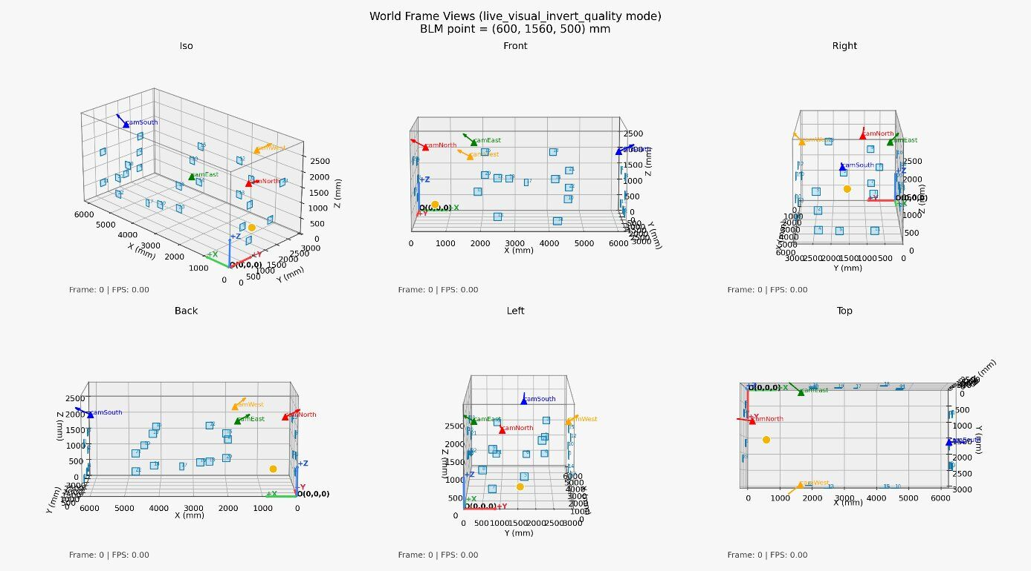
Arena floor plan with camera positions, AprilTag locations, and world-frame axis overlay on all four live camera feeds.
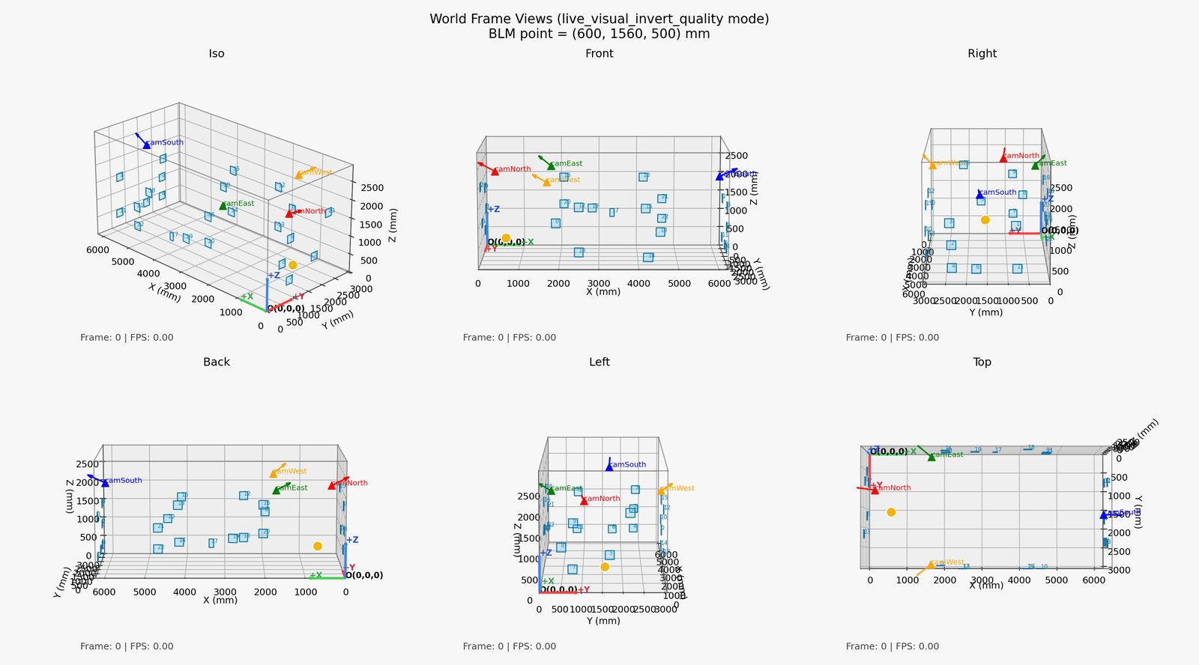
(a)
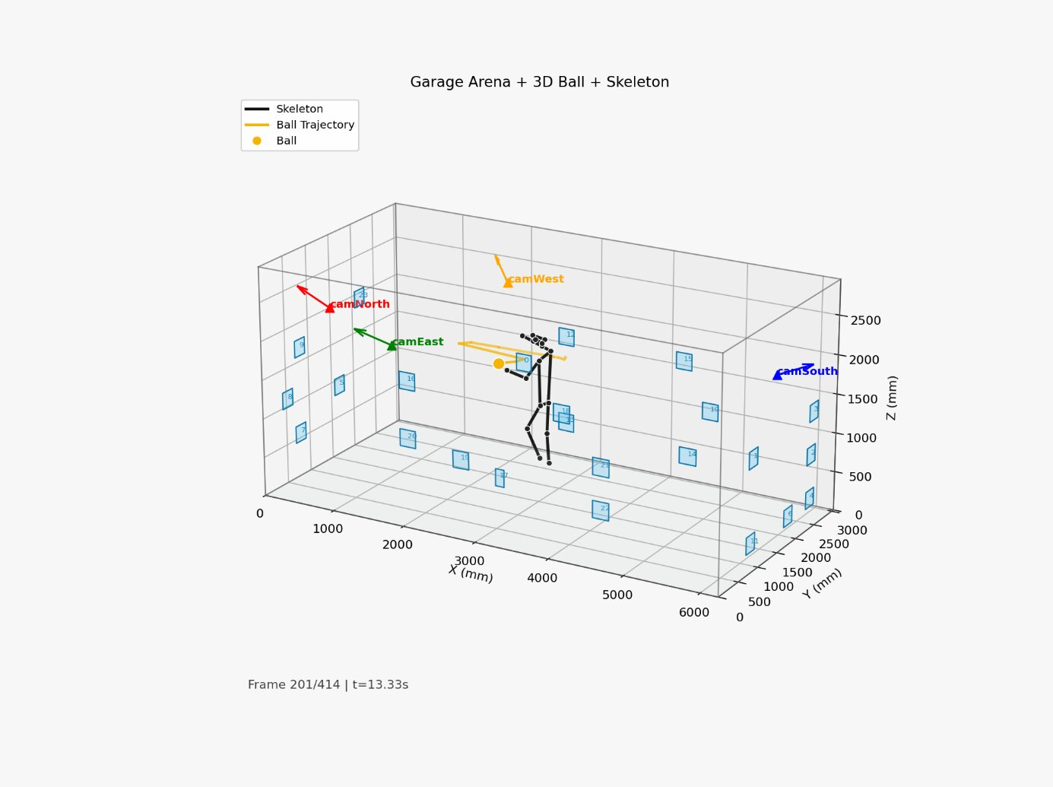
(b)

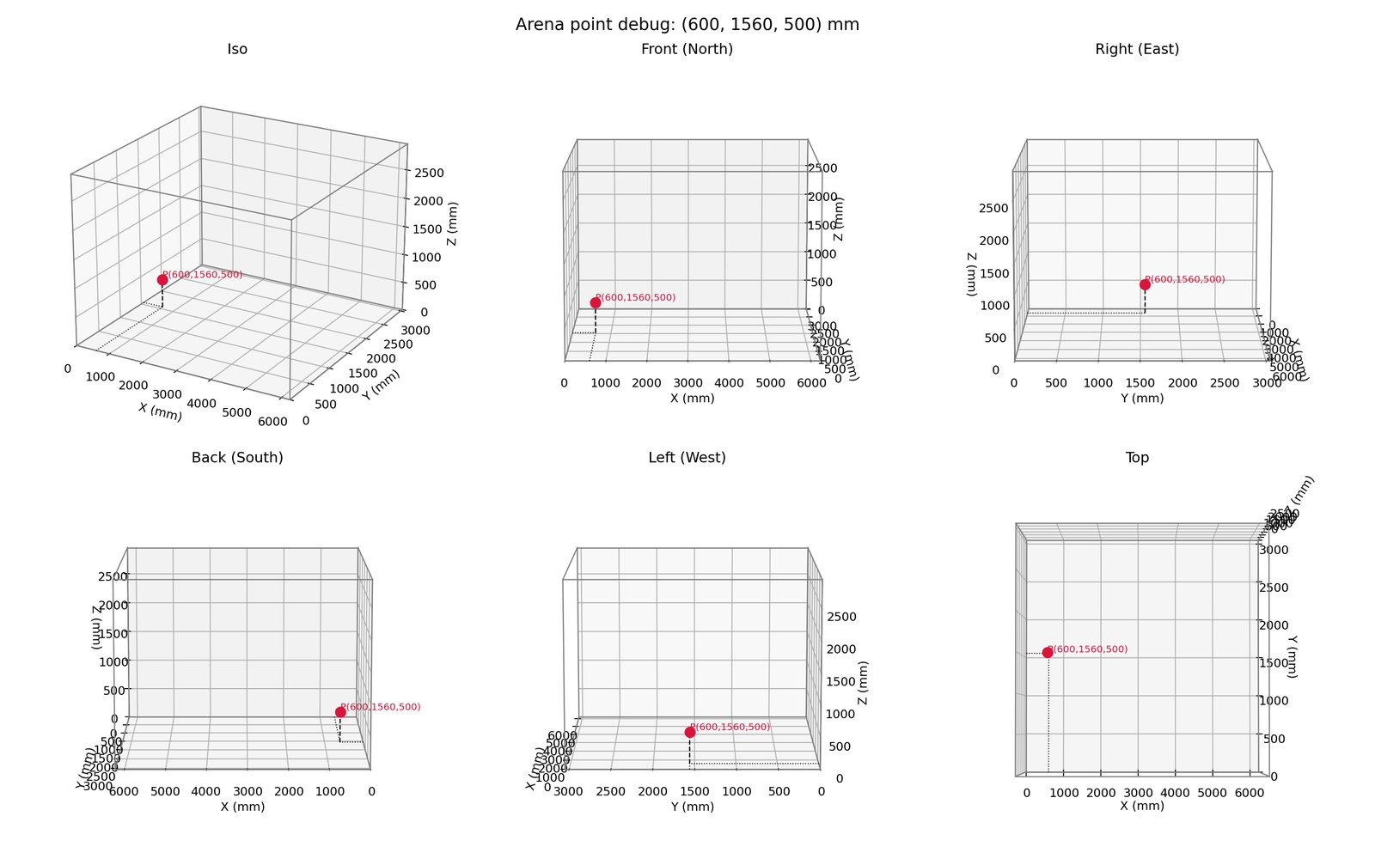
(c)
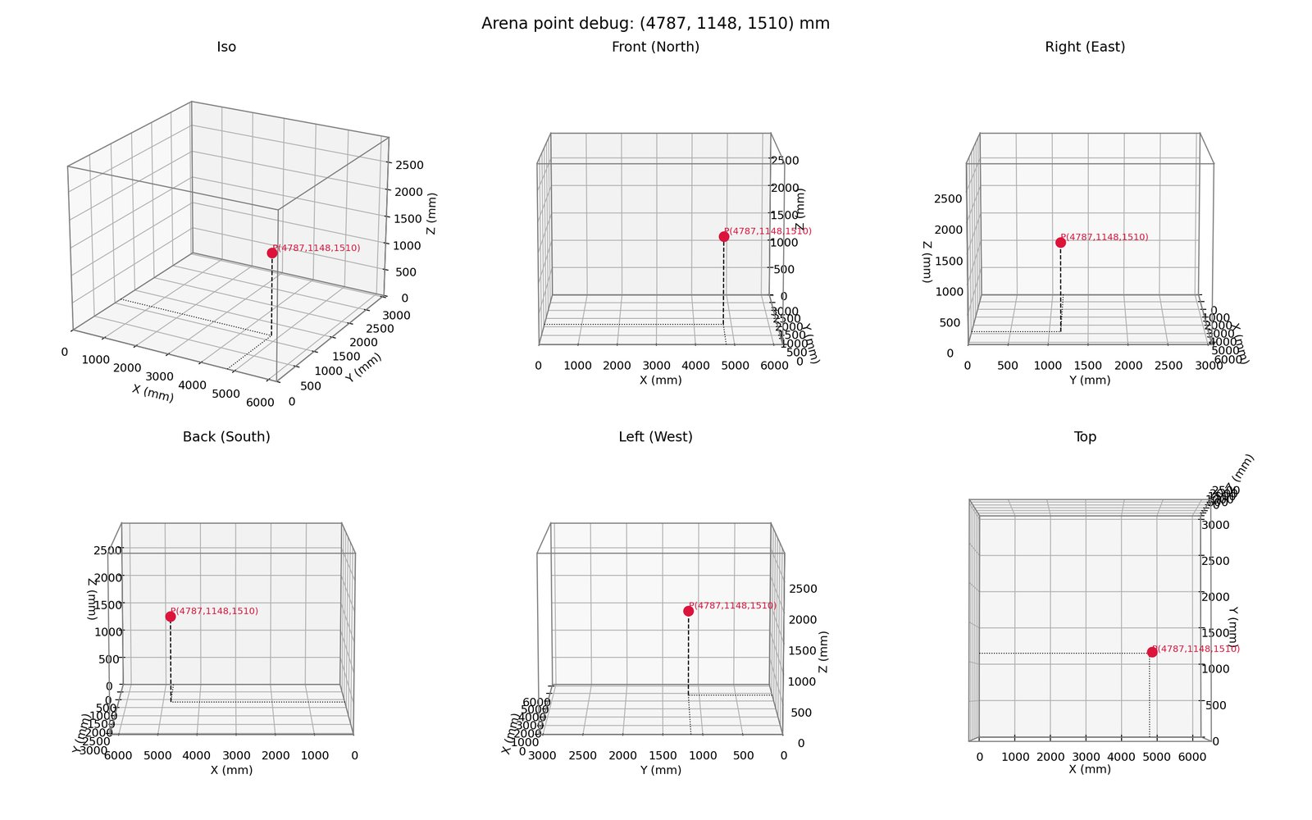
(d)
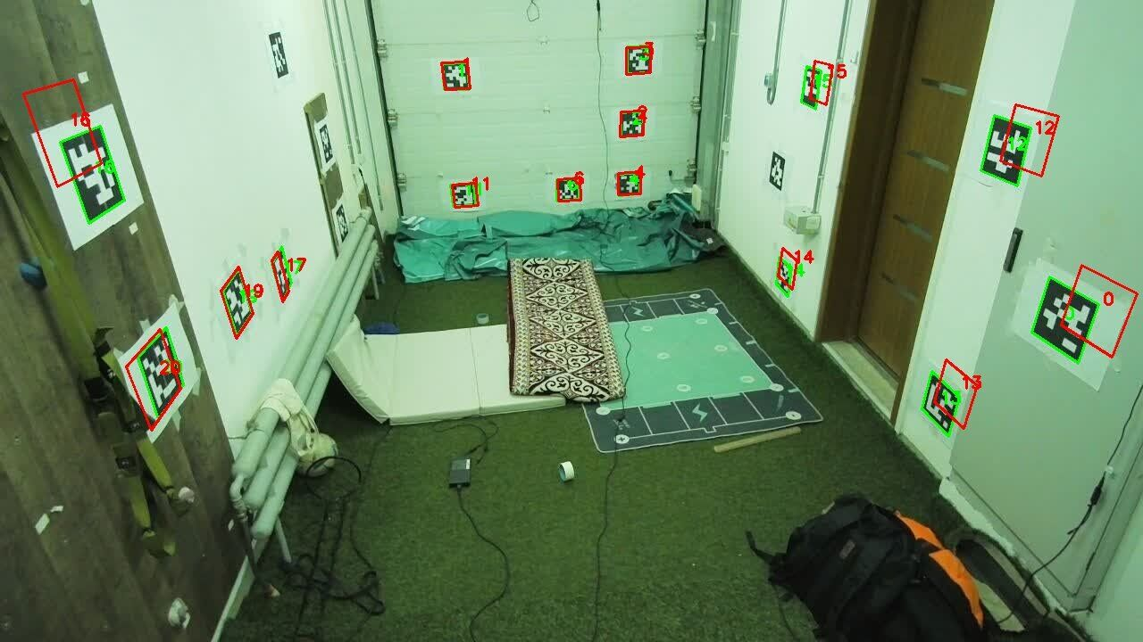
(a)
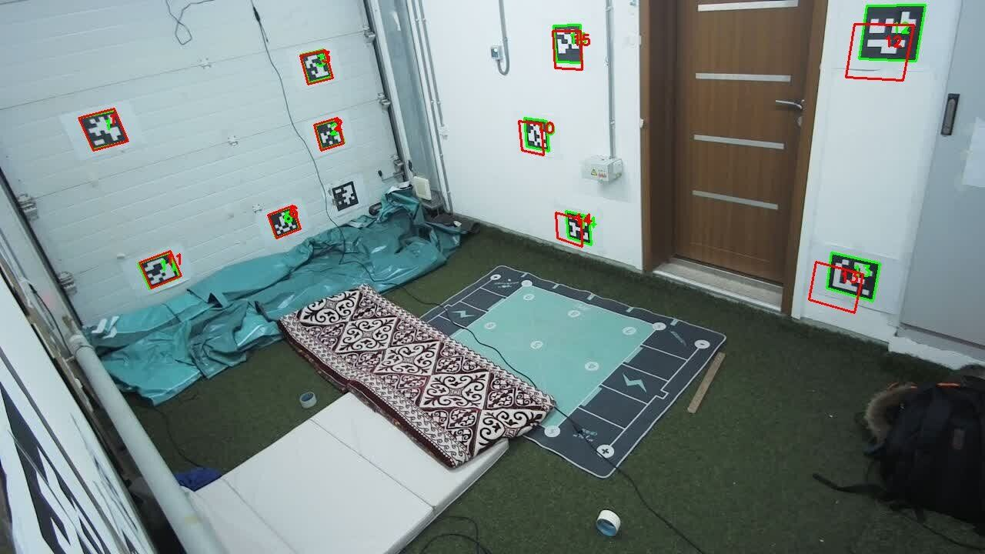
(b)
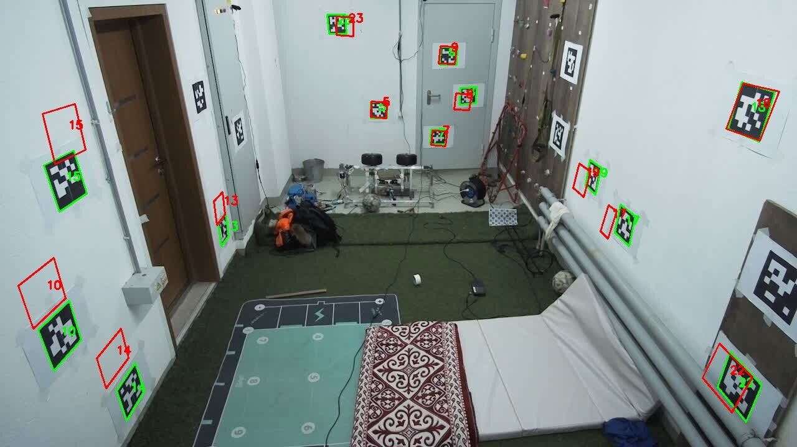
(c)
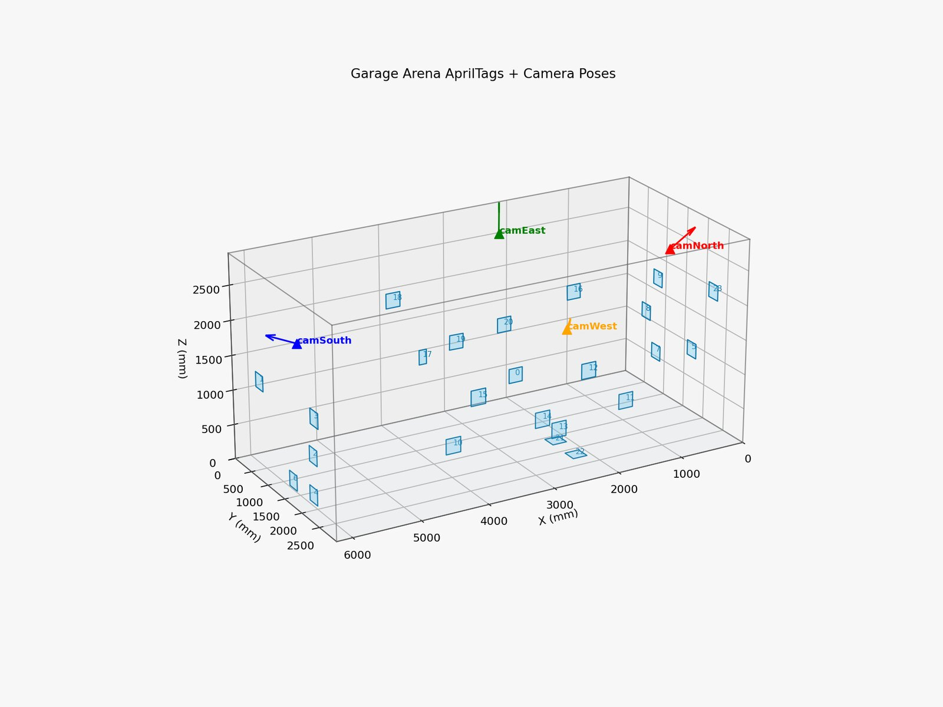
ChArUco calibration board (A4, 300 dpi, 7 $×$ 10 squares, DICT_4X4_1000) used for intrinsic calibration of all four cameras.
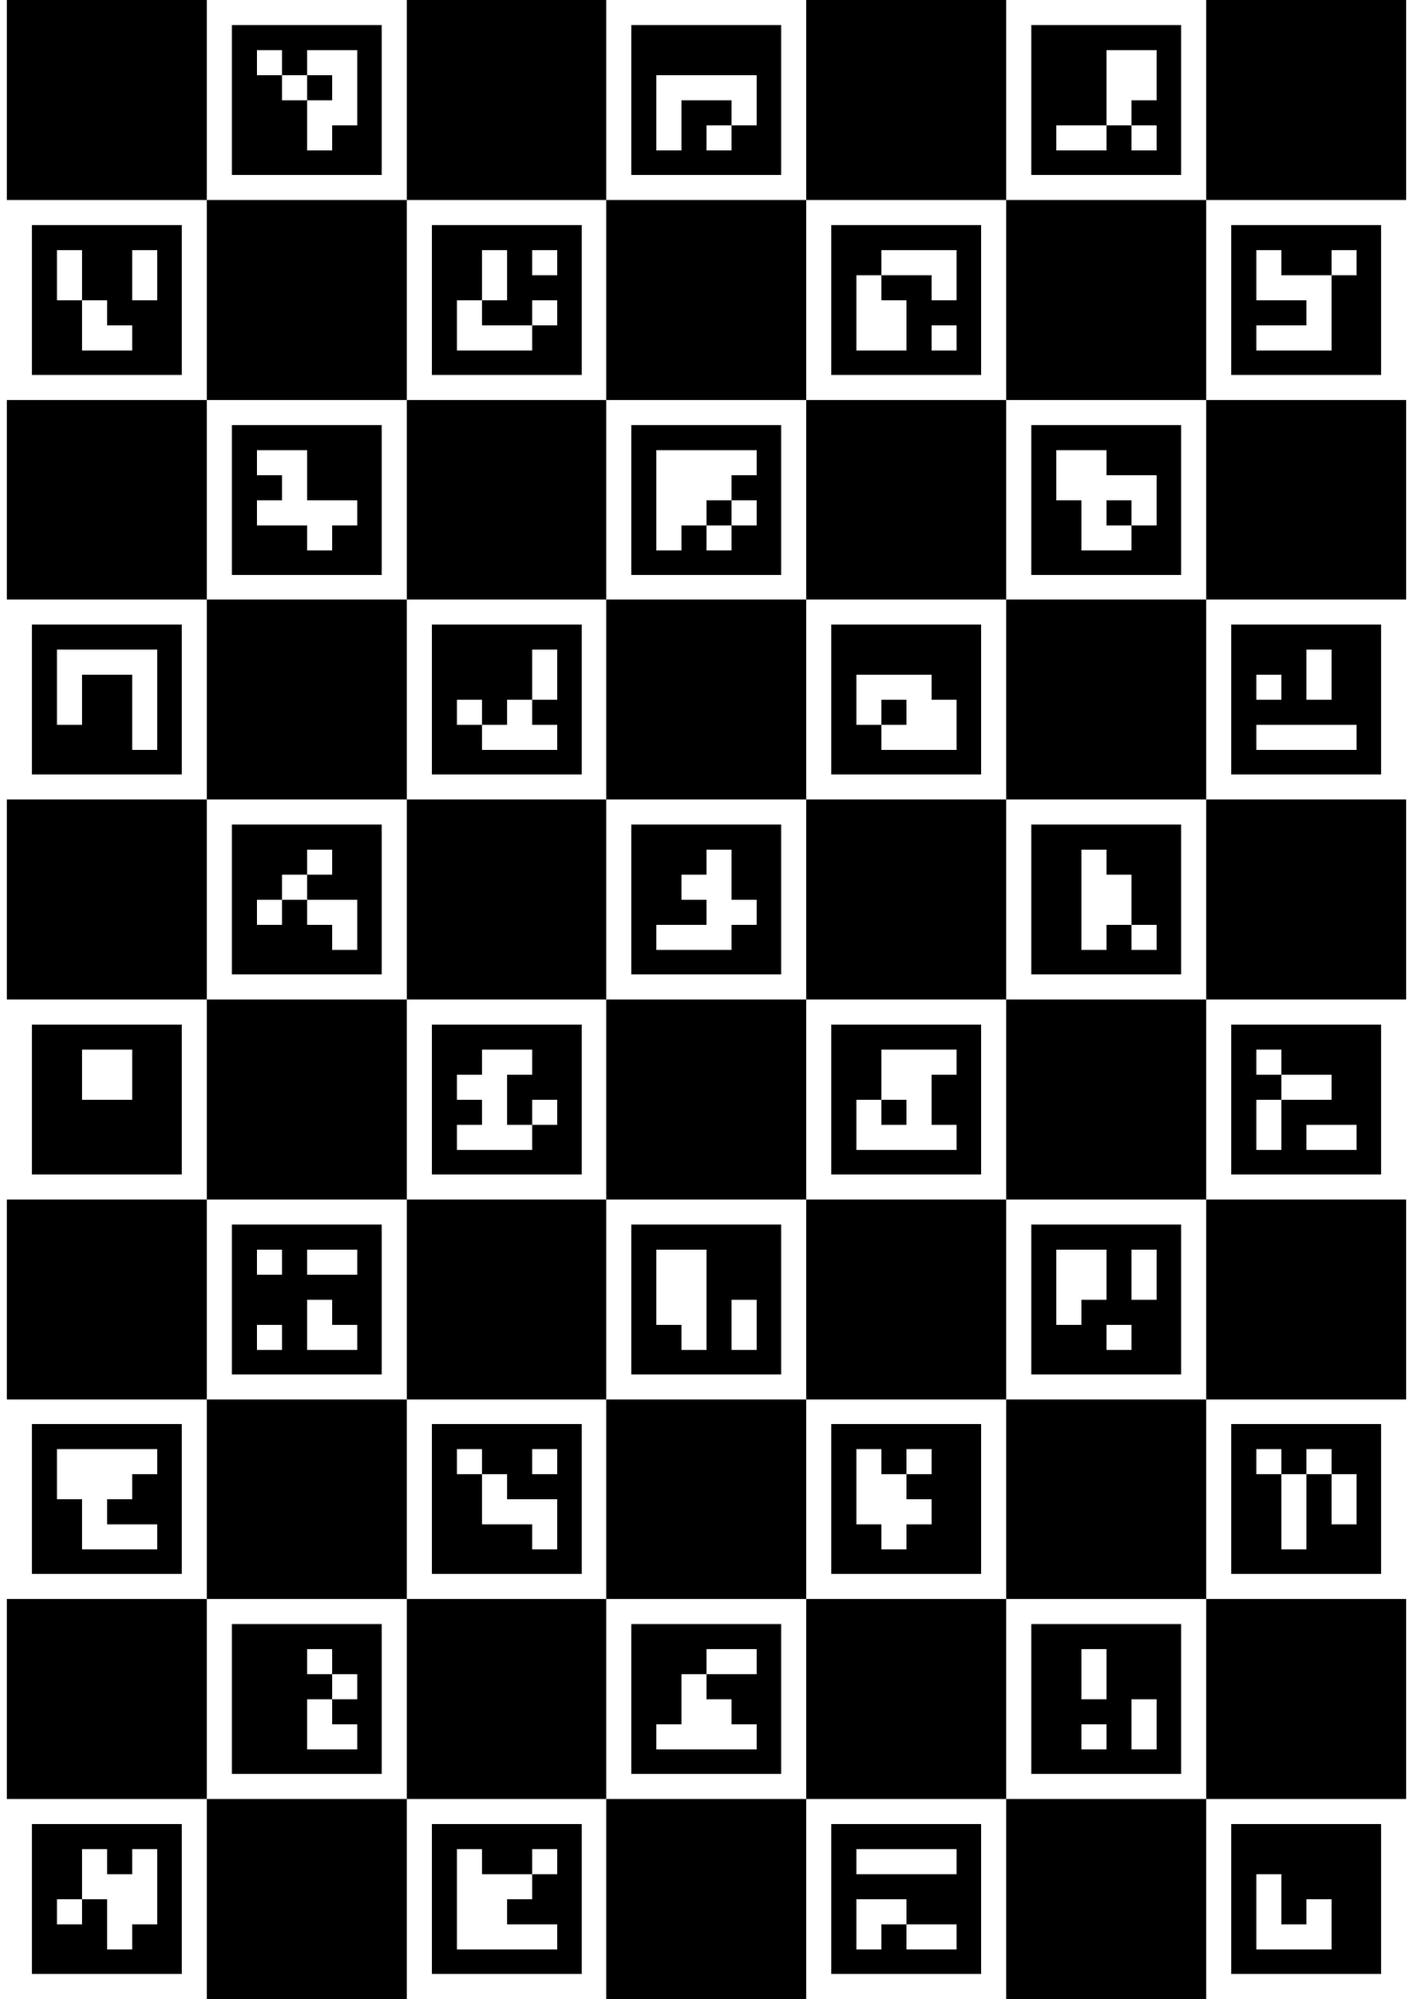
Intrinsic calibration reprojection error per camera: bar chart showing per-camera mean reprojection error after ChArUco calibration.
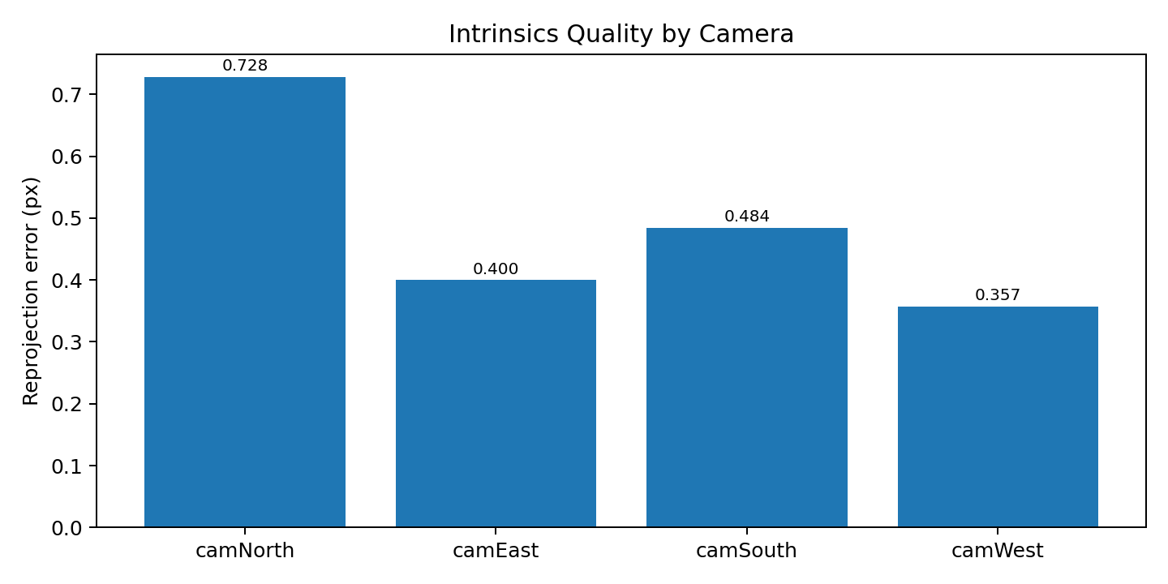
Extrinsic calibration RMSE per camera: bar chart showing residual reprojection error after robust PnP optimisation with sigma-clipping.

YOLO Ball Detector Training Results
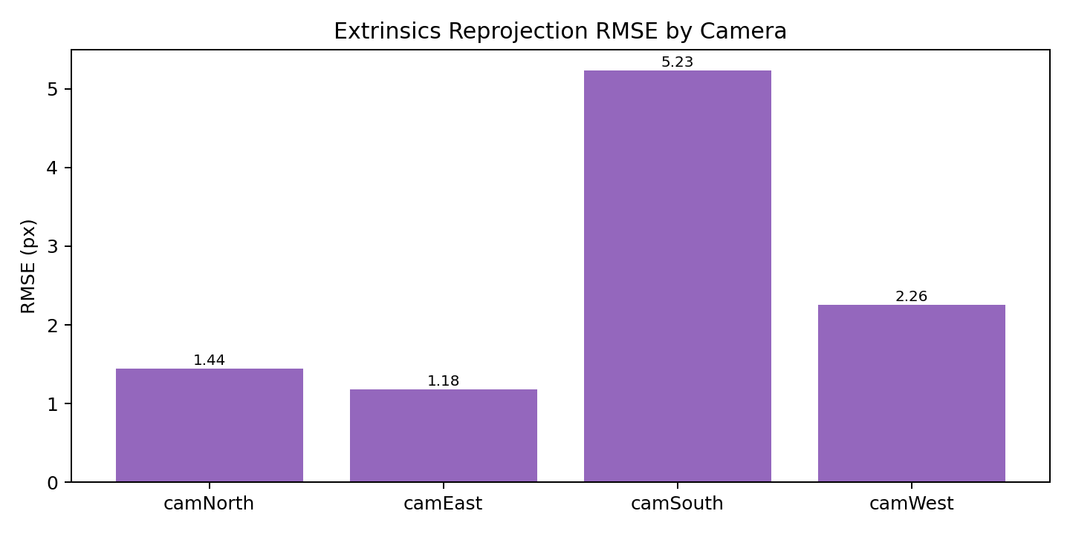
YOLOv26s ball detector training curves: loss, precision, recall, and mAP over 75 training epochs.
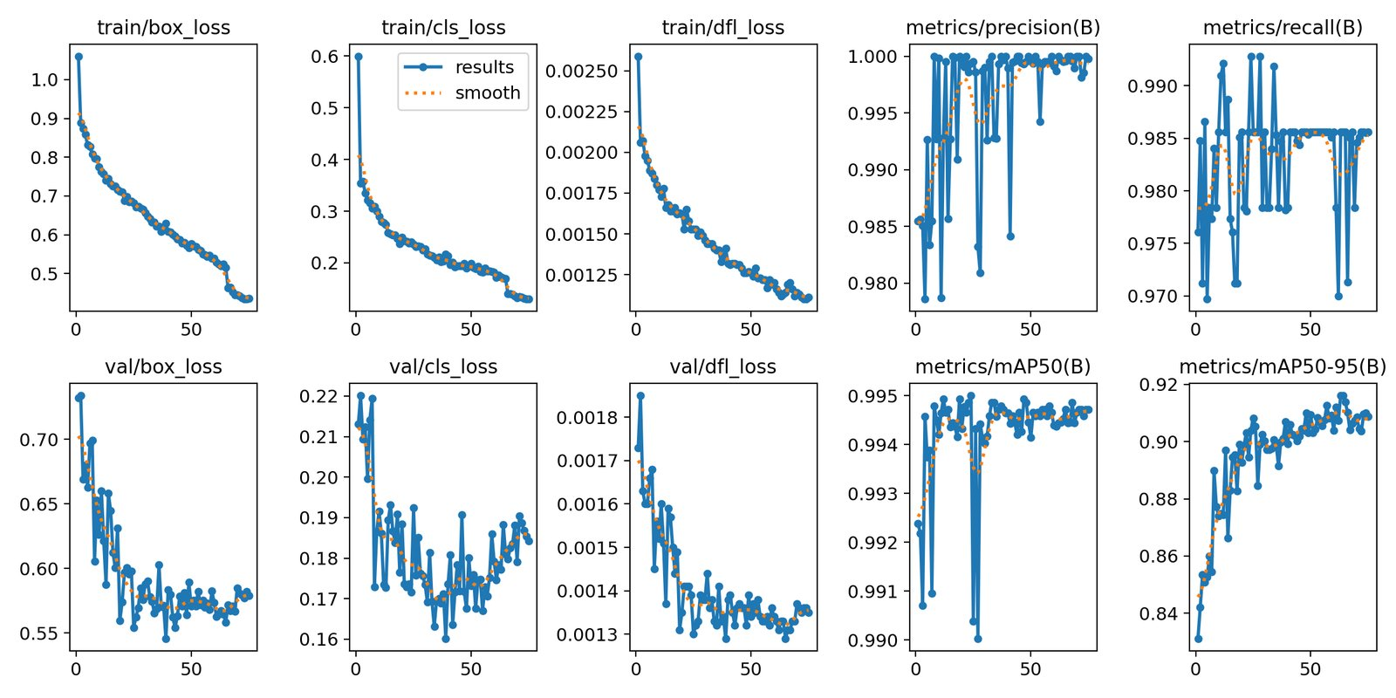
Normalised confusion matrix for the YOLOv26s ball detector on the validation set.
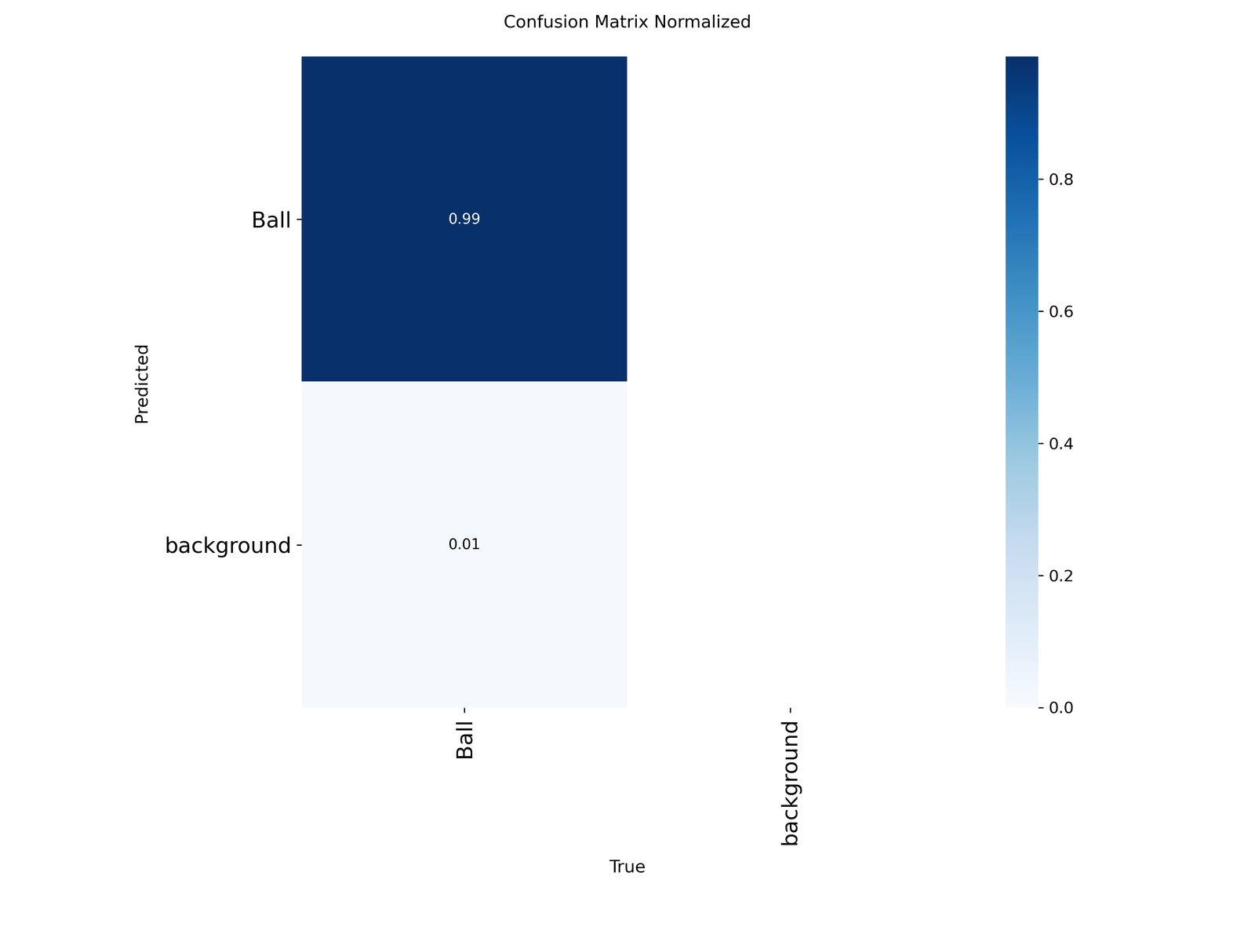
Precision-Recall curve for the YOLOv26s ball detector.
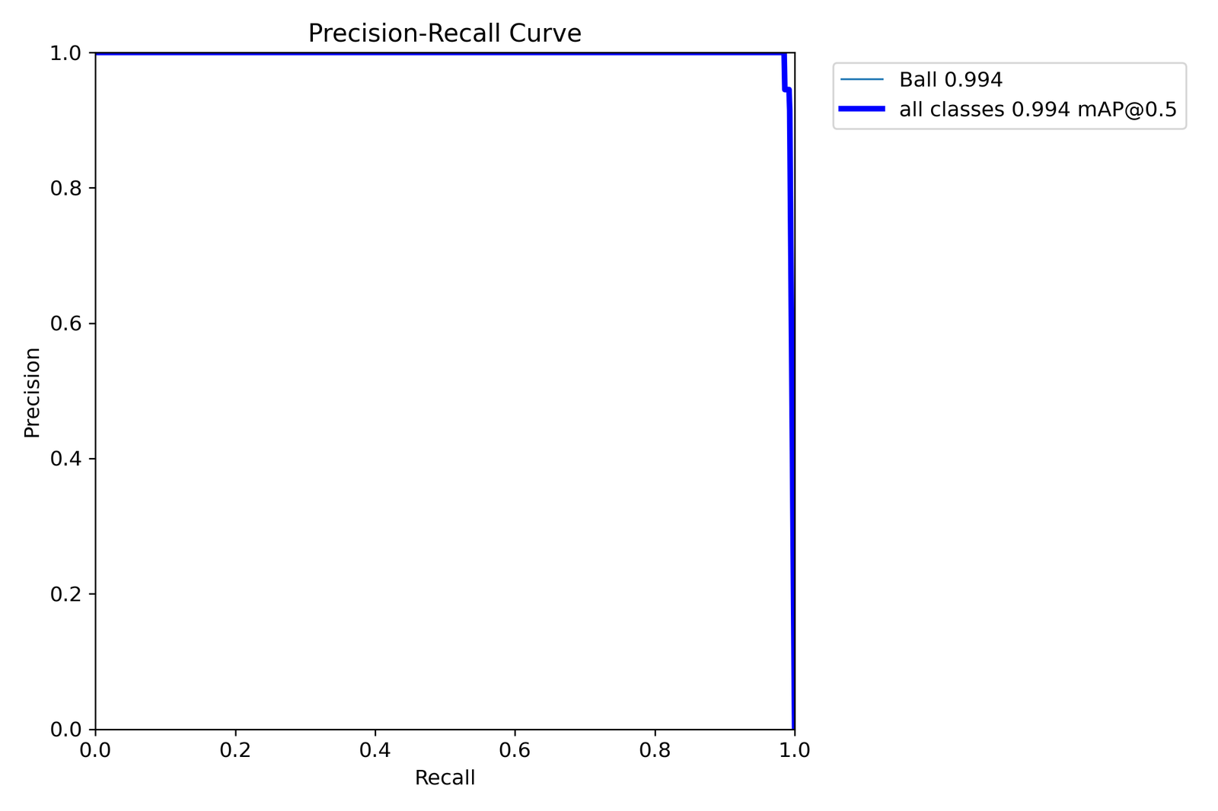
Sample training batch: YOLOv26s ball detection annotations on training images.
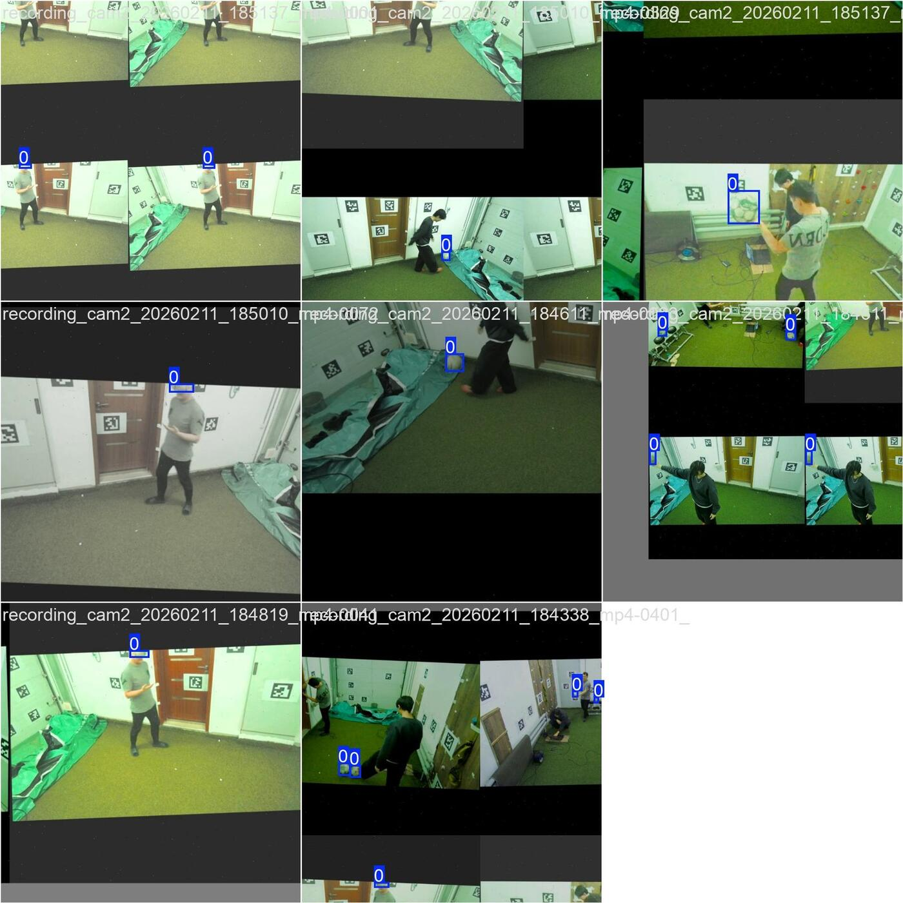
(a)
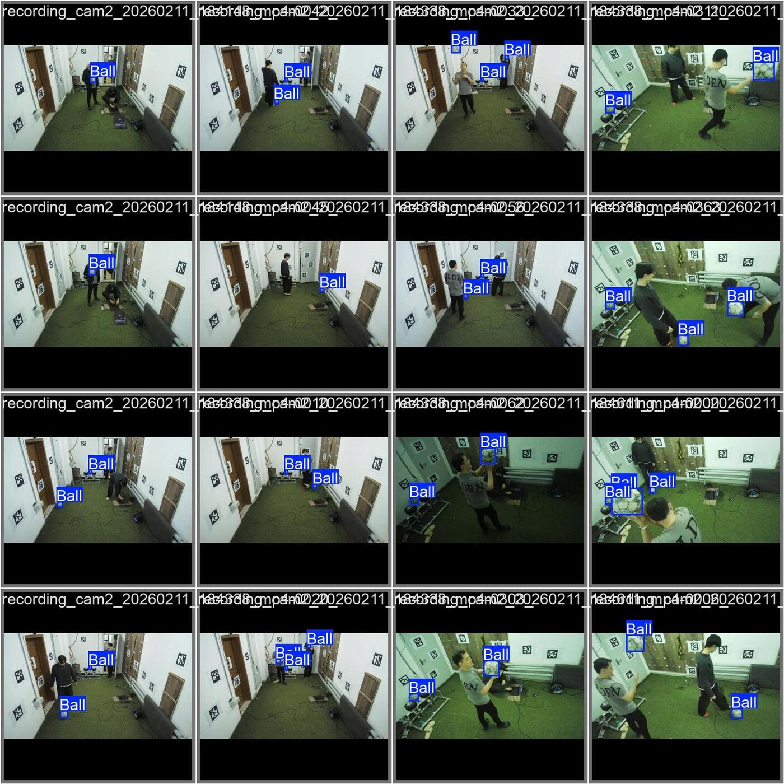
(b)

System Qualitative Results

Smoke test frame at $t≈5.3$ s.
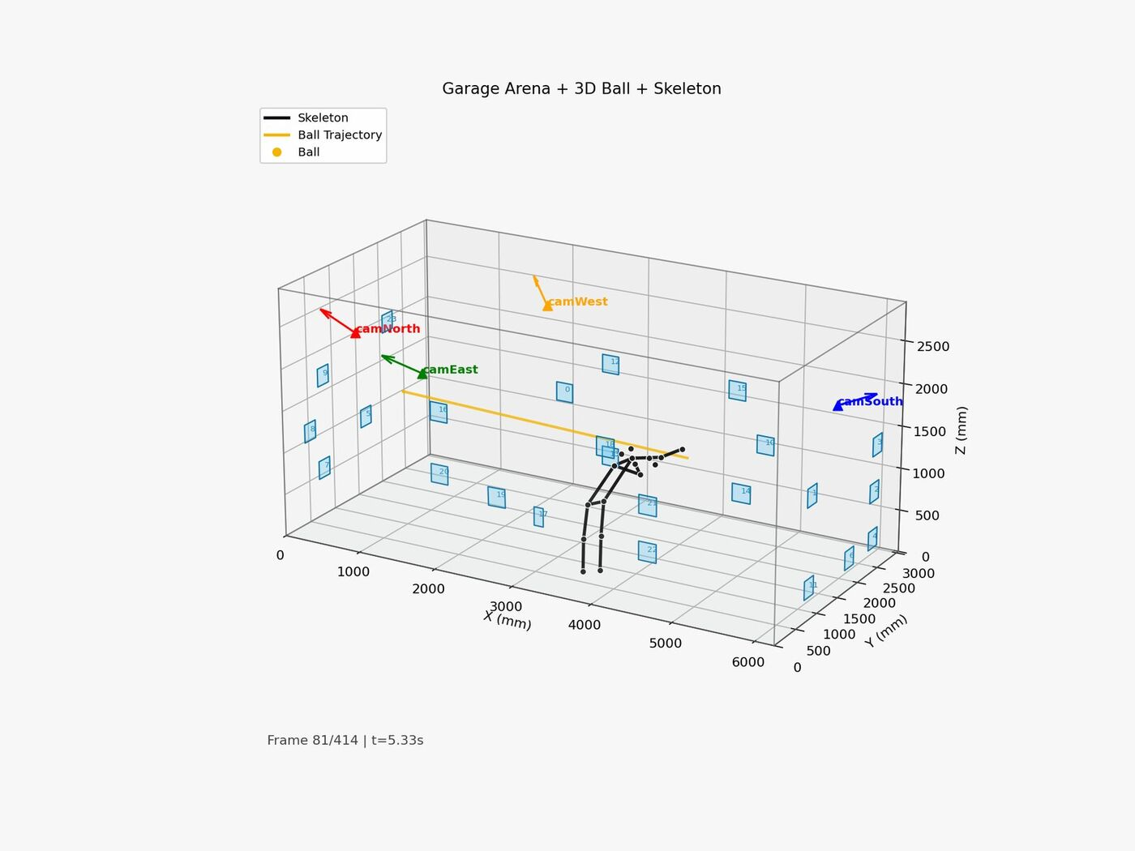
Smoke test frame at $t≈13.3$ s.
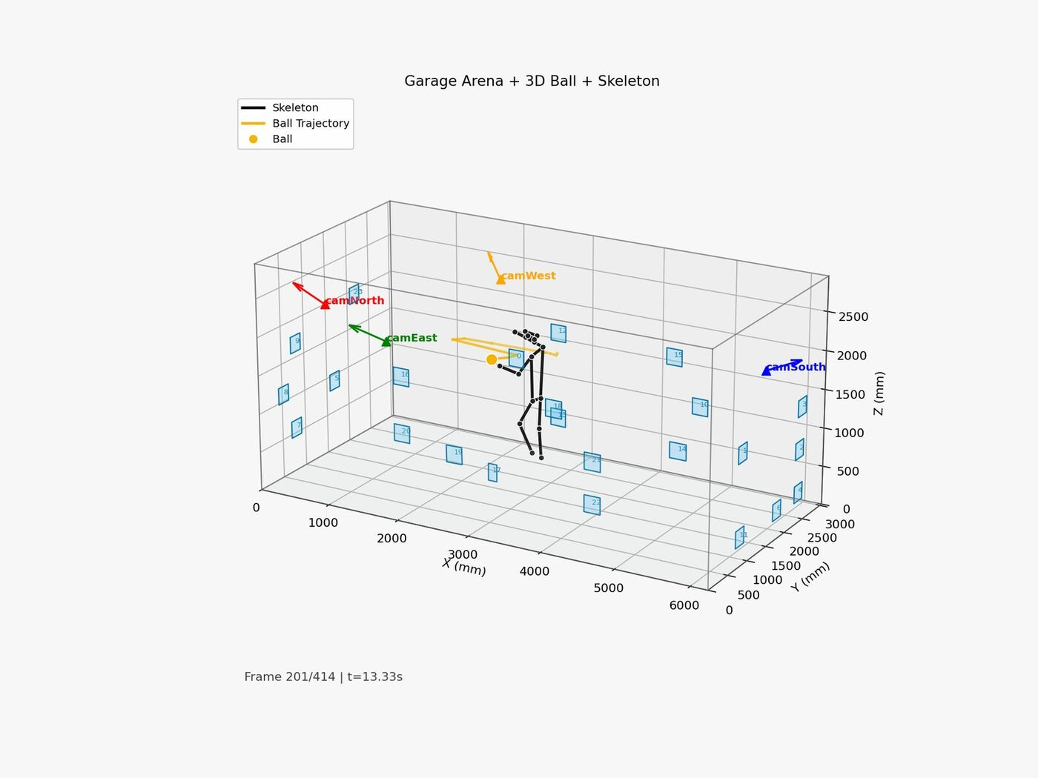
Smoke test frame at $t≈21.3$ s.

References
[1] NaturalPoint Inc. OptiTrack Motion Capture Systems. NaturalPoint Inc. 2024. URL: https://optitrack.com.
[2] M. Windolf; N. Götzen; M. Morlock. Systematic accuracy and precision analysis of video motion capturing systems - exemplified on the Vicon-460 system. Journal of Biomechanics, 41(12): 2776-2780. 2008.
[3] PhaseSpace Inc. PhaseSpace Impulse X2E Motion Capture System. PhaseSpace Inc. 2024. URL: https://phasespace.com.
[4] G. Bradski. The OpenCV library. Dr. Dobb’s Journal of Software Tools, 25(11): 120-125. 2000.
[5] G. Jocher; A. Chaurasia; J. Qiu. Ultralytics YOLOv26. Ultralytics Inc. 2025. URL: https://github.com/ultralytics/ultralytics.
[6] T. Y. Lin; M. Maire; S. Belongie; J. Hays; P. Perona; D. Ramanan; P. Dollár; C. L. Zitnick. Microsoft COCO: common objects in context. Proceedings of European Conference on Computer Vision (ECCV): 740-755. 2014.
[7] Contributors, MMPose. OpenMMLab Pose Estimation Toolbox and Benchmark. 2020.
[8] C. R. Harris; K. J. Millman; S. J. van der Walt; R. Gommers; P. Virtanen; D. Cournapeau; E. Wieser; J. Taylor; S. Berg; N. J. Smith; R. Kern; M. Picus; S. Hoyer; M. H. van Krevelen; M. Brett; A. Haldane; J. F. del Río; M. Wiebe; P. Peterson; P. Gérard-Marchant; K. Sheppard; T. Reddy; W. Weckesser; H. Abbasi; C. Gohlke; T. E. Oliphant. Array programming with NumPy. Nature, 585(7825): 357-362. 2020.
[9] P. Virtanen; R. Gommers; T. E. Oliphant; M. Haberland; T. Reddy; D. Cournapeau; E. Burovski; P. Peterson; W. Weckesser; J. Bright; S. J. van der Walt; M. Brett; J. Wilson; K. J. Millman; N. Mayorov; A. R. J. Nelson; E. Jones; R. Kern; E. Larson; C. J. Carey; İ. Polat; Y. Feng; E. W. Moore; J. VanderPlas; D. Laxalde; J. Perktold; R. Cimrman; I. Henriksen; E. A. Quintero; C. R. Harris; A. M. Archibald; A. H. Ribeiro; F. Pedregosa; P. van Mulbregt. SciPy 1.0: fundamental algorithms for scientific computing in Python. Nature Methods, 17(3): 261-272. 2020.
[10] R. Hartley; A. Zisserman. Multiple View Geometry in Computer Vision. Cambridge University Press. 2004.
[11] H. C. Longuet-Higgins. A computer algorithm for reconstructing a scene from two projections. Nature, 293: 133-135. 1981.
[12] T. Kanade; M. Okutomi. A stereo matching algorithm with an adaptive window: theory and experiment. IEEE Transactions on Pattern Analysis and Machine Intelligence, 16(9): 920-932. 1994.
[13] G. Pingali; Y. Jean; I. Carlbom. Real time tracking for enhanced tennis broadcasts. Proceedings of IEEE Conference on Computer Vision and Pattern Recognition (CVPR): 260-265. 1998.
[14] P. R. Kamble; A. G. Keskar; K. M. Bhurchandi. Ball tracking in sports: a survey. Artificial Intelligence Review, 52(3): 1655-1705. 2019.
[15] Hawk-Eye Innovations Ltd. Hawk-Eye Ball Tracking Technology, Technical Overview Document. 2023.
[16] Z. Zhang. A flexible new technique for camera calibration. IEEE Transactions on Pattern Analysis and Machine Intelligence, 22(11): 1330-1334. 2000.
[17] S. Garrido-Jurado; R. Muñoz-Salinas; F. J. Madrid-Cuevas; M. J. Marín-Jiménez. Automatic generation and detection of highly reliable fiducial markers under occlusion. Pattern Recognition, 47(6): 2280-2292. 2014.
[18] E. Olson. AprilTag: A robust and flexible visual fiducial system. Proceedings of IEEE International Conference on Robotics and Automation (ICRA): 3400-3407. 2011.
[19] M. A. Fischler; R. C. Bolles. Random sample consensus: a paradigm for model fitting with applications to image analysis and automated cartography. Communications of the ACM, 24(6): 381-395. 1981.
[20] J. Redmon; S. Divvala; R. Girshick; A. Farhadi. You only look once: unified, real-time object detection. Proceedings of IEEE Conference on Computer Vision and Pattern Recognition (CVPR): 779-788. 2016.
[21] Z. Cao; G. Hidalgo; T. Simon; S. E. Wei; Y. Sheikh. OpenPose: realtime multi-person 2D pose estimation using part affinity fields. IEEE Transactions on Pattern Analysis and Machine Intelligence, 43(1): 172-186. 2021.
[22] J. L. Meriam; L. G. Kraige. Engineering Mechanics: Dynamics. Wiley. 2012.
[23] M. T. Jones. Embedded Systems Design with the Atmel AVR Microcontroller. Cengage Learning. 2016.
[24] International Electrotechnical Commission. IEC 62061: Safety of Machinery - Functional Safety of Safety-Related Control Systems. IEC. 2021.
[25] International Organization for Standardization. ISO 12100: Safety of Machinery - General Principles for Design. ISO. 2011.
[26] International Organization for Standardization. ISO 10218-1: Robots and Robotic Devices - Safety Requirements for Industrial Robots - Part 1: Robots. ISO. 2011.
[27] I. Sommerville. Software Engineering. Pearson. 2016.
[28] Intel Corporation. Intel RealSense Depth Camera D435 Datasheet. Intel Corporation. 2023. URL: https://www.intelrealsense.com/depth-camera-d435/.
[29] K. Muelling; J. Kober; O. Kroemer; J. Peters. Learning to select and generalise striking movements in robot table tennis. International Journal of Robotics Research, 32(3): 263-279. 2013.
[30] H. Fässler; H. A. Beyer; J. T. Wen. A robot ping pong player: optimized mechanics, high performance 3D vision and intelligent sensor control. Robotersysteme, 6: 161-170. 1990.
[31] C. Cadena; L. Carlone; H. Carrillo; Y. Latif; D. Scaramuzza; J. Neira; I. Reid; J. J. Leonard. Past, present, and future of simultaneous localization and mapping: toward the robust-perception age. IEEE Transactions on Robotics, 32(6): 1309-1332. 2016.
[32] Y. Zhang; P. Sun; Y. Jiang; D. Yu; F. Weng; Z. Yuan; P. Luo; W. Liu; X. Wang. ByteTrack: multi-object tracking by associating every detection box. Proceedings of European Conference on Computer Vision (ECCV): 1-21. 2022.
[33] Y. Du; Z. Zhao; Y. Song; Y. Zhao; F. Su; T. Gong; H. Meng. StrongSORT: make DeepSORT great again. IEEE Transactions on Multimedia, 25: 8725-8737. 2023.
[34] Footbot Ltd. Footbot Interactive Football Training System, Technical Product Description. 2024. URL: https://www.footbot.io.

