1.Create a Node.js server to implement routes for /home, /about, and /contact that respond with

different messages for each route.

Node JS coding

const express =require('express')

const app=express()

app.use(express.json())

app.get('/',(req,res)=>{

    res.send('main page')

})

app.get('/home',(req,res)=>{

    res.send('home page')

})

app.get('/about',(req,res)=>{

    res.send('I am PravinEshwar \n Department of coomputer science engineering')

})

app.get('/contact',(req,res)=>{

    res.send('contact me on  shadowSpade.instagram')

})

app.get('/greet',(req,res)=>{

    const name=req.query.name||guest

    res.send(`Hello, ${name}!`);

})

port = process.env.PORT||6710

app.listen(port,()=>console.log(`Port is running on ${port}`))

The main page after running the node js

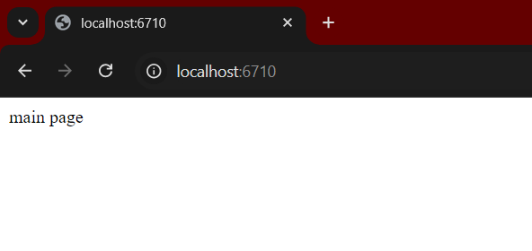

The home page

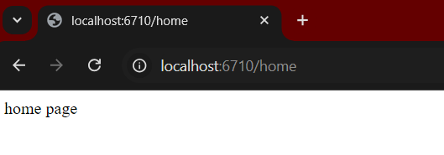

The about page

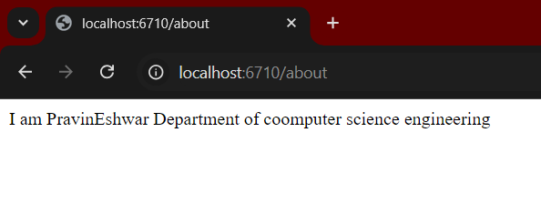

The contact page

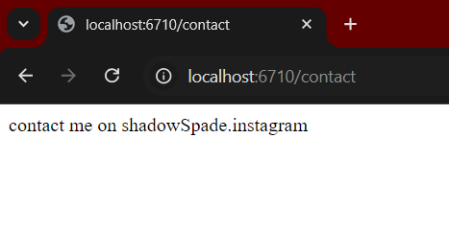

2.Build a server with a route /greet that accepts a query parameter name and responds with personalized greeting message, e.g., &quot;Hello, [name];

Node js coding:

const express = require('express');

const app = express();

app.use(express.urlencoded({ extended: true }));

app.get('/', (req, res) => {

    res.send(`

        <form action="/greet" method="POST">

            <label for="name">Enter your name:</label>

            <input type="text" id="name" name="name">

            <button type="submit">Click</button>

        </form>

    `);

});

app.post('/greet', (req, res) => {

    const name = req.body.name || 'Guest';

    res.send(`Hello, ${name}!`);

});

const PORT = 6710;

app.listen(PORT, () => {

    console.log(`Server is running on http://localhost:${PORT}`);

});

**Oputut:**

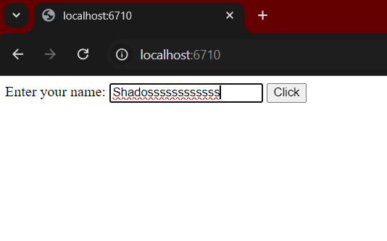

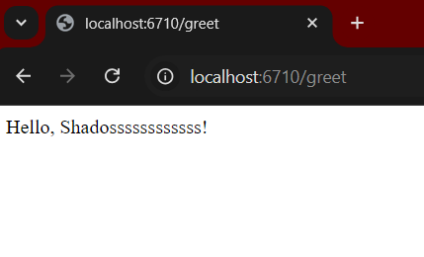s