

Brown, Alec

S1609108

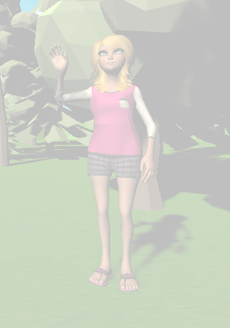

Serious Game Mechanic

Eden’s Garden – The Big Clean

Contents

Executive Summary 2

Product Description Overview 2

Mini-game Research 2

Evaluation 4

Further Development 4

Gameplay Controls 4

Game References 5

Link to Github repository 5

# Executive Summary

Eden’s Garden takes concepts from a typical children’s learning curriculum (ages 3 – 5) and embeds those same principles and teachings into interactive and light-hearted game play.

# Product Description Overview

Using simple single click interactions, the user is encouraged by the narrator to explore the scene to interact with objects in the garden. The scene is low poly and vibrant colours with the intention of drawing and retain the users’ attention. Clicking an area will zoom the camera in to a mini game where the instructions are displayed, and the user can begin the game. As the game is aimed at 3 – 5-year olds, the games cannot be lost. As each game is won, more of the garden is tidied and comes to life; rubbish disappears, flowers grow, birds return, etc.

# Mini-game Research

The research for each mini game comes directly from the current math homework for a 3-year-old child, courtesy of Glenfall Community Primary School, and is replicated in as similar a way as possible to retain the correct learning curve for the age bracket it is intended.

Below are some examples of the 11 homework sheets provided.

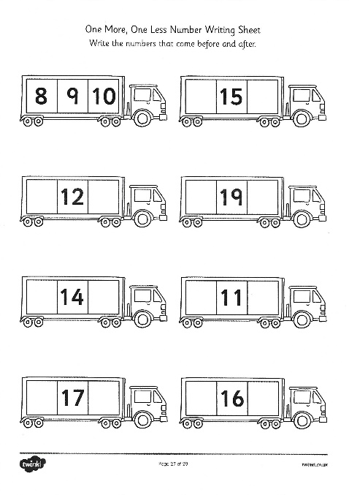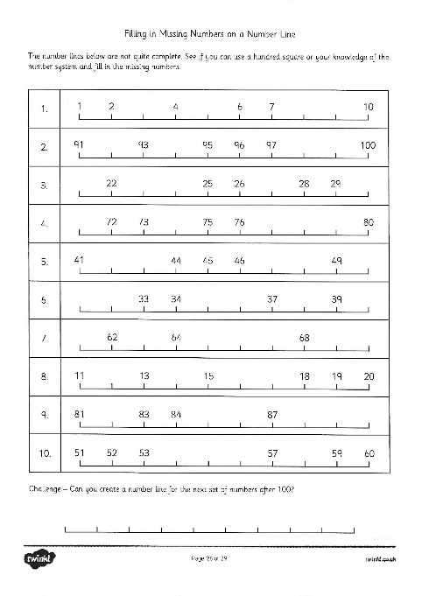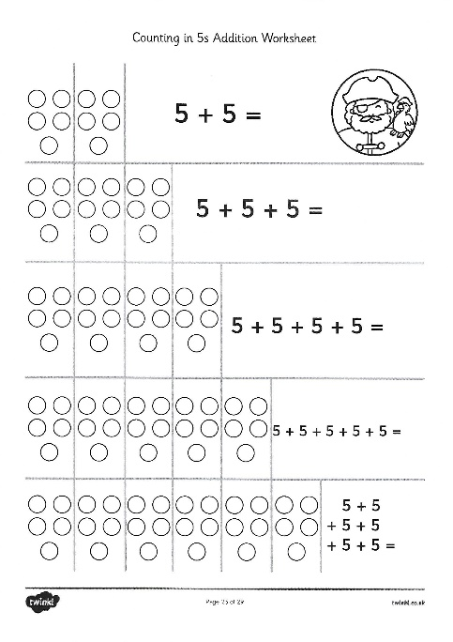

The original concept took each homework sheet and determined how its mini game would fit into a single game scene.

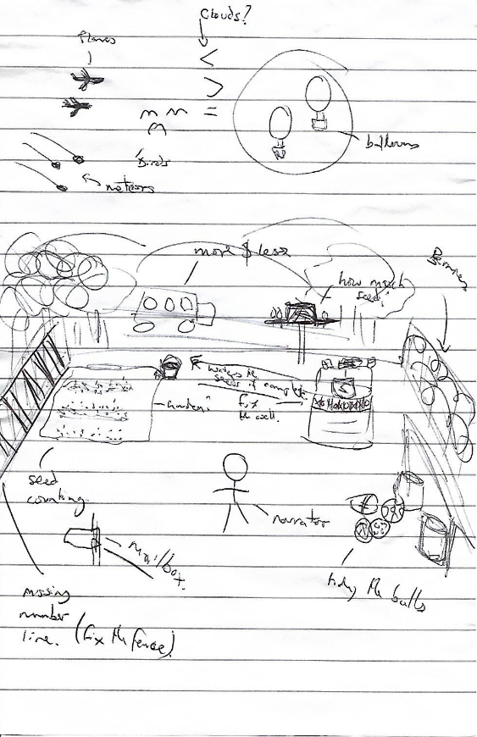

Original Concept Sketch

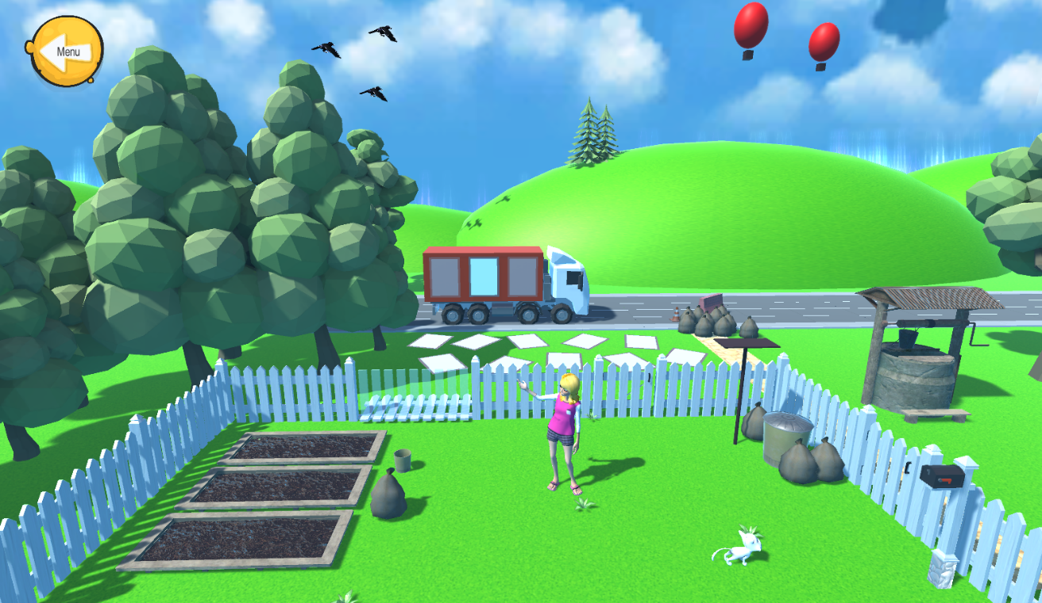The final scene output is a good reflection of the initial concept and each game fits well into the scene.

Final Scene in Unity

# Evaluation

The game provides a welcoming environment for a child’s curiosity. With no set linear gameplay, the child can explore and play what they want to. The games are also tailored for their age range, and in line with government schooling so should be enjoyable and challenging, but still achievable and rewarding. This should make Eden’s Garden as a serious game, a welcomed accompaniment to general mainstream teaching.

## Further Development

The game currently contains a completed truck mini-game (before and after numbers), but would ultimately have 6 mini games, with the others focused around the seed bed (counting), the fence panel (missing numbers), the sky (greater or less than), the bird table (addition) and the well (using plus, minus and equals symbols). Additionally, the environment would be full of non-mini game related interactable objects, for example, clicking the mailbox would make Eden check the mail, fussing the cat, etc. to keep the game fully immersive and entertaining for the exploring user. Additional audio from the narrator would be used to guide the player to certain games or objects when required.

### Gameplay Controls

Left Click: Select

Right Click: Exit a mini game.

# Game References

Audacity, 2000, Open-source Software

Cartoon Cat, 2016, Zealous Interactive, Unity Asset Store

Fantasy Effect, 2019, Pinwheel Studio, Unity Asset Store

Fantasy Treasure Pack, 2017, LowlyPoly, Unity Asset Store

Fantasy Skybox Free, 2018, G. E. Team, Unity Asset Store

Flowerbed, 2020, Mcomp, Unity Asset Store

Free-icons-download.net. 2020. *Back Icon – Free Icons Download*. [online] Available at: <http://www.free-icons-download.net/back-icon-60629/> [Accessed 7 April 2020].

Freesound. 2006. *The Chime.Wav By Zeuss*. [online] Available at: <https://freesound.org/people/zeuss/sounds/22267/> [Accessed 4 April 2020].

Freesound. 2018. *Correct.Wav By Eponn*. [online] Available at: <https://freesound.org/people/Eponn/sounds/421002/> [Accessed 7 April 2020].

Freesound. 2020. *Easter Theme Loop 1.Wav By Mrthenoronha*. [online] Available at: <https://freesound.org/people/Mrthenoronha/sounds/509857/> [Accessed 4 April 2020].

Free Stylized Garden Asset, 2019, Easy3D, Unity Asset Store

Free Trees, 2017, Darth_Artisan, Unity Asset Store

Gormly, T., 2013. *Training Program, Incorrect1.Aif By Timgormly*. [online] Freesound. Available at: <https://freesound.org/people/timgormly/sounds/181858/> [Accessed 7 April 2020].

Kahn, T., 2014. *Passing Trucks 007.Wav By Tim.Kahn*. [online] Freesound. Available at: <https://freesound.org/people/tim.kahn/sounds/249534/> [Accessed 4 April 2020].

LeanTween, 2018, DentedPixel, Unity Asset Store

Living Birds, 2020, Unity Asset Store

Low Poly Cars, 2018, Broken Vector, Unity Asset Store

Low Poly Road Pack, 2018, Broken Vector, Unity Asset Store

Pack, R., 2010. *Menusel.Wav By Runnerpack*. [online] Freesound. Available at: <https://freesound.org/people/RunnerPack/sounds/87035/> [Accessed 7 April 2020].

Road Props – Low Poly, 2019, Laxer, Unity Asset Store

Textures.com. 2019. *Textures.Com - Grass0026*. [online] Available at: <https://www.textures.com/download/grass0026/8961?q=grass> [Accessed 7 April 2020].

The Village Well, 2018, Abandoned World, Unity Asset Store

Tuudurt, 2015. *Piglevelwin2.Mp3 By Tuudurt*. [online] Freesound. Available at: <https://freesound.org/people/Tuudurt/sounds/275104/> [Accessed 7 April 2020].

# Link to Github repository

The full project can be downloaded from <https://github.com/Shadow229/Edens-Garden>