**Concept:** This game will be a strategic top down shooter mixed with a bullet hell. The game will have 3 levels that the player can select from a menu, the levels will be more difficult as the levels increase. Each level will include waves of enemies that increase in difficulty as the levels increase. We will have turrets that will move across the edges of the screen on a conveyor belt, as levels increase they will move faster. The player will be able to shoot turrets to destroy them. There will also be a power up that will give the player a few seconds of bullet absorption which heals the player for a set amount of health. As a level progresses, turrets will continue to spawn, giving the player incentive to destroy turrets.There will be a boss on the third level of the game that will spawn half way through the level. We will have 4 types of turrets, a blue turret that will track and shoot at the player with singular bullets, a red turret that shoots three shots at varying angles, a green turret that shoots a long slow moving laser shot, and a purple boss turret that charges up and shoots a large laser.

**Objective:** To score the highest number of points by surviving, destroying turrets and picking up powerups.

**Controls:** The player will be able to move using the WASD keys, and shoot using the mouse

**To Win:** Survive for 3 minutes and destroy remaining enemies.

**Game Over:** When the player runs out of health.’

**Layout:**

**Level 1**

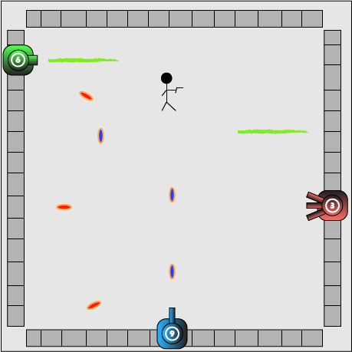

**Level 2**

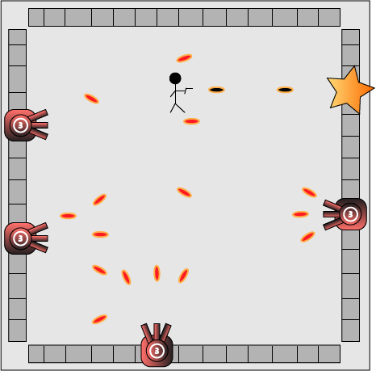

**Level 3**

