Deployment and Run

1. Deployment
   1. Create Virtual Environment (Python)
      1. Install Python into your computer
      2. Open your terminal and use the following command to install venv module:

**pip install virtualenv**

* + 1. Goto the project directory and use the following command to create a virtual environment, here the project directory is the image clustering project you git clone from the repository.

**cd <project-dictory>**

**python -m venv <virtual-environment-name>**

eg.

cd desktop/image_ lustering

python -m venv clustering_env

* + 1. Use the following command to activate the virtual environment

**clustering_env/Scripts/avtivate.bat**

* + 1. Use the following command to verify we have entered virtual environment

**list pip**

After executing this command, we can find this is a new virtual environment by checking the existing modules.

* 1. Install dependencies
     1. you need to use the following commands to install all dependencies which are listed in the requirements.txt

**pip install -r requirements.txt**

1. Run
   1. Input

Put the input raw dataset into the path:

**image_clustering_code\image_clustering_with_gui\data\raw\example**

There should be a testing dataset from COCO in this path at first.

* 1. Run

To Run our program, we firstly need to open the terminal as an administrator. Then we need to activate the virtual environment we created before under the directory of **image_clustering_code\image_clustering_with_gui**:

**clustering_env/Scripts/avtivate.bat**

Then use command:

**python gui_clustering.py**

if you encounter this problem: 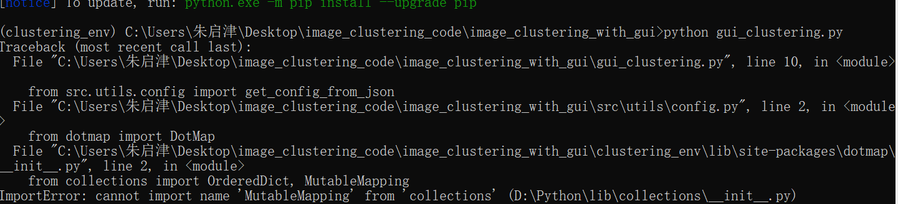

goto image_clustering\clustering_env\Lib\site-packages\dotmap\_init_.py:

change from

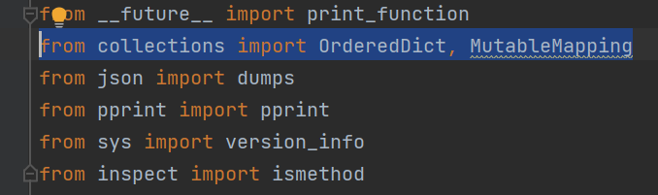

to

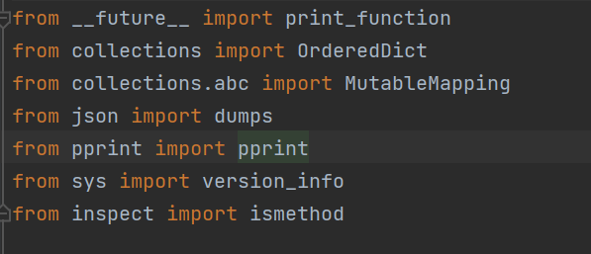

Run clustering by clicking ‘clustering image’ under the ‘clustering’ from menu bar.

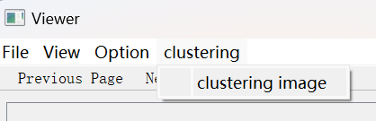

* 1. Output

The progress will show the clustering result while running.