PENETRATION TESTING REPORT
FOOTPRINTING & NETWORK SCANNING PHASES
W2-PM-FINAL | CYBERSECURITY | NETWORKWALKS
Field | Details
Pentester Name (Cybersecurity Professional) | Kynan Patel
Program/Batch | B084 - Networkwalks
Date | 08 November 2026
Modules completed | W2-PM1 (Multiple Kali Tools) & W2-PM5 (Zenmap Scanning)
Client/Target | 1. Networkwalks (networkwalks.com - secured written permission)  2. My own local LAN Network
Permission secured from client? | Yes
Phases covered | Phase 1: Reconnaissance & Footprinting  Phase 2: Scanning & Network Discovery  Phase 3–5: In Progress

1. Liability Disclaimer
I have performed these activities only on the systems & devices where I had secured written permission or the devices/systems that I own myself. All these materials are for education and research purpose only. Do not use anything from here to break the law. The instructor, the authors and Networkwalks are not responsible for what you do with this knowledge. Every action you take is your own responsibility. Misuse can lead to criminal charges, heavy fines, loss of your job and a permanent record. In most countries unauthorised access is a crime even when nothing is damaged.

2. Introduction
This report covers footprinting the networkwalks.com domain using multiple Kali Linux tools (W2-PM1) and scanning my own local network with Zenmap (W2-PM5). One module covers the footprinting phase and the other covers the scanning phase, so together they show how an attacker moves from gathering public information to mapping live hosts on a network. It is the Week 2 part of my ongoing internship program at Networkwalks.
All commands were run in Kali Linux (footprinting) and on a Windows PC with Command Prompt and Zenmap installed (scanning). Every step below includes the exact command used, the result I observed, a screenshot as evidence, and a short note on why the finding matters from an attacker's point of view.

3. Tools Used
The table below lists each tool used in this report and its purpose.
Tool | Purpose
Kali Linux & Windows | Operating systems used for reconnaissance activities
WHOIS | Find domain registration details (registrar, dates, name servers)
whatweb | Fingerprint web technologies (server, CMS, plugins, IP)
nslookup | Resolve the domain name to its IP address using DNS
curl -I | Read the HTTP response headers of the website
wafw00f | Detect whether a Web Application Firewall protects the site
dnsrecon | Enumerate all DNS records (NS, MX, SPF, TXT, SRV)
Windows CMD (ipconfig) | Local IP address and LAN subnet identification
Zenmap (Nmap GUI) | Scan the local subnet to find live hosts, IPs and MAC addresses
4. Activities Performed
4.1 Footprinting & Reconnaissance
I performed reconnaissance against the networkwalks.com domain using six Kali Linux tools: WHOIS, WhatWeb, Nslookup, Curl, Wafw00f and DNSRecon. Each tool was used to collect a different type of information about the target.
First, I used WHOIS (whois networkwalks.com) to obtain publicly available domain registration information and identify the domain’s name servers. The results showed that the domain is registered through GoDaddy (GoDaddy.com, LLC), created on 2019-11-06, and uses HostGator name servers (NS6135.HOSTGATOR.COM and NS6136.HOSTGATOR.COM).
I then used WhatWeb (whatweb networkwalks.com) to identify technologies used by the website. The results identified WordPress 7.1.4 and WP Download Manager 3.3.76, along with Bootstrap 7.1.4, jQuery 3.7.1, an Apache web server, and IP address 192.232.216.135.
Using Nslookup (nslookup networkwalks.com), I resolved the domain name to its IPv4 address using Google's DNS server (8.8.8.8), confirming the hosting server IP address (192.232.216.135).
I used Curl with the -I option (curl -I https://networkwalks.com) to inspect the HTTP response headers. This returned an HTTP/2 200 response, confirmed the Apache server banner, and exposed the WordPress REST API endpoint /wp-json/.
Next, I used Wafw00f (wafw00f networkwalks.com) to determine whether a Web Application Firewall was protecting the website. The result confirmed that https://networkwalks.com is protected behind ModSecurity (SpiderLabs) WAF.
Finally, I used DNSRecon (dnsrecon -d networkwalks.com) to enumerate DNS records. The results identified authoritative name servers, the mail server (mail.networkwalks.com), SPF and Google site verification TXT records, and cPanel autodiscover SRV records.
4.2 Network Scanning with Zenmap
For the second activity, I used Zenmap to perform network discovery on my local network. The practical required me to identify my local IP address and subnet, discover live hosts, identify their IP and MAC addresses, and generate a network topology.
I first used the Windows ipconfig command in Command Prompt to identify my local IPv4 address and LAN subnet. I then entered the local subnet into Zenmap and selected Ping Scan (nmap -sn) to identify active hosts without performing an intrusive port scan.
The scan identified 14 live hosts active on my local subnet along with their corresponding MAC addresses and hardware vendors (specific local IP and MAC addresses have been redacted in the evidence screenshots for privacy). After completing the scan, I opened the Topology section in Zenmap, enabled the legend, and saved the network topology in PDF format as required by the practical task.

5. Risk Analysis / Impact
Based on the information collected during the footprinting and network scanning activities, I identified the following potential risks.
# | Risk / Finding | Evidence / Observation | Potential Impact | Risk Level
1 | Web technology information exposed | WhatWeb identified WordPress 7.1.4 and WP Download Manager 3.3.76 | Attackers may use exposed technology/version information to identify software requiring further security review | ● Medium
2 | Server IP address identifiable | Nslookup resolved the domain to 192.232.216.135 | Provides information about the network location of the web service | ● Low
3 | HTTP technical information exposed | Curl returned HTTP response headers and exposed /wp-json/ | May assist technology fingerprinting and further enumeration | ● Low
4 | WAF technology identifiable | Wafw00f identified ModSecurity (SpiderLabs) | Reveals information about the web application’s security architecture | ● Low
5 | DNS infrastructure information exposed | DNSRecon identified NS, MX, TXT/SPF, and SRV records | DNS information can help build a broader infrastructure profile | ● Medium
6 | Multiple live hosts visible on local network | Zenmap identified 14 live hosts in the local network | Unknown or unauthorized devices may potentially be present on a network | ● Medium
Risk level key: ● Critical ● Medium ● Low
The risks above are observations from the footprinting and scanning exercises, not confirmed vulnerabilities. The practical exercises primarily involved information gathering and host discovery. No exploitation or vulnerability validation was performed as part of these two modules. Therefore, the presence of information such as a software version, IP address, or DNS record does not by itself mean that the system is vulnerable. Further authorized security testing would be required to confirm any actual vulnerability.

6. Recommendations
Based on the observations from these activities, I recommend the following security improvements:
- Review publicly exposed technology information
Organizations should regularly review what information about their web technologies, CMS, and plugins is publicly visible.
- Keep software updated
CMS platforms, plugins, and other web technologies should be regularly updated and reviewed against current security advisories.
- Review HTTP headers
HTTP response headers should be reviewed to determine whether unnecessary technical information is being exposed.
- Review DNS records regularly
DNS records should be checked periodically to ensure that only required information and services are publicly exposed.
- Properly configure and monitor the WAF
Keep the WAF (ModSecurity) enabled and tuned, since it already blocks naive attacks.
- Perform regular internal network discovery
Organizations should periodically scan their own networks to identify active devices.
- Investigate unknown devices
Any unexpected device discovered during network scanning should be investigated and verified.
- Maintain network documentation
Network topology and device information should be documented and updated regularly.
- Perform security testing with authorization
Reconnaissance and scanning should only be performed against systems and networks where appropriate authorization has been provided.

7. Conclusion
During Week 2 of my Cybersecurity & Ethical Hacking internship at Networkwalks, I completed practical exercises covering external footprinting (W2-PM1) and local network scanning (W2-PM5). Combining passive information gathering with active host discovery demonstrated how security professionals map an organization's digital footprint and internal network structure before any deeper assessment takes place.
In the footprinting phase, I used six Kali Linux tools to analyse networkwalks.com. Running whois, whatweb, nslookup, curl -I, wafw00f, and dnsrecon revealed key infrastructure details, including the GoDaddy registrar, HostGator name servers, the hosting IP (192.232.216.135), underlying web technologies (WordPress 7.1.4 and Apache), DNS mail and service records, and active perimeter protection via ModSecurity WAF.
In the network scanning phase, I used ipconfig in Windows Command Prompt to determine my local LAN subnet and ran a non-intrusive Zenmap Ping Scan (nmap -sn). This successfully discovered 14 live hosts along with their MAC addresses and hardware vendors, allowing me to map and export a complete visual network topology.
Overall, these exercises reinforced that thorough reconnaissance is the foundation of effective cybersecurity. Publicly exposed metadata and unmonitored local devices can create avoidable security risks if left unreviewed. Equally important, this module emphasized the necessity of clear technical documentation and operating strictly within authorized scope and written permission at all times.
8. Evidences Collected
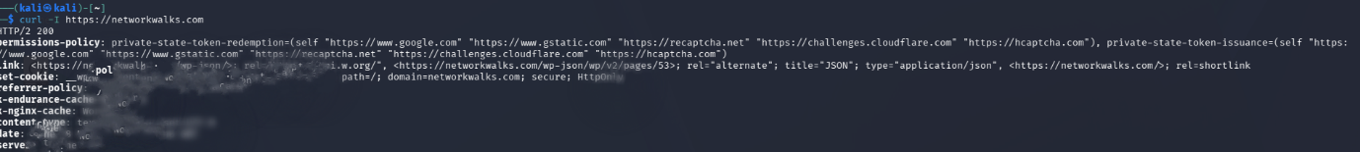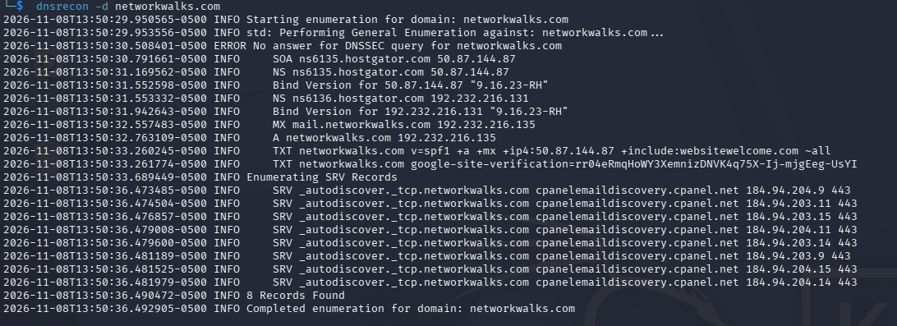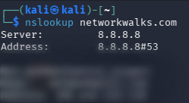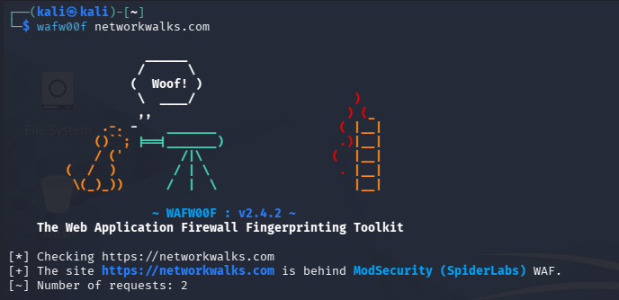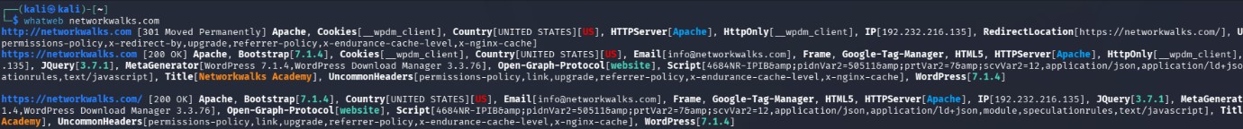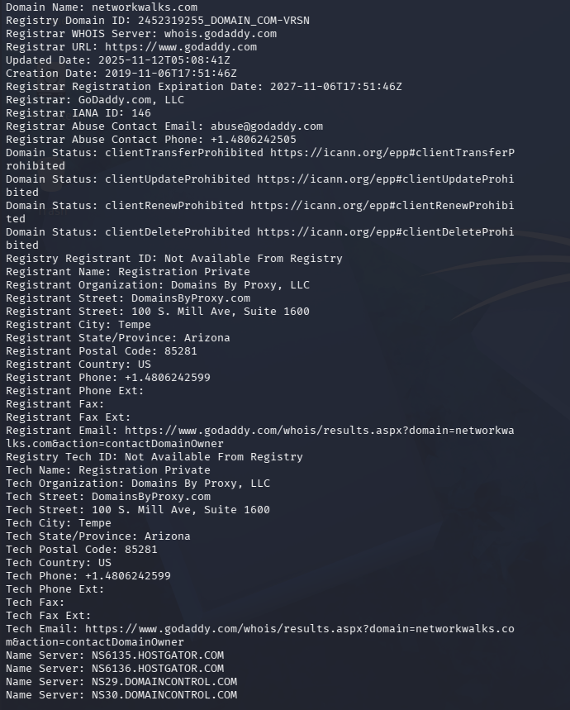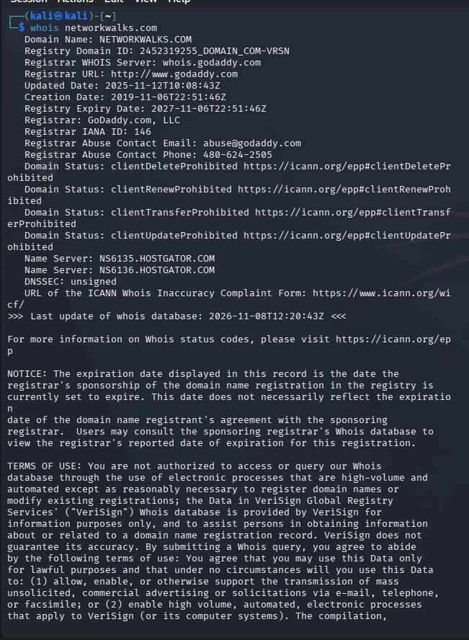
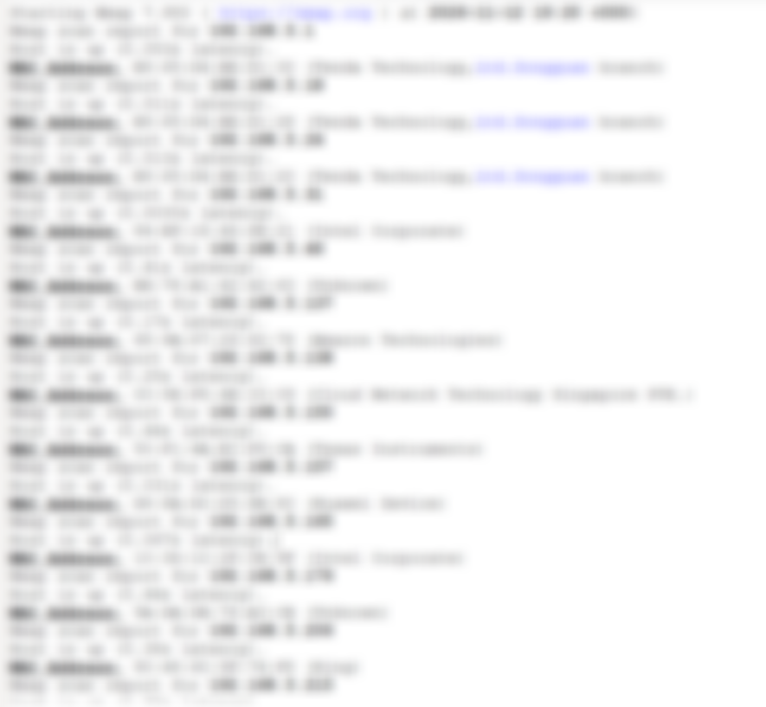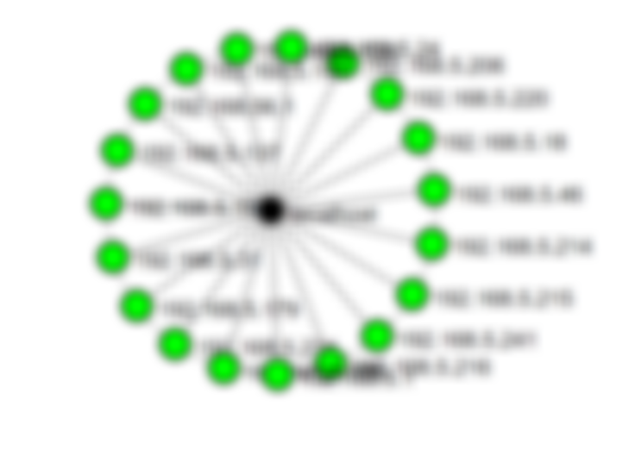
-End-
👤 Author
Kynan Patel
Cybersecurity Student | B084 - Networkwalks
LinkedIn: https://www.linkedin.com/in/kynan-patel-794133423/
📌 Project Information
Program Name: Cybersecurity program at Networkwalks | Week: 02 | Repository: GitHub

