To Rajesh Guiang

We didn't talk to each other at the time, but our first encounter was at the Word Processing competition for BPA held at Fifer Middle School in 8th grade. There I also met Jared for the first time. We met as rivals, trying to surpass the other and make it to the top 5 of the rankings. Because I had trained for a long time prior to the competition, the fact that I didn't place top 5 while everyone at Fifer did made our first encounter a bitter memory.

We met again in 9th grade, at the TSA interest meeting in room A205. Both you and I signed up to compete in the Music Production event. Although I had never talked to you before, I recognized your name, and once again fate had put us together as rivals. That day, I said to you, "We're going to beat you," in the heat of the competitive atmosphere. When I found out that you didn't compete in the event, possibly due to the fact that you didn't have a team, my pride turned into shame.

Then at TSA, Nate Allen, Allen Niemeyer, and I decided to split off from the previous team we were on due to our failure at the state conference. Nate and Allen would be the builders, and I would be the programmer. I felt burdened because I didn't know how to program the robot, and I was the only one who would be able to. When I found out that you would be joining the team, I felt great assurance. After figuring out how to write the code myself, then telling you how the programming works, we were able to create a great robot that allowed us to place 3rd at states. It was a blessing that this encounter allowed us to become friends, rather than making us remain as rivals.

Through our many experiences and hardships at the private competition at DSU, the competition at the TSA State Conference, and the competition against the colleges, I felt that as a team, we were able to form stronger bonds and become closer.

It is unfortunate that you must depart, but as we all have our own paths in life, it can't be avoided. Our Vex Robotics team will have lost an amazing programmer, and I hope that Kurt Florez inherits your will.

I pray for your safety and wellbeing. Continue to do what is right and live life to the fullest; be humble, patient, and follow the moral path, even if it seems to contradict with what most people think. Even the darkness needs light to exist. If you ever need help, contact me at any time, and if you are ever lost, seek God and you will be answered.

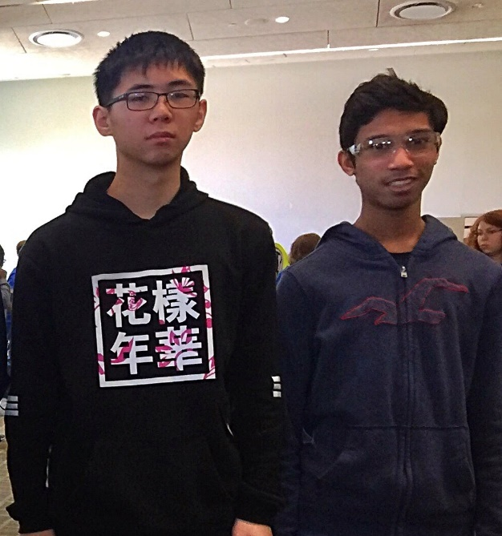

If fate does not allow us to meet ever again in the future, this will serve as my final words to you, a friend whom I will miss very much.

Never forget, that you will always be a member of our team.

Aluminum Ally will forever be a team of 7 members.

- Kerrance Dai

Email: [ryota.sakurai@hotmail.com](mailto:ryota.sakurai@hotmail.com)

Skype: wontonsoup1738

YouTube: ShadowDragonP

Text: (302) 330-8186