Random Forest Classification — Titanic Survival Prediction
ACM ML Induction Task 2026 — Summary Report

Part 1: Data Exploration & Understanding
Dataset: Titanic (Kaggle) — 891 training rows, 418 test rows. Age has 177 missing values, Cabin is missing for most rows, Embarked has 2 missing values.

Survival Rate by Class
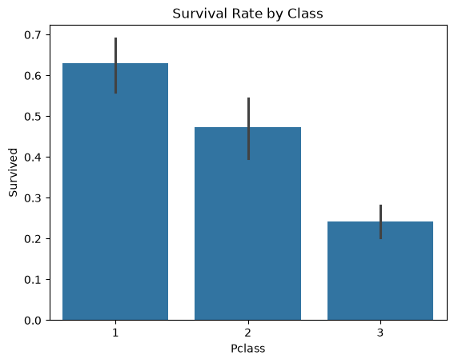Bar chart: Survival Rate by Pclass

Age Distribution by Survival
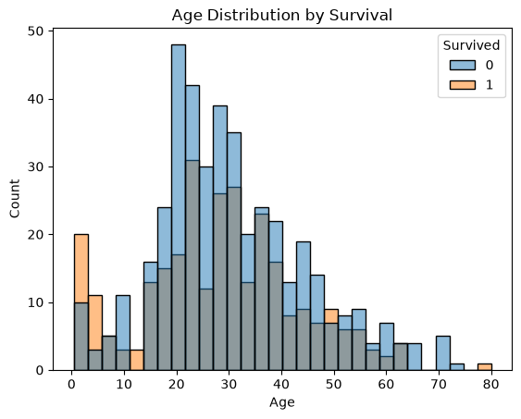Histogram: Age distribution, split by Survived

Survival Rate by Sex
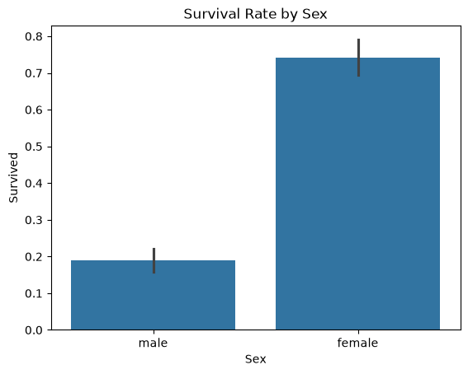Bar chart: Survival Rate by Sex

Fare Distribution
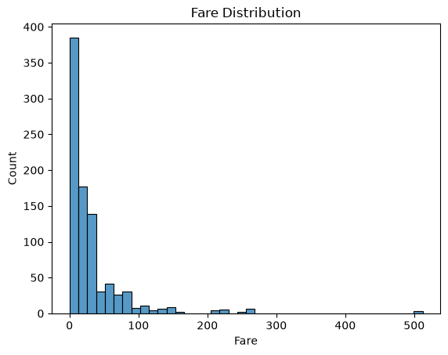Histogram: Fare distribution

Missing Data Pattern
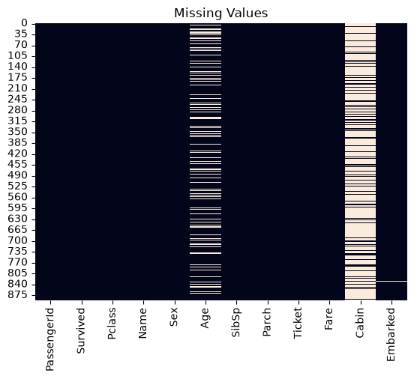Heatmap: missing values across columns

Observations: 1st class ~63% survival vs ~24% for 3rd class. Women ~74% survival vs ~19% for men. Children under 10 show higher survival. Fare is heavily right-skewed.

Part 2: Data Preprocessing
Steps performed:
- Missing values: A
- Feature engineering: T
- Encoding: S
- Dropped columns: P

Part 3: Random Forest Implementation from Scratch
Implemented DecisionTree and RandomForest classes from scratch (no sklearn.tree / sklearn.ensemble). Core components: Gini impurity, information gain, best-split search, recursive tree building, bootstrap sampling, random feature selection (sqrt(n)), and majority-vote prediction.
Stage | Accuracy (Train / Val)
Single Decision Tree | 86.9% / 77.1%
Random Forest (initial: 50 trees, depth 6) | 83.7% / 78.2%
Random Forest (tuned: 50 trees, depth 10, min_split 5) | — / 81.6% (best sweep result)

Part 4: Model Evaluation & Hyperparameter Tuning

Confusion Matrix (Validation Set)
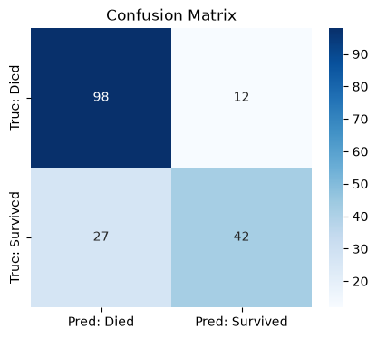
Confusion matrix heatmap

ROC Curve
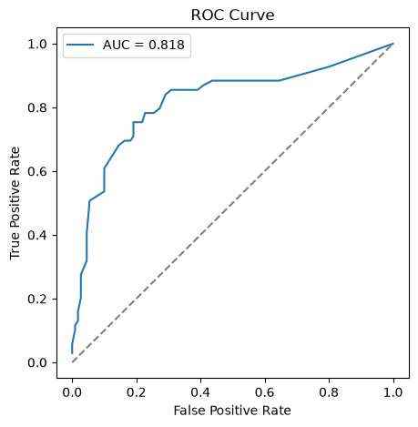ROC curve with AUC value

Metric | Value
Accuracy | 75.4%
Precision | 0.778
Recall | 0.609
F1-score | 0.683
AUC | 0.818

Hyperparameter Sweep
Swept n_estimators ∈ {10, 50, 100, 200}, max_depth ∈ {3, 5, 10, None}, min_samples_split ∈ {2, 5, 10} — 48 combinations total. Best: n_estimators=50, max_depth=10, min_samples_split=5 → 81.6% validation accuracy. More trees did not guarantee better results; moderate depth generalized best.
[ Paste screenshot here ]
(Optional) Table or chart of top hyperparameter sweep results

Feature Importance
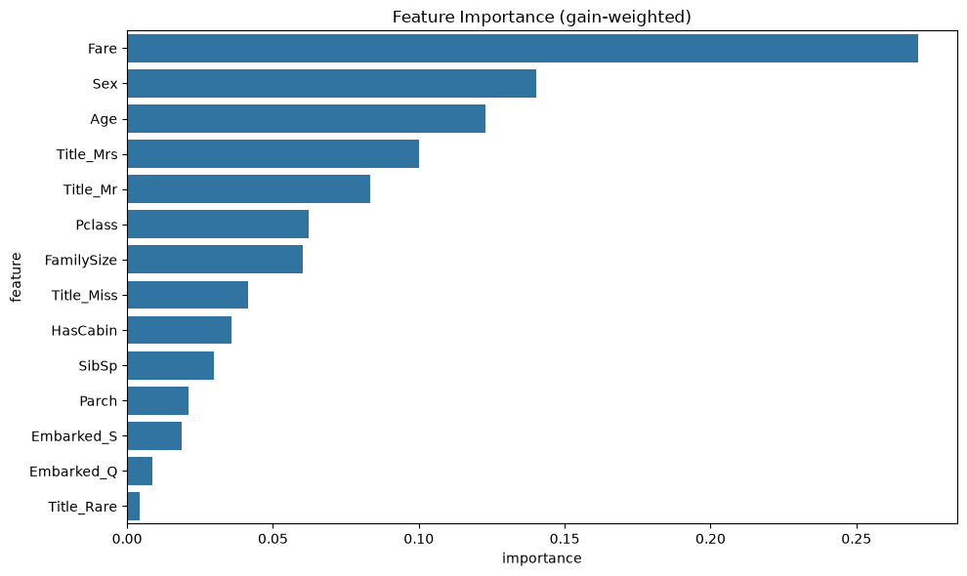Feature importance bar chart (gain-weighted)

Top features: Fare (0.271), Sex (0.140), Age (0.123), Title_Mrs (0.100), Title_Mr (0.083), Pclass (0.062) — consistent with the EDA's survival patterns.

Part 5: Analysis & Insights

1. Results Interpretation
The final Random Forest model achieved 75.4% validation accuracy, with precision 0.778 and recall 0.609 (F1 = 0.683), and AUC 0.818. The precision/recall gap shows the model is conservative in predicting “survived” — correct 78% of the time when it does, but missing ~39% of actual survivors. This reflects the majority class (“died”, ~62%) pulling predictions toward the safer default. AUC of 0.818 confirms solid class separation, well above the 0.5 random baseline.

2. Most Important Features
- Fare (0.271) —
- Sex (0.140) —
- Age (0.123) —
- Title_Mrs / Title_Mr (0.100 / 0.083) —
- Pclass (0.062) —

3. Business / Historical Insights
Results support the “women and children first” protocol and class-based survival disparity. Wealthier, 1st-class passengers had better odds, likely from cabin proximity to lifeboats. Family size showed a “sweet spot” — small families survived more than solo travelers or very large families.

4. Model Limitations
- Overfitting: s
- Run-to-run variance: r
- Threshold search cost: m
- No pruning or OOB scoring: a

5. Suggested Improvements
- Run the sweep across multiple seeds and report mean ± std accuracy.
- Add out-of-bag (OOB) score estimation.
- Use regression-based Age imputation instead of median fill.
- Engineer a Deck feature from the Cabin letter before dropping it.

