Fake News Detection — LSTM Classifier
ACM ML Induction Task 2026 — Brownie Task Summary Report

1. Workflow Summary
Built a Bidirectional LSTM classifier to detect fake news articles, trained on 24,320 labeled Reuters-sourced articles (24,353 originally; 33 empty/link-only rows removed). Text was cleaned (lowercased, URLs/emails stripped, non-alphabetic characters removed), tokenized with a 20,000-word vocabulary, and padded/truncated to 400 words per article, based on the observed median article length of ~373 words.

Class Balance
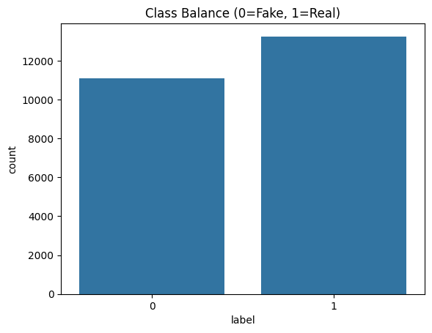Bar chart: class balance (Fake vs Real)

Text Length Distribution
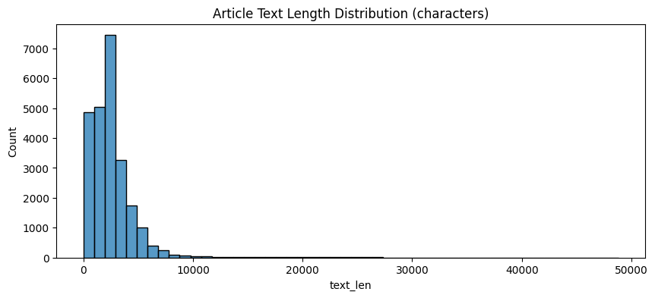Histogram: article text length (characters)

Text Length by Label
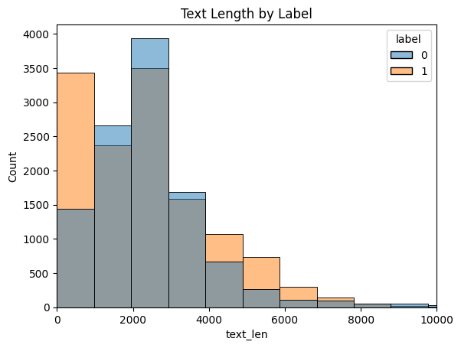Histogram: text length split by label (fake vs real)

Class balance: ~11,100 fake (0) vs ~13,250 real (1) — mild imbalance, no special class weighting needed. Fake articles trend shorter on average.

2. Preprocessing
- Cleaning: l
- Tokenization: K
- Padding: s
- Train/Val split: 8

3. Model Architecture
Embedding(128-dim) → Bidirectional LSTM(64, return_sequences) → Dropout(0.3) → Bidirectional LSTM(32) → Dropout(0.3) → Dense(32, ReLU) → Dropout(0.2) → Dense(1, sigmoid). ~2.7M trainable parameters. Adam optimizer, binary cross-entropy loss, early stopping on validation loss (patience=3).

Training Curves

Training stopped after 4 epochs — validation loss reached its minimum (0.0607) at epoch 1 and began climbing while training loss kept falling, a clear overfitting signal that EarlyStopping correctly caught.

4. Evaluation (Held-Out Test Set)

Confusion Matrix
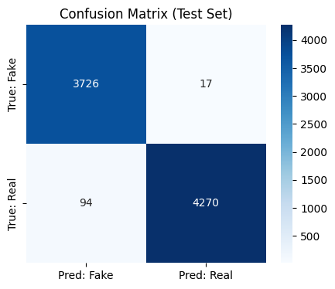Confusion matrix heatmap (test set)

ROC Curve
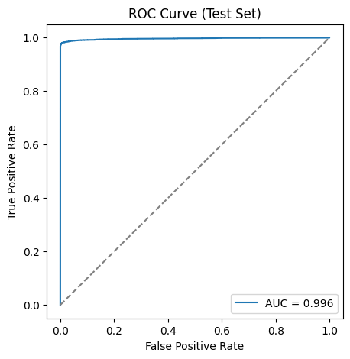ROC curve with AUC value (test set)

Metric | Value
Accuracy | 98.63%
Precision | 0.996
Recall | 0.979
F1-score | 0.987
AUC | 0.996
Evaluation set (evaluation.csv) accuracy | 98.42%

5. Inference on Unseen Data
An inference function was built to classify raw, unseen text as Fake or Real with a confidence score. It was tested on evaluation.csv (8,107 fully unseen articles) and on hand-written custom examples.

Sample Predictions (evaluation.csv)
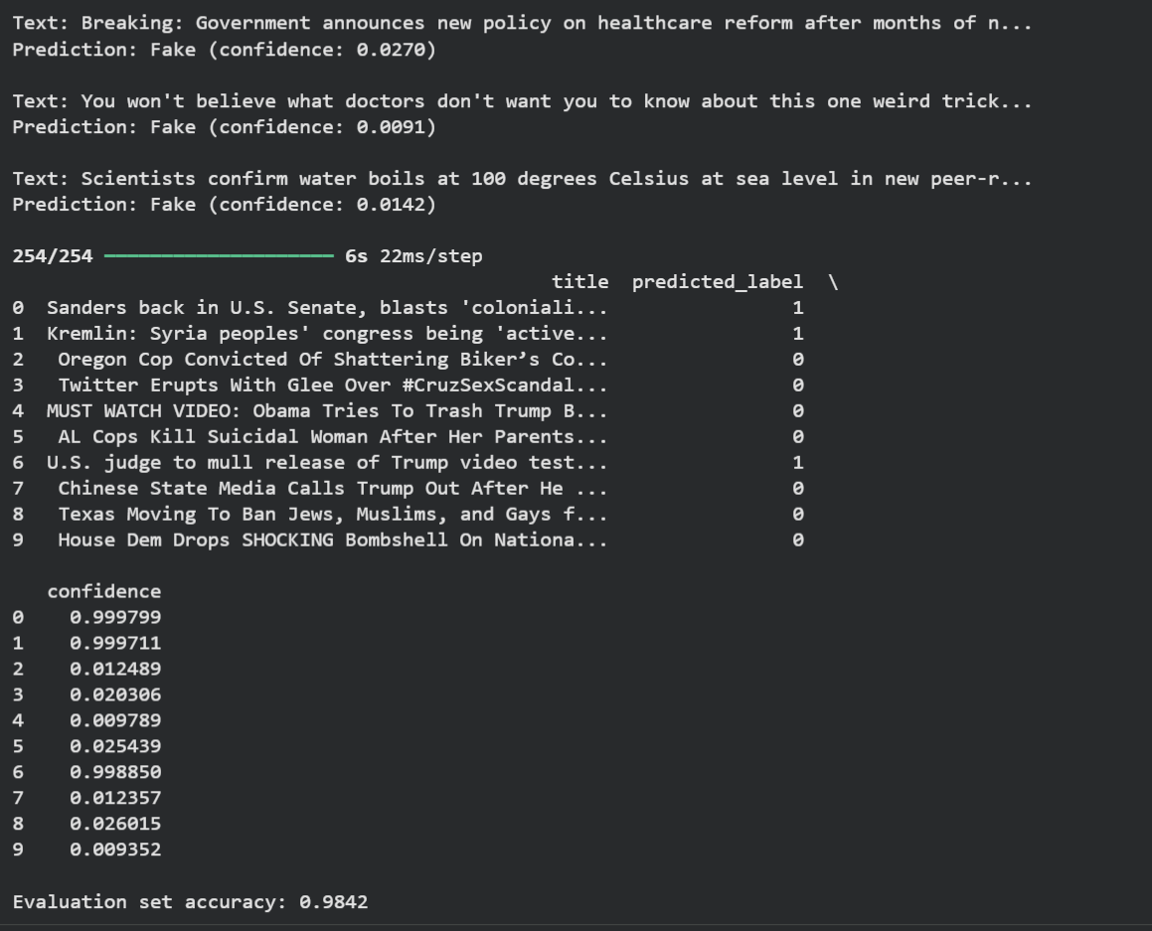Screenshot: sample predictions table (title, predicted_label, confidence)

Custom Example Predictions
Example | Prediction | Confidence
Reuters-style: “WASHINGTON (Reuters) — The White House announced...” | Real | 0.9998
Sensationalist clickbait: “You won’t believe what happened next!...” | Fake | 0.0118
Neutral study summary, non-Reuters style: “A new study published...” | Fake | 0.0223

6. Analysis & Key Insight
The model performs excellently on articles matching Reuters-style formatting (formal dateline, source attribution, measured tone), classifying them as Real with near-100% confidence. However, it also classifies genuinely neutral, non-sensational content as Fake when that content doesn't follow Reuters-style formatting — for example, a plausible, factual-sounding study summary written in a different journalistic style was misclassified as fake with high confidence.
This indicates the model has learned to detect “Reuters-style formatting” rather than a general notion of truthfulness — a direct consequence of the dataset's construction (real = Reuters wire articles, fake = various other sources with different, often sensationalist styles). This is a known characteristic of this specific dataset rather than a flaw unique to this implementation.

7. Model Limitations
- Dataset-specific stylistic bias: c
- No semantic/factual verification: t
- Sequence length cutoff: a
- Binary classification only: n

8. Suggested Improvements
- Train on a more stylistically diverse dataset spanning multiple legitimate news sources.
- Compare against a Transformer/BERT-based approach for more nuanced semantic signal.
- Add adversarial or style-transfer augmentation to force the model to focus on content over formatting.
- Incorporate the title field as an additional input signal alongside the article text.

