Names: Aiden Ocasio, Jacob Rulka, Jhan Gomez
Instructor: Professor Markov
Course: CS-385
Section: 01
Date: 04/02/2026

Progress Report Two – Complete MIPS 16-bit Single Cycle Datapath
Contribution of Team Members
Aiden: Expanded the control from Jacob’s 9-bit implementation to 11 bits, to allow all instructions to work as intended. Also added the MemWrite, and MemtoReg control signals for the load word and store word instructions which needed read and write access to memory, respectively. Added test instructions to the CPU through the IMemory vector, and debugged program to find correct values for the instruction and data memory.

Jacob: Implemented the branch control unit to work with the beq and bne instructions to replace the single AND gate used. Expanded the MainControl from 7 bits to 9 bits (before being expanded to 11 bits by Aiden) to output and implemented the beq and bne control signals. Wired a branch target adder and 16-bit PC mux to select between sequential and the branch target PC. Added the four test cases into the program for taken and not taken options for both bne and beq.

Jhan: Fixed the CPU from progress report one to be according to the instruction format provided. Fixed the 1-bit ALUs to use external modules for the purposes of abstraction and simplification by adding gate level multiplexers, full adder, and drew the new logic diagrams. Created the tables for the branch control unit and the main control unit according to the program. Added the branch control unit table according to the new CPU specifications and wrote report on the implementation and explanation of the complete single cycle data path. Fixed CPU’s broken control signals added signed to the CPU for the monitor values and changed the muxB multiplexer to be correct.

TABLES
Branch Control Unit Truth Table
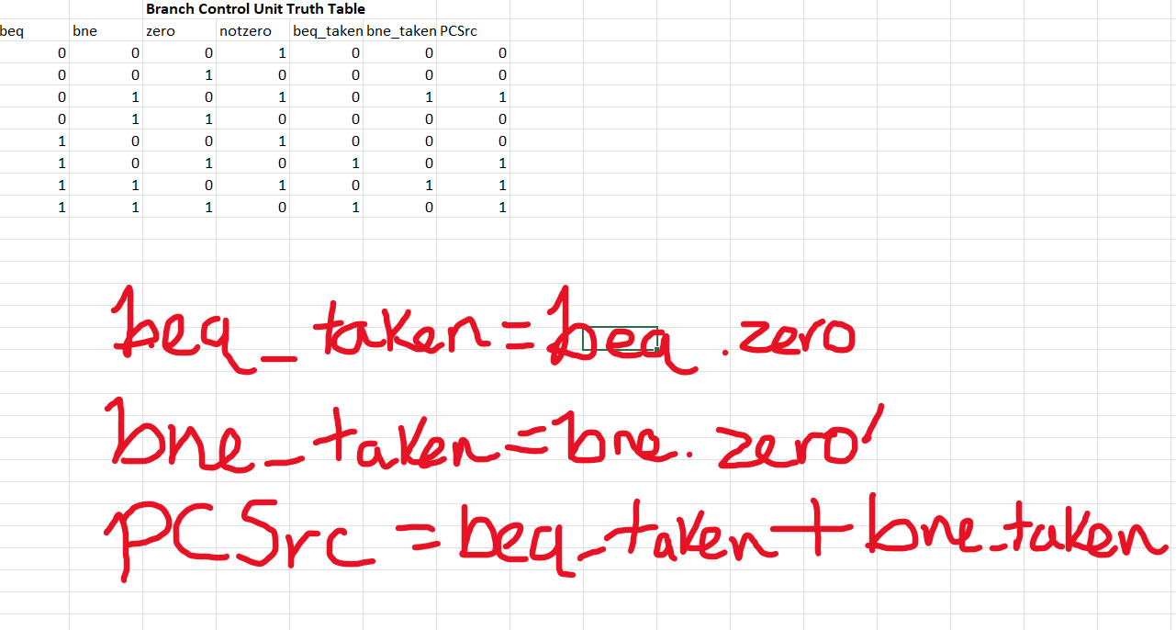

Main Control Unit Truth Table
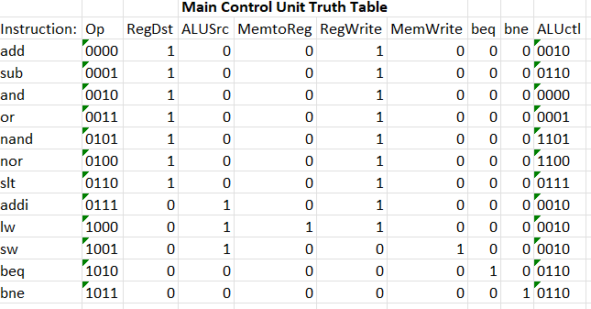

Instruction Set and Format Table (With Explanations)
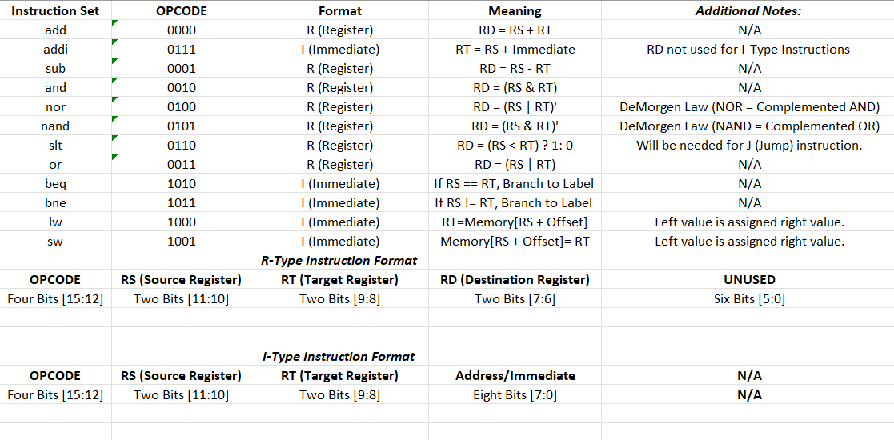

DIAGRAMS
Branch Control Unit
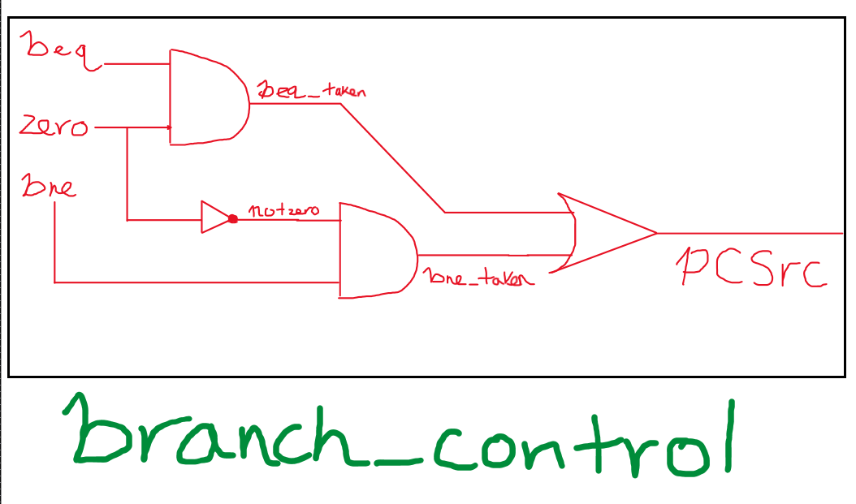

ALU1
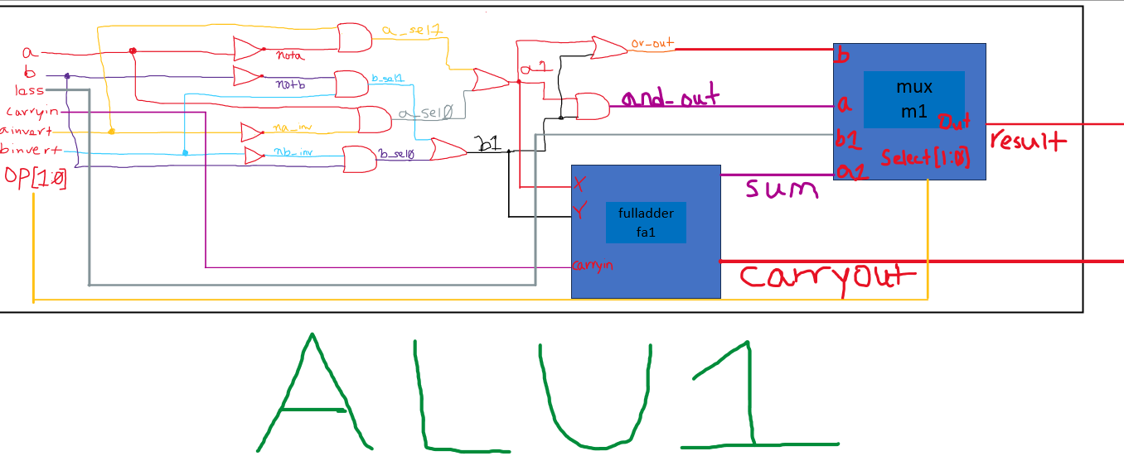

ALUmsb
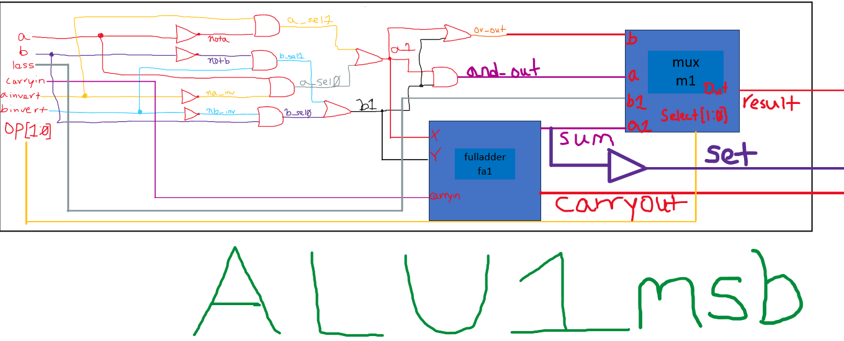

ALU
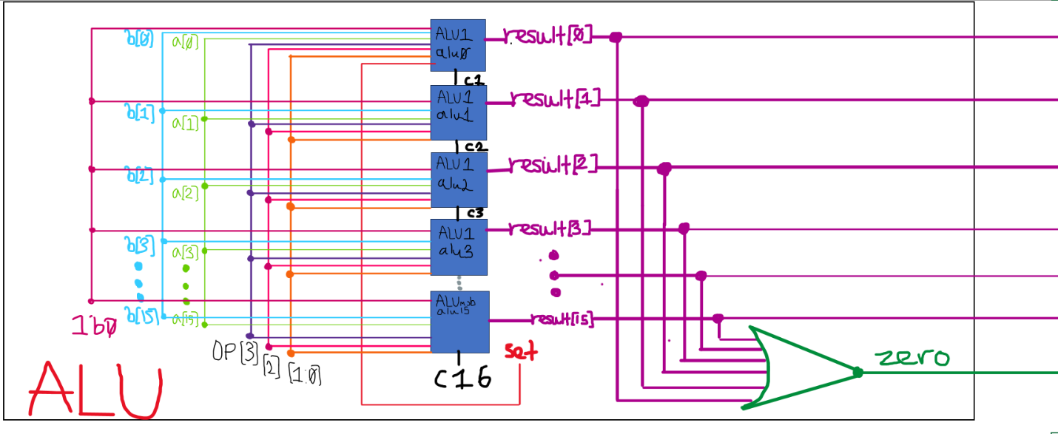
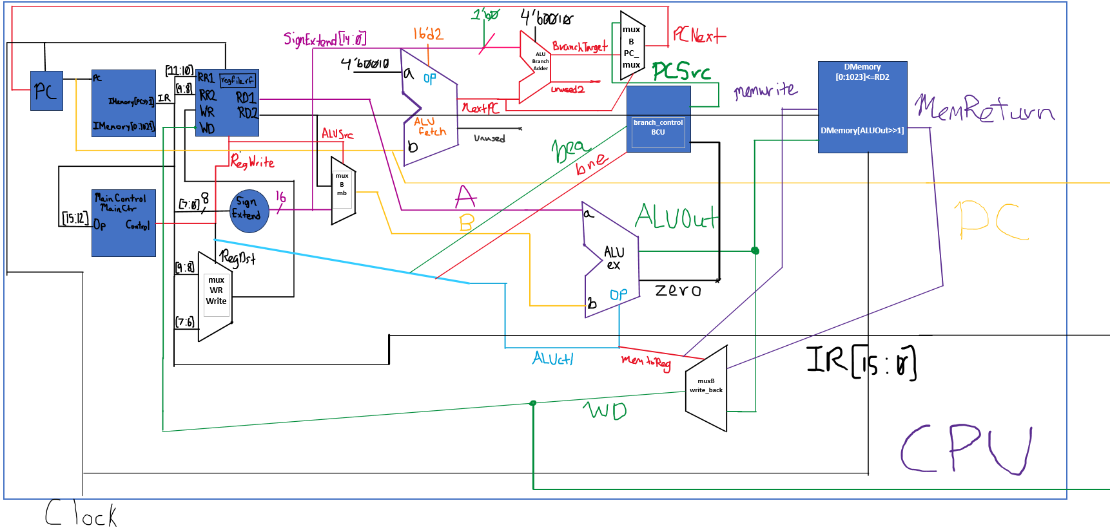
CPU

Complete CPU Code (Default, Result 1, DMemory and BEQ Values), .v extension):
// Names: Aiden Ocasio, Jacob Rulka, and Jhan Gomez
// Instructor: Professor Markov
// Course: CS-385-01
// Date: 04/02/26
// Purpose: 16-bit MIPS single-cycle CPU (R-type + I-type)
// MUXES
//4x1 Multiplexer, used by the ALU to choose wheter it is an and, or, add, less operation.
module mux(a, b, a1, b1, select, out);
input a, b, a1, b1;
input [1:0] select;
output out;
wire notS0, notS1;
not (notS0,select[0]);
not (notS1,select[1]);
wire r0,r1,r2,r3;
and (r0,a,notS1,notS0);
and (r1,b,notS1,select[0]);
and (r2,a1,select[1],notS0);
and (r3,b1,select[1],select[0]);
or (out,r0,r1,r2,r3);
endmodule
//This mux is generic, and is used as a building block for the ALU
module mux2x1(a, b, select, out);
input a, b, select;
output out;
wire notselect;
not (notselect, select);
and (a_out, a, notselect);
and (b_out, b, select);
or (out, a_out, b_out);
endmodule
//This mux is used to select the destination register.
module muxWR(a, b, select, out);
input [1:0] a, b;
input select;
output [1:0] out;
mux2x1 one(a[0], b[0], select, out[0]);
mux2x1 two(a[1], b[1], select, out[1]);
endmodule
//This mux is used for writing back, for the program counter, and to select between the value RD2 in the register file or the immediate field.
module muxB (a, b, select, out);
input [15:0] a, b;
input select;
output [15:0] out;
//16 muxes for the respective 16 bits of RD2 and SignExtend
mux2x1 mux1 (a[0], b[0], select, out[0]);
mux2x1 mux2 (a[1], b[1], select, out[1]);
mux2x1 mux3 (a[2], b[2], select, out[2]);
mux2x1 mux4 (a[3], b[3], select, out[3]);
mux2x1 mux5 (a[4], b[4], select, out[4]);
mux2x1 mux6 (a[5], b[5], select, out[5]);
mux2x1 mux7 (a[6], b[6], select, out[6]);
mux2x1 mux8 (a[7], b[7], select, out[7]);
mux2x1 mux9 (a[8], b[8], select, out[8]);
mux2x1 mux10 (a[9], b[9], select, out[9]);
mux2x1 mux11 (a[10], b[10], select, out[10]);
mux2x1 mux12 (a[11], b[11], select, out[11]);
mux2x1 mux13 (a[12], b[12], select, out[12]);
mux2x1 mux14 (a[13], b[13], select, out[13]);
mux2x1 mux15 (a[14], b[14], select, out[14]);
mux2x1 mux16 (a[15], b[15], select, out[15]);
endmodule
//Full adder is used to handle ALU arithmetic operations.
module fulladder(x, y, sum, carryin, carryout);
input x, y, carryin;
output sum, carryout;
wire xysum, ab, axb_cin;

xor (xysum,x,y);
xor (sum,xysum,carryin);
and (ab,x,y);
and (axb_cin,xysum,carryin);
or (carryout,ab,axb_cin);
endmodule
//1 bit alu works on bits 0-14 and does operations accordingly.
module ALU1 (a,b,ainvert,binvert,op,less,carryin,carryout,result);
input a,b,less,carryin,ainvert,binvert;
input [1:0] op;
output carryout,result;
wire nota,notb,a1,b1,and_out,or_out,sum;
not (nota,a);
not (notb,b);
wire na_inv,nb_inv;
not (na_inv,ainvert);
not (nb_inv,binvert);
wire a_sel0,a_sel1,b_sel0,b_sel1;
and (a_sel0,a,na_inv);
and (a_sel1,nota,ainvert);
or (a1,a_sel0,a_sel1);
and (b_sel0,b,nb_inv);
and (b_sel1,notb,binvert);
or (b1,b_sel0,b_sel1);
and (and_out,a1,b1);
or (or_out,a1,b1);
fulladder fa1(a1, b1, sum, carryin, carryout);
mux m1(and_out, or_out, sum, less, op, result);
endmodule
//Does the same as above but also has a set buffer to the slt flag.
module ALUmsb (a,b,ainvert,binvert,op,less,carryin,carryout,result,set);
input a,b,less,carryin,ainvert,binvert;
input [1:0] op;
output carryout,result,set;
wire nota,notb,a1,b1,and_out,or_out,sum;
not (nota,a);
not (notb,b);
wire na_inv,nb_inv;
not (na_inv,ainvert);
not (nb_inv,binvert);
wire a_sel0,a_sel1,b_sel0,b_sel1;
and (a_sel0,a,na_inv);
and (a_sel1,nota,ainvert);
or (a1,a_sel0,a_sel1);
and (b_sel0,b,nb_inv);
and (b_sel1,notb,binvert);
or (b1,b_sel0,b_sel1);
and (and_out,a1,b1);
or (or_out,a1,b1);
fulladder fa1(a1, b1, sum, carryin, carryout);
mux m1(and_out, or_out, sum, less, op, result);
buf (set,sum);
endmodule
//ALU handles all arithmetic operations by combining the 1 bit alus and nor for the zero flag.
module ALU (op,a,b,result,zero);
input [15:0] a,b;
input [3:0] op;
output [15:0] result;
output zero;
wire c1,c2,c3,c4,c5,c6,c7,c8;
wire c9,c10,c11,c12,c13,c14,c15,c16;
wire set;
// Bit 0
ALU1 alu0 (a[0],b[0],op[3],op[2],op[1:0],set,op[2],c1,result[0]);

// Bits 1-14
ALU1 alu1 (a[1],b[1],op[3],op[2],op[1:0],1'b0,c1,c2,result[1]);
ALU1 alu2 (a[2],b[2],op[3],op[2],op[1:0],1'b0,c2,c3,result[2]);
ALU1 alu3 (a[3],b[3],op[3],op[2],op[1:0],1'b0,c3,c4,result[3]);
ALU1 alu4 (a[4],b[4],op[3],op[2],op[1:0],1'b0,c4,c5,result[4]);
ALU1 alu5 (a[5],b[5],op[3],op[2],op[1:0],1'b0,c5,c6,result[5]);
ALU1 alu6 (a[6],b[6],op[3],op[2],op[1:0],1'b0,c6,c7,result[6]);
ALU1 alu7 (a[7],b[7],op[3],op[2],op[1:0],1'b0,c7,c8,result[7]);
ALU1 alu8 (a[8],b[8],op[3],op[2],op[1:0],1'b0,c8,c9,result[8]);
ALU1 alu9 (a[9],b[9],op[3],op[2],op[1:0],1'b0,c9,c10,result[9]);
ALU1 alu10 (a[10],b[10],op[3],op[2],op[1:0],1'b0,c10,c11,result[10]);
ALU1 alu11 (a[11],b[11],op[3],op[2],op[1:0],1'b0,c11,c12,result[11]);
ALU1 alu12 (a[12],b[12],op[3],op[2],op[1:0],1'b0,c12,c13,result[12]);
ALU1 alu13 (a[13],b[13],op[3],op[2],op[1:0],1'b0,c13,c14,result[13]);
ALU1 alu14 (a[14],b[14],op[3],op[2],op[1:0],1'b0,c14,c15,result[14]);

//MSB ALU for bit 15 includes special set output for ALU0
ALUmsb alu15 (a[15],b[15],op[3],op[2],op[1:0],1'b0,c15,c16,result[15],set);

// Zero flag, later needed for beq and bne.
nor (zero,
result[0],result[1],result[2],result[3],
result[4],result[5],result[6],result[7],
result[8],result[9],result[10],result[11],
result[12],result[13],result[14],result[15]);
endmodule

//reg_file, handles reading and writing of registers.
module reg_file (RR1,RR2,WR,WD,RegWrite,RD1,RD2,clock);
input [1:0] RR1,RR2,WR; //Instead of 5 bits for rs, rt, and rd, it is only two bits.
input [15:0] WD; //16 bits for complete instruction rather than the traditional 32 bits.
input RegWrite,clock;
output [15:0] RD1,RD2; //The read data ports of the reg file are likewise only 16 bits.
reg [15:0] Regs[0:3]; //4 registers, 16 bits long.
assign RD1 = Regs[RR1]; //RS is assigned to read data port 1.
assign RD2 = Regs[RR2]; //RT is assigned to read data port 2.
initial Regs[0] = 0; //$zeri must always be 0.
always @(negedge clock)
if (RegWrite==1 & WR!=0) //Prevents $zero from being overwritten and make sure only when asserted that Write Register is allowed.
Regs[WR] <= WD;
endmodule
//Main control determines if R-type instruction or I-type instruction and sends the coressponding bit [From MSB to LSB] to RegDst, ALUSrc, MemToReg, RegWrite, MemWrite, beq, bne, ALUctl
module MainControl (Op,Control);
input [3:0] Op;
output reg [10:0] Control; //Control is now 11 bits.
// Control bits: RegDst, ALUSrc, MemToReg, RegWrite, MemWrite, beq, bne, ALUctl
always @(Op) case (Op)
// R type Instructions:
4'b0000: Control <= 11'b10010_00_0010; // ADD
4'b0001: Control <= 11'b10010_00_0110; // SUB
4'b0010: Control <= 11'b10010_00_0000; // AND
4'b0011: Control <= 11'b10010_00_0001; // OR
4'b0101: Control <= 11'b10010_00_1101; // NAND
4'b0100: Control <= 11'b10010_00_1100; // NOR
4'b0110: Control <= 11'b10010_00_0111; // SLT
// I type Instructions:
4'b0111: Control <= 11'b01010_00_0010; // ADDI
4'b1000: Control <= 11'b01110_00_0010; // LW
4'b1001: Control <= 11'b01001_00_0010; // SW
4'b1010: Control <= 11'b00000_10_0110; // BEQ
4'b1011: Control <= 11'b00000_01_0110; // BNE
default: Control <= 11'b00000000000;
endcase
endmodule

//Branch control determines if the branch should be taken based on the opcode and the zero flag from the ALU.
module branch_control (beq, bne, zero, PCSrc);
input beq, bne, zero;
output PCSrc;
wire notzero;
not (notzero, zero);
wire beq_taken, bne_taken;
and (beq_taken, beq, zero);
and (bne_taken, bne, notzero);
or (PCSrc, beq_taken, bne_taken);
endmodule

//CPU, ties all modules together.
module CPU (clock,PC,WD,IR);
input clock;
output [15:0] WD,IR,PC;
reg [15:0] PC;
reg[15:0] IMemory[0:1023], DMemory[0:1023]; //Expanded with data memory.
wire [15:0] NextPC,A,B,ALUOut,RD2,SignExtend;
wire [15:0] BranchTarget, PCNext;
wire [3:0] ALUctl;
wire [1:0] WR;
wire [15:0] WD; //Needed to write to a data memory address.
wire RegDst, ALUSrc, RegWrite;
wire beq, bne, Zero, PCSrc;
wire MemWrite, MemtoReg;
wire Unused, Unused2;
wire [15:0] MemReturn;
initial begin
// Program (converted to 16-bit)
IMemory[0] = 16'b1000_00_01_00000000; // lw t1,0($0)
IMemory[1] = 16'b1000_00_10_00000010; // lw t2,2($0)
IMemory[2] = 16'b0110_01_10_11_000000; // slt t3,t1,t2
IMemory[3] = 16'b1010_11_00_00000010; // beq $t3,$zero,skip, see results section!
IMemory[4] = 16'b1001_00_01_00000010; // sw $t1,2($0)
IMemory[5] = 16'b1001_00_10_00000000; // sw$ t2,0($0)
IMemory[6] = 16'b1000_00_01_00000000; // lw $t1,0($0)
IMemory[7] = 16'b1000_00_10_00000010; // lw $t2,2($0)
IMemory[8] = 16'b0100_10_10_10_000000; // nor $t2,$t2,$t2
IMemory[9] = 16'b0111_10_10_00000001; // addi $t2,$t2,1
IMemory[10]= 16'b0000_01_10_11_000000; // add $t3,$t1,$t2
DMemory[1] = 7; //See Results!
DMemory[0] = 5; // address 2 (because >>1), See Results!
end

initial PC = 0;
assign IR = IMemory[PC>>1];
assign MemReturn = DMemory[ALUOut>>1];

muxWR write(IR[9:8], IR[7:6], RegDst, WR);
assign SignExtend = {{8{IR[7]}},IR[7:0]};
muxB mb(RD2, SignExtend, ALUSrc, B);

muxB write_back(ALUOut, MemReturn, MemtoReg, WD);
reg_file rf (IR[11:10],IR[9:8],WR,WD,RegWrite,A,RD2,clock);

ALU fetch (4'b0010,PC,16'd2,NextPC,);
ALU ex (ALUctl, A, B, ALUOut, Zero);

MainControl MainCtr (IR[15:12],
{RegDst, ALUSrc, MemtoReg, RegWrite, MemWrite, beq, bne, ALUctl});

branch_control BCU (beq, bne, Zero, PCSrc);
ALU branch_adder (4'b0010, NextPC, {SignExtend[14:0],1'b0}, BranchTarget,Unused2);
muxB PC_mux(NextPC, BranchTarget, PCSrc, PCNext);
always @(negedge clock) begin
PC <= PCNext;
if (MemWrite)
DMemory[ALUOut>>1] <= RD2;
end
endmodule
//Test module, handles output and clock pulses of the program.
module test ();
reg clock;
wire signed [15:0] WD,IR,PC;
CPU cpu(clock,PC,WD,IR);
always #1 clock = ~clock;
initial begin
$display ("PC IR WD ");
$monitor ("%2d (%b) %d (%b)",PC,IR,WD, WD);
clock = 1;
#20 $finish;
end
endmodule

RESULT 1 and 2: IMemory[3] = 16'b1010_11_00_00000010; // beq $t3,$zero,skip

RESULT 1: DMemory[0] =5, DMemory[1] =7, BEQ = TRUE
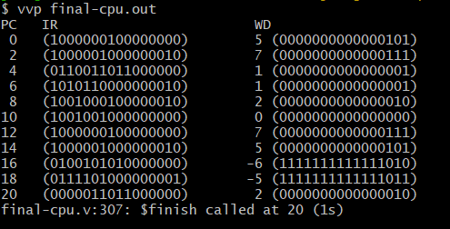

RESULT 2: DMemory[0] =7, DMemory[1]=5, BEQ = FALSE
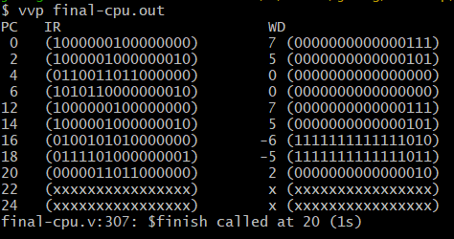

RESULT 3 and 4: IMemory[3] = 16’b1011_11_00_00000010; //bne $t3, $zero, skip
RESULT 3: DMemory[0] =7, DMemory[1] =5, BNE = TRUE
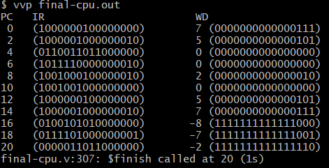

RESULT 4: DMemory[0] =5, DMemory[1]=7, BNE = FALSE
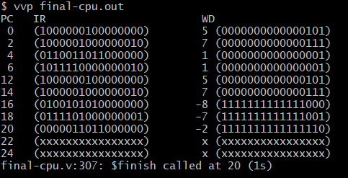

EXPLANATION:
For the complete single-cycle data path implementation, the group had to make several modifications in conjunction with new modules to successfully create a machine that could calculate the previous project’s R-type and I-type instructions, as well as the new load word (lw), store word (sw), branch if equal (beq), and branch if not equal (bne) data memory instructions. To accomplish this, there are a lot of important multiplexers for the 1-bit ALUs, the ALU, and the CPU, which were added, with one of the most important multiplexers being the write back mux, which handles whether the value from the memory should be set as the data source or if the output of the ALU ex should instead be used. This component determines the value that should be written back to the register file, which can be either the value directly from the wire ALUOut or the appropriate value from the data memory. Another crucial multiplexer worth focusing on in this data path is the PCMux, which determines whether the next sequential instruction should be pointed to by the PC or whether a specific label address for branching should be utilized, which would be the case if the conditions for beq or bne are met. The wire for the branch control signal that is fed to the PCMux is handled by a new ALU component called ALU Branch Adder, which uses the first 14 bits of the sign-extended vector concatenated with 0 as the LSB, to determine this. The branch control unit operates by introducing two new signals, labeled beq and bne, which correspond to the respective MIPS instructions and are directly obtained from the main control unit. The output of the branch control unit is sent to the PCMux as the wire PCSrc for evaluation and will cause PCNext to be the branch address if the branch condition is satisfied. In this version of the single-cycle data path, five stages were used: instruction fetch, instruction decode, instruction execution, memory access, and write back. This is due to the new instructions requiring a memory component, which is the DMemory vector. Upon doing all of this, we ran into several issues due to the fact that we had accidentally made mistakes in the main control signals,and the WD write_back multiplexer. The offset for load and store word was 4 instead of 2, and the CPU did not output the wires as signed, resulting in huge 60K+ numbers to be output. Our multiplexer for write back was also incorrect, as it handled the wrong input; the select line was ALUOut rather than the correct MemtoReg, resulting in objectively incorrect results. After a full day of resolving these issues, we successfully implemented the CPU in accordance with the project specifications. One notable difference is that the 32-bit test bench from the sample program has an output of 4 for the branch to skip, whereas ours is 2; this is intentional, as our program is based on offsets of 2 rather than 4. Despite this difference, everything is working as intended, as seen by the output. It is important to note that if the branches aren’t taken, then the output will be x, as the program can’t branch to the label that contains the rest of the instructions and thus terminates.

