Names: Aiden Ocasio, Jacob Rulka, Jhan Gomez
Instructor: Professor Markov
Course: CS-385
Section: 01
Date: 03/10/2026

Progress Report One – Simplified MIPS 16-bit Single Cycle Datapath
Contribution of Team Members
Aiden: Modified the mips-r-type_addi.vl file and reviewed code and diagrams to ensure consistency between modules. Proofread report document to remove errors in grammar and ensured that the report flows accordingly. Converted MIPS 32 addresses to 16 bits and translated the 32-bit connections to 16 bits to properly match the formatting of the instructions.

Jacob: Rewrote the ALU4-mixed.v in gate level code and expanded it from a 4 bit to a 16-bit ALU. Built a module for 1-bit ALU blocks and a MSB ALU to assist with operations like SLT. Also implemented operations such as AND, OR, addition, subtraction, and SLT with the use of logic gates. Also, an additional file was created which is the ALU but programmed using MIPS programming language, which had to match the test module of the Verilog source code.

Jhan: Modified the register file to be in line with project specifications. Created the Control Unit truth table and the instruction set architecture table. Designed and drew all the logic diagrams, tweaked CPU to include NAND (case 38), expanded clock pulses from 16 to 18, and added a new instruction at IMemory[9] . Added comments to Verilog code, combined all the groups work into one singular CPU file, and added some comments to the CPU file. Created a Discord to monitor group’s progress, a GitHub repository as the version control system (https://github.com/ShadowMatrix01/CS-385-01-Semester-MIPS-Machine-Project) ,and the project report itself (with the exception of Aiden and Jacob’s respective contribution sections).

Tables
Control Unit Truth Table
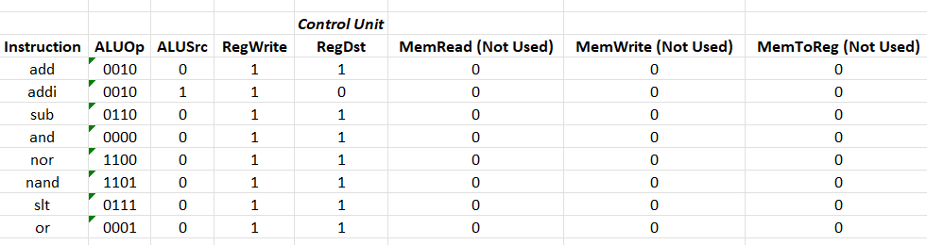

Instruction Set and Format Table (With Explanations)
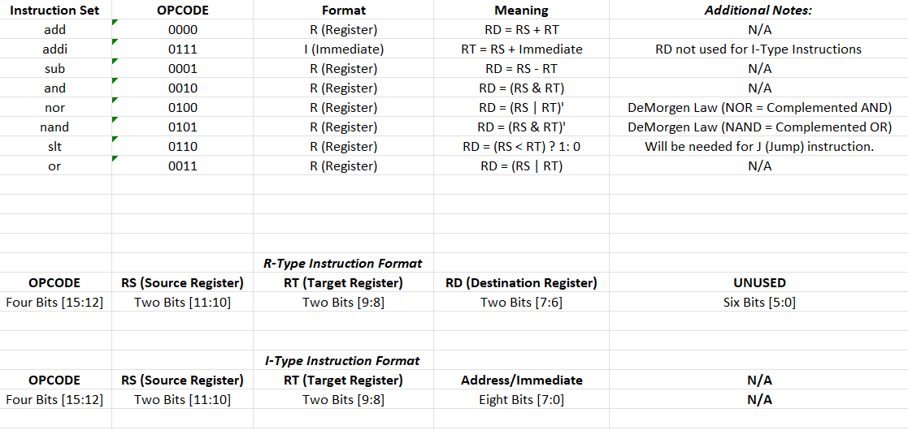

Diagrams
ALU1
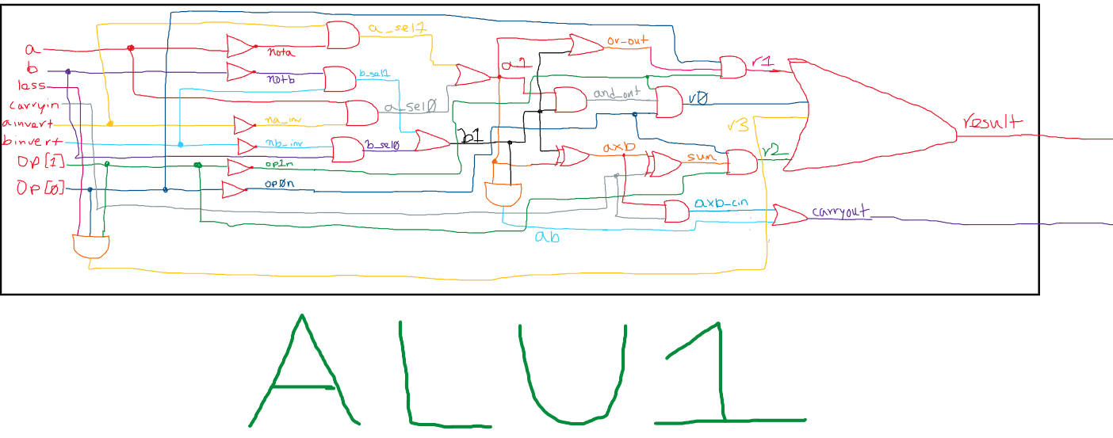
ALUmsb
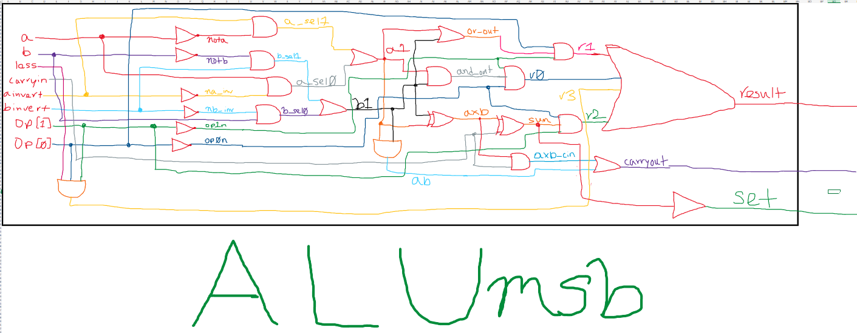

ALU
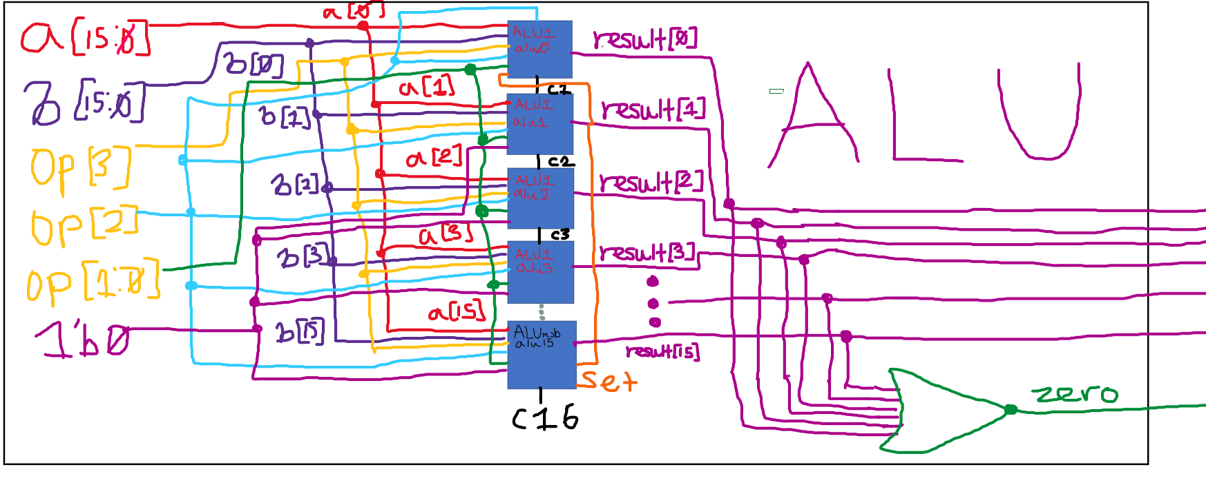
CPU
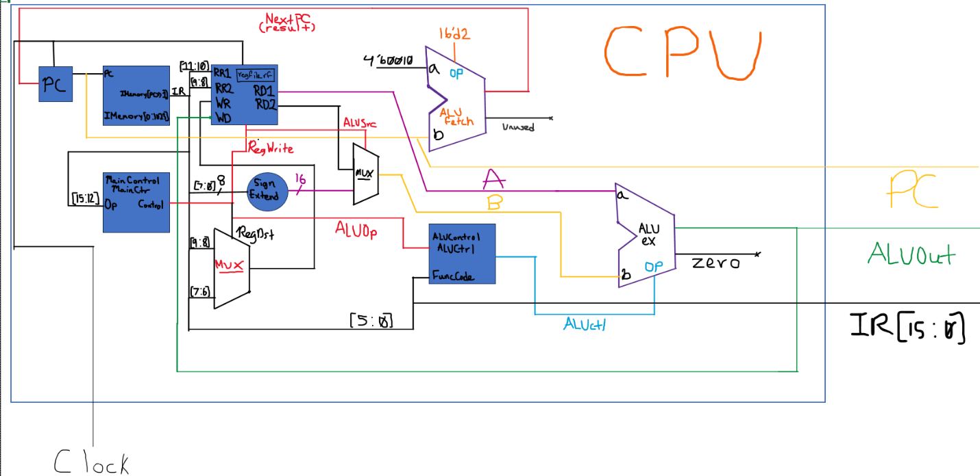
MIPS assembly code (.asm, no pseudo instructions):
#Corresponds to the Verilog code for the test module, albeit in 32 bits since MIPS is 32 bits, not 16 bits.
.data
newline: .asciiz "\n"
.text
.globl main

main: # Machine Code
#15 and 7 are loaded into $t1 and $t2 respectively.
addi $t1, $zero, 15 # I-type, 00100000000010010000000000001111
addi $t2, $zero, 7 # I-type, 00100000000010100000000000000111
and $t3, $t1, $t2 # R-type, 00000001001010100101100000100100

#Print result to console.
addi $v0, $zero, 1 # I-type, 00100000000000100000000000000001
add $a0, $t3, $zero # R-type, 00000001011000000010000000100000
syscall

#Prints a new line
addi $v0, $zero, 4 # I-type, 00100000000000100000000000000100
lui $a0, 0x1001 # I-type, 00111100000001000001000000000001
ori $a0, $a0, 0x0000 # I-type, 00110100100001000000000000000000
syscall

#Subtracts the value from $t1 by $t3 and stored in $t2
sub $t2, $t1, $t3 # R-type, 00000001001010110101000000100010
addi $v0, $zero, 1 # R-type, 00100000000000100000000000000001
add $a0, $t2, $zero # R-type, 00000001010000000010000000100000
syscall

#Prints a new line
addi $v0, $zero, 4 # I-type, 00100000000000100000000000000100
lui $a0, 0x1001 # I-type, 00111100000001000001000000000001
ori $a0, $a0, 0x0000 # I-type, 00110100100001000000000000000000
syscall

#Or’s the values in $t2 with $t3, stored in $t2.
or $t2, $t2, $t3 # R-type, 00000001010010110101000000100101
addi $v0, $zero, 1 # I-type, 00100000000000100000000000000001
add $a0, $t2, $zero # R-type, 00000001010000000010000000100000
syscall

#Prints a new line
addi $v0, $zero, 4 # I-type, 00100000000000100000000000000100
lui $a0, 0x1001 # I-type, 00111100000001000001000000000001
ori $a0, $a0, 0x0000 # I-type, 00110100100001000000000000000000
syscall

#Adds the value in $t2 with the value in $t3
add $t3, $t2, $t3 # R-type, 0000001010010110101100000100000
addi $v0, $zero, 1 # I-type, 00100000000000100000000000000001
add $a0, $t3, $zero # R-type, 000000001011000000010000000100000
syscall

#Prints a new line
addi $v0, $zero, 4 # I-type, 00100000000000100000000000000100
lui $a0, 0x1001 # I-type, 00111100000001000001000000000001
ori $a0, $a0, 0x0000 # I-type, 00110100100001000000000000000000
syscall

#Nors the value in $t2 with the value in $t3.
nor $t1, $t2, $t3 # R-type, 00000001010010110100100000100111
addi $v0, $zero, 1 # I-type, 00100000000000100000000000000001
add $a0, $t1, $zero # R-type, 00000001001000000010000000100000
syscall

#Prints a new line
addi $v0, $zero, 4 # I-type, 00100000000000100000000000000100
lui $a0, 0x1001 # I-type, 00111100000001000001000000000001
ori $a0, $a0, 0x0000 # I-type, 00110100100001000000000000000000
syscall

#If $t3 is less than $t2, $t1 will be set to 1.
slt $t1, $t3, $t2 # R-type, 00000001011010100100100000101010
addi $v0, $zero, 1 # I-type, 00100000000000100000000000000001
add $a0, $t1, $zero # R-type, 00000001001000000010000000100000
syscall

#Prints a new line
addi $v0, $zero, 4 # I-type, 00100000000000100000000000000100
lui $a0, 0x1001 # I-type, 00111100000001000001000000000001
ori $a0, $a0, 0x0000 # I-type, 00110100100001000000000000000000
syscall

#If $t2 is less than $t3, $t1 will be set to 1.
slt $t1, $t2, $t3 # R-type, 00000001010010110100100000101010

#Print result to console.
addi $v0, $zero, 1 # I-type, 00100000000000100000000000000001
add $a0, $t1, $zero # R-type, 00000001001000000010000000100000
syscall

#Prints a new line
addi $v0, $zero, 4 # I-type, 00100000000000100000000000000100
lui $a0, 0x1001 # I-type, 00111100000001000001000000000001
ori $a0, $a0, 0x0000 # I-type, 00110100100001000000000000000000
syscall

# NAND Implementation, since NAND is not a native MIPS instruction.
and $t1, $t2, $t3 # R-type, 00000001010010110100100000100100
nor $t1, $t1, $zero # R-type, 00000001001000000100100000100111

#Prints final NAND result into address line.
addi $v0, $zero, 1 # I-type, 00100000000000100000000000000001
add $a0, $t1, $zero # R-type, 00000001001000000010000000100000
syscall

# Exit Program
addi $v0, $zero, 10 # I-type, 00100000000000100000000000001010
syscall

Complete CPU Code (.v extension):
//Names: Aiden Ocasio, Jacob Rulka, and Jhan Gomez
//Instructor: Professor Markov
//Course: CS-385-01
//Date: 03/10/26
//Purpose: To show a simplified 16-bit MIPS single cycle machine that can execute R-type instructions and I-type instructions using a mix of behavioral and gate-level modeling.

// Behavioral implementation of MIPS Register File
module reg_file (RR1,RR2,WR,WD,RegWrite,RD1,RD2,clock);
input [1:0] RR1,RR2,WR; //Instead of 5 bits for rs, rt, and rd, it is only two bits.
input [15:0] WD; //16 bits for complete instruction rather than the traditional 32 bits.
input RegWrite,clock;
output [15:0] RD1,RD2; //The read data ports of the reg file are likewise only 16 bits.

reg [15:0] Regs[0:3]; //4 registers, 16 bits long.

assign RD1 = Regs[RR1]; //RS is assigned to read data port 1.
assign RD2 = Regs[RR2]; //RT is assigned to read data port 2.

initial Regs[0] = 0; //$zeri must always be 0.

always @(negedge clock)
if (RegWrite==1 & WR!=0) //Prevents $zero from being overwritten and make sure only when asserted that Write Register is allowed.
Regs[WR] <= WD;

endmodule

//ALU1 module is used for bits 0 to 14 but excludes the msb which needs a special set flag.
module ALU1 (a,b,ainvert,binvert,op,less,carryin,carryout,result);

input a,b,less,carryin,ainvert,binvert;
input [1:0] op;
output carryout,result;

wire nota,notb;
wire a1,b1;
wire and_out,or_out;
wire sum;
wire axb,ab,axb_cin;

// Inverters
not (nota,a);
not (notb,b);

// Input select
wire na_inv,nb_inv;
not (na_inv,ainvert);
not (nb_inv,binvert);

wire a_sel0,a_sel1,b_sel0,b_sel1;

and (a_sel0,a,na_inv);
and (a_sel1,nota,ainvert);
or (a1,a_sel0,a_sel1);

and (b_sel0,b,nb_inv);
and (b_sel1,notb,binvert);
or (b1,b_sel0,b_sel1);

// AND / OR
and (and_out,a1,b1);
or (or_out,a1,b1);

// Full Adder
xor (axb,a1,b1);
xor (sum,axb,carryin);

and (ab,a1,b1);
and (axb_cin,axb,carryin);
or (carryout,ab,axb_cin);

// Operation select
wire op0n,op1n;
not (op0n,op[0]);
not (op1n,op[1]);

wire r0,r1,r2,r3;
//And gates determine what operation should be output based on opcodes.
and (r0,and_out,op1n,op0n);
and (r1,or_out,op1n,op[0]);
and (r2,sum,op[1],op0n);
and (r3,less,op[1],op[0]);
//Or gates appropriately select the and wire that is high.
or (result,r0,r1,r2,r3);

endmodule

// 1-bit MSB ALU (bit 15)
module ALUmsb (a,b,ainvert,binvert,op,less,carryin,carryout,result,set);

input a,b,less,carryin,ainvert,binvert;
input [1:0] op;
output carryout,result,set;

wire nota,notb;
wire a1,b1;
wire and_out,or_out;
wire sum;
wire axb,ab,axb_cin;

// Inverters
not (nota,a);
not (notb,b);

// Input select
wire na_inv,nb_inv;
not (na_inv,ainvert);
not (nb_inv,binvert);

wire a_sel0,a_sel1,b_sel0,b_sel1;

and (a_sel0,a,na_inv);
and (a_sel1,nota,ainvert);
or (a1,a_sel0,a_sel1);

and (b_sel0,b,nb_inv);
and (b_sel1,notb,binvert);
or (b1,b_sel0,b_sel1);

// AND / OR
and (and_out,a1,b1);
or (or_out,a1,b1);

// Full Adder
xor (axb,a1,b1);
xor (sum,axb,carryin);

and (ab,a1,b1);
and (axb_cin,axb,carryin);
or (carryout,ab,axb_cin);

buf (set,sum); // SLT set output is just the sum output of the MSB ALU

// Operation select
wire op0n,op1n;
not (op0n,op[0]);
not (op1n,op[1]);

wire r0,r1,r2,r3;
//And gates determine what operation should be outputted based on opcodes.
and (r0,and_out,op1n,op0n);
and (r1,or_out,op1n,op[0]);
and (r2,sum,op[1],op0n);
and (r3,less,op[1],op[0]);
//Or gates appropriately select the and wire that is high.
or (result,r0,r1,r2,r3);

endmodule

// 16-bit ALU
module ALU (op,a,b,result,zero);

input [15:0] a;
input [15:0] b;
input [3:0] op;
output [15:0] result;
output zero;

wire c1,c2,c3,c4,c5,c6,c7,c8;
wire c9,c10,c11,c12,c13,c14,c15,c16;
wire set;

// Bit 0
ALU1 alu0 (a[0],b[0],op[3],op[2],op[1:0],set,op[2],c1,result[0]);

// Bits 1-14
ALU1 alu1 (a[1],b[1],op[3],op[2],op[1:0],1'b0,c1,c2,result[1]);
ALU1 alu2 (a[2],b[2],op[3],op[2],op[1:0],1'b0,c2,c3,result[2]);
ALU1 alu3 (a[3],b[3],op[3],op[2],op[1:0],1'b0,c3,c4,result[3]);
ALU1 alu4 (a[4],b[4],op[3],op[2],op[1:0],1'b0,c4,c5,result[4]);
ALU1 alu5 (a[5],b[5],op[3],op[2],op[1:0],1'b0,c5,c6,result[5]);
ALU1 alu6 (a[6],b[6],op[3],op[2],op[1:0],1'b0,c6,c7,result[6]);
ALU1 alu7 (a[7],b[7],op[3],op[2],op[1:0],1'b0,c7,c8,result[7]);
ALU1 alu8 (a[8],b[8],op[3],op[2],op[1:0],1'b0,c8,c9,result[8]);
ALU1 alu9 (a[9],b[9],op[3],op[2],op[1:0],1'b0,c9,c10,result[9]);
ALU1 alu10 (a[10],b[10],op[3],op[2],op[1:0],1'b0,c10,c11,result[10]);
ALU1 alu11 (a[11],b[11],op[3],op[2],op[1:0],1'b0,c11,c12,result[11]);
ALU1 alu12 (a[12],b[12],op[3],op[2],op[1:0],1'b0,c12,c13,result[12]);
ALU1 alu13 (a[13],b[13],op[3],op[2],op[1:0],1'b0,c13,c14,result[13]);
ALU1 alu14 (a[14],b[14],op[3],op[2],op[1:0],1'b0,c14,c15,result[14]);

//MSB ALU for bit 15 includes special set output for ALU0
ALUmsb alu15 (a[15],b[15],op[3],op[2],op[1:0],1'b0,c15,c16,result[15],set);

// Zero flag, later needed for beq and bne.
nor (zero,
result[0],result[1],result[2],result[3],
result[4],result[5],result[6],result[7],
result[8],result[9],result[10],result[11],
result[12],result[13],result[14],result[15]);

endmodule
//Main control determines if R-type instruction or I-type instruction and sends the coressponding bit [From MSB to LSB] to RegDst,ALUSrc,RegWrite,and ALUOp
module MainControl (Op,Control);
input [3:0] Op;
output reg [3:0] Control;
// Control bits: RegDst,ALUSrc,RegWrite,ALUOp
always @(Op) case (Op)
4'b0000: Control <= 4'b1011; // Rtype
4'b1000: Control <= 4'b0110; // ADDI
endcase
endmodule
//ALUControl chooses the appropriate operation. Note add and addi have the same func code.
module ALUControl (ALUOp,FuncCode,ALUCtl);
input ALUOp;
input [5:0] FuncCode;
output reg [3:0] ALUCtl;
always @(ALUOp,FuncCode) case (ALUOp)
1'b0: ALUCtl <= 4'b0010; // add
1'b1: case (FuncCode)
32: ALUCtl <= 4'b0010; // addi //This is addi, which has the same func code as add yet a different ALUOp.
34: ALUCtl <= 4'b0110; // sub
36: ALUCtl <= 4'b0000; // and
37: ALUCtl <= 4'b0001; // or
38: ALUCtl <= 4'b1101; // nand
39: ALUCtl <= 4'b1100; // nor
42: ALUCtl <= 4'b0111; // slt
endcase
endcase
endmodule

module CPU (clock,PC,ALUOut,IR);
input clock;
output [15:0] ALUOut,IR,PC;
reg[15:0] PC;
reg[15:0] IMemory[0:1023]; //Maximum of 1024, 16 bit instruction memory addresses.
wire [15:0] IR,NextPC,A,B,ALUOut,RD2,SignExtend;
wire[3:0] ALUctl;
wire [1:0] WR;
// Test Program
initial begin
//9 Instructions that display full instruction set architecture are accomplished here.
IMemory[0] = 16'h810f; // addi $t1, $0, 15 ($t1=15)
IMemory[1] = 16'h8207; // addi $t2, $0, 7 ($t2=7)
IMemory[2] = 16'h06e4; // and $t3, $t1, $t2 ($t3=7)
IMemory[3] = 16'h07a2; // sub $t2, $t1, $t3 ($t2=8)
IMemory[4] = 16'h0ba5; // or $t2, $t2, $t3 ($t2=15)
IMemory[5] = 16'h0be0; // add $t3, $t2, $t3 ($t3=22)
IMemory[6] = 16'h0b67; // nor $t1, $t2, $t3 ($t1=-32)
IMemory[7] = 16'h0e6a; // slt $t1, $t3, $t2 ($t1=0)
IMemory[8] = 16'h0b6a; // slt $t1, $t2, $t3 ($t1=1)
IMemory[9] = 16'h0b66; // nand $t1, $t2, $t3 ($t1=1)
end
initial PC = 0;
assign IR = IMemory[PC>>1];
assign WR = (RegDst) ? IR[7:6]: IR[9:8]; // RegDst Mux
assign B = (ALUSrc) ? SignExtend: RD2; // ALUSrc Mux
assign SignExtend = {{8{IR[7]}},IR[7:0]}; // sign extension unit
//assign ALUctl = (ALUOp == 1'b0) ? 4'b0010 : IR[3:0]; // assign bit values to ALUctl
reg_file rf (IR[11:10],IR[9:8],WR,ALUOut,RegWrite,A,RD2,clock);
ALU fetch (4'b0010,PC,16'd2,NextPC,Unused); //Instructions fetched using the program counter incremented by 2 for the next instruction.
ALU ex (ALUctl, A, B, ALUOut, Zero); //Fetched instruction is executed either using R-Type or I-Type instruction format.
MainControl MainCtr (IR[15:12],{RegDst,ALUSrc,RegWrite,ALUOp});
ALUControl ALUCtrl(ALUOp, IR[5:0], ALUctl); // ALU control unit
always @(negedge clock) begin
PC <= NextPC;
end
endmodule

// Test module
module test ();
reg clock;
wire signed [15:0] WD,IR,PC;
CPU test_cpu(clock,PC,WD,IR);
always #1 clock = ~clock;
initial begin
$display ("Clock PC IR WD");
$monitor ("%b %2d %b %3d (%b)",clock,PC,IR,WD,WD);
clock = 1;
#18 $finish; //Changed from 16 to 18 to allow IMemory[9] to be executed.
end
endmodule

RESULT (Assembly Source Code):
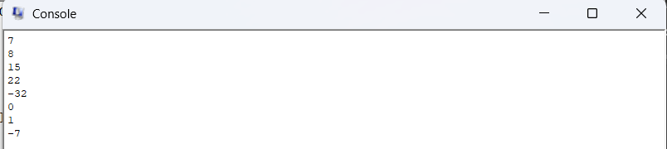
RESULT (Verilog Code):
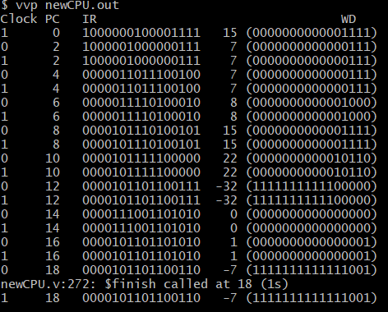

EXPLANATION:
This project saw the three group members conceptualize, design, create, and refine the simplified MIPS single cycle data path that can execute R-type (Register, ADD, AND, SUB, NAND, OR, NOR, & SLT) instructions and I-type (Immediate, ADDI) instructions. Unlike a complete (albeit simplified) implementation of the single cycle data path, our implementation does not support the J-type (Jump) instruction, and it does not support the I-type instructions lw (load word) or sw (store word) instructions ,which uses data memory (not implemented in this CPU). The program does not support the I-type beq (branch if equal) and bne (branch if not equal) instructions either, which use a branch control unit to handle both when the branch conditions are met (not implemented in this CPU). As a result, this CPU, while being easy to implement, relatively speaking, is not practical or suitable for certain programs, as there is no way to branch, load data memory, store from data memory, or jump to a memory label, rendering complex programs that require these operations impossible to accomplish. To allow this simplified single cycle MIPS processor to work correctly, several different modules are used sequentially during the falling edge of the clock pulses.
There are four key stages in our program that allow this implementation to operate as intended:
- Instruction Fetch: Using the program counter (PC) the current instruction is fetched from the instruction memory vector (IMemory[0] through IMemory[9]), after which the program counter is incremented by 2 using ALU fetch (which computes PC + 2) to prepare for the next instruction.
- Instruction Decode: Bits [15:12] of the instruction register (IR) are sent to the main control unit, which is decoded into the appropriate bits for RegDst, ALUSrc, RegWrite, and ALUOp. The register file simultaneousy receives the IR bits [11:10] for Read Register 1 (RR1), and IR bits [9:8] for Read Register 2 (RR2). IR[7:0] is also sign extended from 8 to 16 bits to properly match the formatting of the data, while ALUControl takes ALUOp from the main control unit along with IR bits [5:0] (the function code) to determine the operation for the ALU ex module (Outputted through a wire called ALUctl).
- Instruction Execute: Read data 1 (RD1), is sent as A to ALU ex. For immediate values, the sign extended 16 bits are sent to the mux that is placed before the ALU ex module, where it is then selected as B. For register values, Read Data 2 (RD2) is sent to the mux and is then selected as B. The control line comes from the ALUSrc wire which will determine what will be output as B. Using A, B, and ALUctl, the ALU ex module chooses the appropriate operation to perform on the instruction. Zero is also calculated using the results array.
- Write Back: The result is written back to the register file’s Write Data (WD) port. Using a mux that accepts IR[9:8] and IR[7:6], the program determines if the instruction is an R-type or I-type instruction. If the instruction is of the R-type, then the write register (WR) is set to be the destination register (rd). Otherwise, if the instruction is an I-type instruction, the write register (WR) is set to be the target register (rt). This is selected using a control line, the RegDst wire, from the MainControl module.
All these stages occur simultaneously on the negative edge of the clock, as this is a single cycle implementation. An issue with this approach is that it will be limited by the slowest instruction, which will become apparent in project two when load word and store word are introduced since they take use all four stages, and an additional memory access stage. This is because the complete MIPS single cycle machine has five stages rather than four stages, which are: instruction fetch, instruction decode, instruction execute, data memory access, and write back. The results of the test bench are in line with the expectations we had for the project, and no significant issues have been found in the Verilog implementation. Finally, it is important to note that for the assembly source code, NAND is not a native MIPS instruction and thus had to be implemented using a combination of NOR & AND instructions, as well as the fact lui, ori, and a data memory element (to print a new line) had to be used to demonstrate the program was working, but can be removed to maintain strict adherence to the Verilog program.

