Names: Aiden Ocasio, Jacob Rulka, Jhan Gomez
Instructor: Professor Markov
Course: CS-385
Section: 01
Date: 05/07/26

Final Progress Report – Complete Five Stage Pipelined MIPS 16-bit Datapath
Contribution of Team Members
Aiden: Created, designed, and implemented the logic diagram for the complete 5 stage pipelined data path. Aided in the attempt to recreate the forwarding unit from progress report three and helped the other group members dissect a race condition with the jump instruction which prevented the program counter from properly displaying the correct value when executed.

Jacob: Created and implemented the logic for the extra credit, made modifications to the register file to allow less nops to work, and wrote extra credit section explaining why these modifications allowed the CPU to use less nops then with the previous negedge design. Debugged the program to allow this reduction of no operations through trial and error until results were satisfactory and communicated findings to other group members.

Jhan: Brought over work from previous progress report, including several diagrams that were not modified or changed. Made the main control unit table, with the new control signals, the new Instruction Set Architecture table, added the jump instruction to the CPU, and ensured functionality. Tested the results for accuracy, wrote main explanation, and helped with the extra credit testing and debugging. Compiled all the group members works into singular report and ensured accuracy through different sandbox environments for the progress report.

TABLES
Branch Control Unit Truth Table
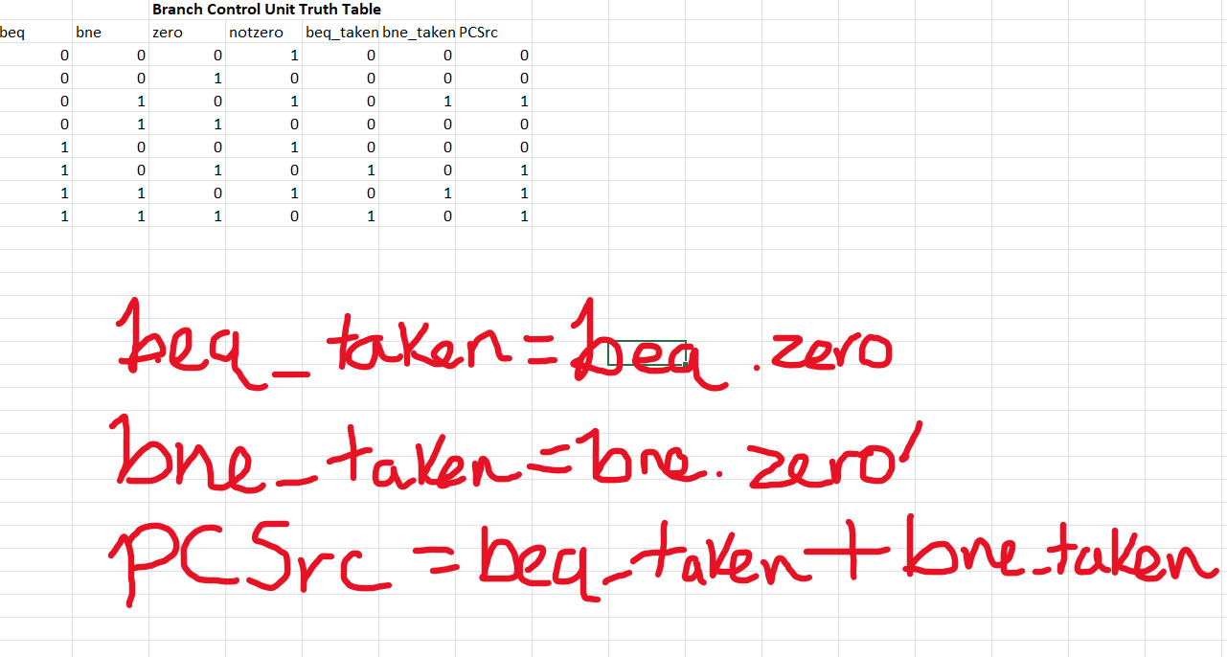

Main Control Unit Truth Table
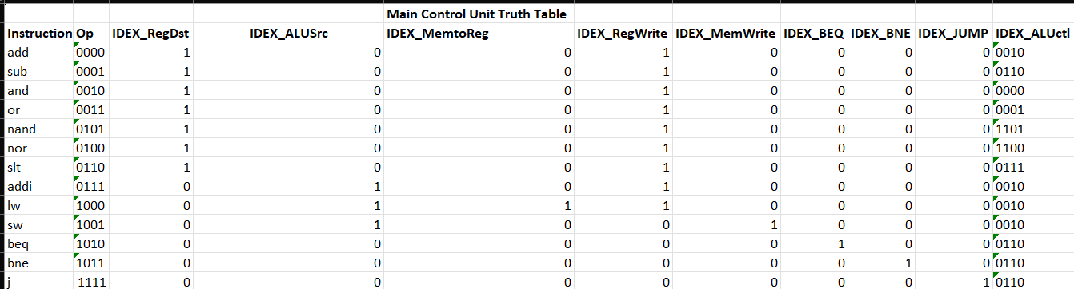
Instruction Set and Format Table (With Explanations)
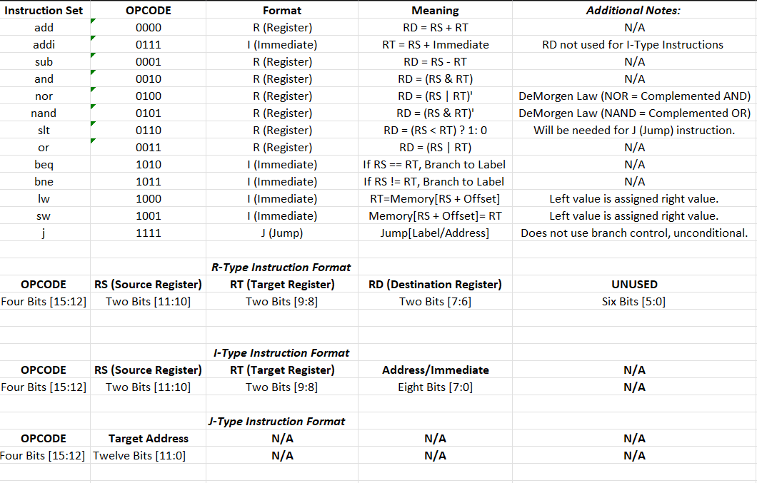
DIAGRAMS
Branch Control Unit
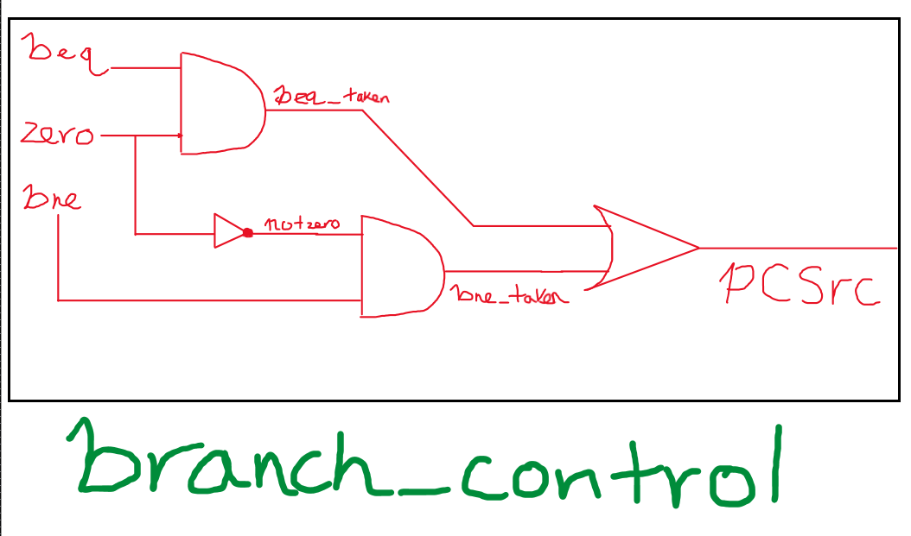

ALU1
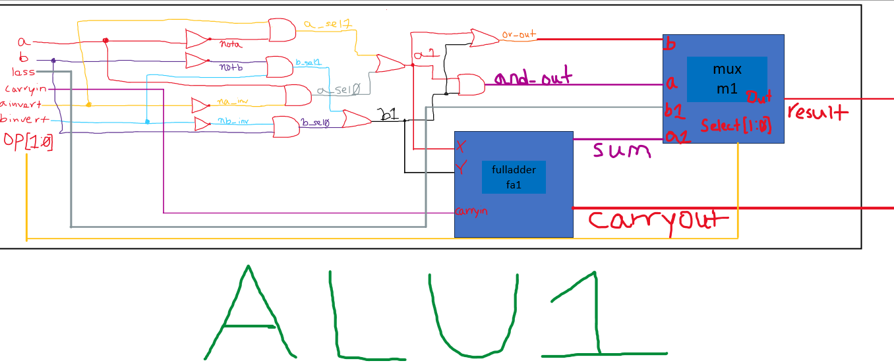

ALUmsb
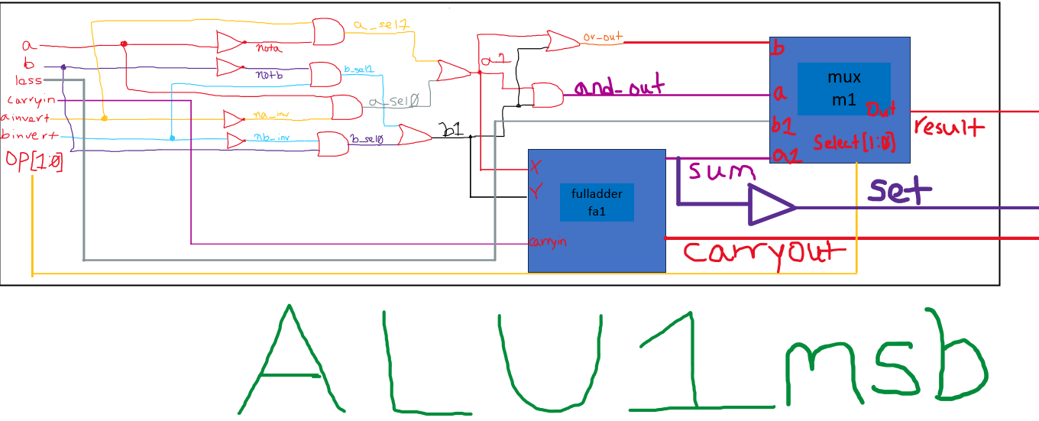

ALU
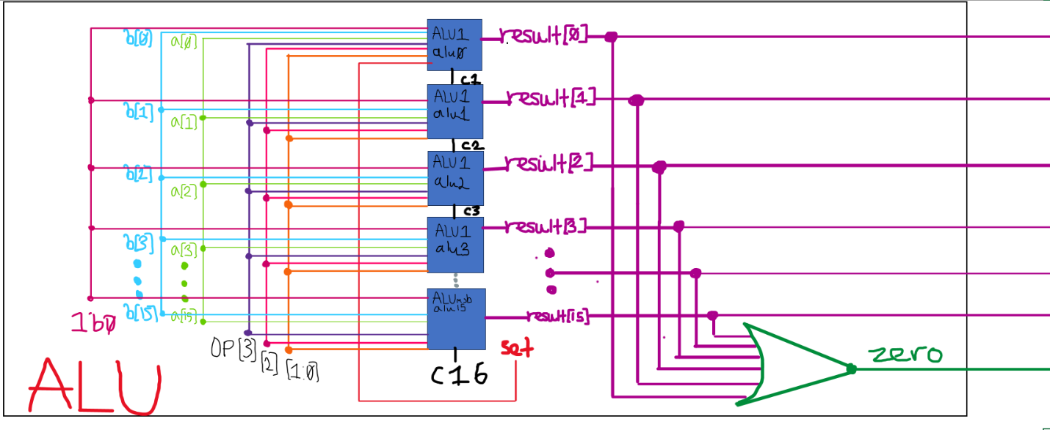

CPU (IF/ID Stage)
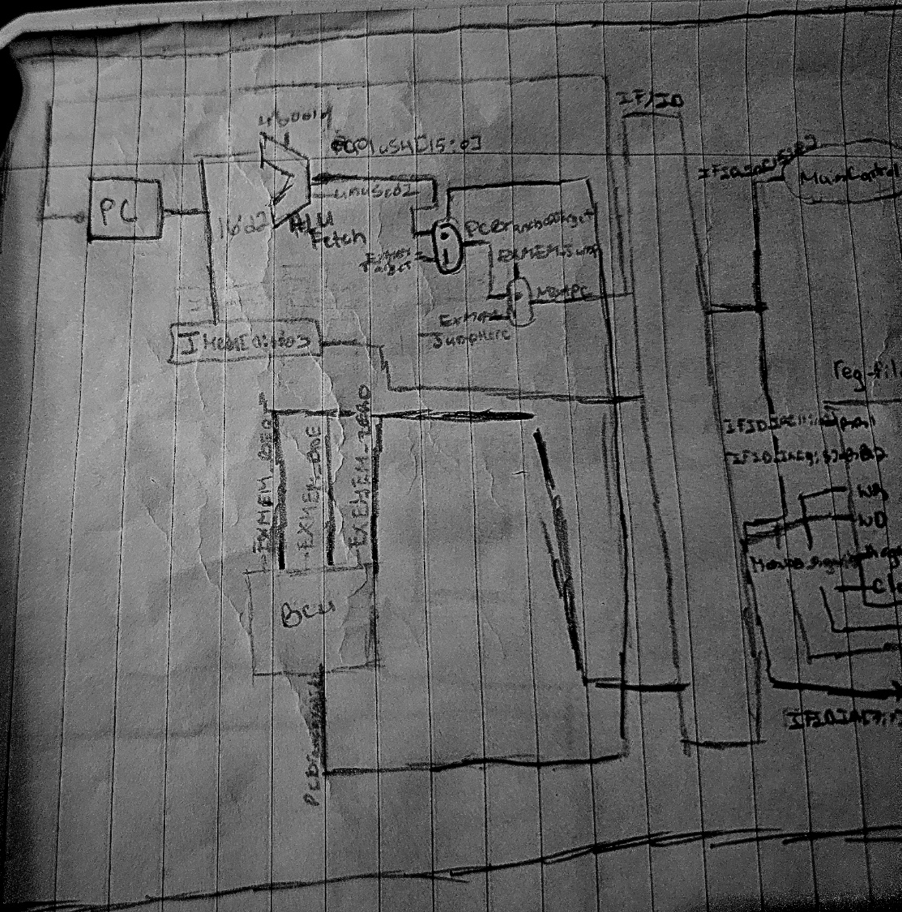

CPU (Complete Version)
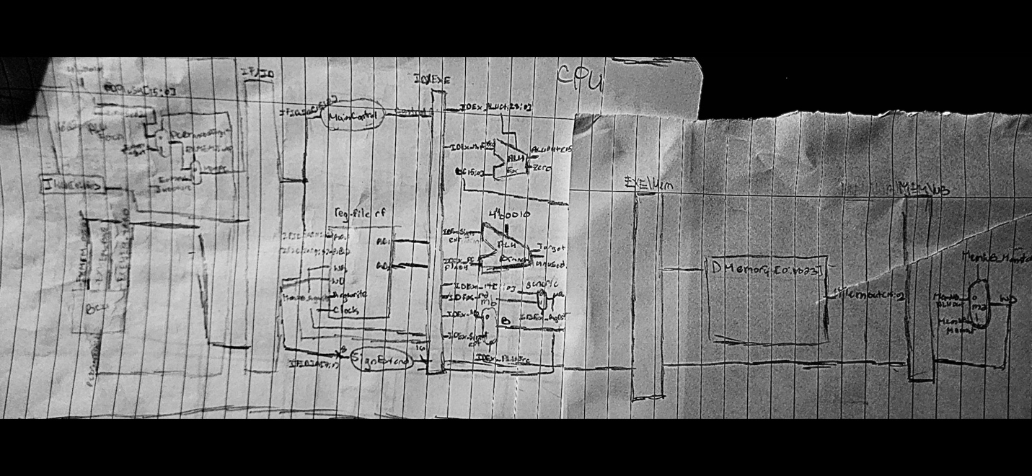

Complete CPU Code (Default, Result 1 Configuration, .v extension):
// Names: Aiden Ocasio, Jacob Rulka, and Jhan Gomez
// Instructor: Professor Markov
// Course: CS-385-01
// Date: 05/07/26
// Purpose: To demonstrate how the final, 5 stage pipelined CPU in MIPS would perform.
module reg_file (RR1,RR2,WR,WD,RegWrite,RD1,RD2,clock);
input [1:0] RR1,RR2,WR; //Instead of 5 bits for rs, rt, and rd, it is only two bits.
input [15:0] WD; //16 bits for complete instruction rather than the traditional 32 bits.
input RegWrite,clock;
output [15:0] RD1,RD2; //The read data ports of the reg file are likewise only 16 bits.
reg [15:0] Regs[0:3]; //4 registers, 16 bits long.
assign RD1 = Regs[RR1]; //RS is assigned to read data port 1.
assign RD2 = Regs[RR2]; //RT is assigned to read data port 2.
initial Regs[0] = 0; //$zero must always be 0.
always @(posedge clock) //Jacob, changed to posedge, explained why in report! Only two nops needed.
if (RegWrite==1 & WR!=0) //Prevents $zero from being overwritten and make sure only when asserted that Write Register is allowed.
Regs[WR] <= WD;
endmodule
//Branch control determines if the branch should be taken based on the opcode and the zero flag from the ALU.
module branch_control (beq, bne, zero, PCSrc);
input beq, bne, zero;
output PCSrc;
wire notzero;
not (notzero, zero);
wire beq_taken, bne_taken;
and (beq_taken, beq, zero);
and (bne_taken, bne, notzero);
or (PCSrc, beq_taken, bne_taken);
endmodule
// MUXES
//4x1 Multiplexer, used by the ALU to choose whether it is an and, or, add, less operation.
module mux(a, b, a1, b1, select, out);
input a, b, a1, b1;
input [1:0] select;
output out;

wire notS0, notS1;
not (notS0,select[0]);
not (notS1,select[1]);

wire r0,r1,r2,r3;

and (r0,a,notS1,notS0);
and (r1,b,notS1,select[0]);
and (r2,a1,select[1],notS0);
and (r3,b1,select[1],select[0]);

or (out,r0,r1,r2,r3);
endmodule

//This mux is generic, and is used as a building block for the ALU
module mux2x1(a, b, select, out);
input a, b, select;
output out;
wire notselect;
not (notselect, select);
and (a_out, a, notselect);
and (b_out, b, select);
or (out, a_out, b_out);
endmodule

//This mux is used to select the destination register.
module muxWR(a, b, select, out);
input [1:0] a, b;
input select;
output [1:0] out;
mux2x1 one(a[0], b[0], select, out[0]);
mux2x1 two(a[1], b[1], select, out[1]);
endmodule

//This mux is used for writing back, *some of the program counter, and to select between the value RD2 in the register file or the immediate field.
module muxB (a, b, select, out);
input [15:0] a, b;
input select;
output [15:0] out;

//16 muxes for the respective 16 bits of RD2 and SignExtend
mux2x1 mux1 (a[0], b[0], select, out[0]);
mux2x1 mux2 (a[1], b[1], select, out[1]);
mux2x1 mux3 (a[2], b[2], select, out[2]);
mux2x1 mux4 (a[3], b[3], select, out[3]);
mux2x1 mux5 (a[4], b[4], select, out[4]);
mux2x1 mux6 (a[5], b[5], select, out[5]);
mux2x1 mux7 (a[6], b[6], select, out[6]);
mux2x1 mux8 (a[7], b[7], select, out[7]);
mux2x1 mux9 (a[8], b[8], select, out[8]);
mux2x1 mux10 (a[9], b[9], select, out[9]);
mux2x1 mux11 (a[10], b[10], select, out[10]);
mux2x1 mux12 (a[11], b[11], select, out[11]);
mux2x1 mux13 (a[12], b[12], select, out[12]);
mux2x1 mux14 (a[13], b[13], select, out[13]);
mux2x1 mux15 (a[14], b[14], select, out[14]);
mux2x1 mux16 (a[15], b[15], select, out[15]);
endmodule

//Fulladder is used to handle ALU arithmetic operations.
module fulladder(x, y, sum, carryin, carryout);
input x, y, carryin;
output sum, carryout;
wire xysum, ab, axb_cin;

xor (xysum,x,y);
xor (sum,xysum,carryin);

and (ab,x,y);
and (axb_cin,xysum,carryin);
or (carryout,ab,axb_cin);
endmodule
//1 bit ALU works on bits 0-14 and does operations accordingly.
module ALU1 (a,b,ainvert,binvert,op,less,carryin,carryout,result);
input a,b,less,carryin,ainvert,binvert;
input [1:0] op;
output carryout,result;
wire nota,notb,a1,b1,and_out,or_out,sum;

not (nota,a);
not (notb,b);

wire na_inv,nb_inv;
not (na_inv,ainvert);
not (nb_inv,binvert);

wire a_sel0,a_sel1,b_sel0,b_sel1;

and (a_sel0,a,na_inv);
and (a_sel1,nota,ainvert);
or (a1,a_sel0,a_sel1);

and (b_sel0,b,nb_inv);
and (b_sel1,notb,binvert);
or (b1,b_sel0,b_sel1);

and (and_out,a1,b1);
or (or_out,a1,b1);

fulladder fa1(a1, b1, sum, carryin, carryout);
mux m1(and_out, or_out, sum, less, op, result);
endmodule
//Does the same as above, but also has a set buffer to the slt flag.
module ALUmsb (a,b,ainvert,binvert,op,less,carryin,carryout,result,set);
input a,b,less,carryin,ainvert,binvert;
input [1:0] op;
output carryout,result,set;
wire nota,notb,a1,b1,and_out,or_out,sum;

not (nota,a);
not (notb,b);

wire na_inv,nb_inv;
not (na_inv,ainvert);
not (nb_inv,binvert);

wire a_sel0,a_sel1,b_sel0,b_sel1;

and (a_sel0,a,na_inv);
and (a_sel1,nota,ainvert);
or (a1,a_sel0,a_sel1);

and (b_sel0,b,nb_inv);
and (b_sel1,notb,binvert);
or (b1,b_sel0,b_sel1);

and (and_out,a1,b1);
or (or_out,a1,b1);

fulladder fa1(a1, b1, sum, carryin, carryout);
mux m1(and_out, or_out, sum, less, op, result);
buf (set,sum);
endmodule
//16 bit ALu, handles arithmetic and logic.
module ALU (op,a,b,result,zero);
input [15:0] a,b;
input [3:0] op;
output [15:0] result;
output zero;
wire c1,c2,c3,c4,c5,c6,c7,c8;
wire c9,c10,c11,c12,c13,c14,c15,c16;
wire set;
// Bit 0
ALU1 alu0 (a[0],b[0],op[3],op[2],op[1:0],set,op[2],c1,result[0]);

// Bits 1-14
ALU1 alu1 (a[1],b[1],op[3],op[2],op[1:0],1'b0,c1,c2,result[1]);
ALU1 alu2 (a[2],b[2],op[3],op[2],op[1:0],1'b0,c2,c3,result[2]);
ALU1 alu3 (a[3],b[3],op[3],op[2],op[1:0],1'b0,c3,c4,result[3]);
ALU1 alu4 (a[4],b[4],op[3],op[2],op[1:0],1'b0,c4,c5,result[4]);
ALU1 alu5 (a[5],b[5],op[3],op[2],op[1:0],1'b0,c5,c6,result[5]);
ALU1 alu6 (a[6],b[6],op[3],op[2],op[1:0],1'b0,c6,c7,result[6]);
ALU1 alu7 (a[7],b[7],op[3],op[2],op[1:0],1'b0,c7,c8,result[7]);
ALU1 alu8 (a[8],b[8],op[3],op[2],op[1:0],1'b0,c8,c9,result[8]);
ALU1 alu9 (a[9],b[9],op[3],op[2],op[1:0],1'b0,c9,c10,result[9]);
ALU1 alu10 (a[10],b[10],op[3],op[2],op[1:0],1'b0,c10,c11,result[10]);
ALU1 alu11 (a[11],b[11],op[3],op[2],op[1:0],1'b0,c11,c12,result[11]);
ALU1 alu12 (a[12],b[12],op[3],op[2],op[1:0],1'b0,c12,c13,result[12]);
ALU1 alu13 (a[13],b[13],op[3],op[2],op[1:0],1'b0,c13,c14,result[13]);
ALU1 alu14 (a[14],b[14],op[3],op[2],op[1:0],1'b0,c14,c15,result[14]);

//MSB ALU for bit 15 includes special set output for ALU0
ALUmsb alu15 (a[15],b[15],op[3],op[2],op[1:0],1'b0,c15,c16,result[15],set);

// Zero flag, later needed for beq and bne.
nor (zero,
result[0],result[1],result[2],result[3],
result[4],result[5],result[6],result[7],
result[8],result[9],result[10],result[11],
result[12],result[13],result[14],result[15]);
endmodule

//Main control determines if R-type instruction or I-type instruction and sends the corresponding bit to {IDEX_RegDst,IDEX_ALUSrc,IDEX_MemtoReg,IDEX_RegWrite,IDEX_MemWrite,IDEX_BEQ, IDEX_BNE, IDEX_JUMP, IDEX_ALUctl}
module MainControl (Op,Control);
input [3:0] Op;
output reg [11:0] Control; //Control is now 12 bits.
always @(Op) case (Op)
// R type Instructions:
4'b0000: Control <= 12'b10010_00_0_0010; // ADD
4'b0001: Control <= 12'b10010_00_0_0110; // SUB
4'b0010: Control <= 12'b10010_00_0_0000; // AND
4'b0011: Control <= 12'b10010_00_0_0001; // OR
4'b0101: Control <= 12'b10010_00_0_1101; // NAND
4'b0100: Control <= 12'b10010_00_0_1100; // NOR
4'b0110: Control <= 12'b10010_00_0_0111; // SLT
// I type Instructions:
4'b0111: Control <= 12'b01010_00_0_0010; // ADDI
4'b1000: Control <= 12'b01110_00_0_0010; // LW
4'b1001: Control <= 12'b01001_00_0_0010; // SW
4'b1010: Control <= 12'b00000_10_0_0110; // BEQ
4'b1011: Control <= 12'b00000_01_0_0110; // BNE
//J-type Instruction
4'b1111: Control <= 12'b00000_00_1_0110; // Jump
default: Control <= 12'b000000000000;
endcase
endmodule

module CPU (clock,PC,IFID_IR,IDEX_IR,EXMEM_IR,MEMWB_IR,WD);
input clock;
output [15:0] PC,IFID_IR,IDEX_IR,EXMEM_IR,MEMWB_IR,WD;

initial begin
// Program: swap memory cells (if needed) and compute absolute value |5-7|=2
IMemory[0] = 16'b1000_00_01_00000000; // lw $t1, 0($0)
IMemory[1] = 16'b1000_00_10_00000010; // lw $t2, 2($0)
IMemory[2] = 16'b0000000000000000; // nop
IMemory[3] = 16'b0000000000000000; // nop
IMemory[4] = 16'b0110_01_10_11000000; // slt $t3,$t1,$t2
IMemory[5] = 16'b0000000000000000; // nop
IMemory[6] = 16'b0000000000000000; // nop
IMemory[7] = 16'b1010_11_00_00000101; // beq $t3,$0,5 IMemory[12], //Correct if not taken.
// IMemory[7] = 16'b1011_11_00_00000101; //bne $t3, $0, 5 IMemory[12]. //Never correct, regardless of taken or not taken
// IMemory[7] = 16'b1111_00_00_00001100; // Jumps to instruction address 12, no swap. j IMemory[12]. never correct, regardless of DMemory.
// IMemory[7] = 16'b1111_00_00_00001010; // Jumps to instruction address 10, swap. j IMemory[10], corecct output if DMemory[0]=5, DMemory[1]=7
IMemory[8] = 16'b0000000000000000; // nop
IMemory[9] = 16'b0000000000000000; // nop
IMemory[10] = 16'b1001_00_01_00000010; // sw $t1, 2($0)
IMemory[11] = 16'b1001_00_10_00000000; // sw $t2, 0($0)
IMemory[12] = 16'b0000000000000000; // nop
IMemory[13] = 16'b0000000000000000; // nop
IMemory[14] = 16'b1000_00_01_00000000; // lw $t1, 0($0)
IMemory[15] = 16'b1000_00_10_00000010; // lw $t2, 2($0)
IMemory[16] = 16'b0000000000000000; // nop
IMemory[17] = 16'b0000000000000000; // nop
IMemory[18] = 16'b0100_10_10_10000000; // nor $t2,$t2,$t2
IMemory[19] = 16'b0000000000000000; // nop
IMemory[20] = 16'b0000000000000000; // nop
IMemory[21] = 16'b0111_10_10_00000001; // addi $t2,$t2,1
IMemory[22] = 16'b0000000000000000; // nop
IMemory[23] = 16'b0000000000000000; // nop
IMemory[24] = 16'b0000_01_10_11000000; // add $t3,$t1,$t2

// Data
DMemory[0] = 7; // switch the cells and see how the simulation output changes
DMemory[1] = 5; // (beq is taken if DMemory[0]=7; DMemory[1]=5, not taken otherwise)
end

// Pipeline
// IF
wire [15:0] PCplus4, NextPC, PCBranchOrTarget;
wire PCBranchValid;
reg[15:0] PC, IMemory[0:1023], IFID_IR, IFID_PCplus4;
ALU fetch (4'b0010,PC,16'd2,PCplus4,Unused1);
branch_control BCU(EXMEM_BEQ, EXMEM_BNE, EXMEM_Zero, PCBranchValid); //Branching
muxB branchOrTarget(PCplus4, EXMEM_Target, PCBranchValid, PCBranchOrTarget); //Branching or Target
muxB addr(PCBranchOrTarget, EXMEM_JumpHere, EXMEM_JUMP, NextPC); //NextPC chosen.
// ID
wire [11:0] Control;
reg IDEX_RegWrite,IDEX_MemtoReg,
IDEX_BEQ, IDEX_BNE, IDEX_JUMP, IDEX_MemWrite,
IDEX_ALUSrc, IDEX_RegDst;
reg [3:0] IDEX_ALUctl;
wire [15:0] RD1,RD2,SignExtend, WD;
reg [15:0] IDEX_PCplus4,IDEX_RD1,IDEX_RD2,IDEX_SignExt,IDEXE_IR;
reg [15:0] IDEX_IR; // For monitoring the pipeline
reg [1:0] IDEX_rt,IDEX_rd;
reg MEMWB_RegWrite; // part of MEM stage, but declared here before use (to avoid error)
reg [1:0] MEMWB_rd; // part of MEM stage, but declared here before use (to avoid error)
reg_file rf (IFID_IR[11:10],IFID_IR[9:8], MEMWB_rd,WD,MEMWB_RegWrite,RD1,RD2,clock);
MainControl MainCtr (IFID_IR[15:12],Control);
assign SignExtend = {{8{IFID_IR[7]}},IFID_IR[7:0]};
// EXE
reg EXMEM_RegWrite,EXMEM_MemtoReg,
EXMEM_BEQ, EXMEM_BNE, EXMEM_JUMP, EXMEM_MemWrite;
wire [15:0] Target;
reg EXMEM_Zero;
reg [15:0] EXMEM_Target,EXMEM_ALUOut,EXMEM_RD2;
reg [15:0] EXMEM_IR; // For monitoring the pipeline
reg [1:0] EXMEM_rd;
reg [15:0] EXMEM_JumpHere;
wire [15:0] B,ALUOut;
wire [1:0] WR;
ALU branch (4'b0010,IDEX_SignExt<<1,IDEX_PCplus4,Target,Unused2);
ALU ex (IDEX_ALUctl, IDEX_RD1, B, ALUOut, Zero);

muxB mb(IDEX_RD2, IDEX_SignExt, IDEX_ALUSrc, B);
muxWR generic(IDEX_rt, IDEX_rd, IDEX_RegDst, WR);
// MEM
reg MEMWB_MemtoReg;
reg [15:0] DMemory[0:1023],MEMWB_MemOut,MEMWB_ALUOut;
reg [15:0] MEMWB_IR; // For monitoring the pipeline
wire [15:0] MemOut;
assign MemOut = DMemory[EXMEM_ALUOut>>1];
always @(negedge clock)
if (EXMEM_MemWrite)
DMemory[EXMEM_ALUOut>>1] <= EXMEM_RD2;
// WB
muxB m2(MEMWB_ALUOut, MEMWB_MemOut,MEMWB_MemtoReg,WD);
initial begin
PC = 0;
// Initialize pipeline registers
IDEX_RegWrite=0;IDEX_MemtoReg=0;IDEX_BEQ=0;IDEX_BNE=0;IDEX_JUMP=0;IDEX_MemWrite=0;IDEX_ALUSrc=0;IDEX_RegDst=0;IDEX_ALUctl=0;
IFID_IR=0;
EXMEM_RegWrite=0;EXMEM_MemtoReg=0;EXMEM_BEQ=0;EXMEM_BNE=0;EXMEM_JUMP=0;EXMEM_Zero=0;EXMEM_MemWrite=0;
EXMEM_Target=0;
MEMWB_RegWrite=0;MEMWB_MemtoReg=0;
end
// Running the pipeline
always @(negedge clock) begin
// IF
PC <= NextPC;
IFID_PCplus4 <= PCplus4;
IFID_IR <= IMemory[PC>>1];
// ID
IDEX_IR <= IFID_IR; // For monitoring the pipeline
{IDEX_RegDst,IDEX_ALUSrc,IDEX_MemtoReg,IDEX_RegWrite,IDEX_MemWrite,IDEX_BEQ, IDEX_BNE, IDEX_JUMP, IDEX_ALUctl} <= Control;
IDEX_PCplus4 <= IFID_PCplus4;
IDEX_RD1 <= RD1;
IDEX_RD2 <= RD2;
IDEX_SignExt <= SignExtend;
IDEX_rt <= IFID_IR[9:8];
IDEX_rd <= IFID_IR[7:6];
// EXE
EXMEM_IR <= IDEX_IR; // For monitoring the pipeline
EXMEM_RegWrite <= IDEX_RegWrite;
EXMEM_MemtoReg <= IDEX_MemtoReg;
EXMEM_BEQ <= IDEX_BEQ;
EXMEM_JUMP <= IDEX_JUMP;
EXMEM_BNE <= IDEX_BNE;
EXMEM_MemWrite <= IDEX_MemWrite;
EXMEM_Target <= Target;
EXMEM_Zero <= Zero;
EXMEM_ALUOut <= ALUOut;
EXMEM_RD2 <= IDEX_RD2;
EXMEM_rd <= WR;
EXMEM_JumpHere <= {4'b0000, IDEX_IR[11:0]} << 1; //This was failing, for Jump to work, it has to be logically pipelined
//I thought it would work if it simply assigned, but then I recalled this was not the single cycle datapath anymore.
//It was driving me nuts for houyrs, but is simple. Since J uses absoulute address simply take the 12 bits of the address, pad with 0s to reach
//the required 16, and shift left by one to multiply by two to align it to the proper byte address, just like normal MIPS.
// MEM
MEMWB_IR <= EXMEM_IR; // For monitoring the pipeline
MEMWB_RegWrite <= EXMEM_RegWrite;
MEMWB_MemtoReg <= EXMEM_MemtoReg;
MEMWB_MemOut <= MemOut;
MEMWB_ALUOut <= EXMEM_ALUOut;
MEMWB_rd <= EXMEM_rd;
// WB
// Register write happens on neg edge of the clock (if MEMWB_RegWrite is asserted)
end
endmodule
// Test module
module test ();
reg clock;
wire signed [15:0] PC,IFID_IR,IDEX_IR,EXMEM_IR,MEMWB_IR,WD;
CPU test_cpu(clock,PC,IFID_IR,IDEX_IR,EXMEM_IR,MEMWB_IR,WD);
always #1 clock = ~clock;
initial begin
$display ("PC IFID_IR IDEX_IR EXMEM_IR MEMWB_IR WD");
$monitor ("%3d %h %h %h %h %2d",PC,IFID_IR,IDEX_IR,EXMEM_IR,MEMWB_IR,WD);
clock = 1;
#69 $finish;
end
endmodule

RESULTS
RESULT 1 and 2: IMemory [7] = 16'b1010_11_00_00000101; // beq $t3,$0, IMemory[12]
RESULT 1: DMemory[0] =7, DMemory[1] =5, BEQ = TRUE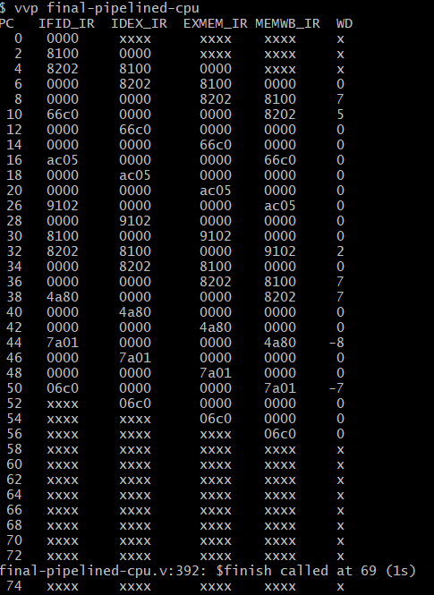

RESULT 2: DMemory[0] =5, DMemory[1]=7, BEQ = FALSE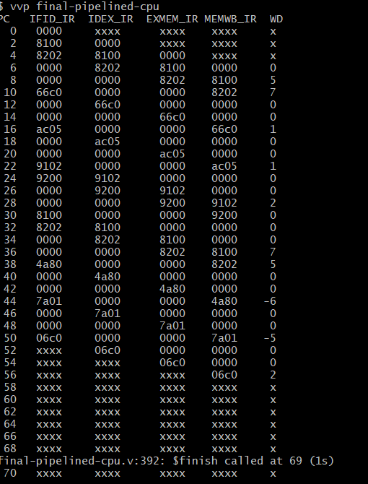

RESULT 3 and 4: IMemory[7] = 16'b1011_11_00_00000101; //bne $t3, $0, IMemory[12]
RESULT 3: DMemory[0] =5, DMemory[1] =7, BNE = TRUE
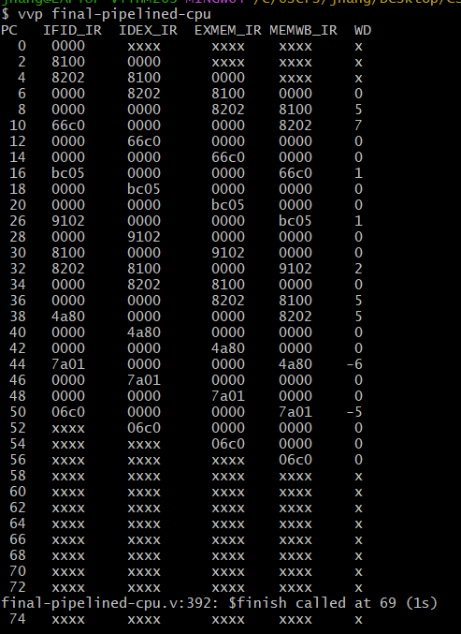

RESULT 4: DMemory[0] =7, DMemory[1]=5, BNE = FALSE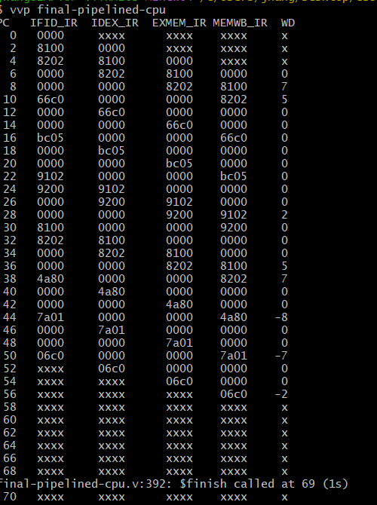

RESULT 5 and 6: IMemory[7] = 16'b1111_00_00_00001100; //j IMemory[12]
RESULT 5: DMemory[0] =5, DMemory[1]=7, Jump = True
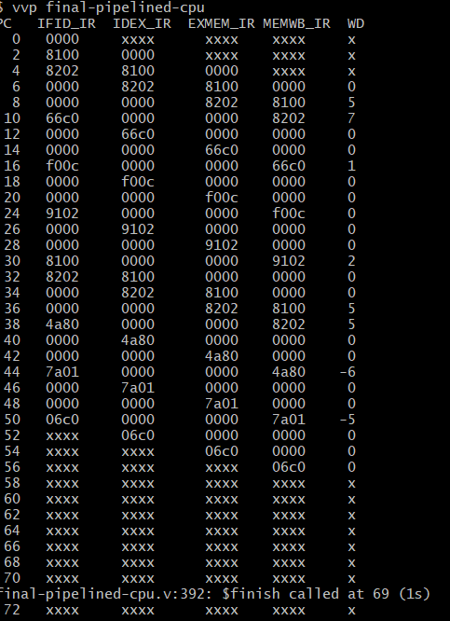

RESULT 6: DMemory[0] =7, DMemory[1]=5, Jump = True
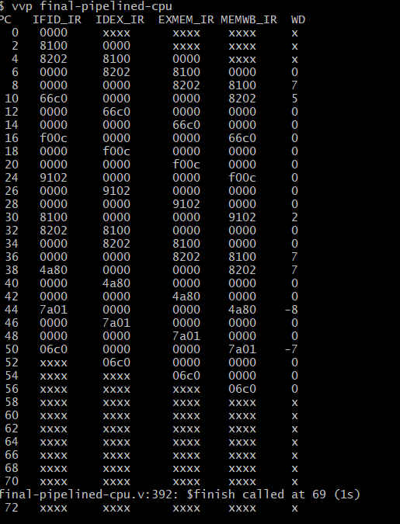

RESULT 7 and 8: IMemory[7] = 16'b1111_00_00_00001010; // j IMemory[10]
RESULT 7: DMemory[0] =5, DMemory[1]=7, Jump = True
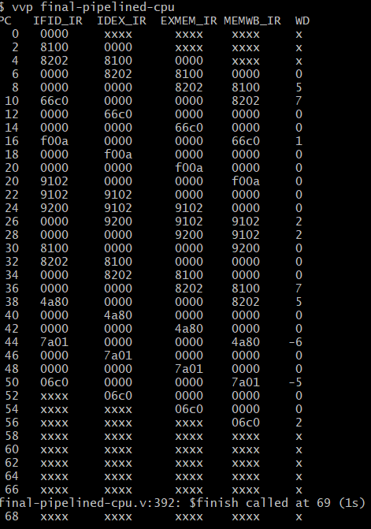

RESULT 8: DMemory[0] =7, DMemory[1]=5, Jump = True

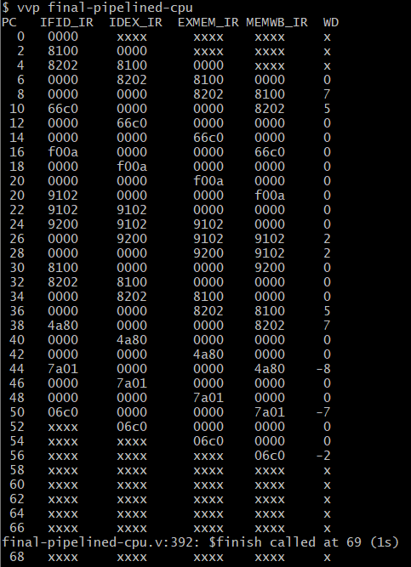

Main Explanation
The final version of the 16-bit Mini MIPS Machine features a complete five-stage pipelined implementation, along with several architectural enhancements, including the introduction of a jump instruction format and improvements that reduce the number of required no-operation (NOP) instructions. The reduction in NOP usage and the reasoning behind it will be discussed later. Before analyzing the jump instruction, however, it is important to first explain the modifications made to the previous CPU implementation. Unlike the earlier three-stage pipelined CPU, which relied exclusively on instructions independent of the data memory component, the final implementation reintroduces the Load Word (lw), Store Word (sw), Branch if Equal (BEQ), and Branch if Not Equal (BNE) instructions from the complete single-cycle datapath developed in Progress Report Two. As in the second iteration of the processor, branching functionality is handled through a dedicated branch control unit responsible for determining whether branch conditions are satisfied. While these instructions retain the same functionality as in the single-cycle implementation, they are now executed within the pipelined architecture. To support both the restored memory and branch instructions, as well as the newly introduced jump operation, several modules required modification to ensure proper operation. One of the most significant changes occurred within the Main Control Unit, which was expanded from seven control signals to twelve total signals: IDEX_RegDst, IDEX_ALUSrc, IDEX_MemtoReg, IDEX_RegWrite, IDEX_MemWrite, IDEX_BEQ, IDEX_BNE, IDEX_JUMP, and IDEX_ALUctl[3:0]. These additional signals provide support for branching, jumping, and data-memory-related control logic. The functionality is implemented through two additional multiplexer instantiations, muxB branchOrTarget() and muxB addr(). The first multiplexer uses the output of the branch control unit as its select signal to determine whether the processor should output the incremented program counter (PC + 1) or the branch target address generated by the BEQ or BNE instructions. The second multiplexer then processes the output of the first multiplexer and uses the EXMEM_JUMP signal as its select signal to determine whether the next PC value should correspond to the sequential instruction, a branch target, or the absolute address specified by the jump instruction. The jump instruction introduces a distinct J-type instruction format that differs from both R-type and I-type formats. Unlike those instruction types, the jump instruction does not require source, target, or destination registers, as it operates solely through control-flow logic. The jump target is encoded using a 12-bit address field, which is insufficient to represent the full 16-bit address space directly. To compensate, the address is concatenated with four leading zeros at the most significant bits and shifted left by one position. This shift operation is necessary because the least significant bit is always discarded during instruction alignment and must therefore be restored to correctly reach the intended target address. The results revealed that only two test cases successfully produced the intended output of |5 − 7| = 2. Specifically, the correct result was obtained when the BEQ instruction was not taken and when the jump instruction targeted the swap sequence while DMemory[0] = 5 and DMemory[1] = 7. In the BEQ case where the branch was taken, $t1 = 7$ and $t2 = -7$, resulting in the computation 7 + (−7) = 0 rather than the intended absolute value. Similarly, the BNE instruction produced incorrect behavior under both branch outcomes. When the branch was taken, the CPU produced $t1 = 5$ and $t2 = -5$, which again resulted in cancellation and an output of zero. When the branch was not taken, the NOR and ADDI operations transformed $t2 into −7 while $t1 remained 5, producing the computation 5 + (−7) = −2. This same incorrect results also occurred for the jump instruction that targeted the absolute address of IMemory[12], since the unconditional logic forced the CPU to always skip the swap making the result wrong. Due to this, the cases where the absolute value of |5-7|=2 was correctly calculated can only be seen in results 2 and 7.
Extra Credit Explanation
Why are 3 NOPs needed originally?
- In a 5-stage pipeline (IF, ID, EX, MEM, WB), a data hazard happens when an instruction is dependent on the result that is computed in the previous instruction but hasn’t been able to write it back yet. Due to both the register file WB stage and the ID stage being activated on the negedge, both happen on the same clock edge. The WB hasn’t been able to write the computation yet, and the ID stage read is already grabbing the value. This shows that the instruction is dependent on and must wait for an extra cycle meaning that there needs to be 3 NOPs to make sure that correct data is ready to be read.
Why does changing to posedge reduce it to 2 NOPs?
- When changing the register file writer to trigger on the posedge of the clock, the writing is done in the first half of the clock cycle. This is because the posedge happens first, and the read stage remains on the negedge and they can both occur in one clock cycle but at different instances. By the time that the ID stage reads the register file, which is on the negedge, the WB stage has already written the commutated answer on the posedge of the same cycle. You can essentially get one cycle of forwarding with this change, and it eliminates the need for the third NOP. Overall, this little change reduces the requirement of 3 NOPs to only need 2 NOPs. However, when this is done and tested, the third sequenced NOP for in the code can be commented out but in doing so the IMemory[ i ] has to be changed to not have any gaps and must be incremented by 1 for every step.

