SmartCare v0.3 - Domain Model Workbook
Week 6 student resource

Requirement-to-Concept Trace
Requirement | Concept | State/behaviour | Decision
FR-01 — Create and update patient record | Patient | Patient information is created and updated. | Keep
FR-02 — View patient information | Patient | Patient information can be viewed. | Keep
FR-03 — Search for a patient record | Patient | Patient records can be searched. | Keep
FR-04 — Create a practitioner record | Practitioner | Practitioner information is created. | Keep
FR-05 — View practitioner information | Practitioner | Practitioner information can be viewed. | Keep
FR-06 — Create an appointment for a patient with a practitioner | Appointment | Appointment stores the connection between a patient, practitioner and appointment time. | Keep
FR-07 — Practitioners view their scheduled appointments | Appointment / Practitioner | Practitioner can view appointments associated with them. | Keep
FR-08 — Change an appointment | Appointment | Appointment information can be changed. | Keep
FR-09 — Cancel an appointment | Appointment | Appointment can be cancelled. | Keep
FR-10 — Prevent two appointments for the same practitioner at the same time | Appointment | Appointments must be checked for conflicting practitioner/time combinations. | Keep

CRC Cards

Patient
Responsibilities
- Represent patient information.
- Support creation and updating of patient information.
- Support viewing patient information.
- Support identification/search of the patient record.
Collaborators
Appointment

Practitioner
Responsibilities
- Represent practitioner information.
- Support creation of practitioner information.
- Support viewing practitioner information.
- Support access to the practitioner's scheduled appointments.
Collaborators
Appointment

Appointment
Responsibilities
- Represent appointment information.
- Link a patient with a practitioner.
- Store the appointment time.
- Support creating an appointment.
- Support changing an appointment.
- Support cancelling an appointment.
- Support checking for conflicting appointments for the same practitioner.
Collaborators
Patient
Practitioner

UML Class Diagram
Insert/draw UML here. Include defensible relationships and multiplicities.
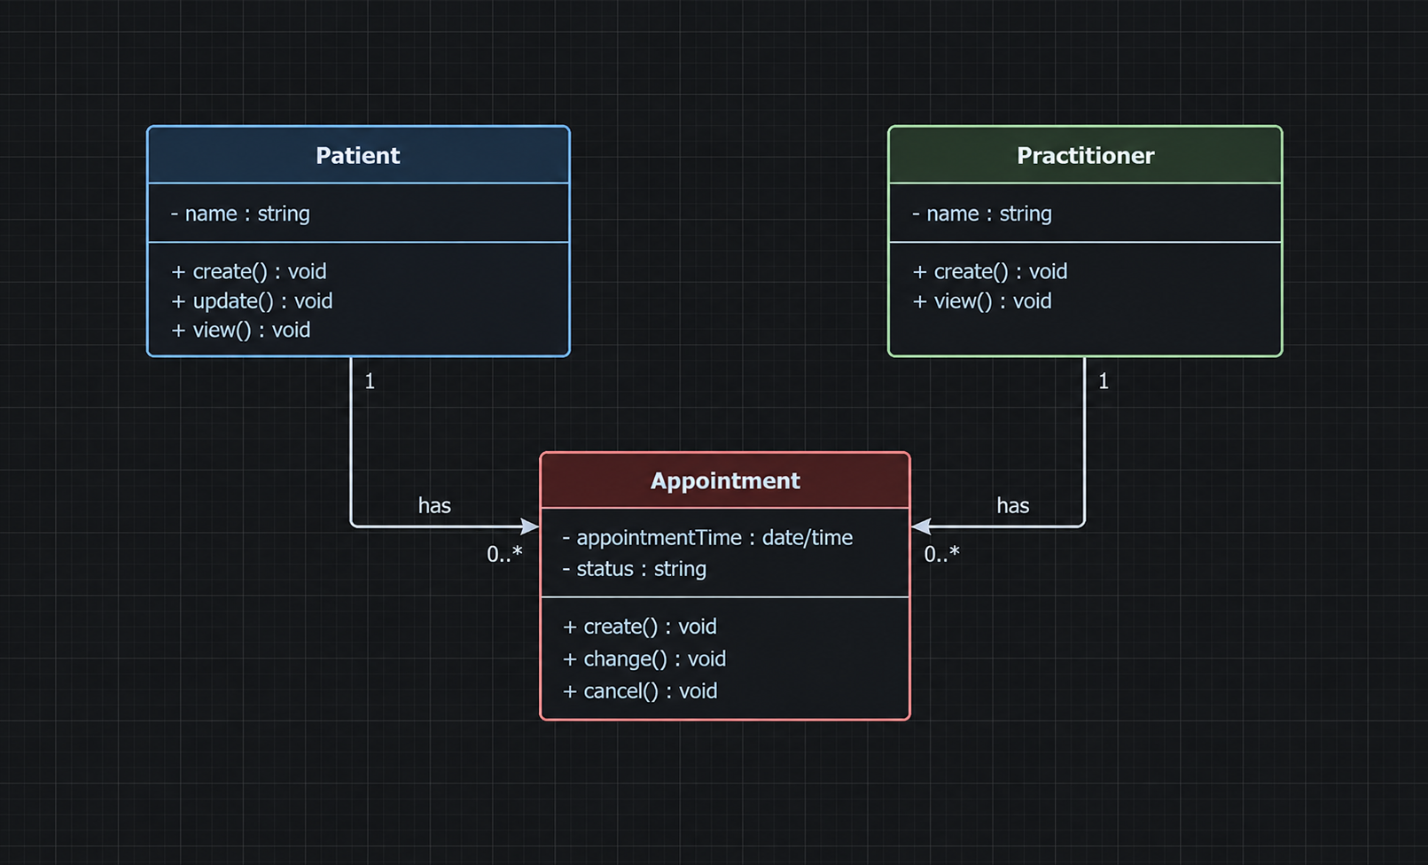
Relationships
Patient → Appointment
Patient 1 ─── 0..* Appointment
A patient can have zero or many appointments; each appointment belongs to one patient.
Practitioner → Appointment
Practitioner 1 ─── 0..* Appointment
A practitioner can have zero or many appointments; each appointment belongs to one practitioner.

Design Rationale
Explain class selection, responsibility allocation and key relationships.
The SmartCare system contains three primary entities within its Domain Model which represent all of the requirements from the SmartCare requirements document. Those entities are:
Patient (domain entity representing a patient record)
Practitioner (domain entity representing a practitioner record)
Appointment (domain entity representing an appointment record).
In terms of Responsibility Allocation:
- Patient is responsible for representing patient information, including information that can be created, updated and viewed by clinic staff.
- Practitioner is responsible for representing practitioner information and supporting practitioners in viewing their scheduled appointments.
- Appointment has responsibility for the creation/modification/cancellation of appointments.
Also, there are relationships defined in the Domain Model. An instance of a Patient may be related to zero or multiple instances of an Appointment; each Appointment being related to one Patient. Likewise, an instance of a Practitioner may also be related to zero or multiple instances of an Appointment; each Appointment being related to one Practitioner. The relationship established here is representative of the SmartCare requirement that appointments link patients and practitioners together.

AI Design Review Record
AI suggestion | Evidence | Decision | Reason | Model change
Patient Manager | FR-01, FR-02, FR-03 | Rejected | The requirements support patient management, but they do not require a separate Patient Manager domain class. The domain model already represents Patient as the relevant concept. | No change; keep Patient as a domain class.
Practitioner Manager | FR-04, FR-05 | Rejected | The requirements support practitioner management, but they do not require a separate Practitioner Manager domain class. | No change; keep Practitioner as a domain class.
Appointment Manager | FR-06–FR-10 | Modified | Appointment management is clearly supported, but a separate manager class is not required by the confirmed requirements. Appointment should remain the core domain concept, while system-level coordination can be handled outside the domain model if needed. | Keep Appointment; do not add Appointment Manager to the domain model.
Clinic Controller | FR-01–FR-10 indirectly | Rejected | Copilot itself says this is an architectural choice rather than a confirmed requirement. It should not be added to the domain model without evidence. | No change.
Notification Manager | None | Rejected | No confirmed requirement supports notifications, reminders or messaging. | No change.

