SmartCare v0.5 - Architecture and Refactoring Workbook
Week 8 student resource

Current Architecture Problems
Problem | Evidence | Impact | Refactoring
Workflow coordination not separated from domain objects | Appointment has state/behavior but no service | Use-case coordination could become mixed into domain objects | Introduce AppointmentService
No repository abstraction | No repository contract exists | Future data-access changes could become coupled to the service | Introduce AppointmentRepository
No persistence layer | No storage implementation exists | Data-access responsibilities are not separated | Introduce persistence layer
No presentation layer | No dedicated presentation component exists | User interaction could become mixed with other responsibilities | Introduce presentation layer
Domain responsibilities need separation from workflow | Appointment owns state/transition behavior | Service could duplicate domain rules | Keep Appointment rules in domain and use Service for coordination
Problem | Evidence | Impact | Refactoring
Workflow coordination not separated from domain objects | Appointment has state/behavior but no service | Use-case coordination could become mixed into domain objects | Introduce AppointmentService

Layer Responsibilities
Layer | Responsibilities | Must not contain
Presentation | Read user input and format/display responses. | Business rules, SQL/database operations.
Service | Coordinate application workflows such as booking, changing and cancelling appointments. | SQL/database implementation or presentation formatting.
Domain | Represent SmartCare entities and enforce domain rules such as appointment status transitions and validation. | SQL, UI logic or application workflow coordination.
Repository | Define the data-access operations required by the service. | Database-specific implementation details.
Persistence | Implement repository operations and handle database/storage details. | UI logic or domain business rules.

Architecture Diagram
Insert SmartCare v0.5 architecture and dependency direction.
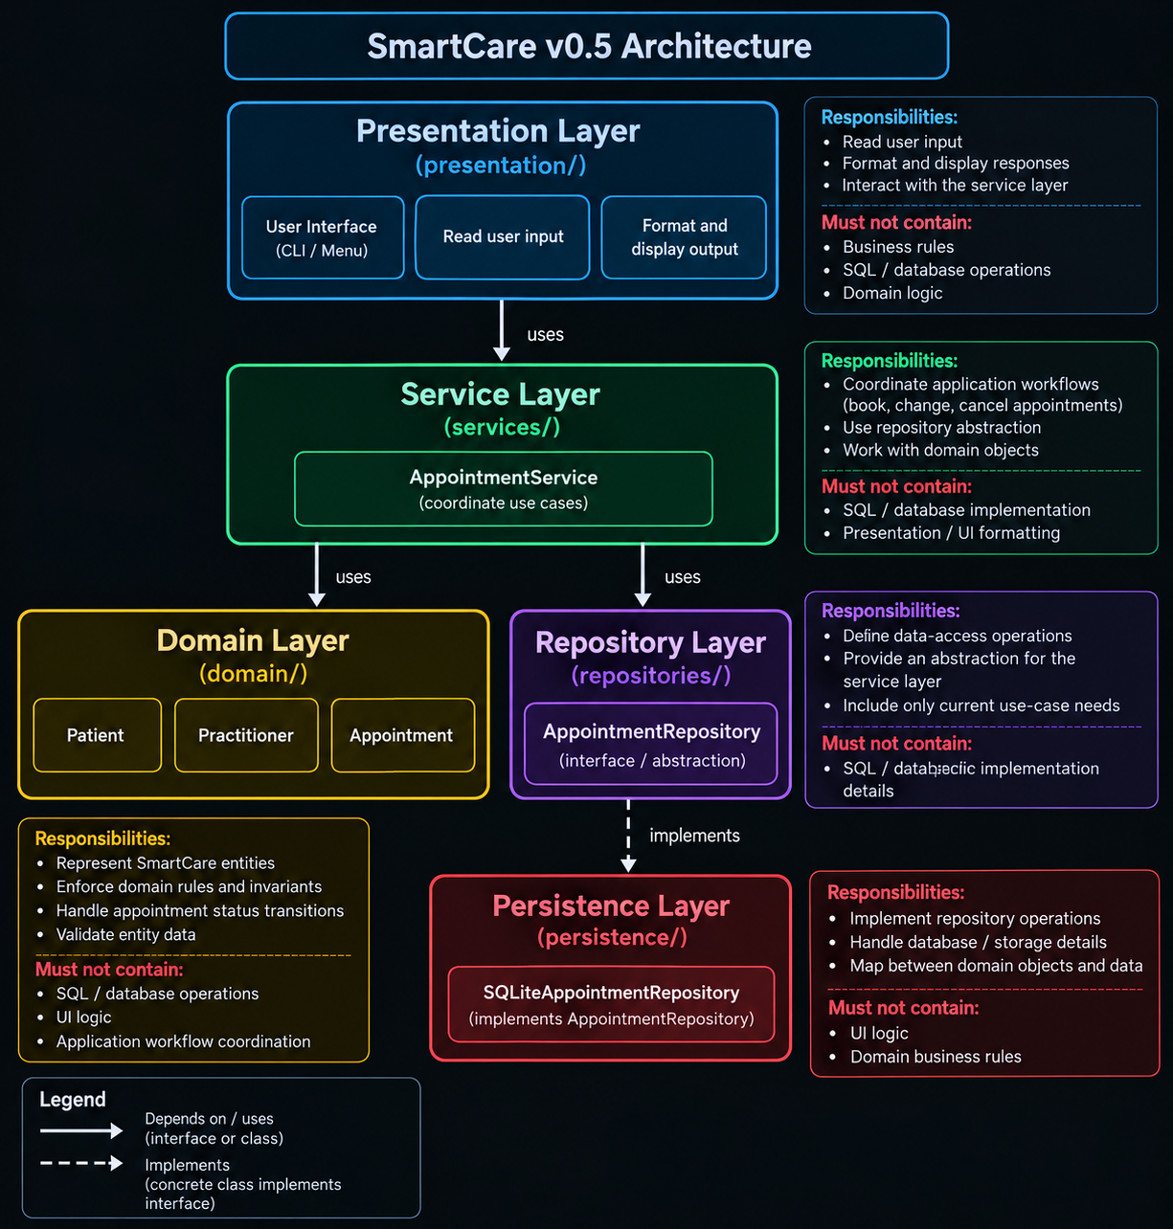

SOLID Review
Principle | Relevant? | Evidence | Decision
SRP | Yes | AppointmentService coordinates workflows while Appointment handles appointment state and rules. | Keep responsibilities separated.
OCP | Partly | The repository abstraction allows persistence implementations to change without changing the service. | Keep the small abstraction without adding unnecessary complexity.
LSP | Yes | AppointmentRepository is an abstraction that can be implemented by a persistence class without changing the service's expected operations. | Maintain compatible repository implementations.
ISP | Yes | AppointmentRepository contains only the two operations currently required: find_by_id and save. | Keep the interface small.
DIP | Yes | AppointmentService depends on the Repository abstraction rather than a concrete persistence implementation. | Keep the dependency on the abstraction.

AI Architecture Review
AI suggestion | Observed problem? | Decision | Reason | Verification
Remove the AppointmentRepository abstraction | No | Rejected | Stage 5 explicitly requires a Repository abstraction between Service and Persistence. | Repository abstraction retained in week8/repositories/.
Move appointment state changes into Appointment | Yes | Accepted | Keeps domain behavior inside the Appointment class. | Existing Appointment status-transition behavior remains unchanged.
Keep AppointmentService focused on workflow coordination | Yes | Accepted | Matches the Stage 5 requirement for workflow coordination. | AppointmentService contains workflow coordination rather than domain rules.
Keep persistence separate from the domain | Yes | Accepted | Prevents storage responsibilities from entering domain classes. | Persistence implementation is in week8/persistence/.
Replace the repository with a concrete persistence class | No | Rejected | Would remove the required Repository abstraction and unnecessarily change the approved architecture. | Repository abstraction was retained.
AI suggestion | Observed problem? | Decision | Reason | Verification

