SmartCare v0.4 - Domain Implementation Workbook
Week 7 student resource

1. UML-to-Code Trace
UML element | Python element | Implemented? | Notes
Patient name : string | Patient.name: str | Yes | Implemented with a type hint and empty-name validation.
Patient create() | Patient.create() | Yes | Implemented as a placeholder; object creation is handled by __init__().
Patient update() | Patient.update() | Yes | Updates the patient name and validates that it is not empty.
Patient view() | Patient.view() | Yes | Returns the patient name.
Practitioner name : string | Practitioner.name: str | Yes | Implemented with basic validation.
Practitioner create() | Practitioner.create() | Yes | Implemented as a placeholder.
Practitioner view() | Practitioner.view() | Yes | Returns practitioner name and specialty.
Practitioner identifier | Practitioner.identifier: str | Yes | Added because the Stage 4 lab explicitly requires an identifier.
Practitioner specialty | Practitioner.specialty: str | Yes | Added because the Stage 4 lab explicitly requires a specialty.
Appointment appointmentTime : date/time | Appointment.appointmentTime: datetime | Yes | Implemented using datetime.

2. Domain Invariants
Class | Invariant / rule | How protected
Patient | Patient name cannot be empty. | __init__() and update() raise ValueError when the name is empty.
Practitioner | Practitioner identifier, name and specialty cannot be empty. | __init__() validates each value and raises ValueError when empty.
Appointment | A cancelled appointment cannot be cancelled again. | cancel() checks for CANCELLED status and raises AppointmentStateError.
Appointment | A cancelled appointment cannot be changed. | change() checks for CANCELLED status and raises AppointmentStateError.
Class | Invariant / rule | How protected
Patient | Patient name cannot be empty. | __init__() and update() raise ValueError when the name is empty.

3. Composition / Inheritance Decisions
Relationship | Decision | Rationale
Appointment and Patient | Association | An Appointment is associated with one Patient, while a Patient can have zero or many Appointments.
Appointment and Practitioner | Association | An Appointment is associated with one Practitioner, while a Practitioner can have zero or many Appointments.
Doctor and Practitioner | No inheritance | Doctor is only a hypothetical example and is not part of the confirmed SmartCare requirements or approved domain model.
Clinic and Appointment | No composition | Clinic is not represented as a domain class in the approved model, and the current requirements do not require a Clinic object to own Appointments.
Relationship | Decision | Rationale

4. AI Pair-Programming Record
AI contribution | Conforms? | Decision | Reason | Verification
AppointmentStatus enum | Yes | Accepted | The lab requires an AppointmentStatus enum. | Reviewed against Stage 4 lab instructions.
AppointmentStateError | Yes | Accepted | Supports protected status transitions and invalid cancellation attempts. | Will be tested during manual behavior checks.
Patient and Practitioner references | Yes | Accepted | Matches the approved UML relationships. | Checked against the approved UML.
Appointment change() and cancel() behavior | Yes | Accepted | Matches the approved Appointment operations and required behavior. | Will be tested manually.
@dataclass and unused imports | No | Rejected | They were unnecessary for the approved design and added no required functionality. | Removed during code review.

5. Updated UML
Insert updated UML only if implementation revealed a justified design change. Explain every change.
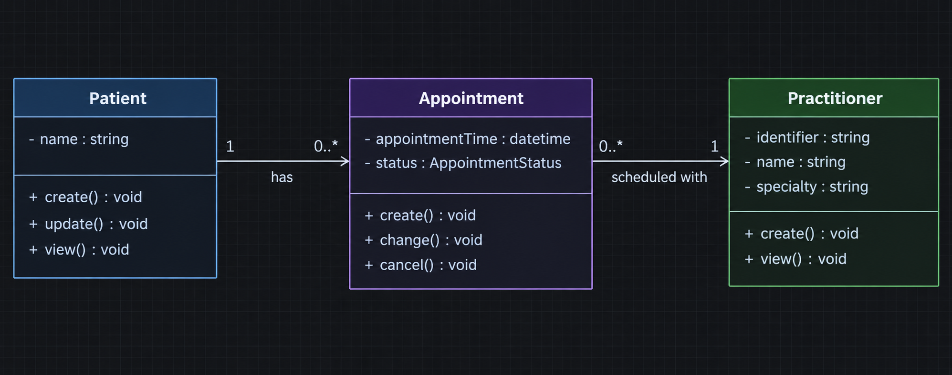
Explaining the changes to the Practitioner Class
Practitioner was added as an attribute in both Identifier and Specialty. This is based on the explicit requirement that Stage 4 requires these two attributes. None of the other UML Classes or Relationships were modified as no new Domain Classes or Relationships were needed to support this implementation.

