Stage 1 Lab - Human vs AI: Building Your First SmartCare Prototype

Learning objectives
- Create and run a simple Python file with basic input,output and processing statements
- Use lists, dictionaries and functions to enhance the Python file
- Build a small SmartCare appointment prototype.
- Use AI as a tutor rather than a replacement.
- Compare human-written and AI-generated code.
- Verify AI-generated code through execution and test inputs.
- Document a short AI-use reflection.

Files to create and commit in GitHub
stage01/
smartcare_v01.py
comparison.md
reflection.md
ai_usage.md

Part A - Understand the Problem: AI OFF
SmartCare needs a small prototype that allows a receptionist to record patient appointments. Each appointment records patient name, practitioner name and appointment time.
What data must be stored?
Patient name, practitioner name and appointment time
What functions might be useful?
A function to book an appointment and a function to display the recorded appointments
What could go wrong?
The patient name could be blank, incorrect information could be entered, or two appointments could be booked for the same practitioner at the same time
What requirements are unclear?
It is unclear whether the system should prevent duplicate appointments, what information besides names and time should be stored, and how appointments should be changed or cancelled

Part B - Build a Human-Written Prototype: AI OFF
#task 1
# Create and run a simple Python file with basic input,output statements

print("Welcome to SmartCare: Community Clinic Appointment Booking System!")

# First Appointment
patient1_name = 'Alice Smith'
practitioner1_name = 'Dr. John Doe'
appointment1_time = '2024-07-20 10:00 AM'
print(f"Patient: {patient1_name} | Practitioner: {practitioner1_name} | Time: {appointment1_time}")

# Second Appointment
patient2_name = 'Bob Johnson'
practitioner2_name = 'Dr. Jane Roe'
appointment2_time = '2024-07-20 11:30 AM'
print(f"Patient: {patient2_name} | Practitioner: {practitioner2_name} | Time: {appointment2_time}")

#task1enhanced
# Use lists, dictionaries and functions to enhance the Python file

appointments = []

def book_appointment(patient_name, practitioner_name, appointment_time):
if not patient_name:
raise ValueError("Patient name cannot be empty")
appointment = {
"patient": patient_name,
"practitioner": practitioner_name,
"time": appointment_time
}
appointments.append(appointment)

def display_appointments():
if not appointments:
print("No appointments recorded.")
return
for appointment in appointments:
print(f"Patient: {appointment['patient']} | Practitioner: {appointment['practitioner']} | Time: {appointment['time']}")

print("Welcome to SmartCare: The Clinical Appointment Booking System!")
book_appointment('Alice Smith', 'Dr. John Doe', '2024-07-20 10:00 AM')
book_appointment('Bob Johnson', 'Dr. Jane Roe', '2024-07-20 11:30 AM')
display_appointments()

^ Now, run both programs , and identify at least five limitations.
- The appointments are hard-coded, so the receptionist cannot enter appointment details while the program is running.
- The program does not prevent duplicate appointments for the same practitioner at the same time.
- Only the patient name is checked, while the practitioner name and appointment time are not validated.
- Appointments are only stored temporarily in memory, so the information is lost when the program closes.
- There is no way to edit or cancel an appointment after it has been recorded.

Part C - Use AI as Tutor: AI ON (Use only UC approved GenAI Tool such as Microsoft CoPilot)
Suggested prompt structure:
Act as a Python tutor.
I am learning introductory software technology.
Here is a small appointment-booking function.
1. Explain what the code does.
2. Identify three limitations.
3. Suggest improvements.
4. Do not rewrite the whole application.
5. Ask me two questions to test my understanding.\
Copilot response:
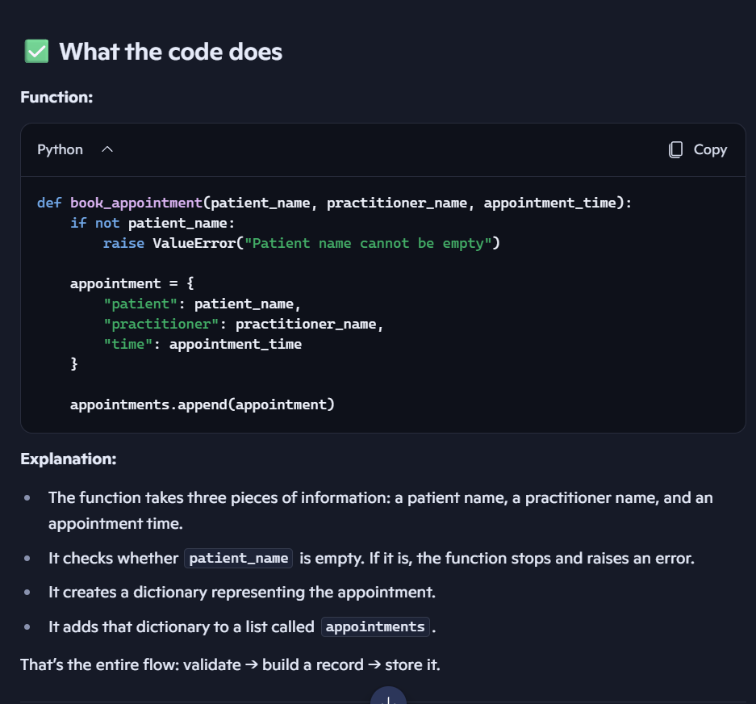
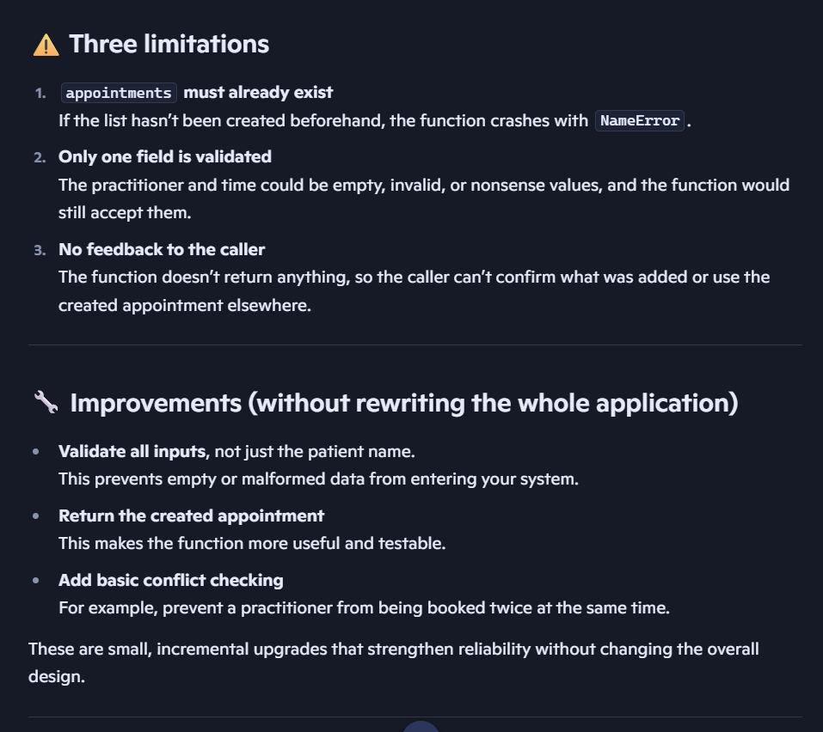
The two questions Copilot asked:
- Why is it risky to rely on a global list like appointments without checking whether it exists?
It is risky because if the appointments list has not been created before the function is called, the program will produce a NameError and stop

- What advantage do you gain by returning the appointment dictionary from the function?
Returning the appointment dictionary allows the part of the program that called the function to confirm what was created and use the appointment information elsewhere

Part D - Generate an Alternative: AI ON
Ask AI to create a simple beginner-friendly Python function that stores patient name, practitioner name and appointment time. Explicitly prohibit a database or GUI.
Copilot code and response:
appointments = []

def book_appointment(patient_name, practitioner_name, appointment_time):
"""Store a basic appointment in a list."""

appointment = {
"patient": patient_name,
"practitioner": practitioner_name,
"time": appointment_time
}

appointments.append(appointment)
return appointment
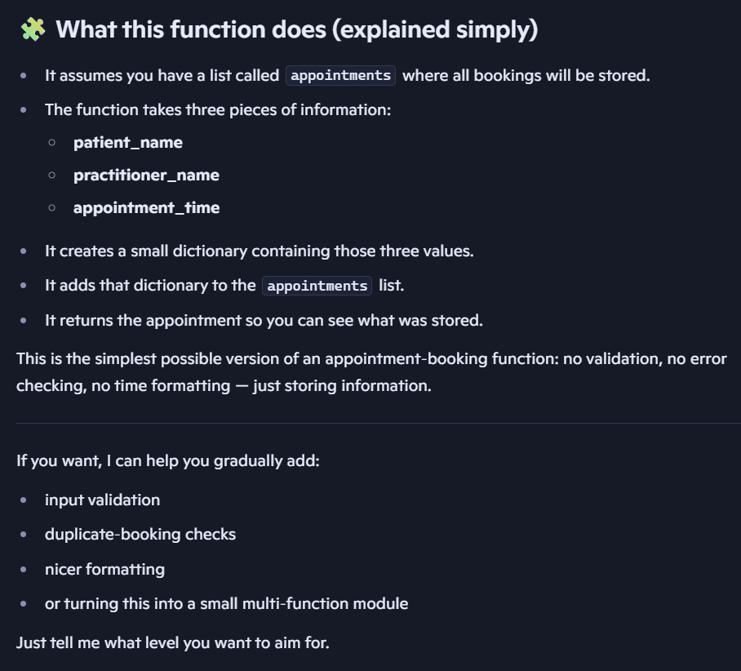

Part E - Compare Human and AI Versions
Question | Human version | AI version
Easy to understand? | Yes, although it is more verbose because it includes validation and the appointment display function. | Yes, it is simple and easy to understand.
Runs successfully? | Yes | Yes, provided the appointments list exists.
Uses only required features? | Yes | Yes
Adds assumptions? | No major assumptions | Yes — it assumes an appointments list already exists.
Handles errors? | Yes, it checks for an empty patient name. | No, it has no input validation or error checking.
Could I explain it? | Yes | Yes, after reviewing how the list, dictionary and function work.

Part F - Verify Behaviour
- Normal appointment
- Blank patient name
- Two appointments for the same practitioner/time
- Strange input such as patient_name=None or appointment_time=None

Test | Human version | AI version
Normal appointment | Works — appointment is stored and displayed. | Works — appointment is stored and returned.
Blank patient name | Rejected — raises ValueError. | Accepted — no validation is performed.
Two appointments for the same practitioner/time | Accepted — there is no duplicate/conflict check. | Accepted — there is no duplicate/conflict check.
patient_name=None or appointment_time=None | patient_name=None is rejected because it is treated as empty; appointment_time=None is accepted. | Both are accepted because there is no validation.

Part G - Improve One Thing
Choose exactly one controlled improvement, for example: if not patient_name: raise ValueError("Patient name cannot be empty")
I improved the program by adding validation for an empty practitioner name. This prevents an appointment from being stored without a practitioner and improves the reliability of the prototype.

Part H - Reflection (150-250 words)
What did you build before using AI?
What did AI help you understand?
Did AI make assumptions?
How did you verify the AI output?
What engineering work remained for you?

Before using AI, I built a simple SmartCare appointment prototype using Python. I used a list and dictionaries to store patient names, practitioner names and appointment times, and created functions to book and display appointments. I also added validation to prevent an empty patient name and later added one controlled improvement to validate the practitioner name.
AI helped me understand how the booking function works and identified limitations such as the need for the appointments list to already exist, limited input validation and the lack of feedback from the function. AI also suggested improvements such as input validation and duplicate appointment checking.
The AI-generated version made an assumption that an appointments list already existed and did not include validation. I did not automatically accept the AI output. I verified its suggestions by reading the code, running the program and testing normal and unusual inputs, including blank and None values and duplicate appointments.
The engineering work that remained for me was deciding which suggestions were appropriate, testing the behaviour and making the final controlled improvement. This showed me that AI can help explain and suggest ideas, but I still need to understand, evaluate and verify the code myself.

Submission checklist [GitHub Commit]
- Python file runs.
- Comparison table completed.
- Normal and unusual inputs tested.
- AI assistance documented.
- Reflection completed.
- I can explain my code.

