Tarantal Madness
Development history
How the game came together, from the first commit to today
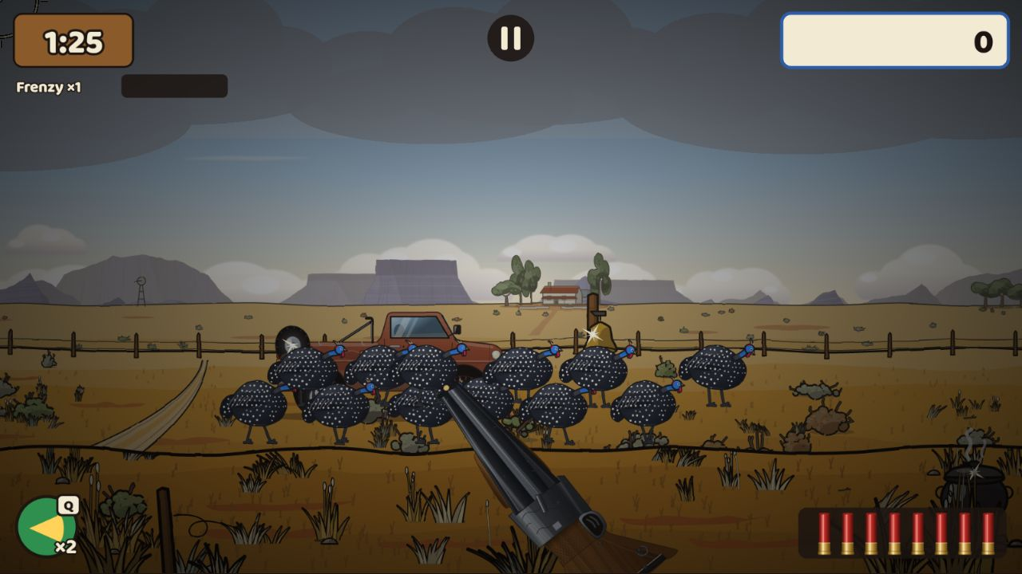
The game on 23 October 2026, after graphics pass 3: a Karoo hunt.
19–27 October 2026
Last updated 27 October 2026, 02:00 UTC
A living record: a new chapter is added each time a milestone merges. All times are UTC.
Contents

If the page numbers are missing, right-click the table and choose Update Field.

At a glance
Tarantal Madness is a browser shooting gallery set in Southern Africa, starring the helmeted guineafowl. It plays on desktop and phone browsers, with app-store and Steam versions possible later. Its signature is a guineafowl flock that behaves like the real thing, and a four-season Season Run.
The game went from an empty repository to a launch-ready v1.0 in about two and a half days, then through three graphics passes and two feature releases in the next day and a half. Everything below is live on the GitHub Pages test build; nothing has been published to a portal or store yet.
By the numbers (23 October 2026)
Measure | Count
Days since the first commit | 8
Commits on main | 1,018
Pull requests | 84 merged, plus this history update; Karoo polish is being built
Game code (TypeScript, without tests) | about 54,000 lines
Automated tests | 1,325 unit tests, 62 browser test suites on 3 device profiles
Hunting areas | 5: the four seasons (Karoo, Bushveld, Okavango, Kalahari) and Namibië, each with 7 weekday maps and 3 bonus maps (Verder, Nog Verder, Die Verste)
Guns | 8 (Dubbelloop, Windbuks, Kettie, Plaas-Pomp, Die Twee-Twee with 3 sights, Die Langloop with a 3–9× scope, Voorlaaier, Mielie-Masjien)
Creatures | 13 (guineafowl and variants, bosses, flyers), plus meerkat colonies on the desert maps, and bats and owls on the Halloween Spookjag
Languages | English, Afrikaans, German and Dutch text; Oupa voiced in English, Afrikaans and German
Design decisions logged | 50 (D-001 to D-050)

Who builds it
Who | What they do
Product owner | Sets the direction, approves looks, gives feedback; anything that needs an account, money, a real phone or a person
Tank | Coding agent on the product owner’s server: writes the game code, interim art and sound, tests and docs for each job
Claude | Writes each job’s brief, checks in every 10 minutes (with an hourly backup check), reviews looks and code, fixes small test and CI problems, merges on green tests, keeps the status doc and this history current
GitHub CI | Runs the tests on every pull request (about 15 minutes) and the full suite on every merge; records the visual-test screenshots; publishes the test build to GitHub Pages

The look over time
The automated visual tests record the same moment of a hunt (same seed, same instant, desktop) after every change to the look. Side by side they show how the game’s appearance developed.
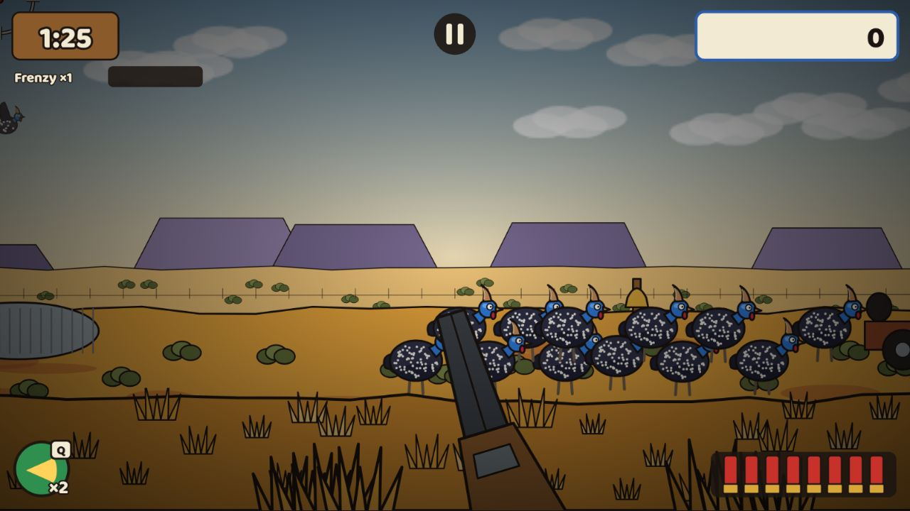
v1.0.0 (21 Oct): code-drawn placeholder art.
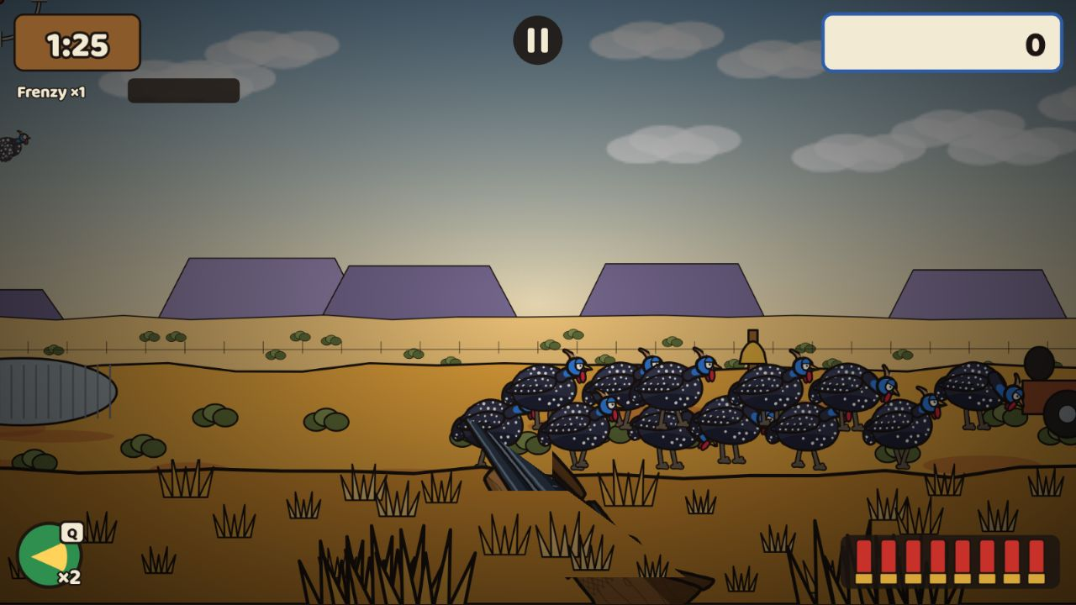
Graphics pass 1 (22 Oct): detailed guineafowl and a long double-barrel.
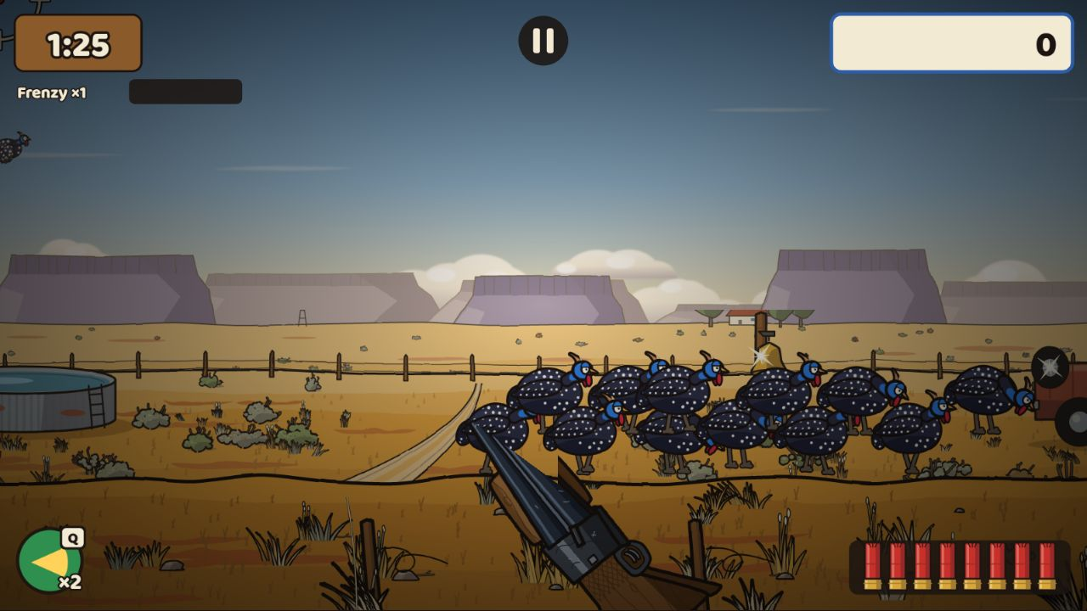
Graphics pass 2 (23 Oct): interim Karoo landscape, farmstead, water tank, bushes and sky.
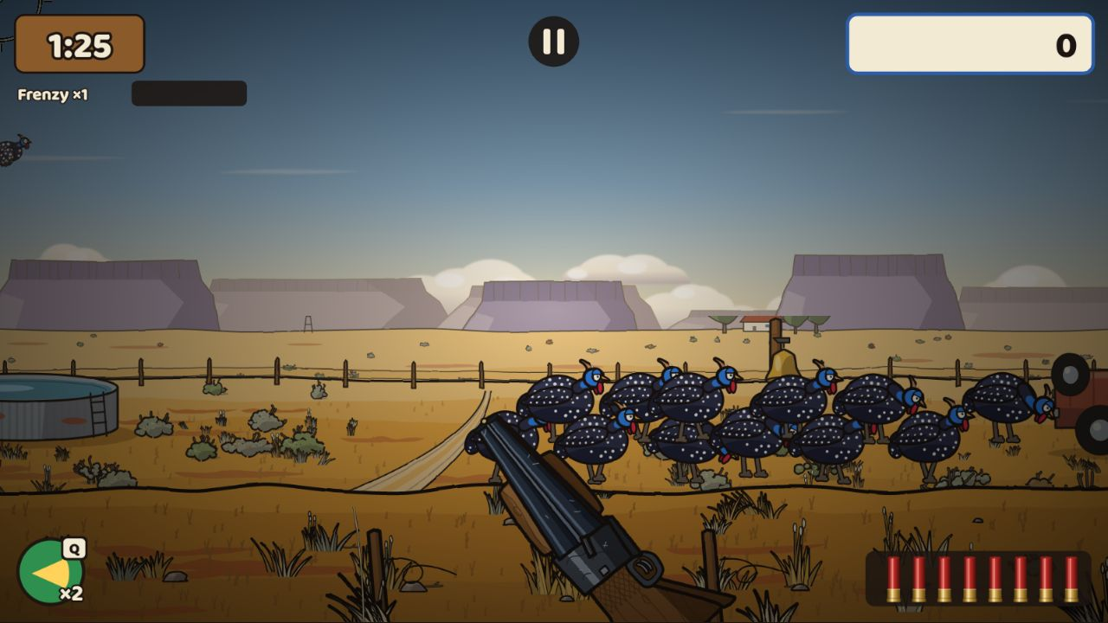
v1.1 (23 Oct): real shotgun shells in the ammo belt.
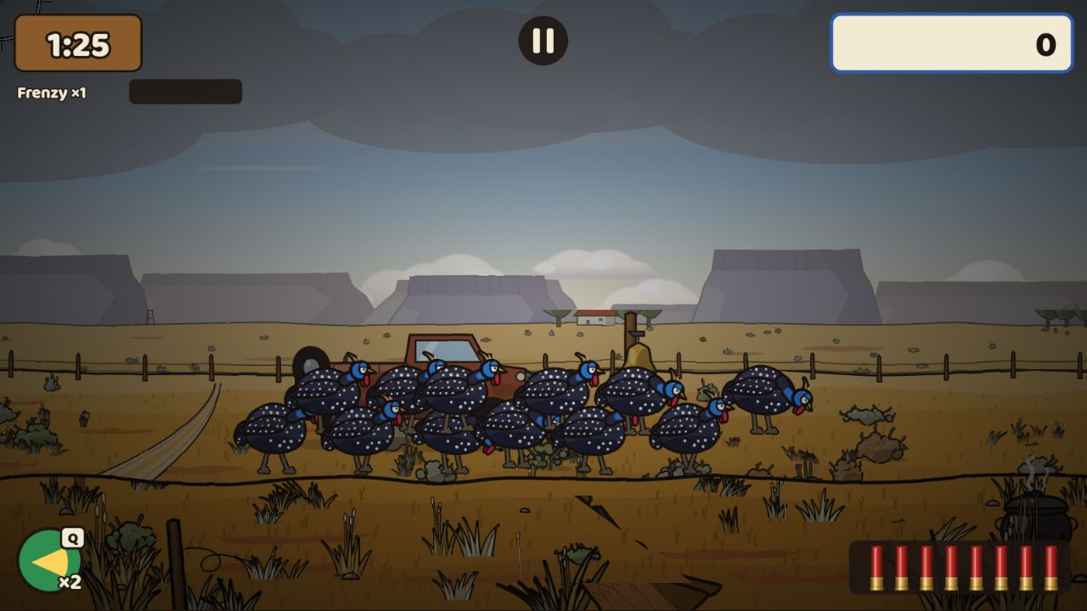
v1.2 (23 Oct): a weekday map (overcast light, the bakkie moved).
Graphics pass 3 (23 Oct): rounded hills, the farmstead whole, semi-realistic guineafowl and gun.

Timeline
Every milestone, in order. Pull request numbers refer to github.com/ShadowNam/Tarantal.
When (UTC) | Milestone | Pull requests
19 Oct 2026, 20:33 | M0 — Scaffold and guardrails | #1
19 Oct 2026, 21:15 | M1 — Deterministic game engine | #2
20 Oct 2026, 11:10 | M2 — First playable hunt | #3
20 Oct 2026, 13:17 | M3 — The Flock | #4
20 Oct 2026, 16:19 | M4 — The Karoo | #5
20 Oct 2026, 18:41 | M5 — Menus, saves and the tutorial | #6
21 Oct 2026, 05:14 and 06:58 | M6 — Season Run | #7, #8 (and #9: the playable test build on GitHub Pages)
21 Oct 2026, 10:27 and 11:08 | M7 — Daily Hunt | #10, #11
21 Oct 2026, 14:05–17:04 | M8 — Three more areas and the arsenal | #12–#16
21 Oct 2026, 20:30–21:31 | M9 — Platform, speed, accessibility, languages | #17–#21
22 Oct 2026, 01:25 | M10 — v1.0.0, ready for a soft launch | #22–#29
22 Oct 2026, 08:34–14:19 | v1.0.1 — Clean-up | #30, #31, #33, #34, #37, #38
22 Oct 2026, 16:04 | Faster delivery | #39
22 Oct 2026, 16:45–17:19 | Graphics pass 1 — detailed guns and guineafowl | #32, #35, #36
22 Oct 2026, 18:54 | The long-range plan | #40
22 Oct 2026, 23:18 and 23 Oct 00:05 | Graphics pass 2 — landscapes for all four areas | #41, #42
23 Oct 2026, 04:24 and 04:40 | v1.1 — Gun feel | #43, #44 (and #45: a CI fix)
23 Oct 2026, 11:57 | v1.2 — Day-of-week maps and the bonus map Verder | #47 (includes #46)
23 Oct 2026, 13:30 (requested 11:50, live 13:32) | Playtest admin page | #48
23 Oct 2026, 14:10 | Speed tests run alone | #50
23 Oct 2026, 17:58 (started 11:59) | Graphics pass 3 — towards semi-realistic | #49
23 Oct 2026, 21:20 | Screenshot baselines recorded on GitHub | #55
24 Oct 2026, 02:24 (started 23 Oct, 18:00; part A merged 02:14) | v1.3 — Long range: the Ver plane, sights and zoom, Die Twee-Twee | #53, #54
24 Oct 2026, 05:38 (started 02:25) | Training ground (Skietbaan) | #58
24 Oct 2026, 10:21 (asked for at 05:45) | Training ground update: mixed targets, steel plates, hit feedback | #61
24 Oct 2026, 13:23 (started 05:40) | v1.4 part A: Die Langloop and a faster scope view | #60
24 Oct 2026, 21:36 (started 24 Oct, 12:40) | v1.4 part B: the Namibië pack, camelthorn trees and the family nest, angry weavers | #64
25 Oct 2026, 00:25 (started 24 Oct, 21:37) | Skietbaan gongs: clean steel plates with lasting hit marks | #66
25 Oct 2026, 04:39 (started 25 Oct, 00:28) | v1.5 Languages: text, voice and names for every audience | #68
25 Oct 2026, 16:56 (started 25 Oct, 04:45) | v1.6 Veld art: trees, fruit, far animals and the windmill | #70
25 Oct 2026, 18:43 (started 25 Oct, 06:45) | v1.6b Reload power-ups: Blitslaai and Oupa Laai | #71, #75
25 Oct 2026, 20:06 (asked for at 17:51) | The Project overview page in the admin | #76
25 Oct 2026, 22:55 (started 25 Oct, 13:00) | v1.7 Meerkat colonies on the desert maps | #72
26 Oct 2026, 02:40 (started 25 Oct, 21:31) | v1.7b Power-ups explained, and an Oupa switch | #77
26 Oct 2026, 05:34 (started 26 Oct, 01:11) | v1.7c Fruit that swings and drops | #79
26 Oct 2026, 10:32 (started 26 Oct, 04:50) | Halloween Spookjag (Feesdae) | #80
26 Oct 2026, 18:34 (started 26 Oct, 08:51) | Perspective: birds get smaller with distance | #82
27 Oct 2026, 01:36 (started 26 Oct, 18:39) | v1.8 Blikkies: tin cans on the fence posts | #83

Foundations

M0 — Scaffold and guardrails
When: 19 Oct 2026, 20:33 · Pull requests: #1 · Decision: D-017
The project started from a build kit: the game design, architecture, art bible and build plan, written before any code.
What it added
- Phaser 4 (pinned), TypeScript in strict mode, Vite, Zod for content, Vitest and Playwright for tests, ESLint and Prettier.
- The ground rule: the game’s rules ("the sim") are pure, deterministic code that never touches the screen, so every hunt can be replayed exactly.
- All tuning numbers live in JSON content files, checked by schemas.

M1 — Deterministic game engine
When: 19 Oct 2026, 21:15 · Pull requests: #2 · Decision: D-018
A whole hunt ran without graphics: from a seed, the content and the player’s inputs to a result.
What it added
- 60 ticks per second; named random streams so spawns, pellets and events never disturb each other.
- Own sine, cosine and exponent maths, so every browser and phone computes the same numbers.
- Scoring, guns, pellet spread, hit tests and replays; "golden" replays fail the tests if any rule changes by accident.

M2 — First playable hunt
When: 20 Oct 2026, 11:10 · Pull requests: #3 · Decision: D-019
The game became playable in the browser with placeholder art.
What it added
- A 90-second Classic hunt on a panning, layered landscape (near, middle and far planes).
- Click or tap to shoot, right-click or tap the shell belt to reload; timer, score and shells on screen.
- Desktop and phone (Pointer Events, no browser zoom or scrolling).
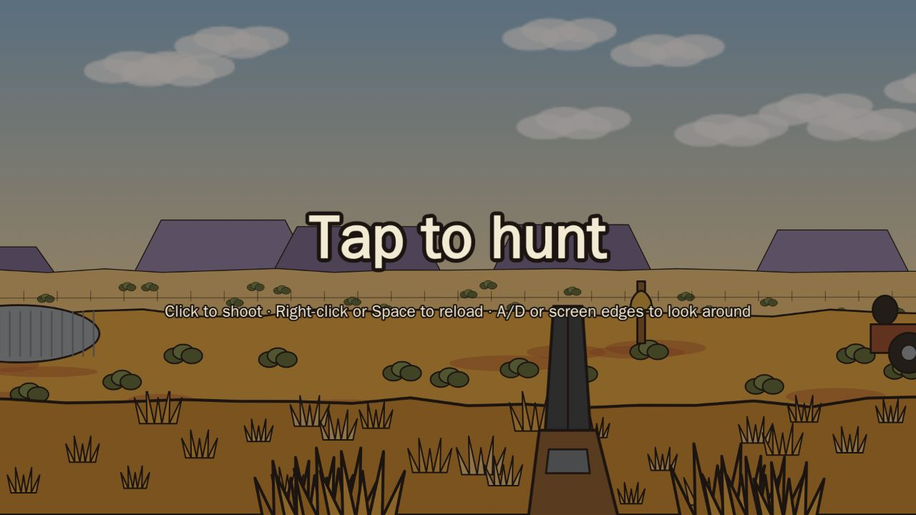
M2: the start card.
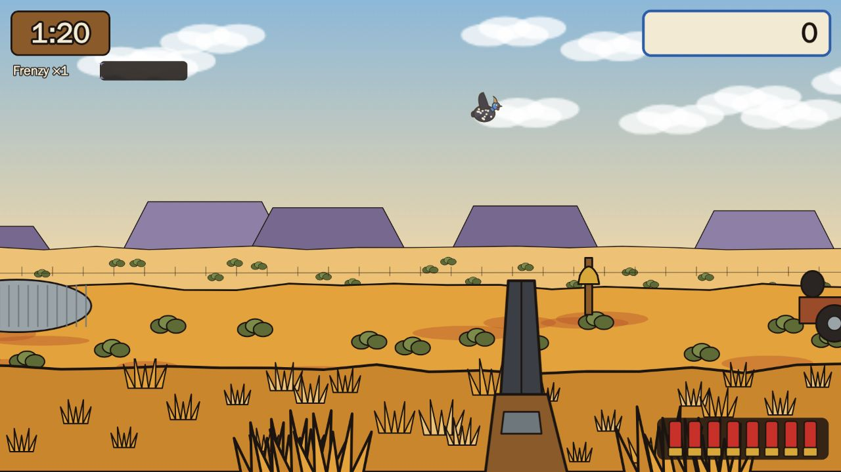
M2: the first playable hunt.

M3 — The Flock
When: 20 Oct 2026, 13:17 · Pull requests: #4 · Decision: D-020
The signature mechanic: guineafowl behave like a real flock.
What it added
- Forage, then alert, then run, then flush into the air; the flock reacts to shots and misses.
- Juice pass 2: hit feedback, feathers, score pops.
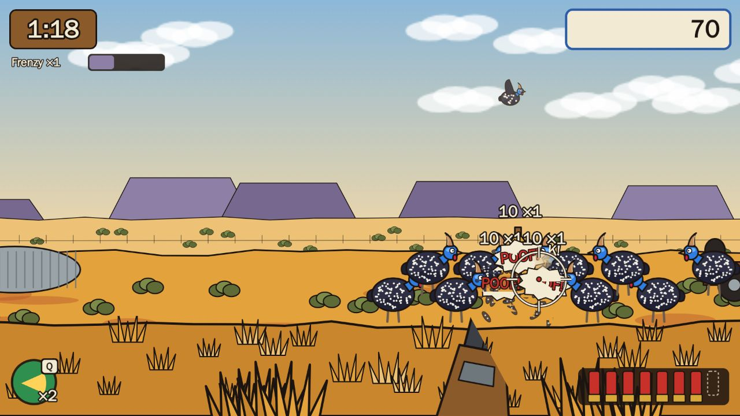
M3: the first foraging flock, a moment after a shot: "POOF!" and score pops.

M4 — The Karoo
When: 20 Oct 2026, 16:19 · Pull requests: #5 · Decision: D-021
The home level, built entirely from content files.
What it added
- Secrets to shoot: the windpomp, the spare wheel, the potjie, the fence bell.
- Events (a hadeda, a crop sprayer you must not hit) and the area’s omen.
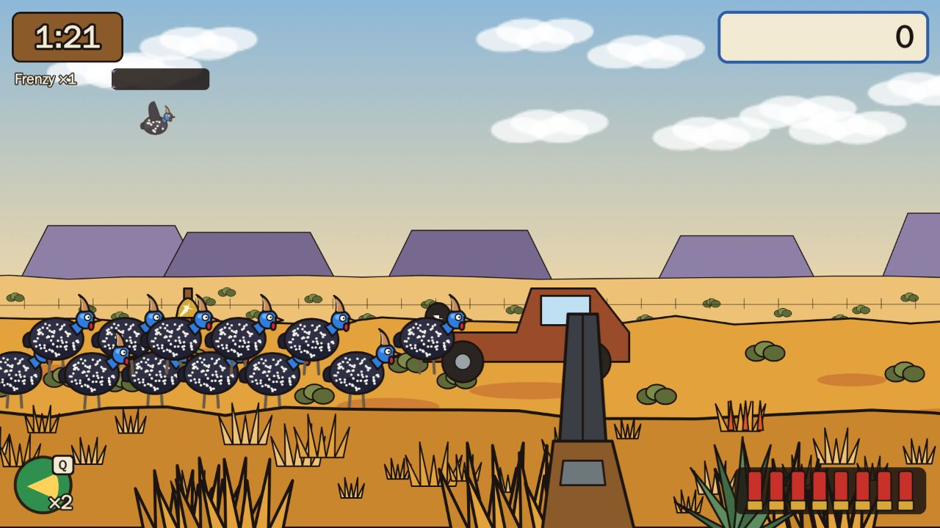
M4: panning right along the Karoo level shows the bakkie, an agave and a bottle to shoot.

M5 — Menus, saves and the tutorial
When: 20 Oct 2026, 18:41 · Pull requests: #6 · Decision: D-022
What it added
- Safe saving (works even when the browser blocks storage), the title screen, the Skiet-Skuur (gun shed), settings and pause.
- A first-time tutorial for new players.
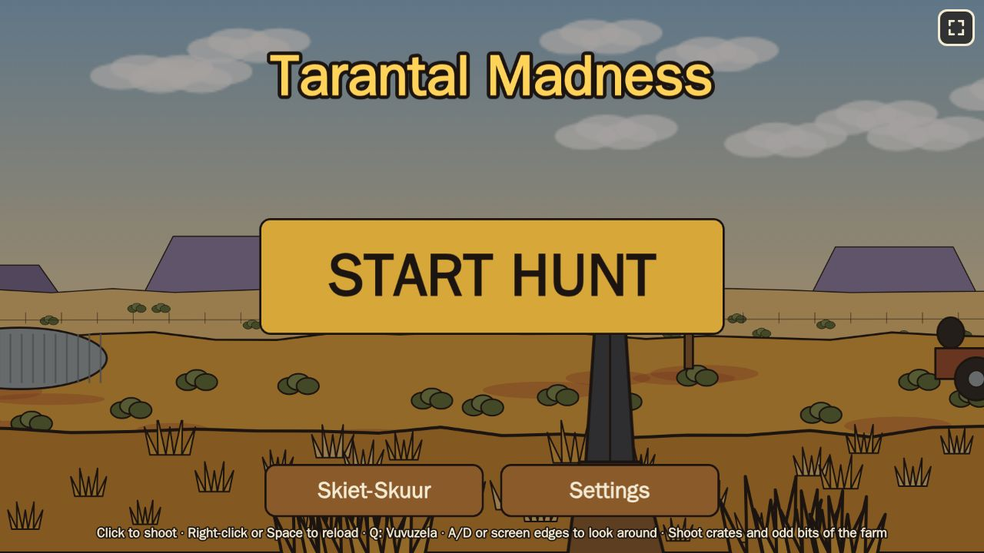
M5: the first real title screen, with the Skiet-Skuur and Settings.

Game modes

M6 — Season Run
When: 21 Oct 2026, 05:14 and 06:58 · Pull requests: #7, #8 (and #9: the playable test build on GitHub Pages) · Decision: D-023
A roguelite run through four seasons.
What it added
- Quotas per hunt, charms that change the rules, boss hunts and omen hunts.
- The Padstal (farm stall) between hunts to buy charms; save and resume a run.
- From 21 Oct every merge is playable on the GitHub Pages test build.
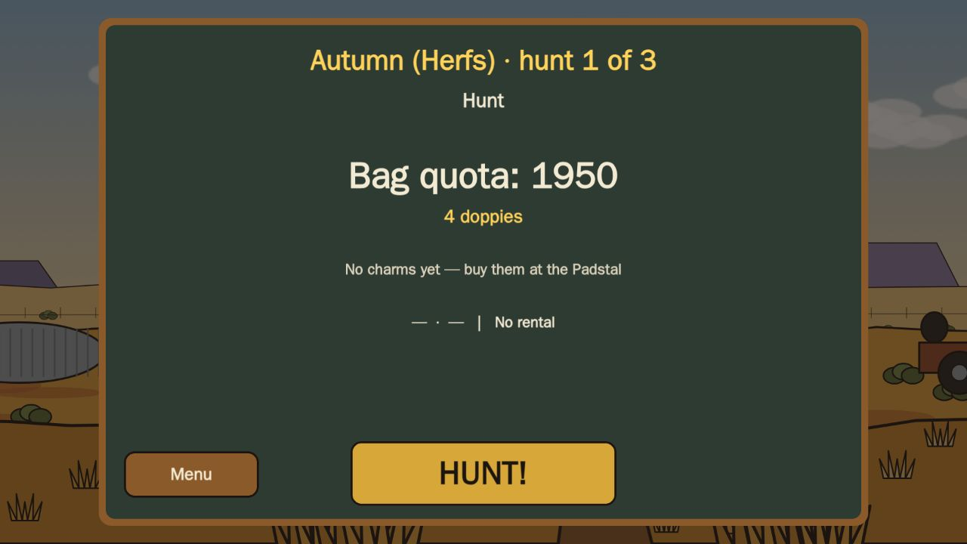
M6: the card before a Season Run hunt: autumn, hunt 1 of 3, the bag quota.
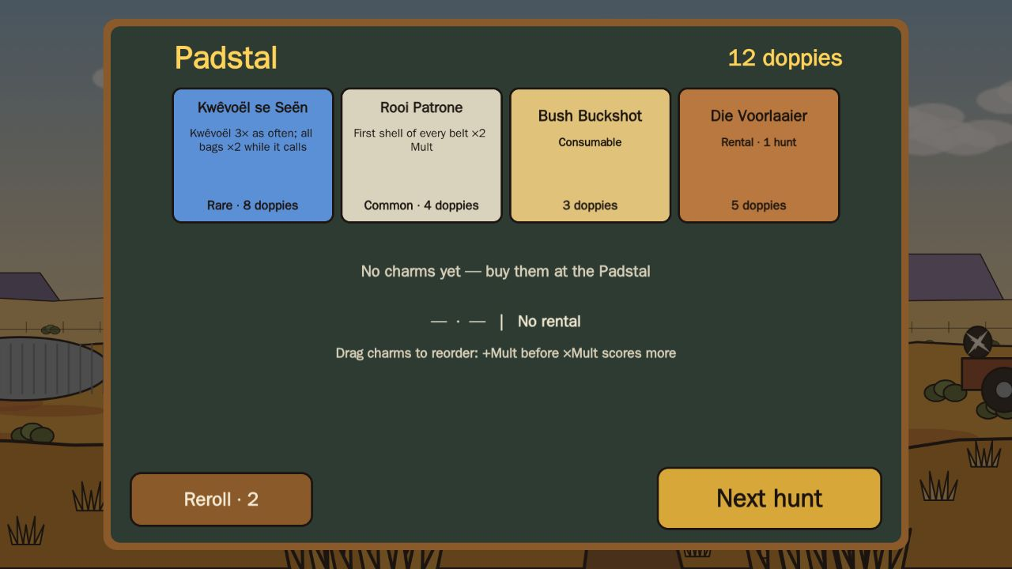
M6: the Padstal between hunts, with four charms on offer.

M7 — Daily Hunt
When: 21 Oct 2026, 10:27 and 11:08 · Pull requests: #10, #11 · Decision: D-024
What it added
- The same seeded hunt for everyone each day, with a streak (and a streak freeze).
- A share card and challenge links ("beat this score").
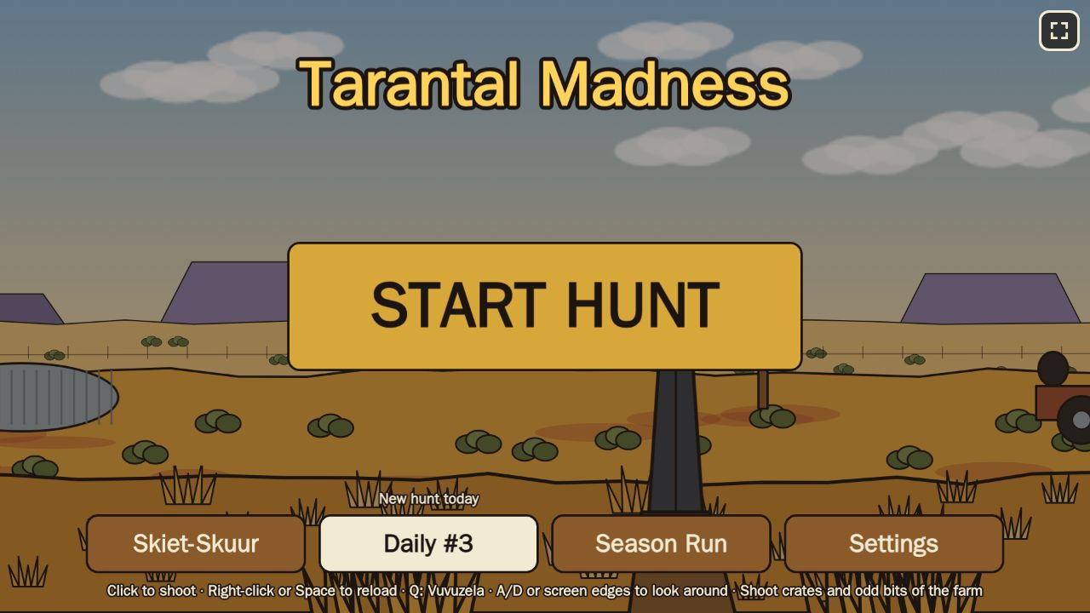
M7: the title gains the Daily button and Season Run.
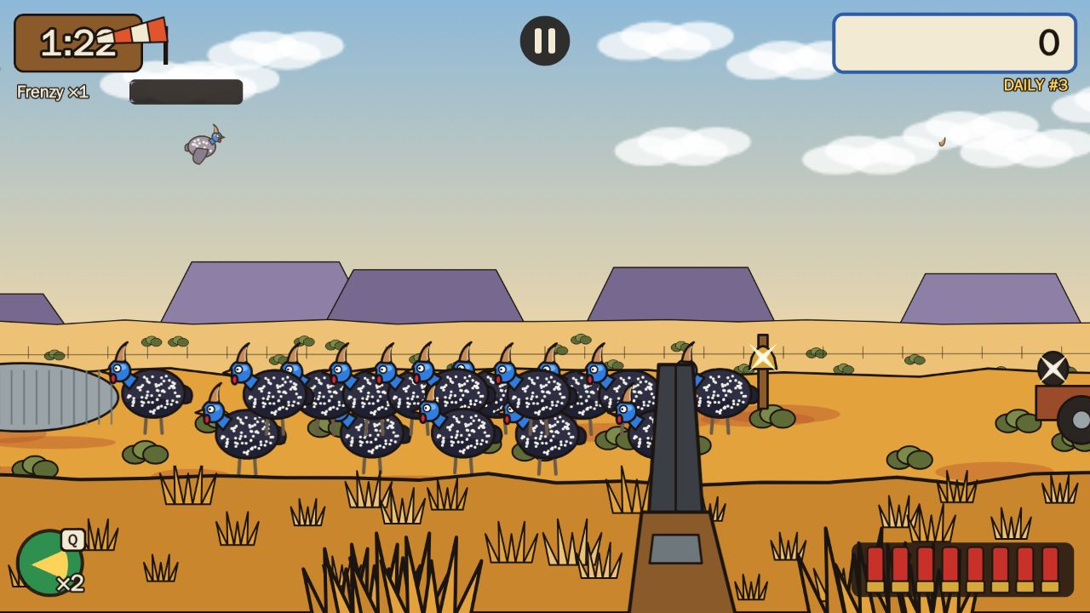
M7: a Daily Hunt, with its tag and the wind sock.

Content and platform

M8 — Three more areas and the arsenal
When: 21 Oct 2026, 14:05–17:04 · Pull requests: #12–#16 · Decision: D-025
What it added
- New guns: the Kettie (catapult, stones fly a moment before they land), the Plaas-Pomp and the Windbuks.
- Winter in the Bushveld: running flocks, dassie and boulder secrets, the boss Ou Grys, winter glare.
- Spring in the Okavango: splashing water, sun-showers, crested guineafowl hopping out of the reeds, the boss Kuifkop Koning.
- Summer in the Kalahari: heat haze turning into a storm, lightning, Die Stormvoël, a weaver nest.
- The Season Run now travels through all four real seasons.
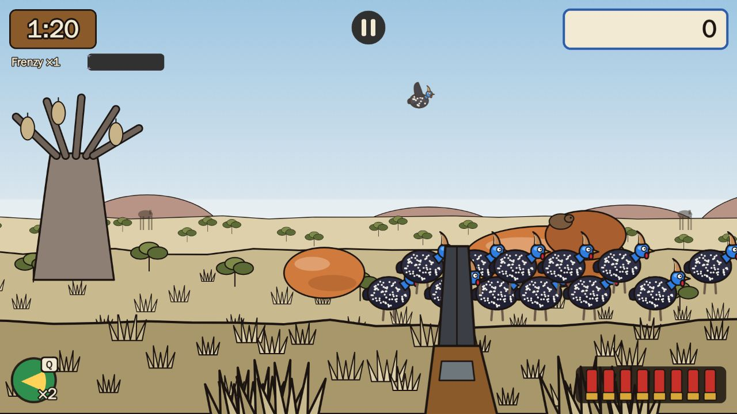
M8: winter in the Bushveld (placeholder art).
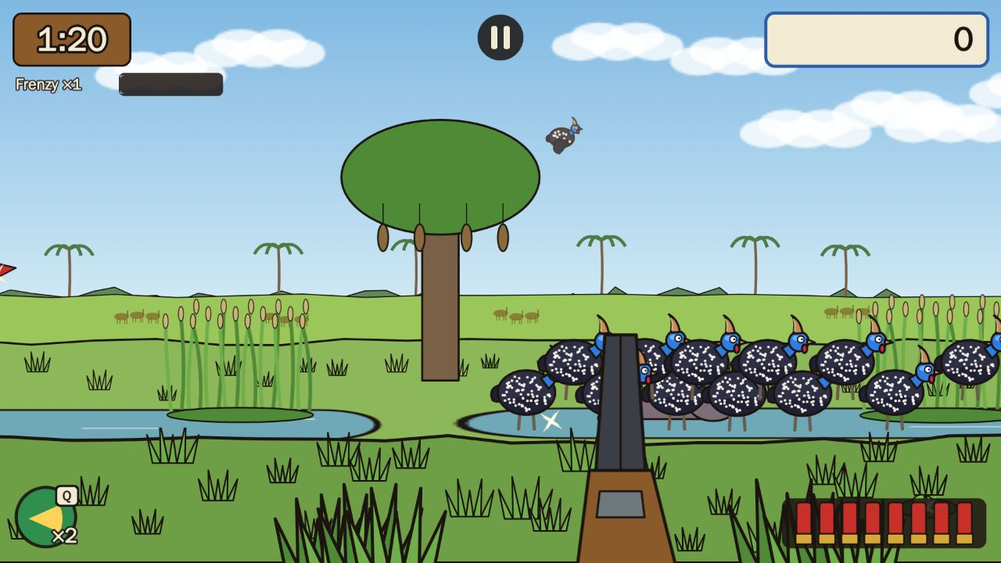
M8: spring in the Okavango (placeholder art).
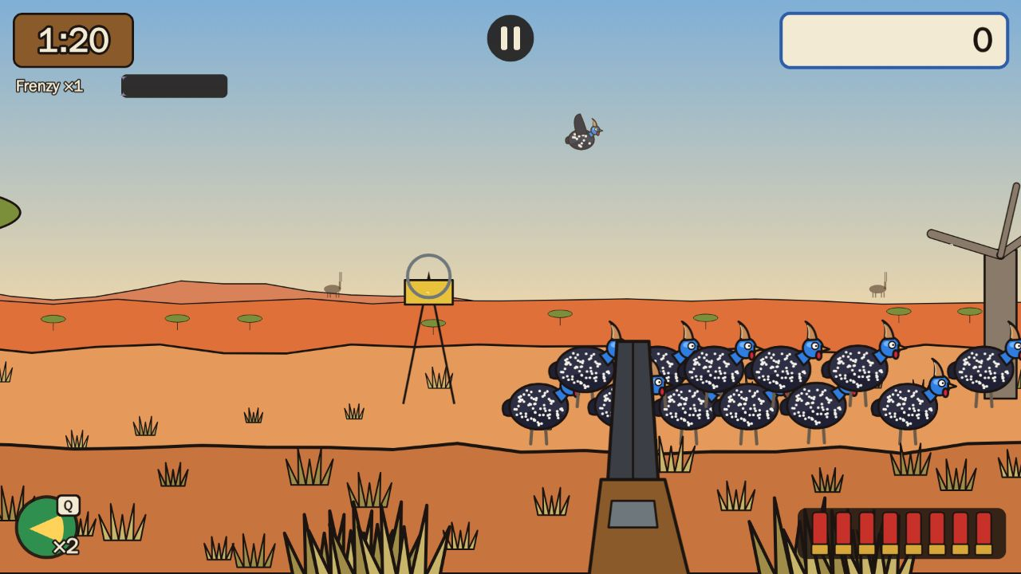
M8: summer in the Kalahari (placeholder art).

M9 — Platform, speed, accessibility, languages
When: 21 Oct 2026, 20:30–21:31 · Pull requests: #17–#21 · Decision: D-026
What it added
- Builds for the web, Poki and CrazyGames; ads only between hunts, a rewarded retry, a privacy screen.
- Quality tiers for slower phones, areas downloaded only when needed, a size budget enforced by the tests.
- Accessibility checklist; German and Dutch translations; Afrikaans complete.
- Touch aim assist that rescues a near miss instead of widening every shot.
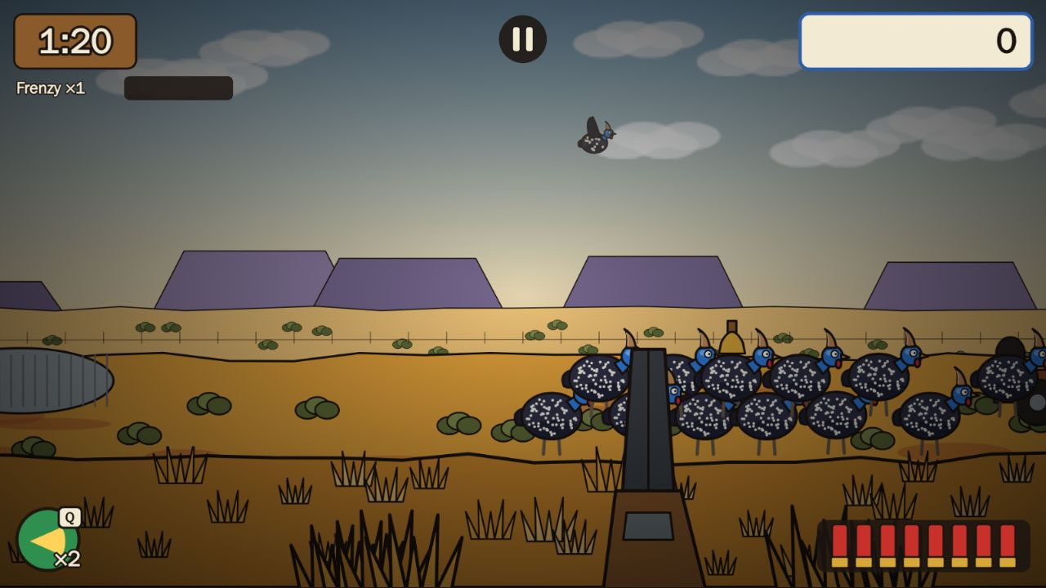
M9: the quality tiers add a vignette and colour grade.

Version 1.0

M10 — v1.0.0, ready for a soft launch
When: 22 Oct 2026, 01:25 · Pull requests: #22–#29 · Decision: D-027
What it added
- An asset pipeline with one switch between final and placeholder art; an audit of every asset.
- Recorded audio with a fallback, music and ambience per area; a juice pass on the tally and the Stampede.
- A capture mode for trailers, self-hosted fonts, visual regression tests, and the portal submission kit.
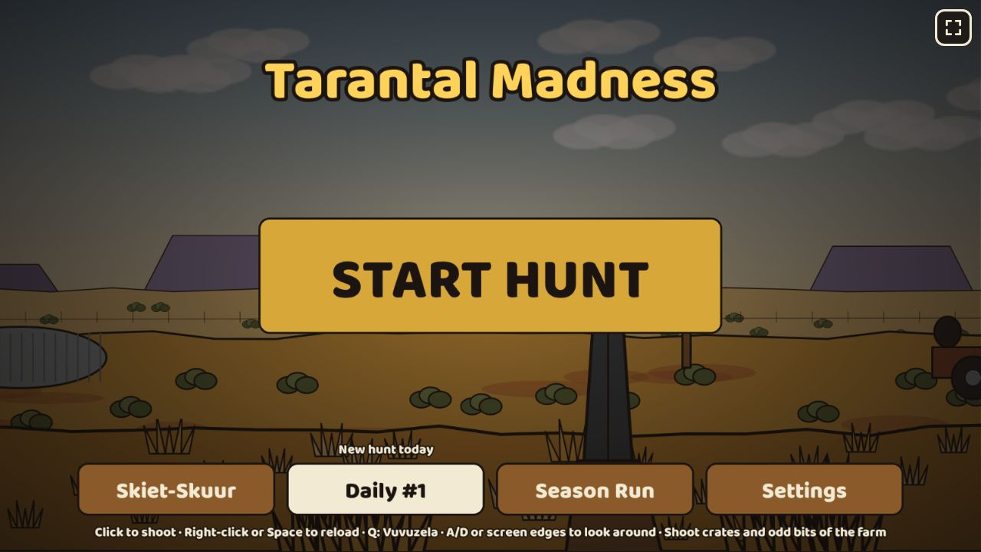
v1.0.0: the title screen (visual test baseline).
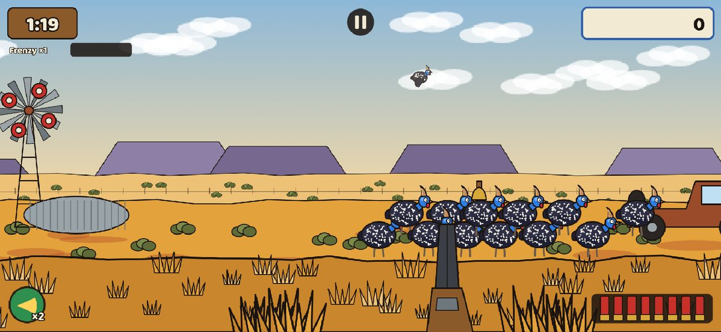
v1.0.0 on an iPhone-sized screen.

v1.0.1 — Clean-up
When: 22 Oct 2026, 08:34–14:19 · Pull requests: #30, #31, #33, #34, #37, #38 · Decision: D-028
What it added
- The public build keeps the Daily unranked until launch; the Daily start date is one content value.
- Faster score pops; a key hint in capture mode.
- Oupa’s barks: 43 lines as text now, voice later.
- A balance check across all modes (no changes needed).

Faster delivery
When: 22 Oct 2026, 16:04 · Pull requests: #39 · Decision: D-030
The product owner found the build loop too slow. Tests on a pull request went from about 48 minutes to about 15.
What it added
- A quick test lane on pull requests and the full suite on every merge to main.
- Tests run inside the official Playwright image (installing browsers had cost up to 22 minutes per job).
- Working rules: one or two pull requests per job, check-ins every 20 minutes, and a stalled agent turn is restarted at once.

The look

Graphics pass 1 — detailed guns and guineafowl
When: 22 Oct 2026, 16:45–17:19 · Pull requests: #32, #35, #36 · Decision: D-029
An art generator and atlas pipeline, six first-person guns with recoil and reload, and detailed guineafowl. Human art can replace it later.
What the product owner asked for
Birds looked grey and washed out → back to dark slate with bright cobalt faces so they pop against the veld.
The shotgun read as a stubby revolver from behind → redrawn as a long double-barrel pointing into the scene.
Download size and memory rose sharply → trimmed for low-end phones.
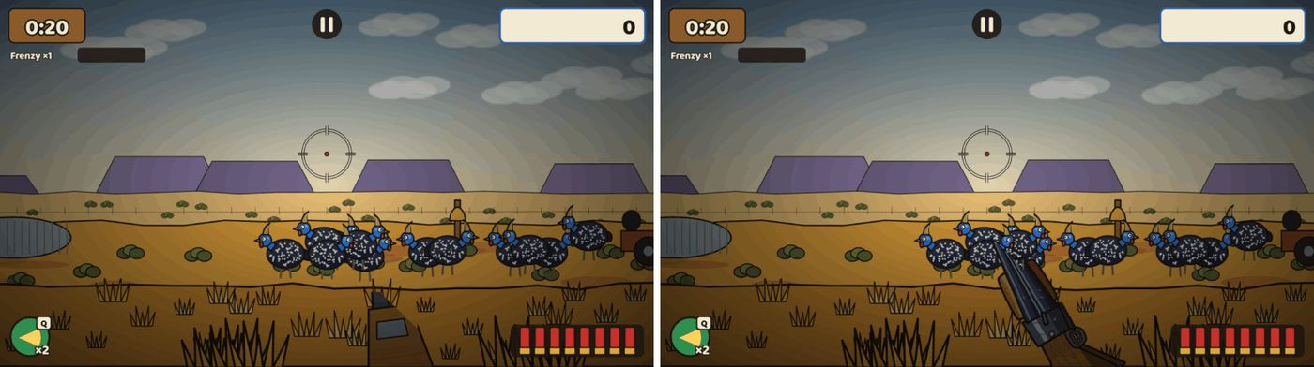
Before | after: the Dubbelloop.
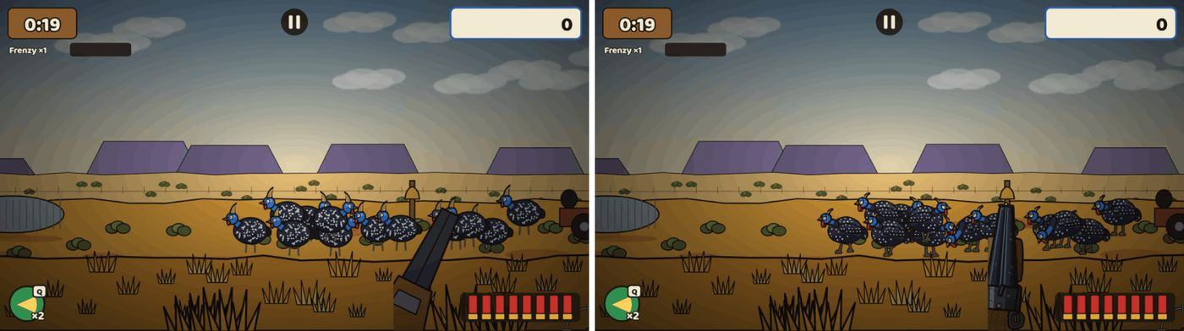
Before | after: a foraging flock.
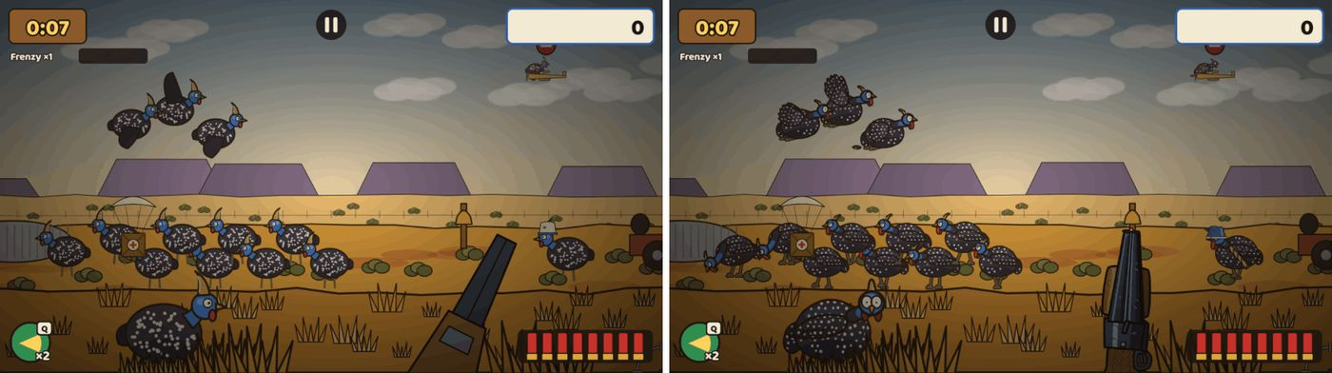
Before | after: the boss Generaal.

The long-range plan
When: 22 Oct 2026, 18:54 · Pull requests: #40
The product owner’s list after graphics pass 1 became an approved plan (docs/08), split into v1.1 to v1.4.
What the product owner asked for
Ammo on screen must match each gun and look real: shells, stones, air-rifle pellets, .22 rounds.
Sound effects are very important.
The crosshair should change per gun.
A .22 long rifle, targets much further away, iron sights, peep sight and a low-power scope with zoom.
Voices for Oupa through a text-to-speech subscription (needs the product owner’s account; later).

Graphics pass 2 — landscapes for all four areas
When: 22 Oct 2026, 23:18 and 23 Oct 00:05 · Pull requests: #41, #42 · Decision: D-031
Interim landscapes, props, other creatures and effects for the Karoo, Bushveld, Kalahari and Okavango.
What the product owner asked for
Grass was stamped in a repeating pattern → varied tufts, stones and stalks in irregular clusters.
Bushes were flat green blobs → twiggy Karoo bossies with light and shadow.
The sky was plain → an autumn gradient with soft cumulus.
A dark band behind the Kalahari dunes read as a glitch → a distant thunderhead.
"Karoo approved, carry on with the other areas" (22 Oct, evening), together with the standing instruction to keep development going around the clock.
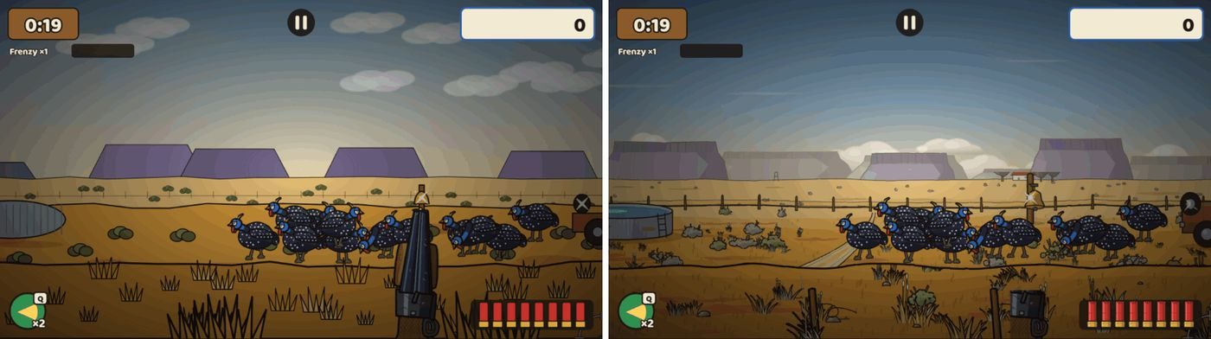
Before | after: the Karoo.
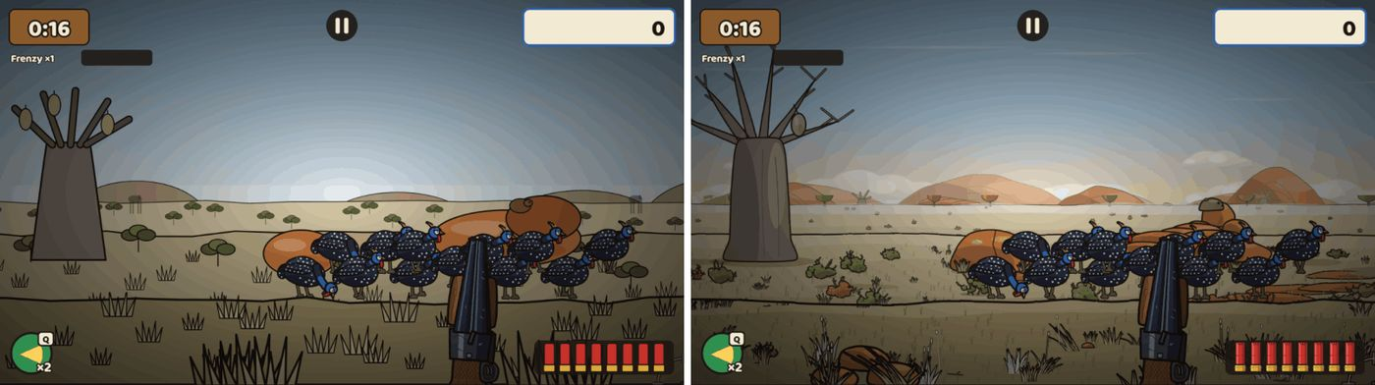
Before | after: the Bushveld.
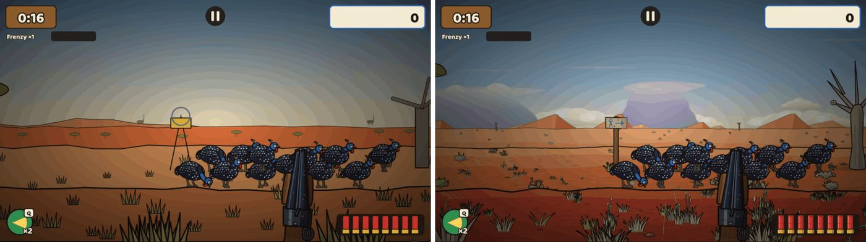
Before | after: the Kalahari.
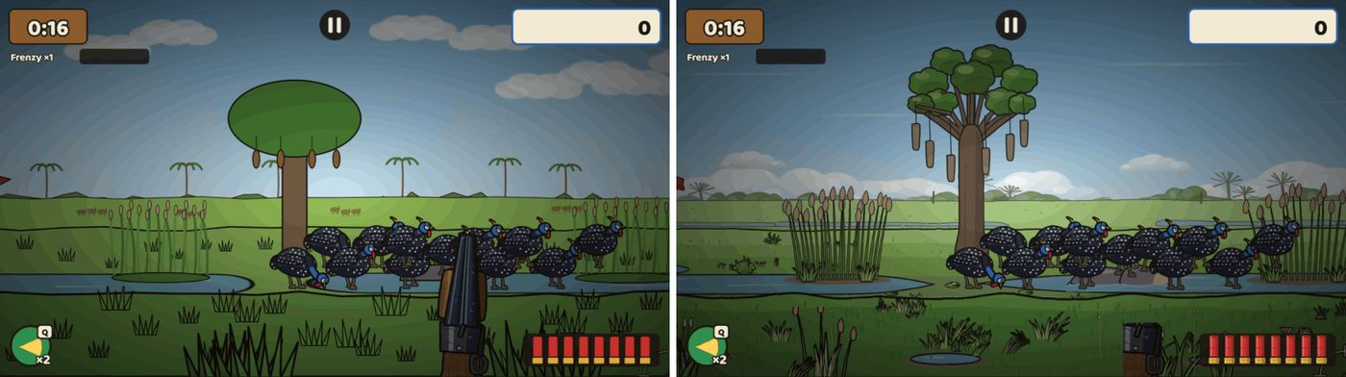
Before | after: the Okavango.

Version 1.x

v1.1 — Gun feel
When: 23 Oct 2026, 04:24 and 04:40 · Pull requests: #43, #44 (and #45: a CI fix) · Decision: D-032
What it added
- Realistic ammo per gun: shotgun shells, stones, air-rifle pellets, paper cartridges, a mielie-kernel hopper.
- A crosshair per gun that shows its spread; an offset crosshair on touch screens so the finger doesn’t hide the target.
- 30 interim sound effects, plus music and ambience for each area.
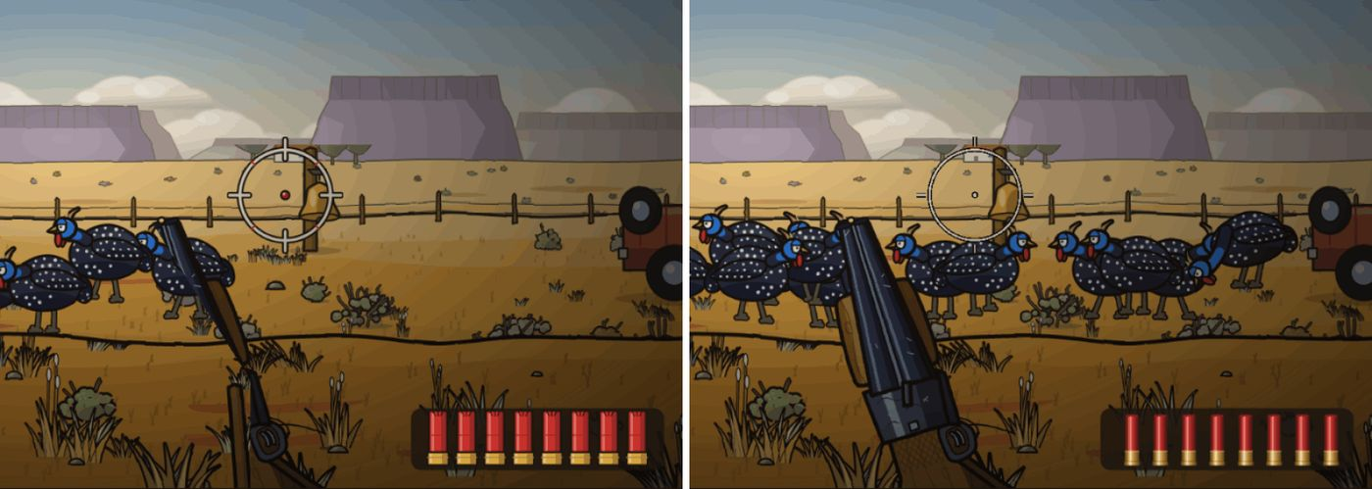
Before | after: the Dubbelloop’s shells and crosshair.
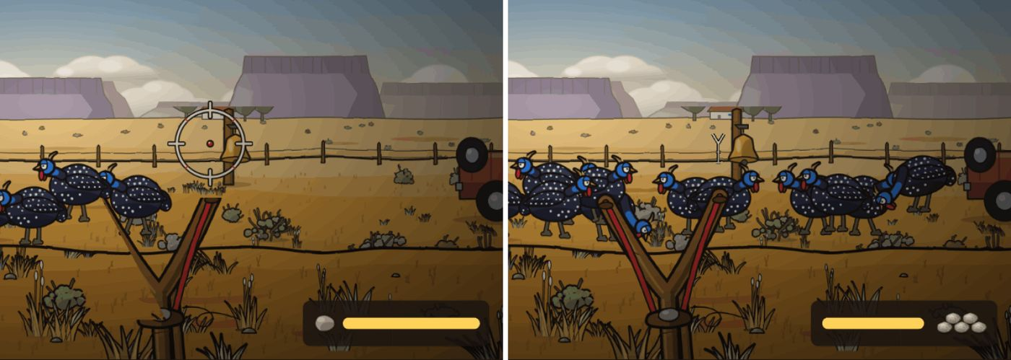
Before | after: the Kettie’s stones and crosshair.
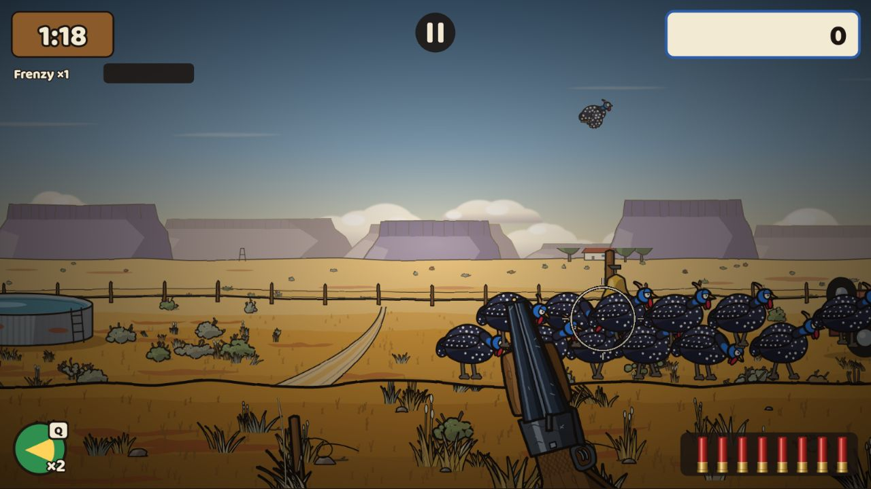
v1.1: the shotgun crosshair over the flock.

v1.2 — Day-of-week maps and the bonus map Verder
When: 23 Oct 2026, 11:57 · Pull requests: #47 (includes #46) · Decision: D-033
Look review before merging
Claude’s look review: make each weekday’s light clearly different (Monday haze, Tuesday clear midday, Wednesday overcast, Thursday golden afternoon, Friday dusty wind, Saturday dusk, Sunday bright); give Saturday a real dusk glow; vary the feeding spots. All done before merging.
What it added
- Seven layouts per area, one per weekday (UTC): light, props, feeding spots, fly-over routes and weather change.
- Classic and the Daily play today’s map; replays and challenge links remember it.
- Beat the day’s target to unlock Verder, a bonus map further out; it resets at midnight UTC.
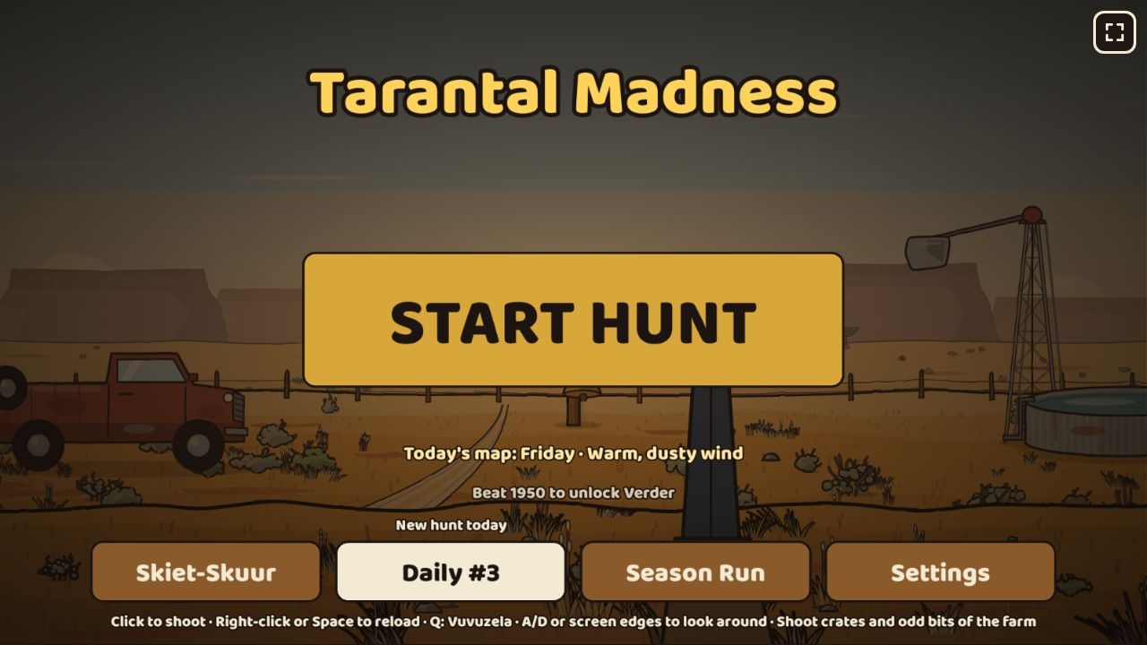
v1.2: the title names today’s map and the score that unlocks Verder.
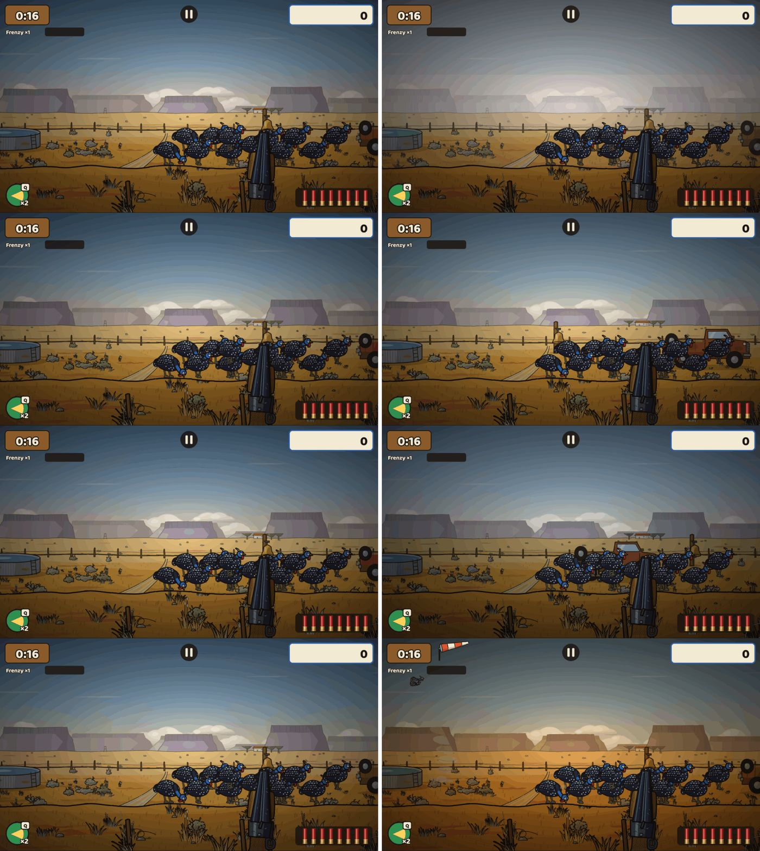
The Karoo, Monday to Thursday.
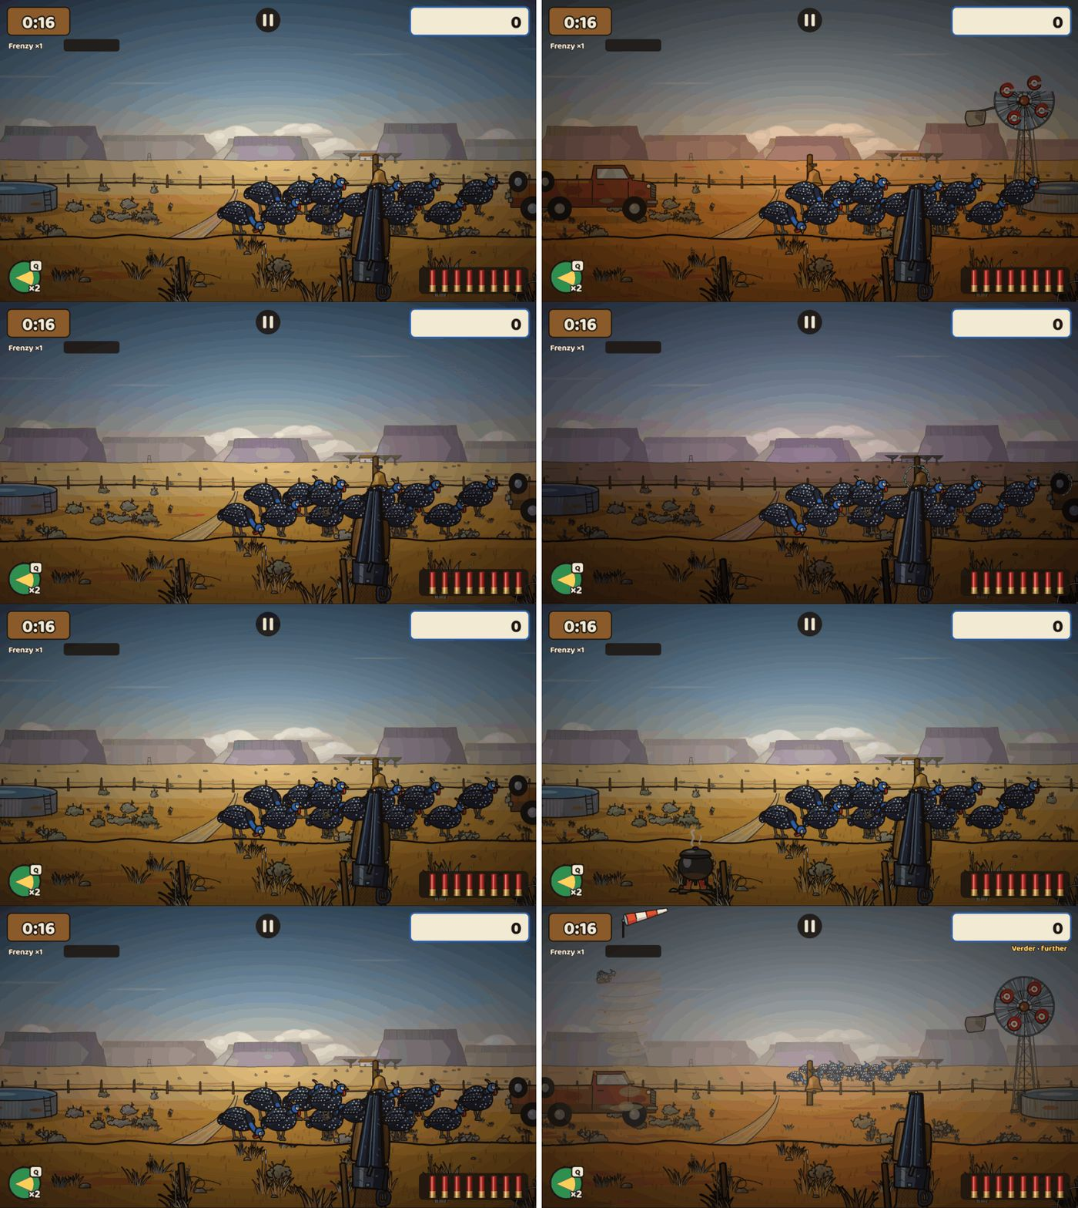
The Karoo, Friday to Sunday and Verder.
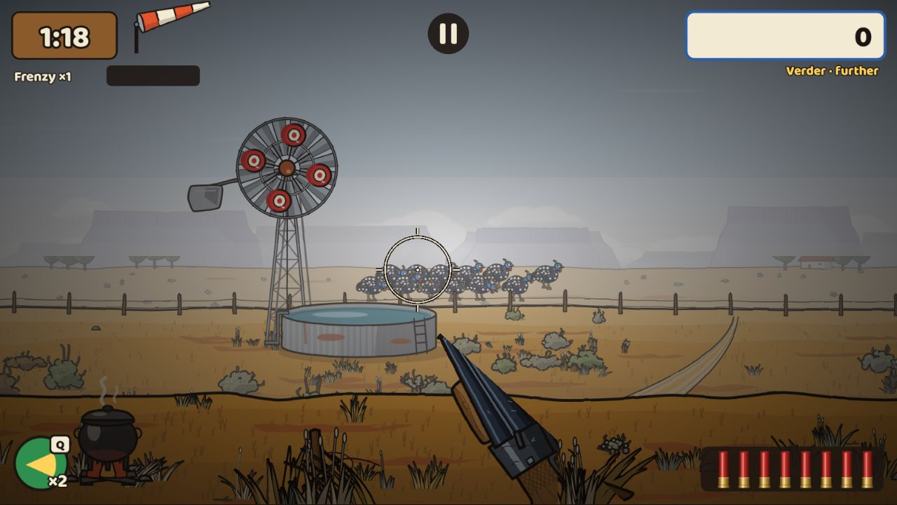
Verder: the flock far out at the horizon, in haze.

Playtest admin page
When: 23 Oct 2026, 13:30 (requested 11:50, live 13:32) · Pull requests: #48 · Decision: D-034
Open the test site with ?admin=1 to reach every level directly.
What the product owner asked for
"I want an ADMIN url that I can activate in my browser that enables access to all the levels to test them … select a level, review and test them one by one and give feedback." (spelling tidied)
What it added
- Lists all 49 levels: each area plain, its seven weekday maps and Verder, the Daily on any date, and every Season Run stage.
- Choose the gun, seed, hunt length and weather; Play; come back to rate it (OK or Needs work, 1–5 stars, notes).
- "Send to GitHub" opens a pre-filled feedback issue; "Copy report" copies it. Admin hunts never touch normal progress. Web test build only.
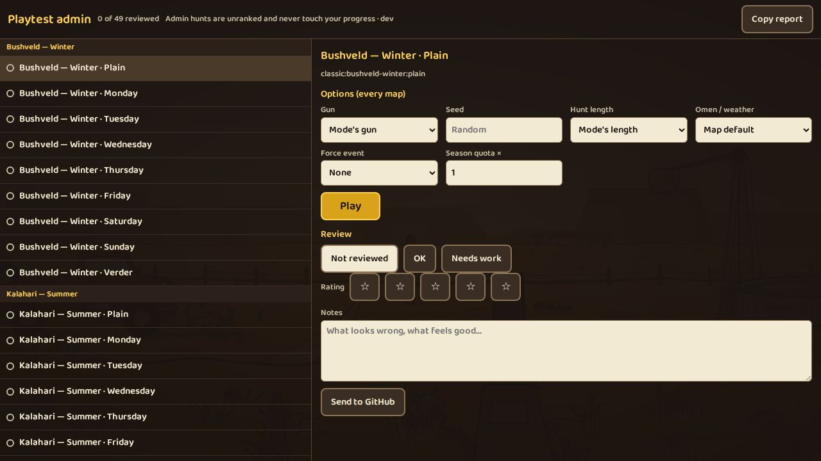
The admin page: every map grouped by area and day, with options, review, stars and notes.

Speed tests run alone
When: 23 Oct 2026, 14:10 · Pull requests: #50
A low-end-phone speed test kept failing on the shared test machine. Run alone, the frame cost is 11 ms against a 20 ms budget, so the game itself was fine; the test now runs in its own job.

Graphics pass 3 — towards semi-realistic
When: 23 Oct 2026, 17:58 (started 11:59) · Pull requests: #49 · Decision: D-035
What the product owner asked for
"The farmhouse seems half cut, layers issue. Also the mountains can’t all be flat, look at mountains in Namibia and make them more interesting. The car detail needs to be better. And the detail on the guns needs a more realistic touch, they look too cartoony; the same applies for the birds. I see there is even a bird that has no texture at all." (23 Oct, about 11:40; spelling tidied)
What it added
- Round 1 (done 15:05): the farmhouse stands whole; every area has varied, Namibia-inspired hills (layered mesas, granite domes like Spitzkoppe, a massif like the Brandberg); a detailed old bakkie with no badge; finer guns and guineafowl; the bird with no texture was the kwêvoël (grey go-away-bird) and is now textured.
- Round 2 (done 15:36, after Claude’s review notes): guns without cartoon outlines, with fine wood grain, blued steel, a real stock shape and a slim pump slide; a hump-backed, egg-shaped guineafowl with a small head on a slim barred neck, a small eye, ringed spots and a soft edge; rounded, lopsided koppies instead of cones; Kalahari dunes with curved crests and slip faces.
- Code review fixes (done 17:33): the gun shed draws small picture icons instead of loading whole gun image sheets (about 1 MB instead of 16 MB or more; 101 MB in total after a hunt on a low-end phone, against a 128 MB limit); the last near-black gun edges went; the bakkie’s spare wheel now hangs where it can be seen and shot.
- Merged at 17:58 with all tests green: 851 unit tests, first download 2.9 MB of 3 MB. The game’s rules did not change.
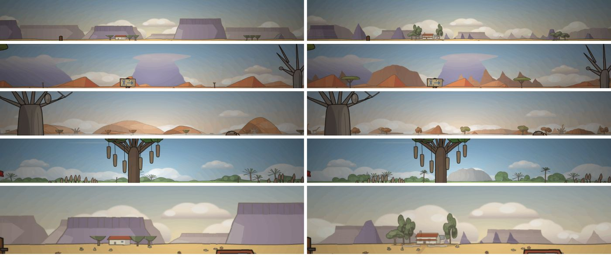
Round 1, before | after: hills in the Karoo, Kalahari, Bushveld and Okavango, and the farmhouse.
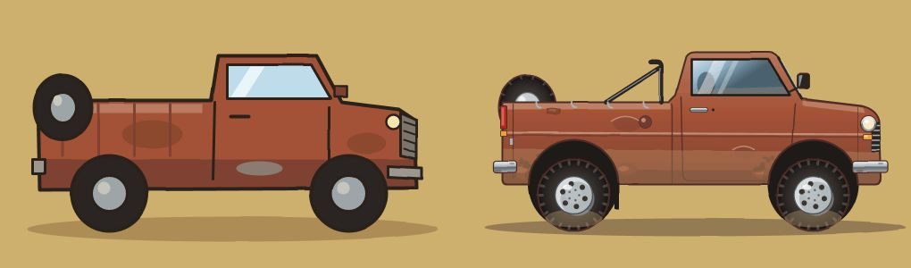
Round 1, before | after: the bakkie.
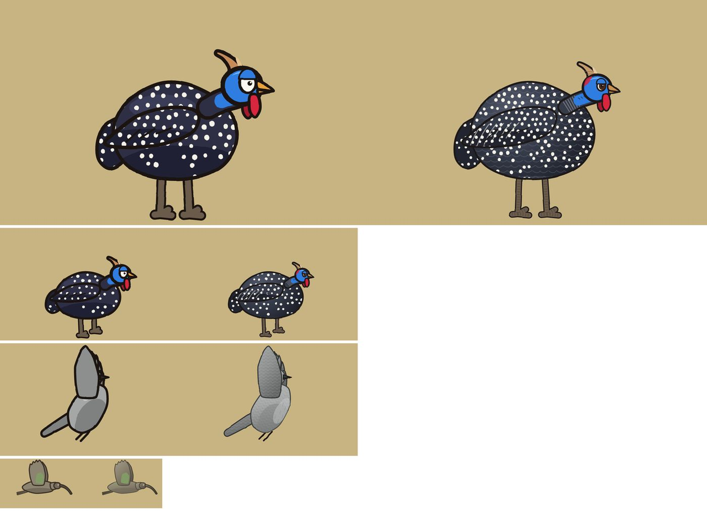
Round 1, before | after: guineafowl (near and middle distance), the kwêvoël and the hadeda.
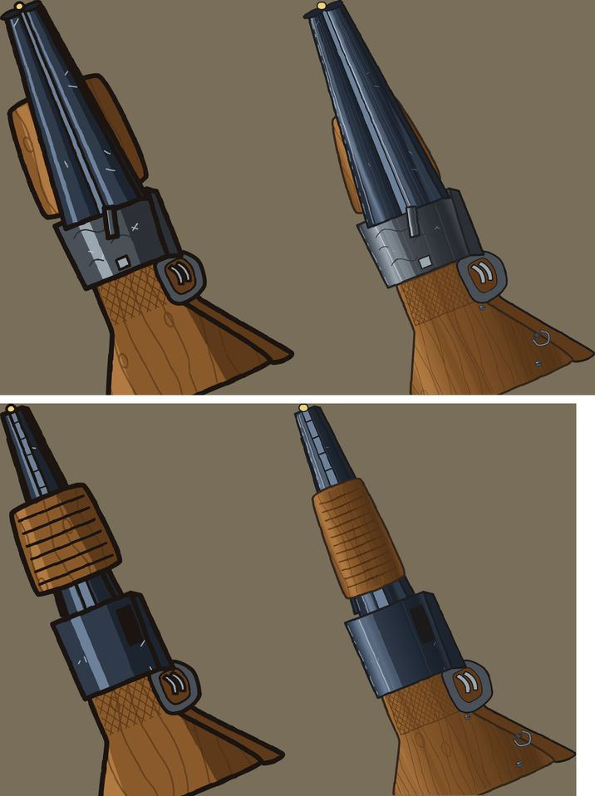
Round 1, before | after: the Dubbelloop and the Pomp.
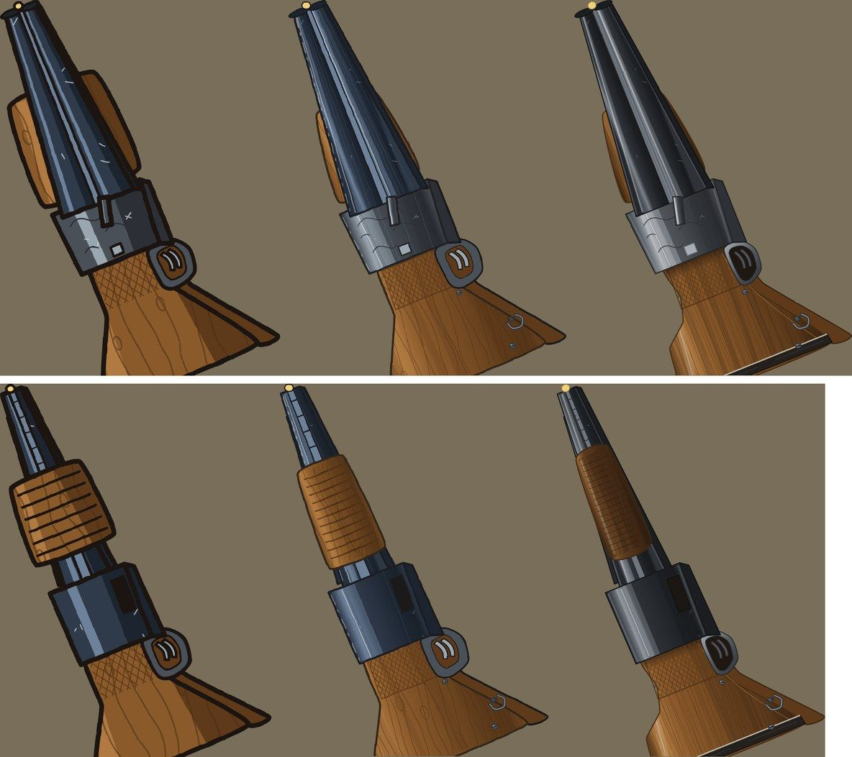
v1.2 | round 1 | round 2: the Dubbelloop (top) and the Pomp (bottom).
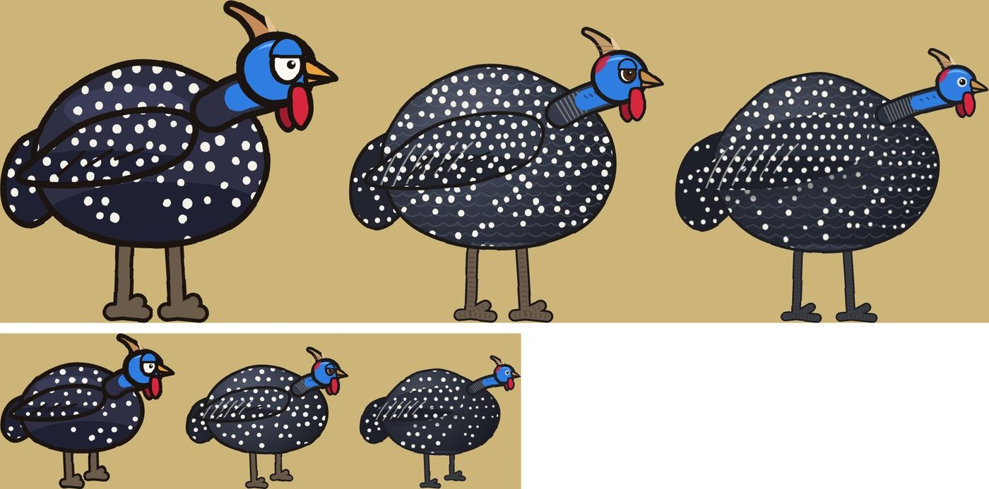
v1.2 | round 1 | round 2: the guineafowl near (top) and at middle distance (bottom).
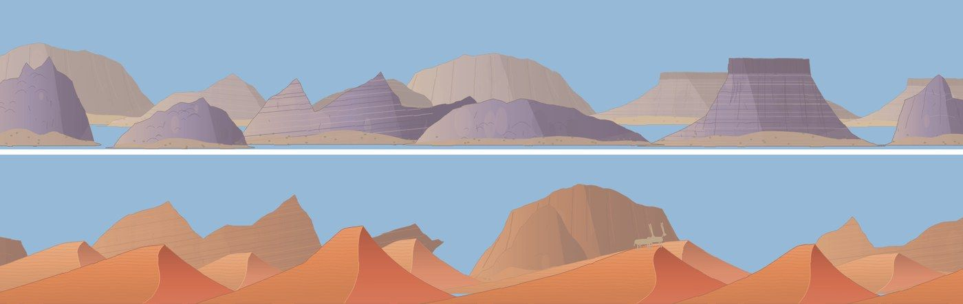
Round 2: rounded Karoo koppies (top) and Kalahari dunes with curved crests (bottom).
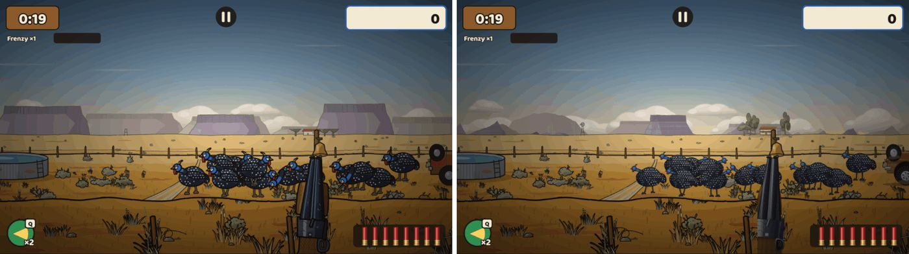
Before | after, in the game: the Karoo at the start of a hunt.
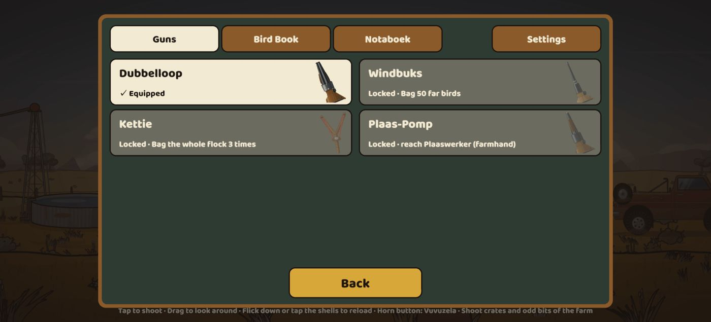
The Skiet-Skuur gun cards with their new pictures, on an iPhone 14 held sideways.

Screenshot baselines recorded on GitHub
When: 23 Oct 2026, 21:20 · Pull requests: #55 · Decision: D-030
The visual tests compare each screen with a stored screenshot. Those reference screenshots are now taken by GitHub, not on the build server.
What the product owner asked for
"yes, let GitHub record the screenshot baselines" (23 Oct, about 20:50)
What it added
- Label a pull request update-baselines (or start the workflow by hand): GitHub renders the screens in the same browser image as the tests, commits the ones that changed to the branch and re-runs the tests.
- The heavy screenshot container no longer runs on Tank’s server, which had been the slowest step there, and every machine now compares against the same pictures.

v1.3 — Long range: the Ver plane, sights and zoom, Die Twee-Twee
When: 24 Oct 2026, 02:24 (started 23 Oct, 18:00; part A merged 02:14) · Pull requests: #53, #54 · Decision: D-036
The first rifle. A new farthest layer of the landscape that only rifles can reach, sights that zoom when you hold, and two harder bonus maps.
Look review and independent review before merging
Claude’s look review: the scope and peep looked right; the iron sight’s rear leaf covered too much of the view and its front post was a hairline. Redrawn with a slim leaf and a broad, lit post; the dark area fell from about 35–40 % of the view to 13–15 %.
The independent review found that the rifle test bot never shot crates or secrets, so the first balance figures were wrong. With the bot fixed, the .22 and the bonus maps were retuned (Nog Verder ×0.6, Die Verste ×0.46). It also restored the approved rule that Die Verste needs a scope and fixed the bonus-map names, a mid-hunt stutter when a crate gun loaded, the rifle hints in four languages and the replay tool’s file format.
Speed: the scoped view passes its CPU budget on desktop and Pixel 7. On the phone profile it draws about 2.6 times the pixels of an open hunt, because the far layers all fill the screen when zoomed in; that is tracked in issue #56 for a check on a real phone before v1.4’s stronger scope.
What it added
- Memory first: gun pictures are freed after a hunt on low-end phones, so the game stays under their 128 MB limit (about 106 MB at most, down from 125 MB after a hunt with both crate guns).
- The Ver plane: a farthest layer with its own flocks, feeding spots and fly-overs, reachable only with a rifle.
- Hold to raise the sight and zoom, let go to fire; sway and a breath hold. Iron sight 1.5×, peep 2×, small scope 4×. Sliding onto the ammo (touch) or right-clicking (mouse) lowers it without firing.
- Die Twee-Twee (.22, 5 rounds) with three sights fitted in the Skiet-Skuur and unlocked through rank and the Notaboek.
- Bonus maps Nog Verder and Die Verste; Die Verste needs a rifle with a scope, and its button says so.
- Replays of zoomed shots play out identically on desktop, Pixel 7 and iPhone.
- Balance (500 hunts per bot): the .22 scores below both shotguns on the plain maps (3 971 / 3 849 / 3 620 with iron / peep / scope, against 4 180 and 4 306); on the bonus maps every gun stays under 4 500. First download 2.94 MB of 3 MB; 908 unit tests.
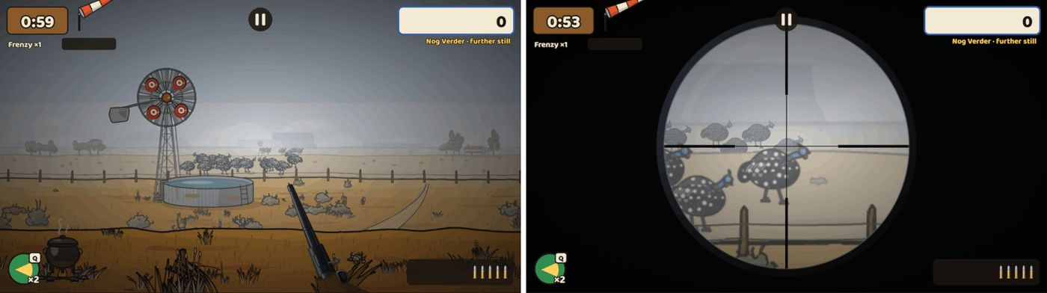
Open view | small scope 4× on Nog Verder, held on a Ver flock (desktop).
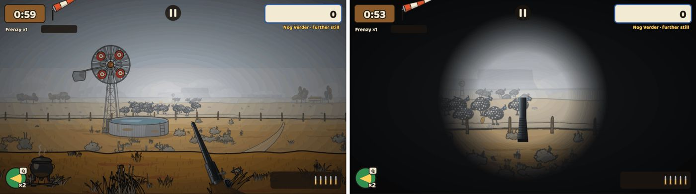
Open view | peep sight 2× (desktop).
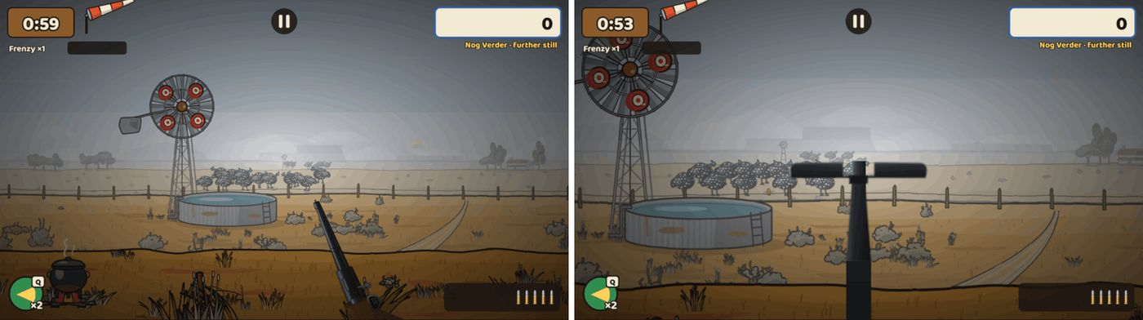
Open view | iron sight 1.5×, after the redraw (desktop).
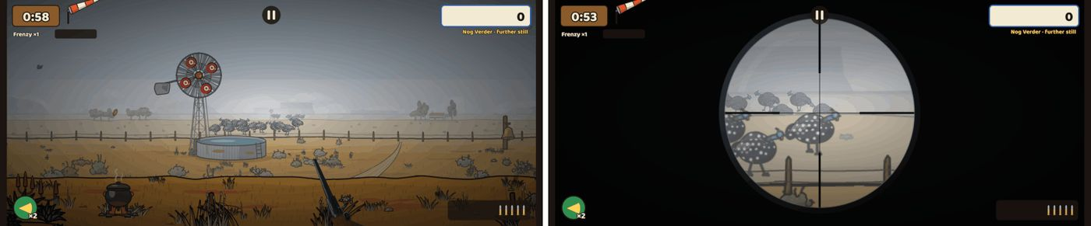
The small scope on a Pixel 7 held sideways.
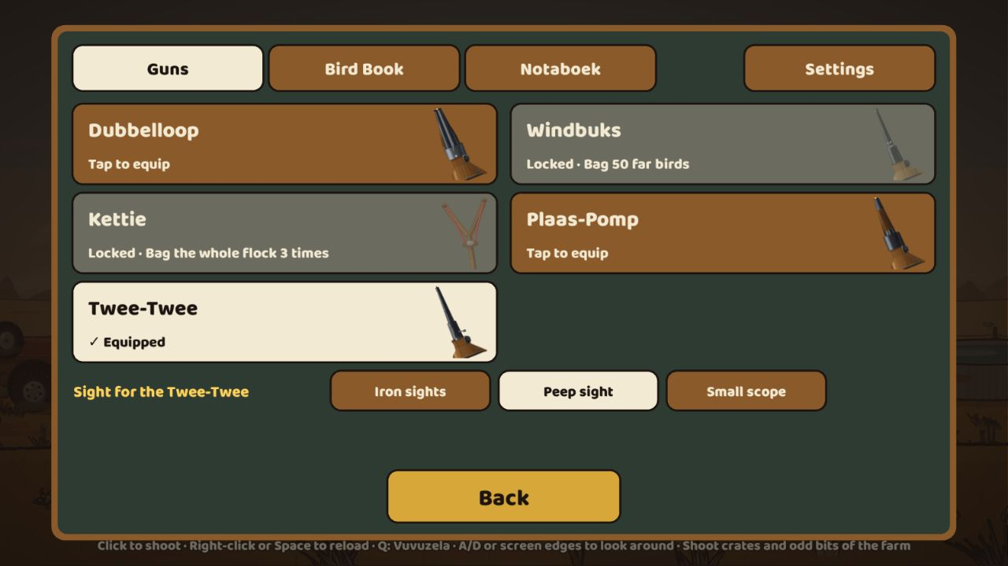
The Skiet-Skuur: the Twee-Twee with its three sights.
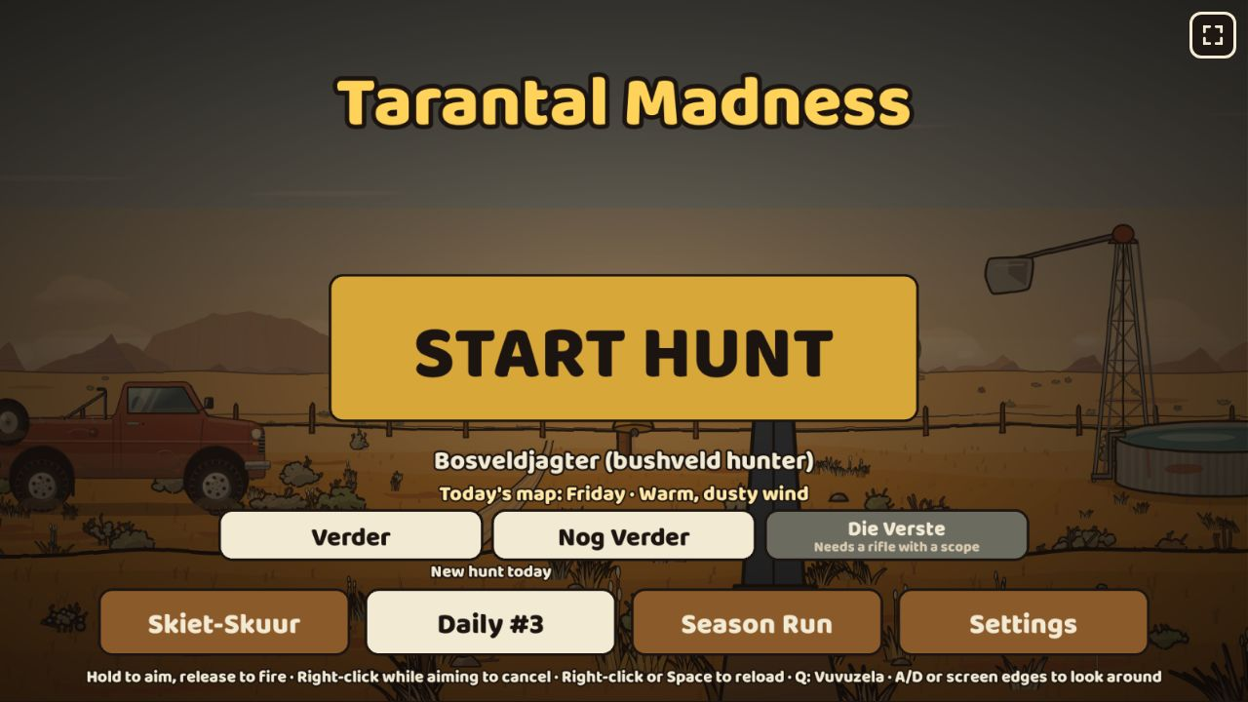
The title: Die Verste locked until a scoped rifle is fitted; the rifle hints along the bottom.

Training ground (Skietbaan)
When: 24 Oct 2026, 05:38 (started 02:25) · Pull requests: #58 · Decision: D-037
A shooting range on the admin page: try any gun, locked ones too, at any distance and see exactly how it shoots, without the pressure of a hunt.
Look review and independent review before merging
The independent review found the code sound: hunts, Daily seeds and challenge links are unchanged (the range is left out of the content fingerprint), the portal builds are clean and the save is never written.
Claude’s look review on the phones: Start was off the bottom of a Pixel 7 screen, the page jumped back to the top after every tap, and the stats box hid the flying birds. Now Start sits in a footer with a summary of the choices, the page keeps its place, the stats shrink to a small box that lets taps through, and hunt-style score labels no longer show on the range. A browser test now also shoots a flying bird.
What it added
- Pick a gun (all 9, including the Twee-Twee with each sight and the two crate guns), an area, a distance (near, middle, far or Ver; guns that can’t reach Ver say "out of reach") and a target: a paper target, a standing bird, a flying bird or a small flock.
- It runs on the real game engine, so every hit is exactly what a hunt would give: no timer, score, Frenzy or penalties, endless spare ammo but reloads as normal. A test replays a range session twice and gets the same result.
- Statistics per gun and distance: shots, hits, misses, hit %, shotgun pellets on target per shot; on paper, the last 20 holes are drawn with the group size (also as a % of a guineafowl’s width at that distance) and where the group centres against the aim. Reset and "Copy report".
- It never touches the save: a browser test compares every stored value before and after a session, byte for byte.
- Only in the GitHub Pages test build, from ?admin=1. The Poki and CrazyGames builds don’t contain it at all, and the size check fails any portal build that does. Its code loads only when opened (8.7 KB); the first download grew by 1.1 KB to 2.94 MB of 3 MB.
- Strings in English, Afrikaans, German and Dutch; browser tests on desktop, Pixel 7 and iPhone 14 held sideways.
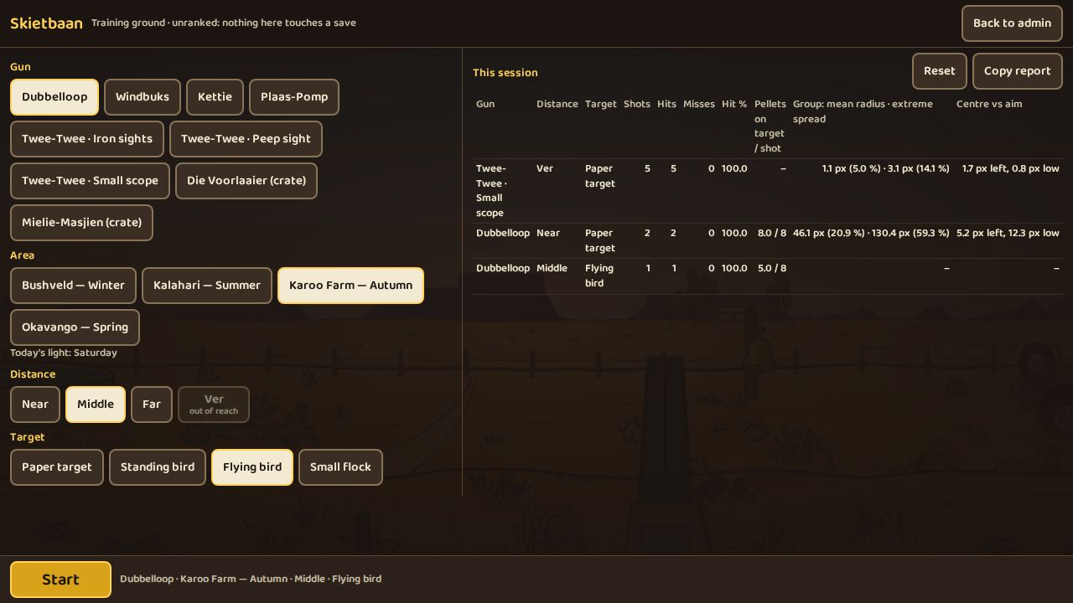
The setup page with the session table (desktop). Ver is "out of reach" for the Dubbelloop.
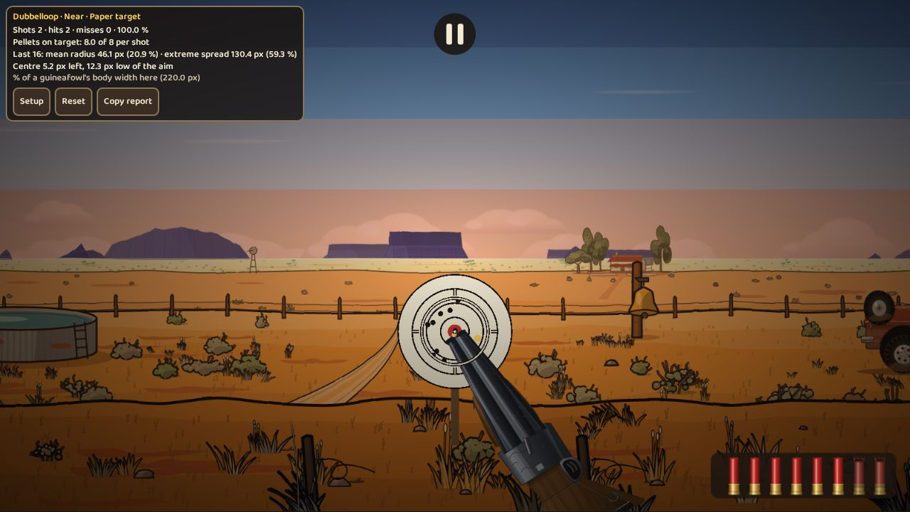
Dubbelloop at near on the paper target: 16 pellet holes from two shots, with the group size and centre.
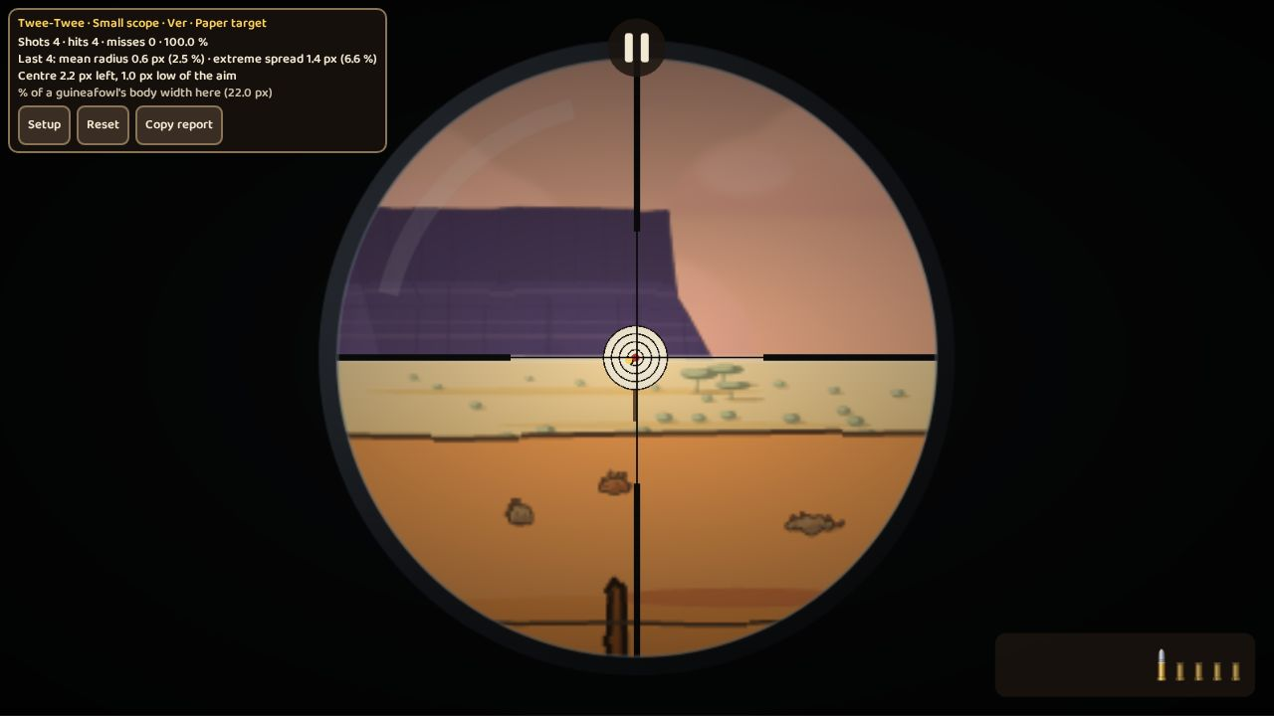
The .22 with the small scope at Ver: four shots inside 1.4 px.
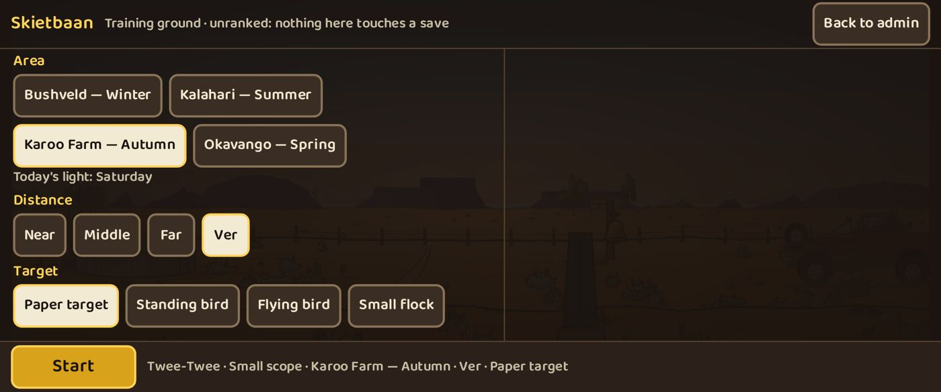
The setup page on a Pixel 7 held sideways, with Start in a footer that is always on screen.
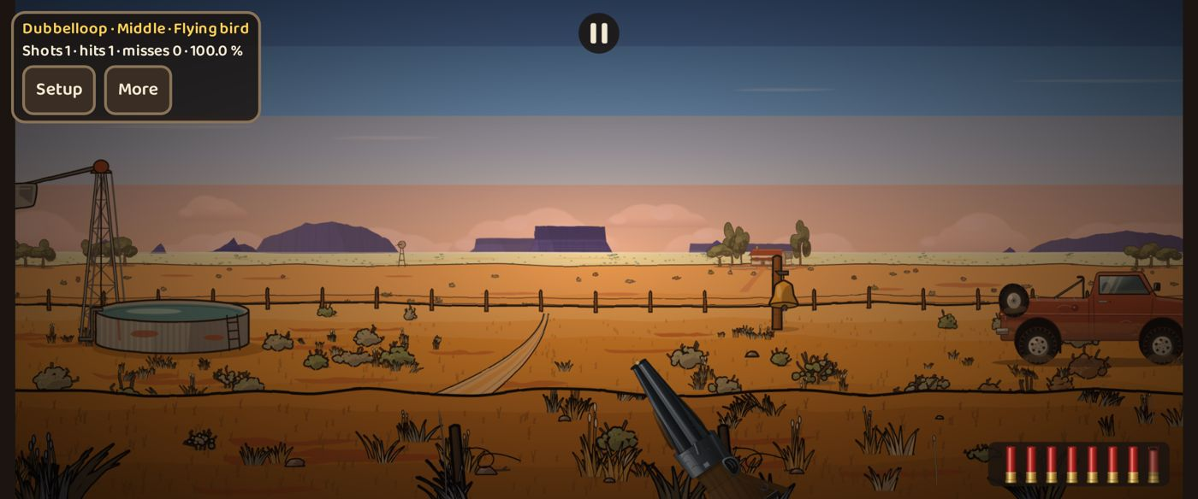
A flying bird bagged at middle distance on a Pixel 7; the stats shrink to a small box with "More".

Training ground update: mixed targets, steel plates, hit feedback
When: 24 Oct 2026, 10:21 (asked for at 05:45) · Pull requests: #61 · Decision: D-037 (update 24 Oct)
After the product owner played the training ground: more targets at once, every distance for every gun, and a clear reaction on every hit.
Look review and independent review before merging
The first Tank job kept losing its connection to Claude mid-turn; a fresh job with a short brief finished the work.
The independent review found that Kettie stones flew through paper targets and plates at near and middle distance, and that in about half of the mixed layouts a target stood behind a nearer one. Both were fixed: stones now stop on every target, the course was re-spaced, and a content check now rejects any layout where targets overlap. Rapid fire no longer floods the sound, and Shuffle always deals a new layout.
What it added
- Mixed course: paper targets, steel plates, standing birds, a fly-over and a small flock at near, middle, far and Ver at the same time. Shuffle deals a new layout; the layout comes from the seed, so it is the same on every device.
- Every distance for every gun: the Kettie or a shotgun can be tried at Ver. Their shots fall short as in a hunt and are counted as "fell short" in the stats.
- Steel plates: a gong on a post that swings and rings when hit, easy to read at long range where paper holes are too small to see.
- A reaction on every hit: paper blinks and thwacks, plates ring and swing, birds play a hit sound, and a HIT ring appears on the target, visible even at Ver without zooming. A miss shows a dust puff, or SHORT where the shot fell short.
- Stats count each hit for the gun, distance and kind of target it struck, and each miss for the target nearest the aim.
- First download +0.9 KB (2.94 MB of 3 MB); everything new loads with the training ground. 971 unit tests.
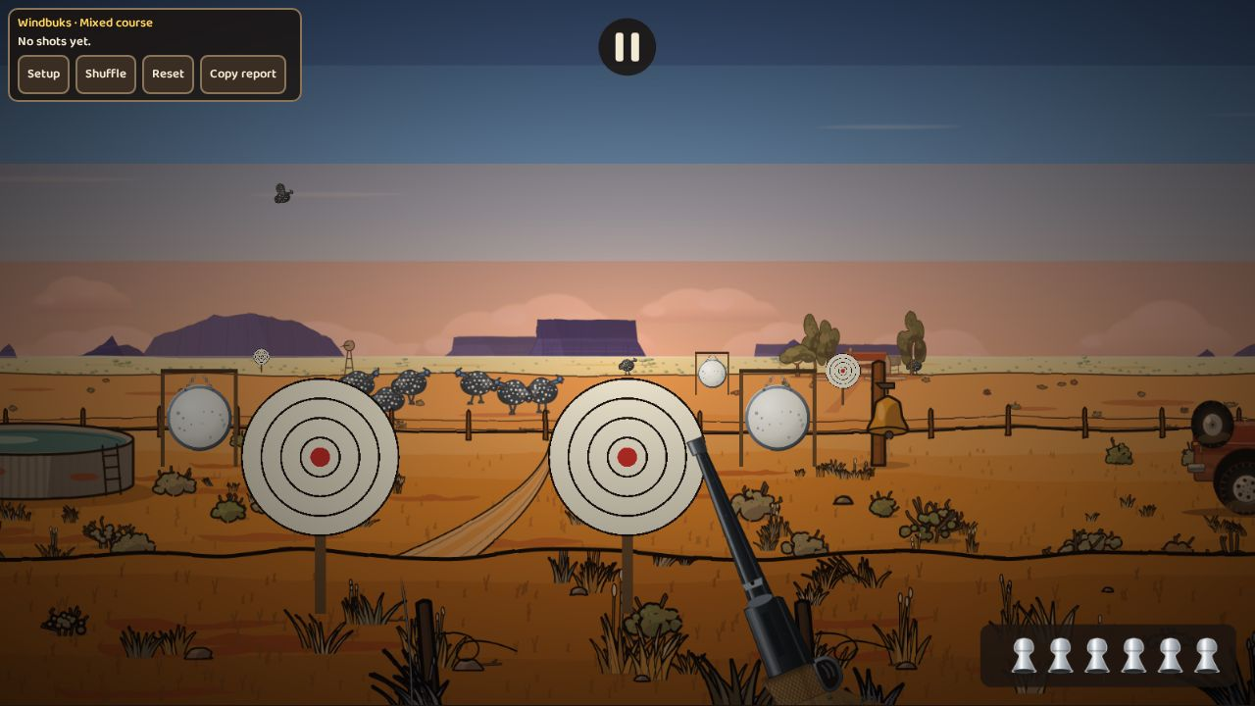
The mixed course: targets at all four distances at once (desktop, after the re-spacing).
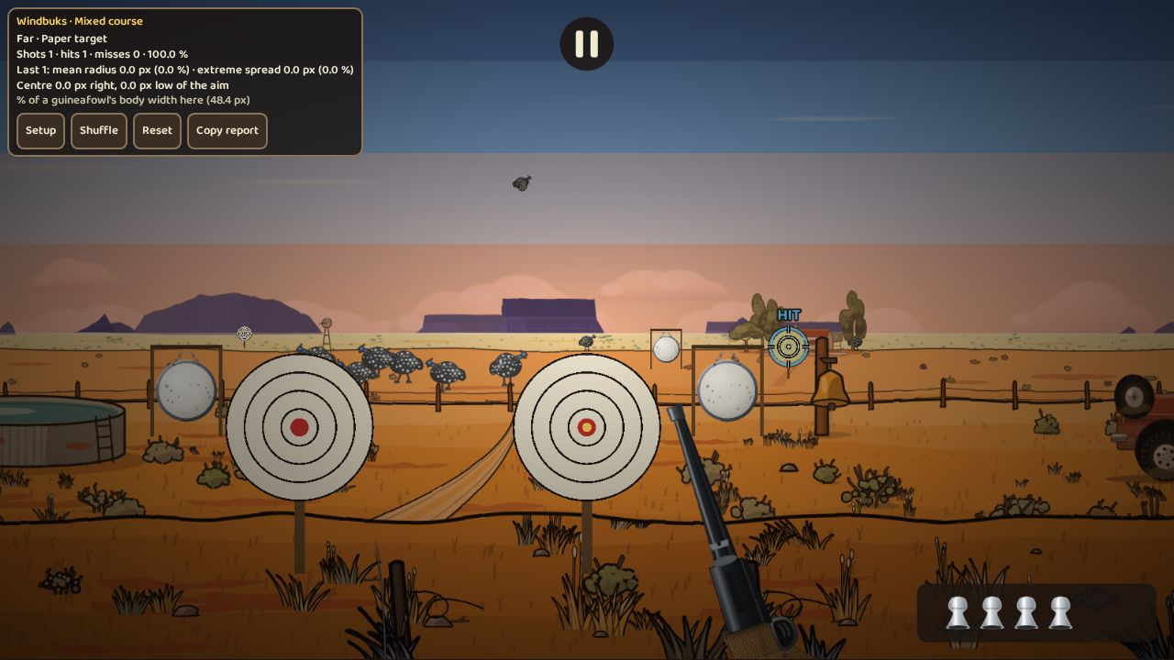
A hit on a far paper target: the HIT ring and the stats for that distance.
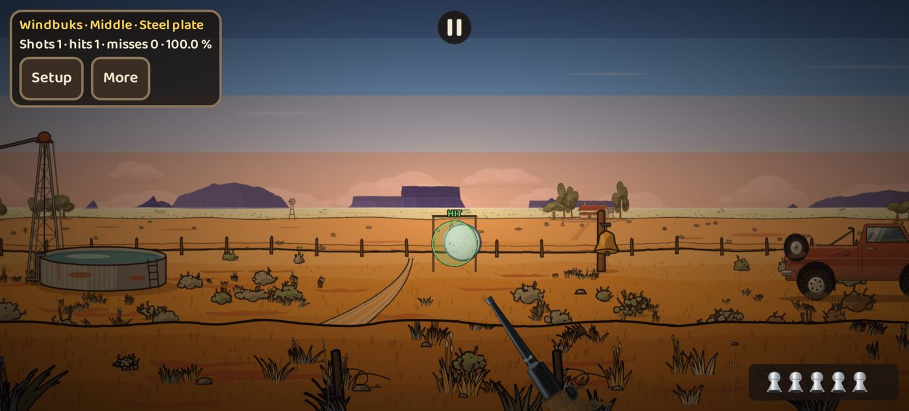
A steel plate hit at middle distance on an iPhone 14 held sideways.
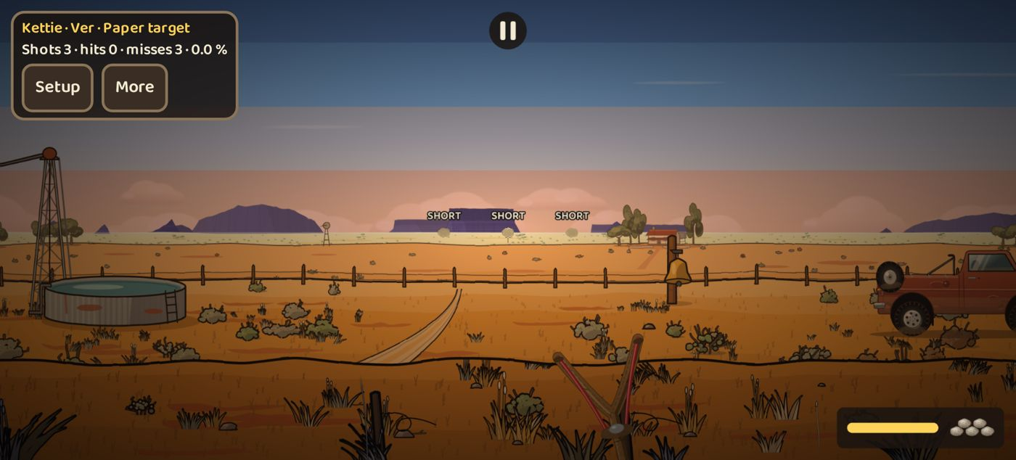
The Kettie at Ver: the stones fall short and each shot is marked SHORT.

v1.4 part A: Die Langloop and a faster scope view
When: 24 Oct 2026, 13:23 (started 05:40) · Pull requests: #60 · Decision: D-038
The long rifle from the approved long-range plan, after a fix for the scope view running slowly on phones (issue #56).
Look review and independent review before merging
Tank’s turns kept ending mid-step, and one earlier job lost its connection; a fresh job with a short brief finished the work.
Claude fixed two test problems on the way: a data file the browser tests could not load, and a dust devil that kept swaying in a frozen test frame.
The independent review found one gap: players who had already reached Die Verste in v1.3 would never get the Langloop. Claude fixed it, with a test, before merging. It also noted that the scoped .22 still scores slightly higher on the farthest maps; that is recorded as a trade-off for the product owner to decide.
What it added
- Faster scope view (issue #56): while zoomed, the game skips drawing what cannot be seen. On the Pixel 7 test profile the scoped view went from 1.33× to 0.78× the cost of the open view, and a browser test checks the picture is unchanged.
- Die Langloop: a long rifle with 3 rounds, a 0.8 s bolt and a 1.5 s magazine change. It reaches the farthest (Ver) birds and scores ×2 there.
- Variable scope at 3×, 6× and 9×: the mouse wheel or +/- keys on desktop, −/+ buttons beside the ammo on phones. Each step is recorded, so a replay comes out the same on every screen.
- Very loud: every shot alerts every flock, so the player picks the bird before pressing.
- Unlocked the first time Die Verste is unlocked in any area. Players who had already reached Die Verste get it on their next hunt.
- Brass cartridges with pointed bullets and an empty case when spent, a thin crosshair, and interim gun art and shot sound.
- Balance over 500 hunts per bot: below both shotguns on the plain maps and under the 4 500 cap on the long-range maps. First download 2.89 MB of 3 MB; 994 unit tests.
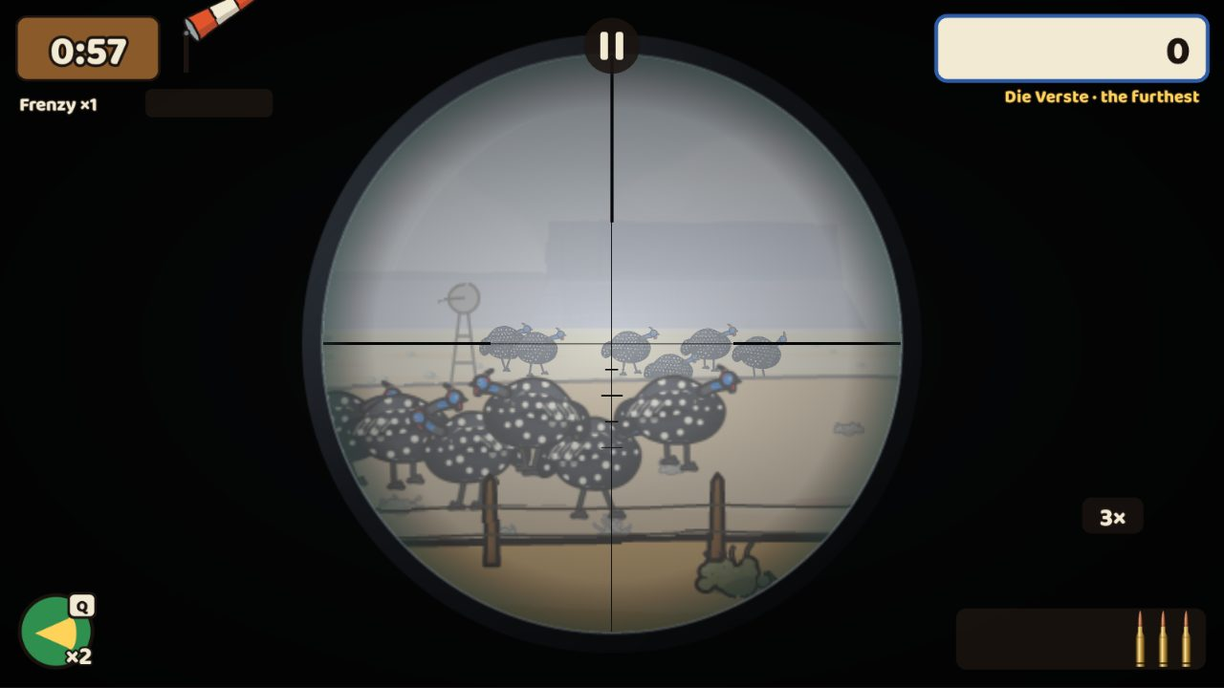
Die Langloop at 3× on Die Verste (desktop): the scope ring, the fine cross with range marks, and 3 brass cartridges.
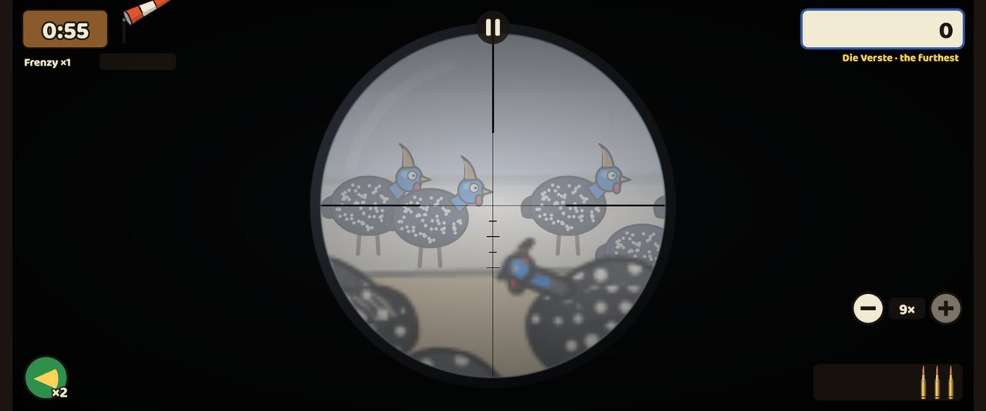
At 9× on a Pixel 7 held sideways, with the −/+ zoom buttons beside the ammo.
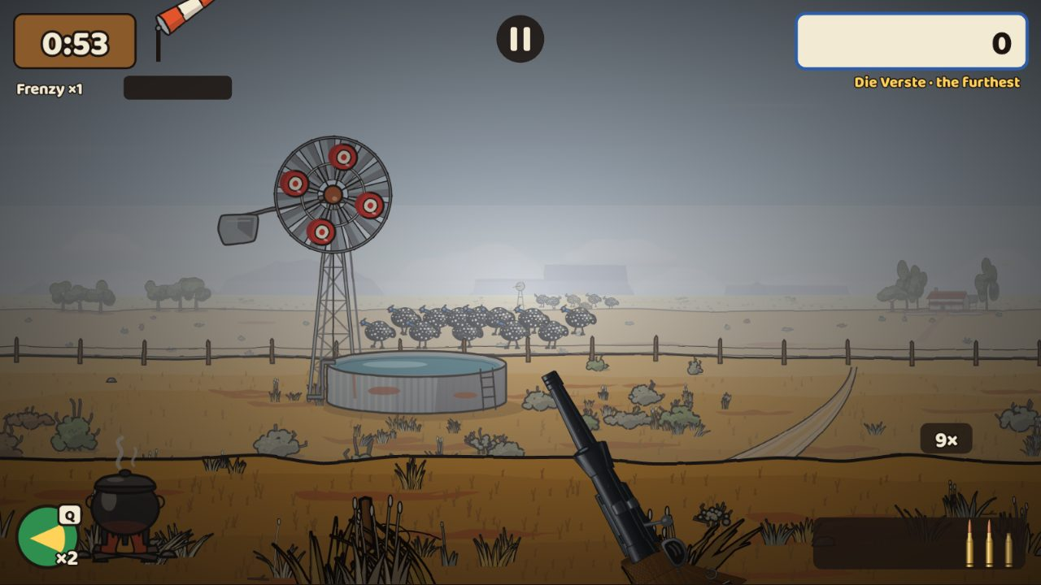
Open view after one shot: two cartridges left and an empty case.
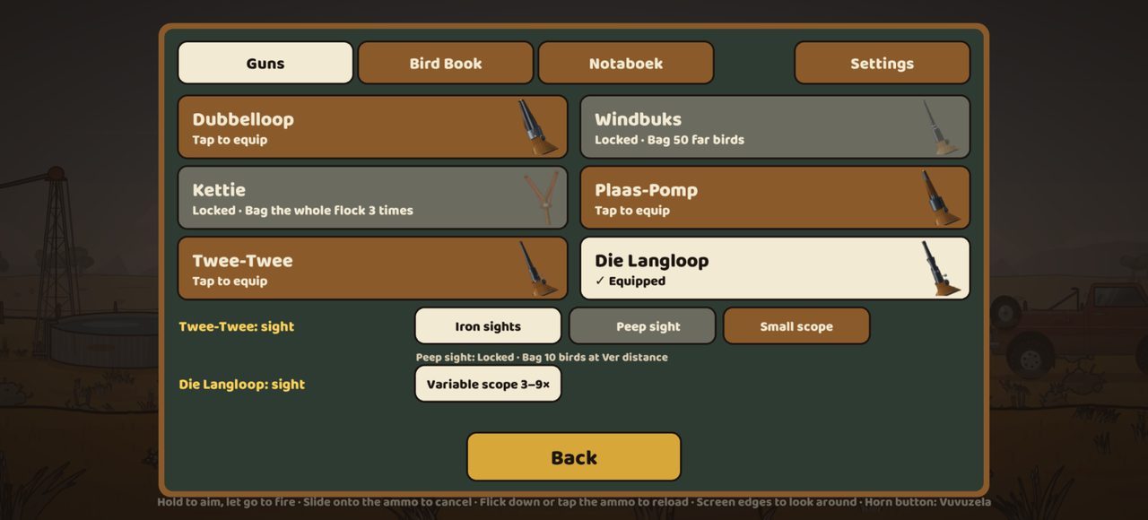
The Skiet-Skuur on an iPhone 14: Die Langloop equipped, with its variable scope row.

v1.4 part B: the Namibië pack, camelthorn trees and the family nest, angry weavers
When: 24 Oct 2026, 21:36 (started 24 Oct, 12:40) · Pull requests: #64 · Decision: D-039
A fifth hunting area, built for long range, and the first props drawn at the new, higher quality bar.
Look reviews, independent review and fixes before merging
Product owner (24 Oct, 12:05): "the graphics of that nest is terrible … increase quality by 500 %". The trees and nest were redrawn first and shown as close-ups for approval before the rest of the area was built.
The independent review found four things, all fixed before the merge: the waterhole tree hid part of the far flock at the opening view (moved; a new check proves 0 % hidden), the scoped .22 scored over the cap, the bonus maps could open in the wrong area, and older saves could miss the unlock.
Tank’s own browser tests kept overloading its server, so Claude took over the screenshot runs (desktop, Pixel 7 and iPhone 14) and the balance sweeps.
What it added
- Camelthorn trees drawn in layers: furrowed bark lit and shaded on every limb, zig-zag branches, an umbrella crown of feathery clumps with sky between them, grey seed pods and dappled shade. The product owner approved them on 24 Oct.
- The sociable weavers’ family nest: a domed haystack with over 2 000 straws, a hanging fringe and 10–20 entrance holes underneath. Branches pass through it and leaves grow over the top.
- Angry weavers: shooting the nest costs 10 points and sends 6–15 small birds pouring out of the holes; they swirl, a few dart at the camera, and settle back after about 4 seconds. Their flight is worked out from the hunt itself, so replays show the same birds.
- Namibië: the white Etosha salt pan, red Namib dunes, quiver trees, camelthorns and a waterhole flock far out on the pan. Every weekday map opens the farthest (Ver) plane; on Tuesdays, Thursdays and the bonus maps the far birds shimmer in a mirage.
- It unlocks for good once Die Verste is reached in any area. The title screen gains an area picker that shows Namibië locked, with how to unlock it.
- Balance: every gun and sight was measured over 200 hunts on all seven weekday maps and Saturday’s three bonus maps. A new per-plane points setting brought the scoped .22 (the strongest) under the 4 500 cap everywhere; its worst map is now 4 421.
- First download still within the 3 MB budget; 1 027 unit tests.
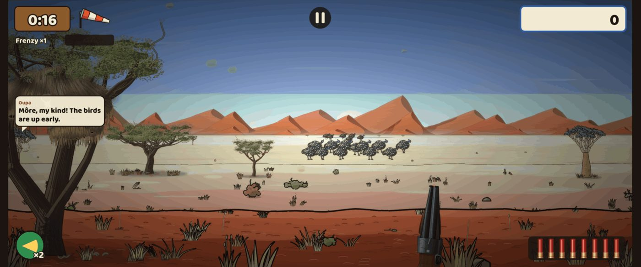
Namibië on a Pixel 7 held sideways (Tuesday): the salt pan, the Namib dunes, quiver trees and the waterhole flock out on the pan.
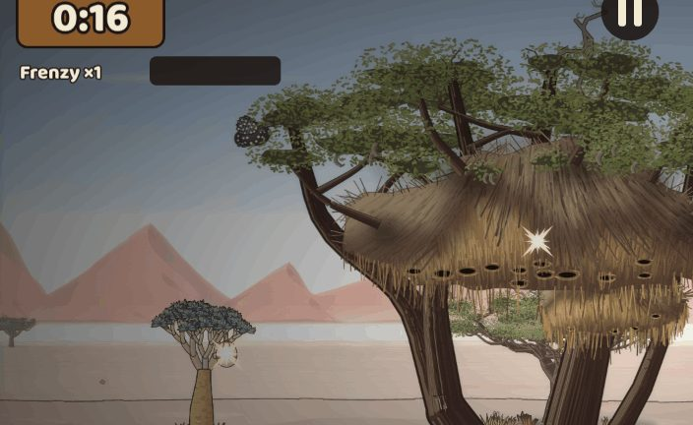
The family nest in its camelthorn (desktop close-up).
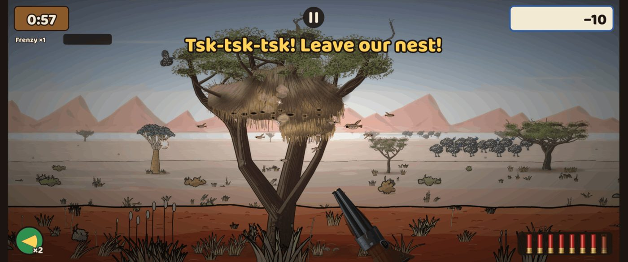
The nest shot: angry weavers pour out and Oupa’s nest bark appears (Pixel 7).
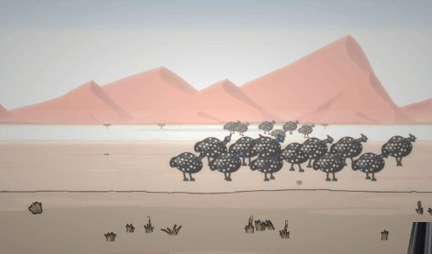
After the review fix: the waterhole flock stands clear of the trees at the opening view.
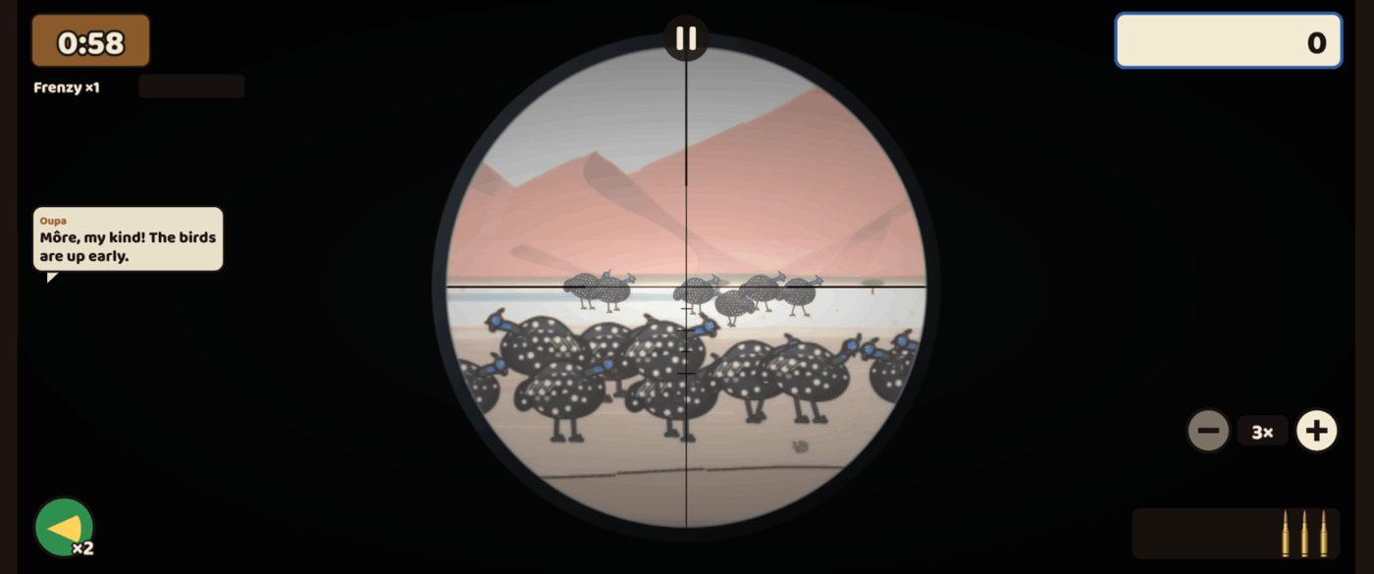
The waterhole flock through Die Langloop’s scope (Pixel 7).
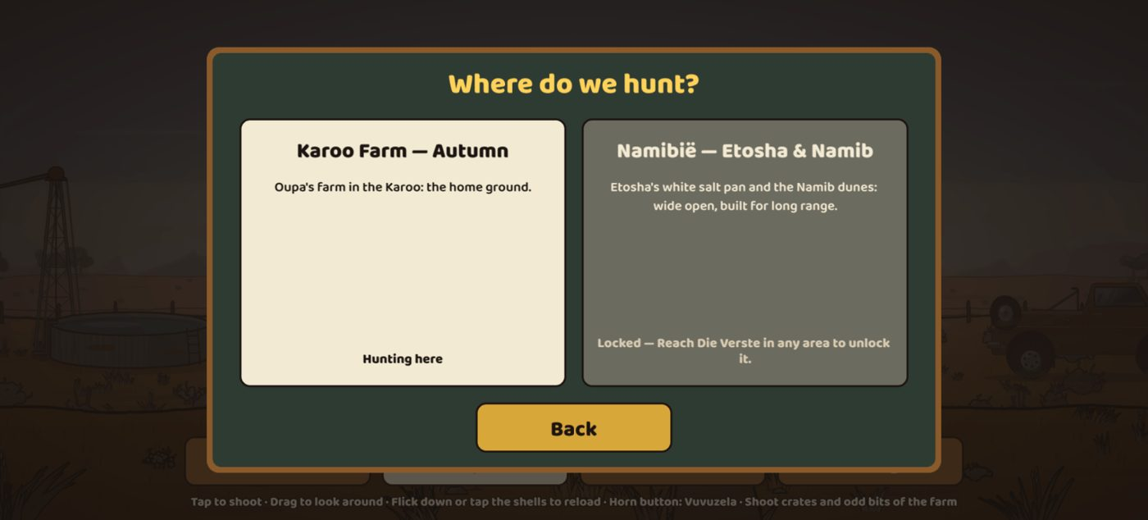
The new area picker on an iPhone 14: Namibië locked until Die Verste is reached.

Skietbaan gongs: clean steel plates with lasting hit marks
When: 25 Oct 2026, 00:25 (started 24 Oct, 21:37) · Pull requests: #66 · Decision: D-040
The product owner asked for clean steel gongs on the training ground, with every shot visible for the whole session.
Reviews and fixes before merging
Product owner (24 Oct, 17:45): "The metal gongs need to be clean. And when shot, the shot should be visible and stay visible during the session. I want to see consistency."
The independent review found that the plate drawn before its picture loaded came out blank, a test that could not catch the bug it was meant for, marks shared between courses, and gun sizes written into the code instead of the gun data. Tank fixed all of them.
Claude’s screenshots showed no targets at all. A browser check found the cause in the tests rather than the game: the test mouse rested at the screen edge, which scrolls the view, so the shots went where the plate used to be. The tests now reload with a key and fail loudly if the view moves.
What it added
- A freshly painted plate every visit: the fake "old hits" baked into the plate picture are gone. The plate has a clean bevelled steel rim and chains, and hangs from a timber frame with grain and bolts, drawn at double resolution so it stays sharp in the 3–9× scope.
- Every hit leaves a lead-splash mark exactly where the bullet struck: a silver star with a dark centre and small flecks, sized by the gun. A shotgun pellet leaves a small mark, the .22 a medium one, and the Langloop and Kettie a large one. Each mark’s shape comes from the shot itself, so a replay draws the same marks.
- Marks swing with the plate, and the newest one glints for a moment.
- Steel and paper follow one rule: every mark and hole stays for the whole visit, through gun swaps, the scope and switching distances (paper used to show only the last 20). New buttons clear them on purpose: Repaint, New paper and Fresh targets.
- Up to 400 marks per target are baked into one picture, so phones stay fast.
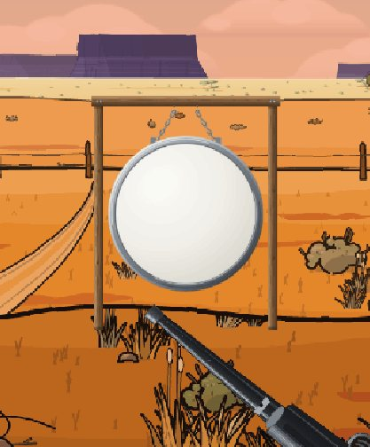
A freshly painted gong on its timber frame (Pixel 7 close-up).
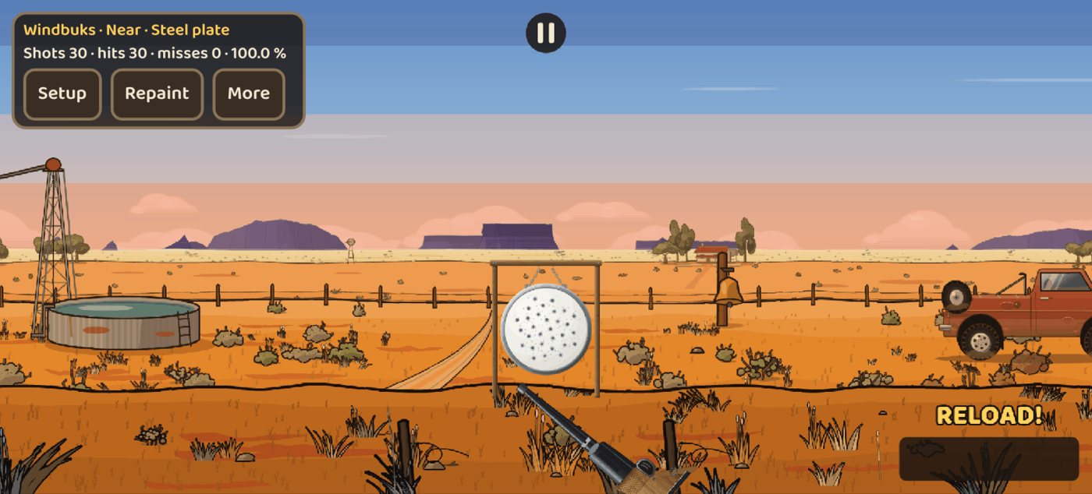
After 30 shots with the air rifle: 30 hits, every mark still there (iPhone 14 held sideways).
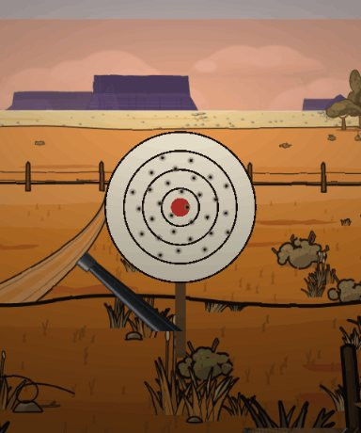
Paper with 30 holes: paper now keeps every hole too.
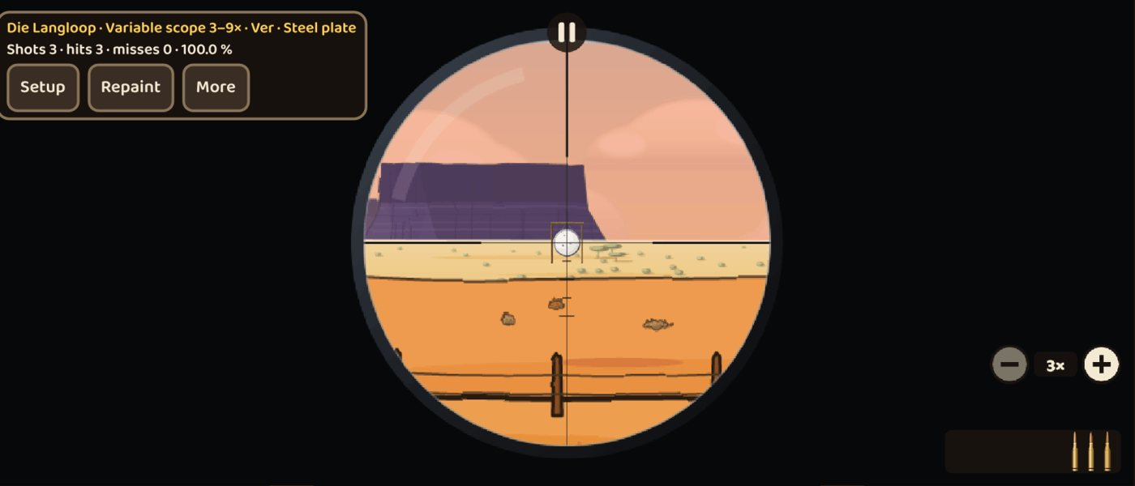
A gong at the farthest distance in Die Langloop’s scope (Pixel 7).

v1.5 Languages: text, voice and names for every audience
When: 25 Oct 2026, 04:39 (started 25 Oct, 00:28) · Pull requests: #68 · Decision: D-041
The product owner wanted the game, the voice and the names in English, Afrikaans and German, so it works for more audiences.
Reviews and fixes before merging
Product owner (24 Oct): "I want options to have game and voice either German, English, Afrikaans. And text. Adjust also names accordingly, as the game needs to cater for multiple audiences."
Claude reviewed the names table before any files changed (German "Season Run" became "Saisonjagd").
The independent review found six things, all fixed before the merge: Oupa’s first greeting was usually silent because the voice was still loading, a test never proved a voice line was heard, a failed download was never retried, an old language’s voice stayed in memory, a stray build file was committed, and the setting hints were too small to read on phones.
On GitHub, a new voice test failed on the slow phone runner because it read Oupa’s line twice and the line had already gone. Claude fixed the test.
What it added
- Two separate settings: the text language (Auto, English, Afrikaans, German, Dutch) and the voice language (Same as text, English, Afrikaans, German). You can play with an Afrikaans voice and English subtitles. Dutch text uses the Afrikaans voice, the closest match.
- Every name now has a proper English, German and Dutch version: guns, maps, the Gun Shed, the Notebook, the Bird Book, birds, secrets, charms, ranks and helpers. Dubbelloop becomes Double Barrel in English and Doppelflinte in German; Afrikaans keeps the farm names. Place names stay as they are.
- An "Afrikaans names" switch keeps the Afrikaans flavour names in any language, for players who like them.
- Oupa now speaks: his 43 comments and the short scolds are voiced in English, Afrikaans and German. The voices are interim, made offline with free, commercially usable text-to-speech (Kokoro, Apache-2.0). No good free Afrikaans voice exists, so the Afrikaans lines are read by the English voice using Afrikaans pronunciation rules; they can be swapped for a real voice later.
- Only the chosen voice language is downloaded, after the first tap. Each voice pack is under 1 MB, and the first download is unchanged.
- Share cards, the Daily share text and the end-of-hunt tally follow the text language.
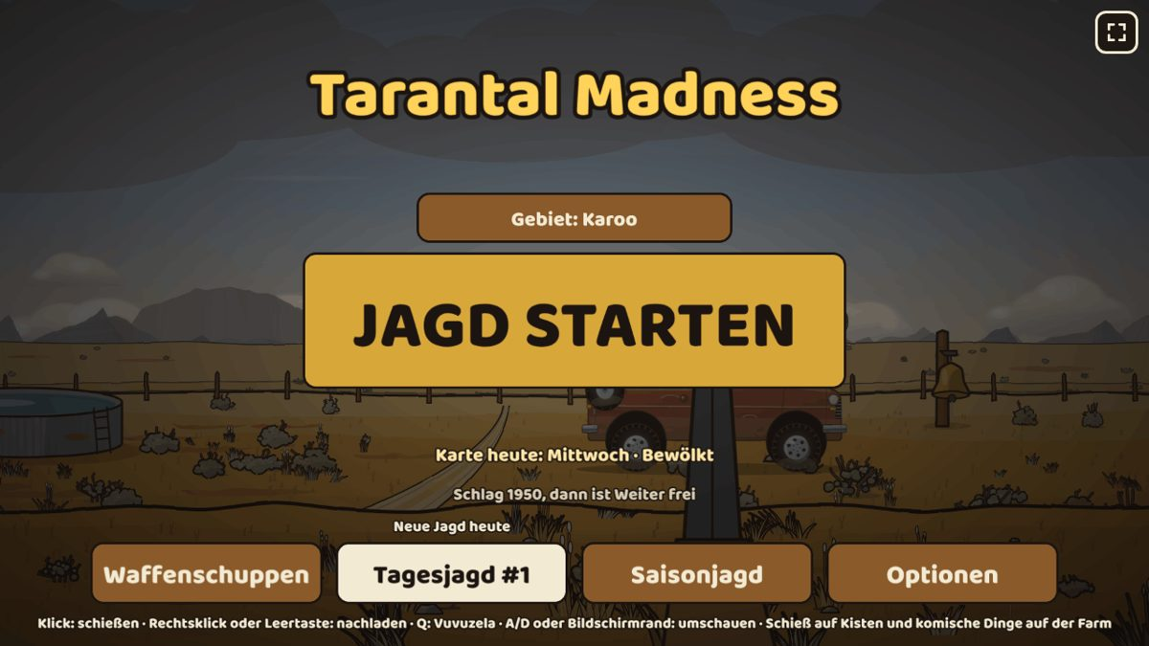
The title screen in German (desktop).
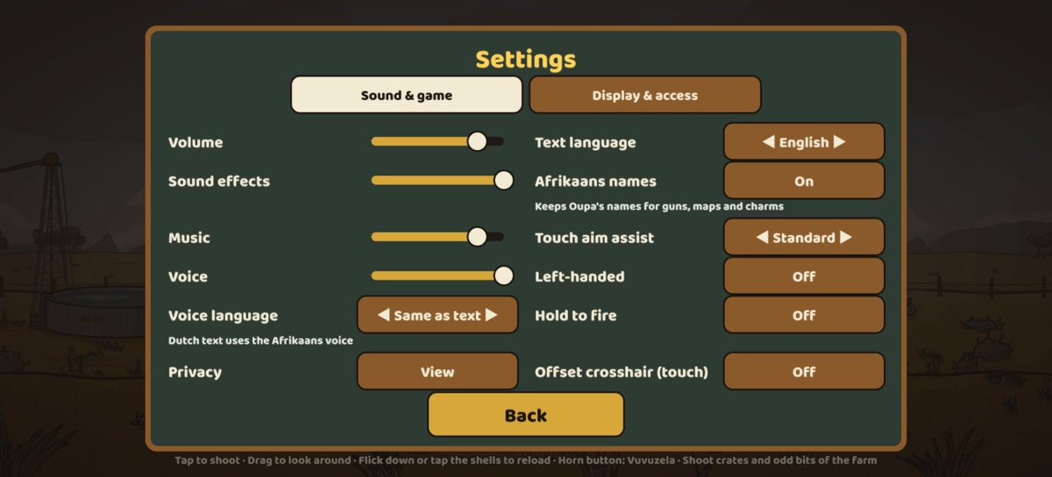
Settings on an iPhone 14: the text and voice languages and the "Afrikaans names" switch, with readable hints.
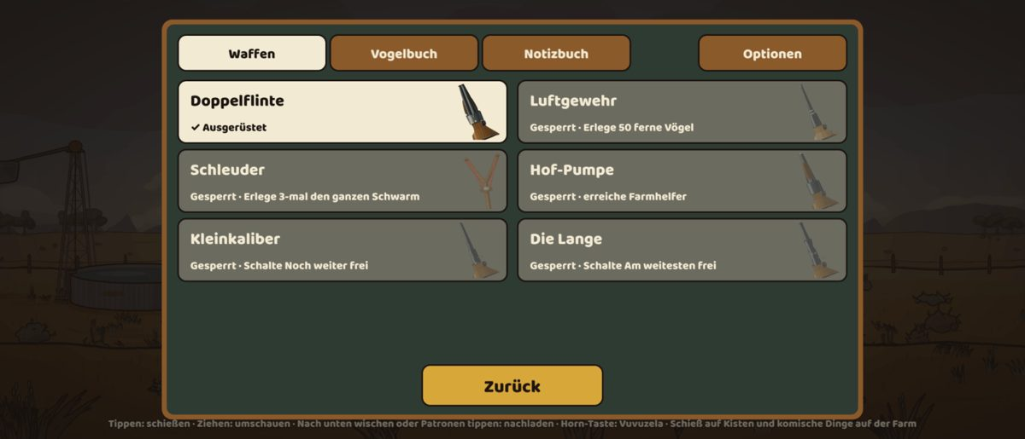
The Gun Shed in German on a Pixel 7: Doppelflinte, Luftgewehr, Schleuder, Hof-Pumpe.
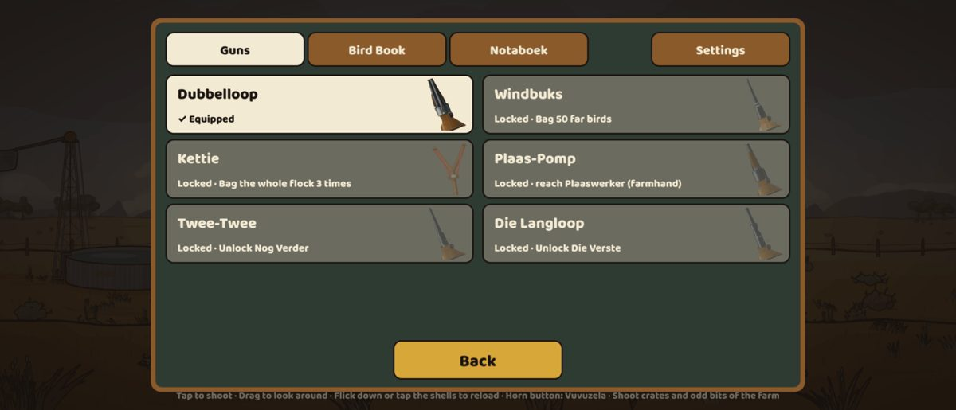
English text with "Afrikaans names" on: Dubbelloop, Windbuks, Kettie and Plaas-Pomp keep their farm names.
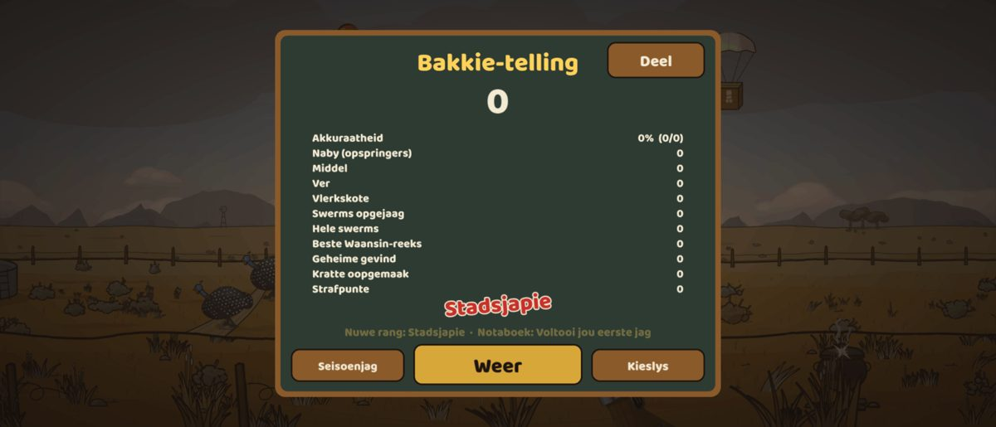
The end-of-hunt tally in Afrikaans (Bakkie-telling).

v1.6 Veld art: trees, fruit, far animals and the windmill
When: 25 Oct 2026, 16:56 (started 25 Oct, 04:45) · Pull requests: #70 · Decision: D-042
The product owner wanted every map’s trees, bushes, grass and fruit at the quality of the camelthorn, and far animals that look like animals, not rough shapes.
Reviews and fixes before merging
Product owner (25 Oct, about 06:50): the windmill needs more detail, a wheel with missing blades, and it should turn with the wind and spin.
About 07:00: the dassie "needs to be increased a lot". About 07:05: the giraffes’ "detail needs to become more realistic". About 07:10: the far trees look like blobs.
About 07:10–07:15: placeholder art on a MacBook Air in Brave, fixed by a hard reload. Claude traced it to the offline cache keeping an old file list after a deploy.
About 07:20: a version number on every map. About 07:25: the Kalahari dead tree "needs a lot of work" and the clouds "need to be more realistic".
Later, from the product owner’s photos of a real windmill: "not that ring on the outside … more missing ones, in random order … old and rusted". The redraw was approved: "looks great, implement it". The product owner also asked for the Fresh load button.
The independent review found five issues, all fixed: the reload bar showed when nothing had changed and sat over the game; a missing file list on the live site was not treated as an error; the scope and far-plane files that load late were not checked and retried; and parts of the view were not rebuilt once late art arrived.
Claude fixed the scope’s pale ring and the Kalahari windmill, whose wheel was hidden while the sign’s secret was live.
On GitHub, a loading test checked a retry counter too early (fixed); one long training-ground test timed out once on the slow runner and passed on a re-run.
What it added
- Plants redrawn on every map at the camelthorn quality bar. Karoo: sweet thorns and aloes, renosterbos and ganna bushes. Bushveld: a baobab with hanging pods, mopane and marula with fallen fruit. Okavango: the sausage tree, jackalberries, ilala palms, papyrus and water lilies. Kalahari: shepherd’s trees, camelthorn pods and silvery Bushman grass. Namibië: quiver trees in yellow flower and !nara melons on the dunes.
- Far animals redrawn with true body shapes: giraffes with real anatomy, patches and calves, springbok, gemsbok, zebra, wildebeest, elephants, lechwe and ostriches. They stay sharp through the scope.
- Far trees are drawn per species with broken crowns, instead of blobs. Each area has realistic, softly drifting clouds of its own.
- The dassie is bigger and more lifelike, on grey granite boulders. The dead camelthorn in the Kalahari is now a weathered tree skeleton.
- The windmill was redrawn from the product owner’s photos: 20 curved sheet-metal sails, several missing, one bent and one torn, with rust. It turns into the wind and spins on windy days. The Kalahari windmill now has its wheel.
- The placeholder-art bug is fixed: a hunt or the Skietbaan waits for its art behind a loading veil and retries if a file fails; the offline cache no longer serves an old file list after a new version goes live; a bar offers a reload when a new version is ready.
- A build stamp on every map, the title and the Skietbaan: version, commit, date, area, weekday and whether the art loaded (for example "v1.6.0 · 89ec664 · 25 Oct 12:11 · Okavango · Sun · art ok").
- A "Fresh load" button in the Skietbaan (test builds only) clears the game’s caches and reloads, without a manual hard refresh. The save is untouched.
- The pale ring inside the scope is gone: it was the placeholder sight showing before the real one loaded.
- Only the look changed: the game’s rules and replays are the same. First download 2.96 MB of 3 MB; every area pack within its 1.5 MB limit. 1 098 unit tests.
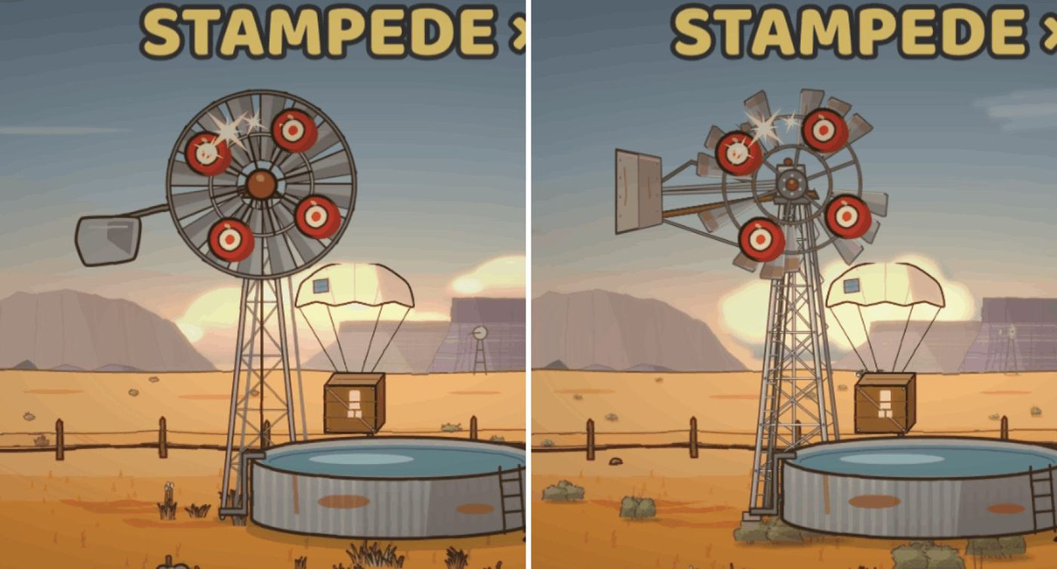
Before | after on a phone: the Karoo windmill, redrawn from the product owner’s photos, with missing and bent sails and rust.
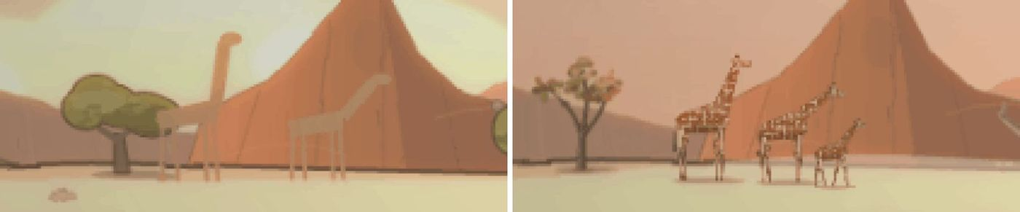
Before | after: far giraffes through the scope, now with patches, true proportions and a calf.
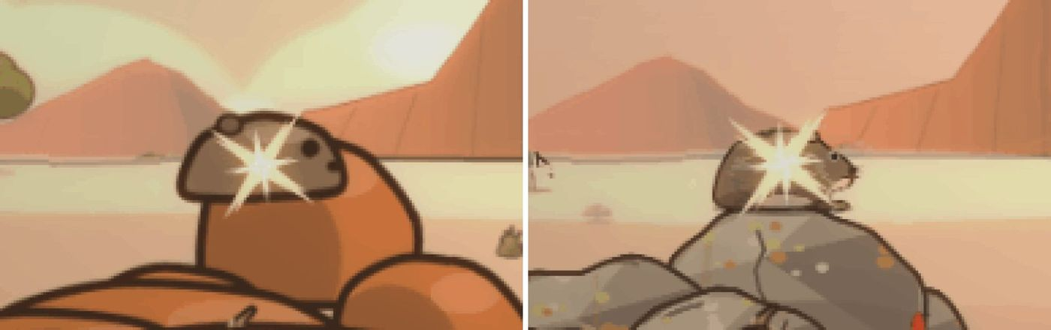
Before | after: the Bushveld dassie, bigger and lifelike, on grey granite.
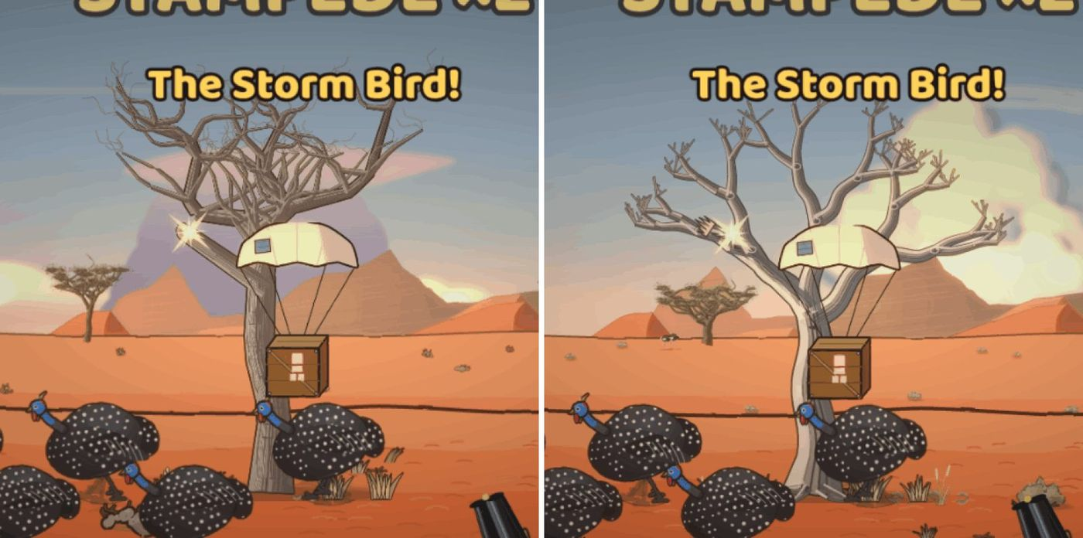
Before | after on a phone: the Kalahari dead camelthorn and the new clouds.
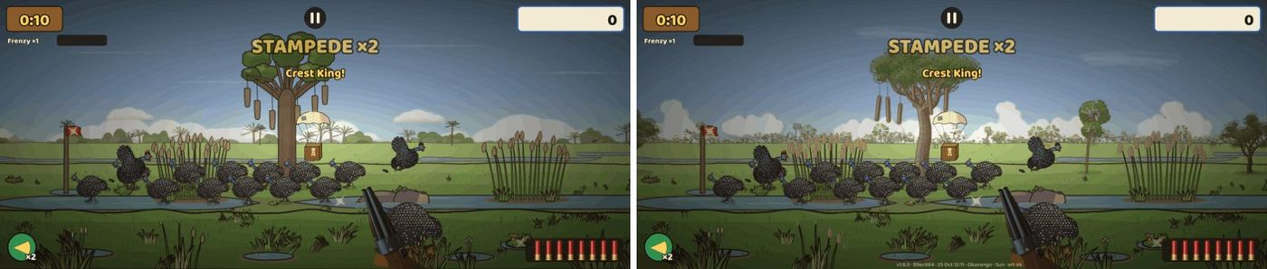
Before | after on a phone: the Okavango sausage tree, ilala palms and clouds, with the build stamp along the bottom.
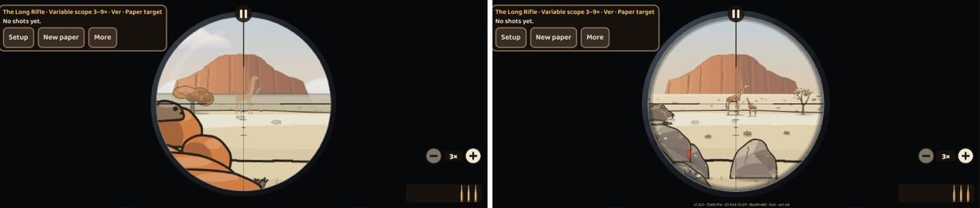
Before | after in the Skietbaan: Die Langloop at 3× in the Bushveld. The pale ring is gone; giraffes and the dassie on granite.
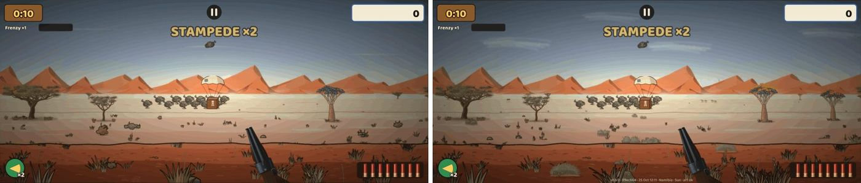
Before | after on a phone: Namibië with quiver trees in yellow flower, !nara hummocks and far animals on the pan.

v1.6b Reload power-ups: Blitslaai and Oupa Laai
When: 25 Oct 2026, 18:43 (started 25 Oct, 06:45) · Pull requests: #71, #75 · Decision: D-043
The product owner asked for "an AUTO reload, and a fast reload" as power-ups.
Reviews and fixes before merging
Main, with v1.6, was merged in as version 1.6.1. Claude changed one browser test so it always checks the lightning icon, not only sometimes.
A slow Skietbaan browser test (the D-040 gongs) timed out on GitHub, on main as well. Claude split it into two tests that shoot inside the page (#75), and the same fix went into this PR.
Screenshots of both power-ups on desktop and a phone were taken after the merge.
What it added
- Blitslaai (Lightning Load): for 12 seconds every reload takes about a third of the time. It covers full-belt reloads, shell-by-shell reloads, the Voorlaaier’s ramrod and the Kettie’s draw. Small lightning glints hop along the rounds and a reload starts with a quick metallic zip.
- Oupa Laai (Oupa Loads): for 12 seconds the gun reloads by itself the moment it is empty, and a shell-by-shell gun tops up when you pause. Oupa’s hand sits by the belt and he says "I’ll load for you, my kind!" (in English, Afrikaans and German). A shot always cuts an automatic reload, so it never locks you out of a shot.
- Both come from supply crates in any hunt and cost 2 coins at the Padstal in a Season Run. They are the first power-ups with icons on their HUD chips.
- Balance: the competent bot’s Classic score rose 1.9 %; every Season Run gate still passes (spring with good buys is 69.6 %, inside its target).
- First download 3,026.6 KB of 3 MB (+13 KB for the icons, the glints, the zip and the code).
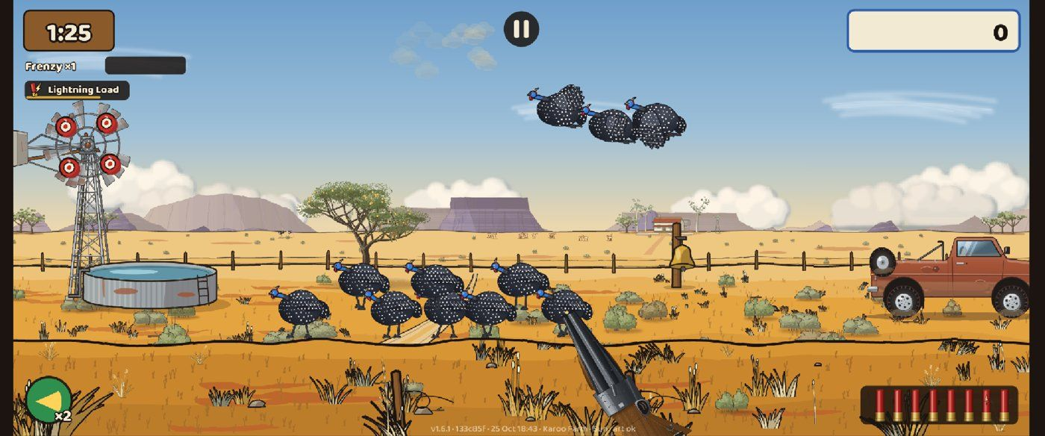
On a phone: the Lightning Load chip with its icon at the top left, during a Karoo hunt.
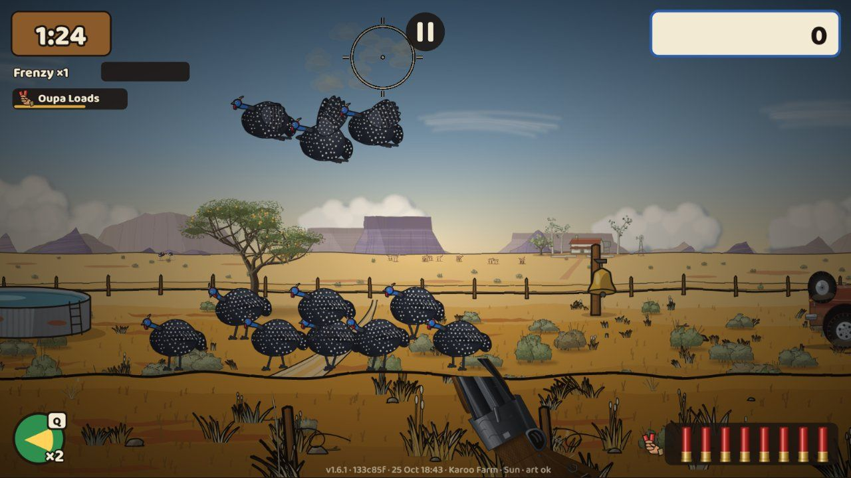
The Oupa Loads chip, and Oupa’s hand by the belt (bottom right) while it runs.

The Project overview page in the admin
When: 25 Oct 2026, 20:06 (asked for at 17:51) · Pull requests: #76 · Decision: D-045
The product owner wanted one place to see the project’s status without asking: what is done and outstanding with dates and expected builds, open questions and decisions, what is built and what will be, suggestions, and the history with its pictures.
Reviews and fixes before merging
Claude’s own review moved "now building" to the top, put the roadmap in running → planned → done order, and kept lettered options (A, B, C) from being numbered twice.
The product owner looked before it was merged ("I don’t see the Project page"); it went live 25 minutes later.
What it added
- A "Project overview" button on the admin page (test builds only; players never download it).
- Tabs: Overview (needs you, now building, up next, last done, numbers, links and recent activity), Roadmap (running, planned and done, each with its build number and expected time), Requests, Ideas, and History with pictures that open full size.
- Every time is shown in Namibia time.
- Claude updates the data on its own branch (project-log) at every merge and screenshot round, so the page is current within about 5 minutes, with no new build or deploy.
- If the connection drops, the last copy that loaded is shown and marked as an offline copy.
- Links and pictures are only accepted from the project’s own GitHub and Claude pages, so a crafted link can’t show a fake status.
- Works on desktop, Pixel 7 and iPhone 14, with the page’s own text in English, Afrikaans, German and Dutch.
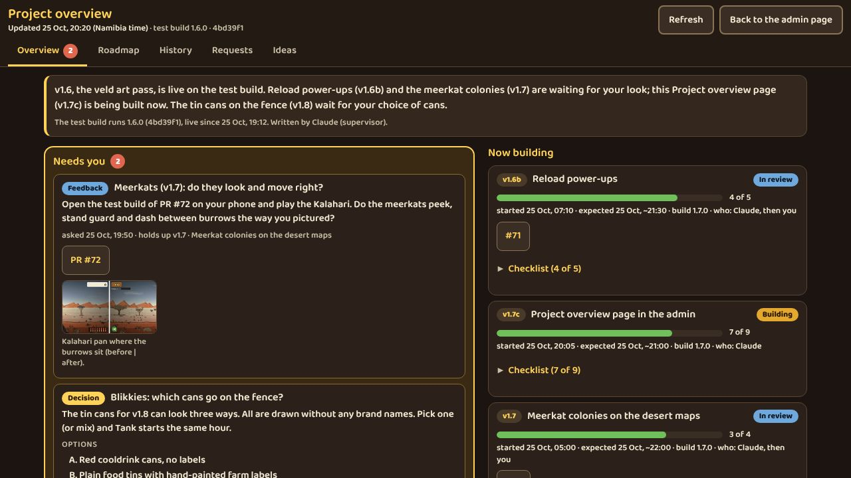
The Overview tab: what needs the product owner, what is being built now and what comes next.
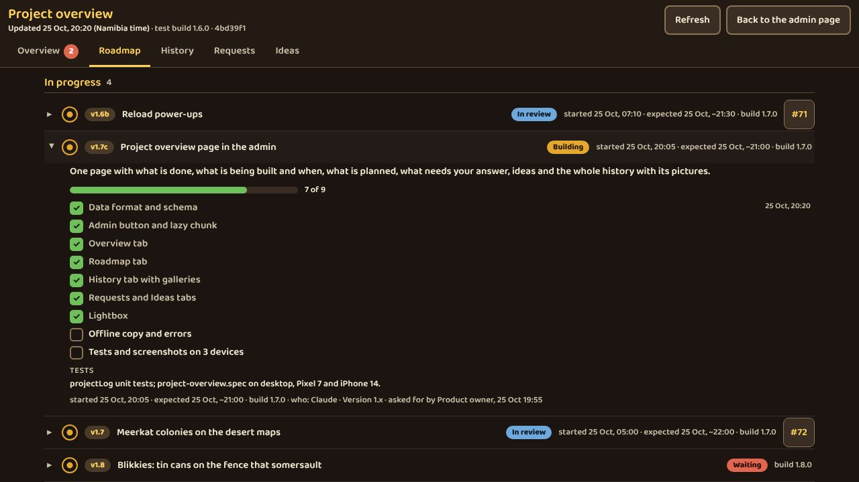
The Roadmap tab: every job with its build number and expected time.
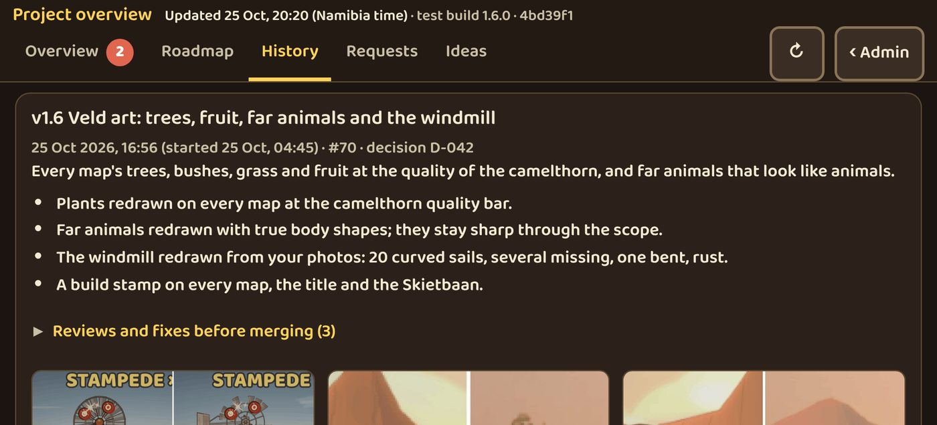
The History tab on an iPhone 14, with the build pictures.

v1.7 Meerkat colonies on the desert maps
When: 25 Oct 2026, 22:55 (started 25 Oct, 13:00) · Pull requests: #72 · Decision: D-044
The product owner asked for meerkat holes on the desert maps, with meerkats that "peek out and run from one nest to the other. Be creative."
Reviews and fixes before merging
Claude’s first look round: the meerkats looked flat, below the camelthorn quality bar. Redrawn with a rounded body, a cream belly, shading, an eye mask and a fluffier pup; the burrows got holes with shadows and fresh sand.
The independent review found a shot pup that stayed stuck for the rest of the hunt, and a placement check that ignored the mounds. Both fixed, with tests.
Colonies were moved so none sits under the HUD on desktop, Pixel 7 or iPhone 14, and so they stay clear of the gun. Meerkats now keep a body width apart.
Product owner (25 Oct, about 17:45): "a little bit more hairy … a tick more furry, and a little bit nicer faces". Round 3 drew every meerkat as fur, with a teardrop eye mask, a small eye with a catch-light and a short muzzle.
On GitHub, a browser test expected −10 for a meerkat shot but got +29: a bird near the moved colony shared the shot. The game was right; the test now takes a shot the meerkat gets alone. The balance was re-checked on all 20 maps after the move.
What it added
- One or two meerkat colonies on every Kalahari and Namibië map, on burrow mounds with dark holes, fresh sand and tracks.
- The meerkats peek, come out, sit, forage and sunbathe in Monday’s dawn light. A sentinel stands guard on the highest mound, and they dash between burrows in a file, stopping halfway to look. A pup follows its mother.
- They react to the hunt: a shot nearby sends the colony down (the scout comes back first after 3–6 seconds); the Langloop sends every colony down; a raptor or the crop sprayer overhead sets off the sentinel’s alarm bark, which also alerts the nearest guineafowl flock.
- Shooting a meerkat costs 10 points; it tumbles, then scolds you ("We’re not guineafowl!").
- A new secret, the Familiefoto: hold fire for 4 seconds with a whole family out near the middle of the screen and they line up for a photo, with a camera click, for +25. It is in the Bird Book and has a Notaboek challenge.
- They are part of the game’s rules, not decoration, so replays, challenge links and the Daily Hunt play them the same on every device.
- Balance: on all 20 desert maps the scores stay within −1.2 % and +2.5 % of the same maps without colonies.
- The meerkat art and sounds load with either desert map. A Kalahari hunt downloads 1,534.9 KB of its 1,536 KB limit; the first download is 3,055 KB.
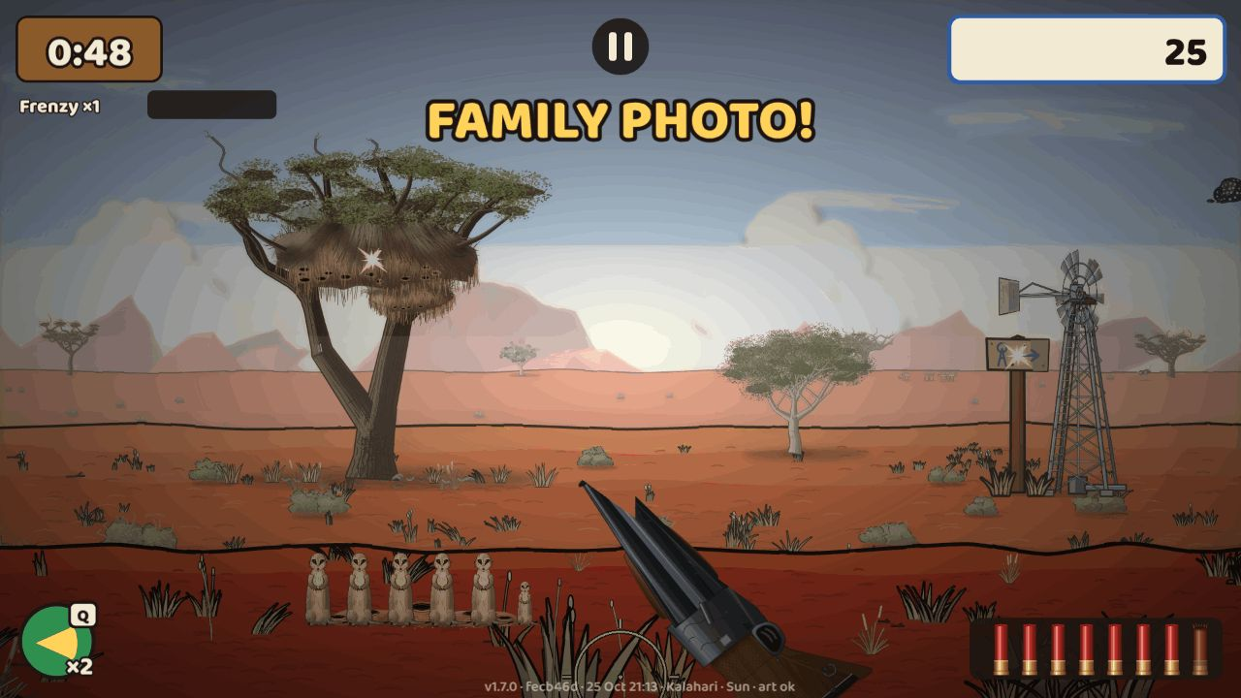
The Familiefoto in the Kalahari: hold fire and the family lines up for a photo (+25).
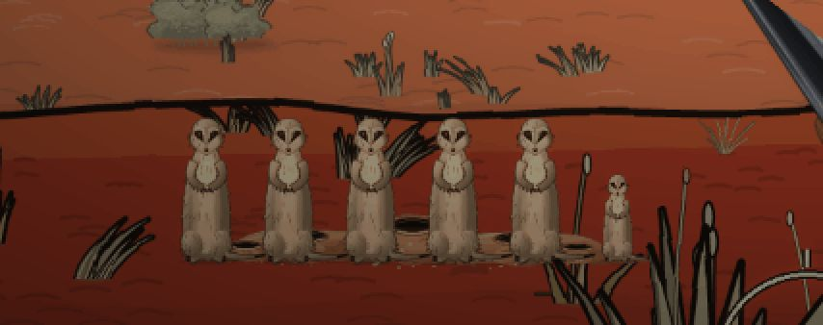
Close-up of the Familiefoto, with the pup at the end of the row.
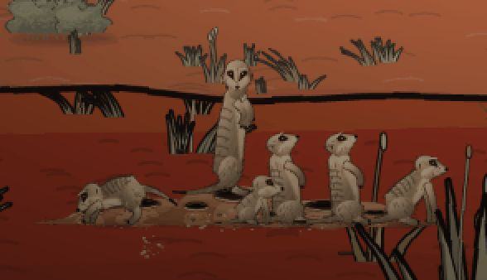
Close-up: the sentinel on the highest mound, the pup by its mother, and the burrow holes.
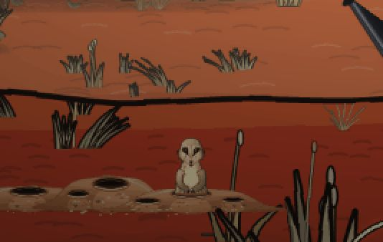
A meerkat scolds after being shot ("We’re not guineafowl!").
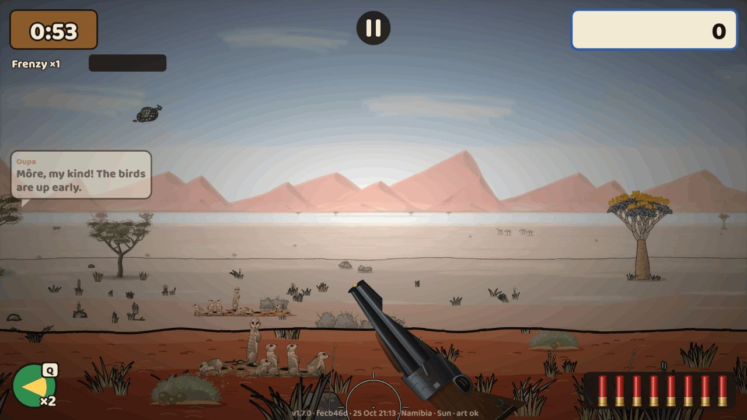
Two Namibië colonies on a Sunday, clear of the gun and the HUD.
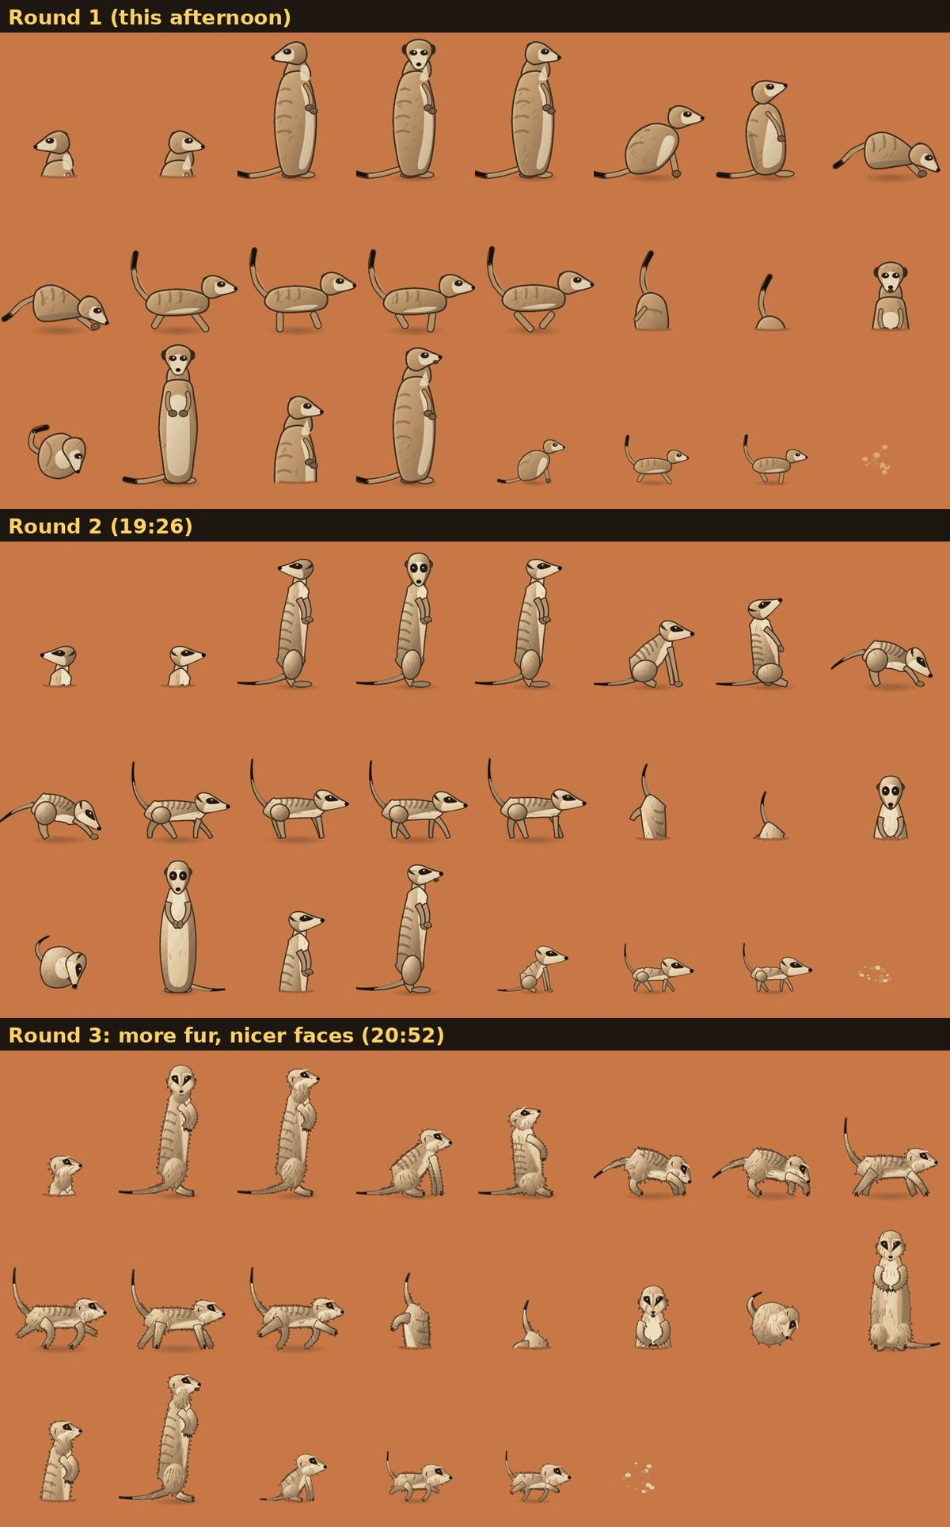
The three look rounds of the meerkat sheet: the first draft, the redraw, and round 3 with more fur and nicer faces (times in Namibia time).

v1.7b Power-ups explained, and an Oupa switch
When: 26 Oct 2026, 02:40 (started 25 Oct, 21:31) · Pull requests: #77 · Decision: D-046
The product owner: "When one collects these power-ups, one is very unsure what they actually do … there needs to be a clear indication in this menu", and an option to switch Oupa’s comments off because "some people would be irritated by always having a grandfather give his input".
Reviews and fixes before merging
Claude’s screenshots (desktop, Pixel 7, iPhone 14): the crate’s icon was too small and faint, the old floating item name still landed on the HUD, and two icons were too thin at chip size. All fixed and re-checked.
The independent review found the first download over 3 MB and the pickup card able to cover the crosshair, plus seven smaller points (a card in the training ground, a raw caption, Oupa’s switch silencing the meerkats, tests that could not fail, a changelog line, Oupa’s lines ignoring the Afrikaans names). All fixed.
Moving the icons to a later download caused a freeze right after a crate pickup on GitHub’s phone test: the placeholder icons were deleted while still on screen. Claude found it, fixed it (the placeholder is now renamed instead of deleted) and re-took all 45 screenshots before merging.
What it added
- Icons for all eight power-ups and crate guns, readable on a HUD chip and big in the Gun Shed.
- A Power-ups tab in the Gun Shed: for each one a picture, one plain sentence of what it does with its numbers, how to get it, and a tip. Ones not found yet are marked, but still explained.
- In the hunt: a falling crate shows the icon of what it holds, on the parachute and on the box; a card says what you picked up (the first time with Oupa’s word); the chip counts the seconds or shells down and blinks before it ends; each power-up has a small look of its own (an ∞ on the belt, a wider spread ring, a warm slow-motion tint); the tally lists the power-ups you used.
- Settings → Oupa’s comments: On, Text only (his bubble without his voice) or Off. The tutorial and the first pickup still explain themselves as plain text when he is off; other voices (the meerkats, the weavers, the frog) still speak.
- Every number the player reads comes from the content files; a test keeps hand-typed numbers out of the texts in all four languages.
- The first download stayed under the 3 MB line (3,069 KB): the new icons load a little later in the hunt, before the first crate can drop.
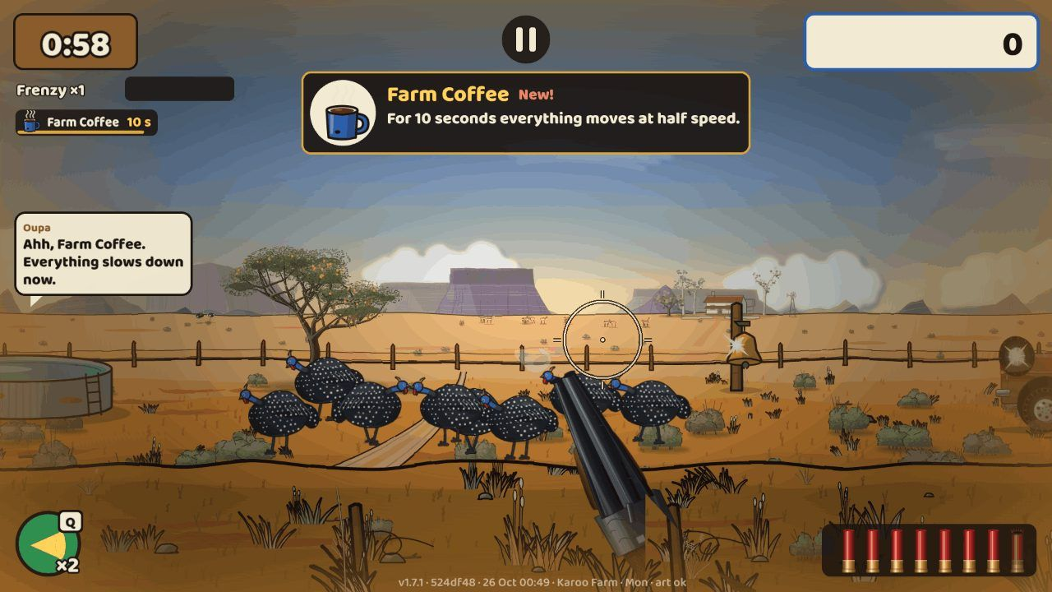
The card the first time you pick up Farm Coffee, with Oupa’s word; the chip counts down at the top left.
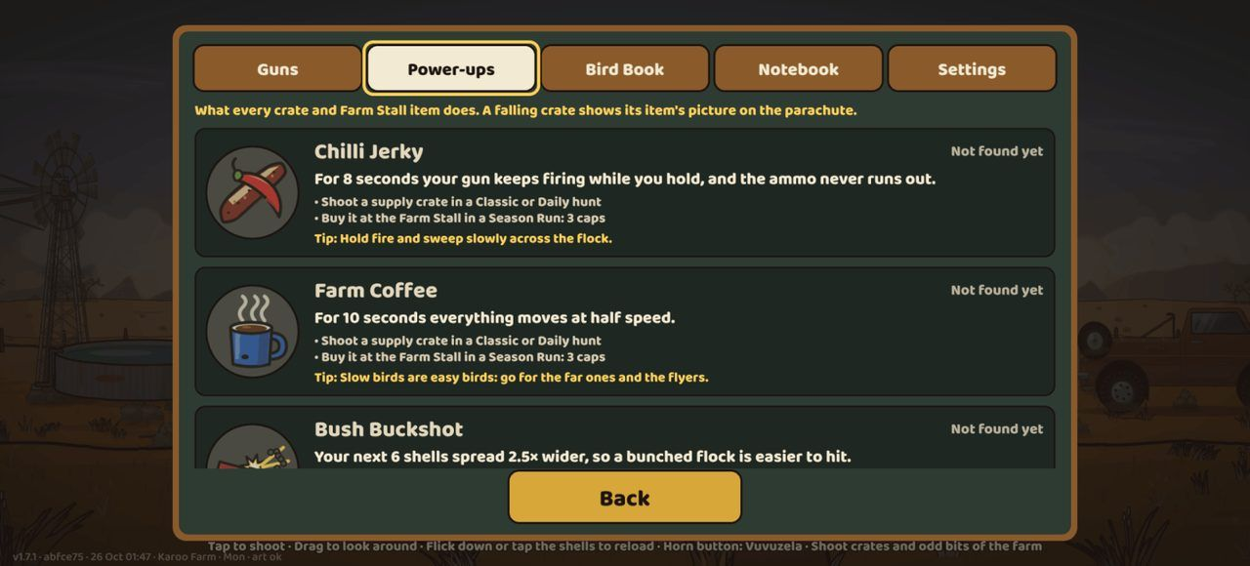
The Gun Shed’s new Power-ups tab on an iPhone 14.
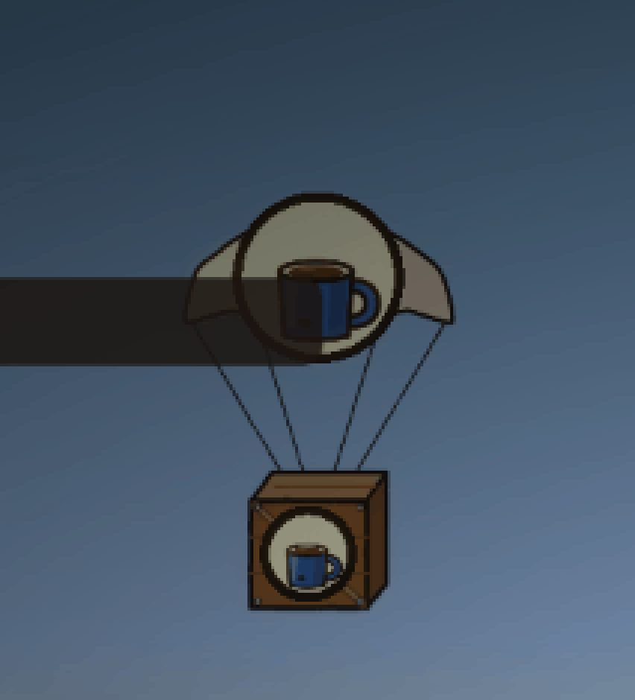
A falling crate shows what it holds, on the canopy and on the box.
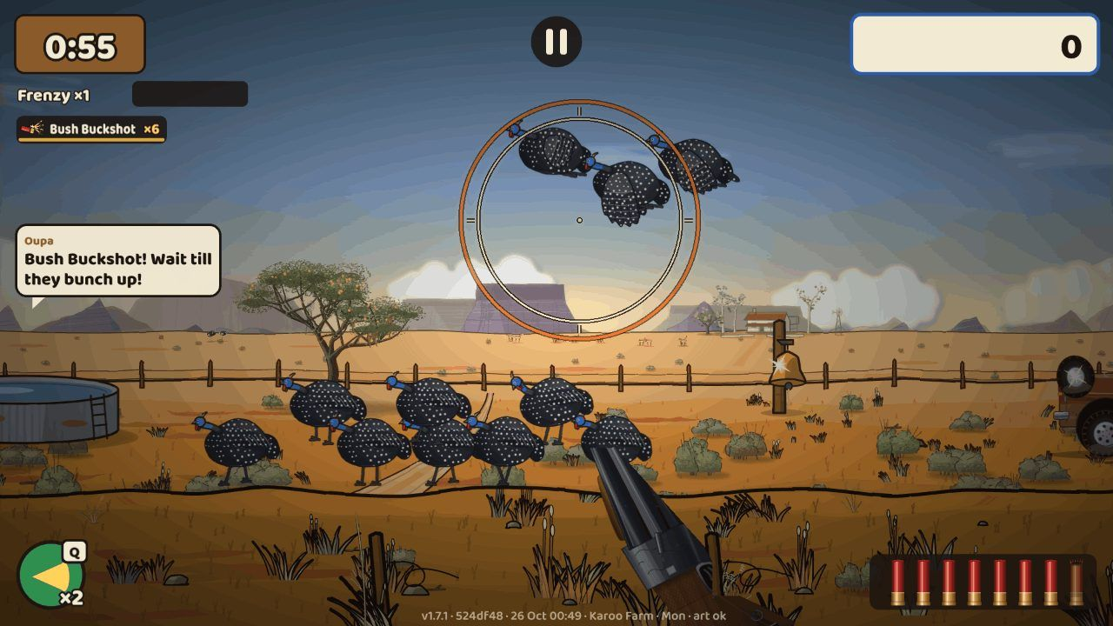
Bush Buckshot: the chip counts shells, and the spread ring is wider.
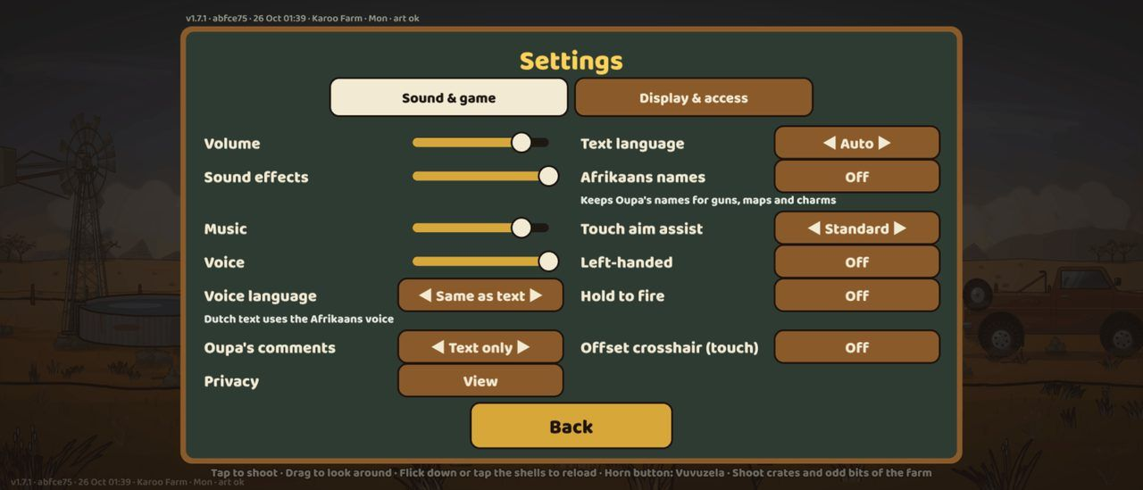
Settings on a Pixel 7: Oupa’s comments On / Text only / Off.
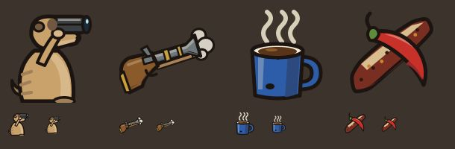
Two icons redrawn after the screenshot round: the Meerkat Spotter with its binoculars up, and the Voorlaaier.

v1.7c Fruit that swings and drops
When: 26 Oct 2026, 05:34 (started 26 Oct, 01:11) · Pull requests: #79 · Decision: D-047
The product owner, testing the sausage tree in the Okavango: "When shooting these fruits, make them swing or drop down."
Reviews and fixes before merging
Claude’s screenshots: the first fruit pictures were plain shapes (tan "pills", grey eggs), and a dropped sausage lay across the trunk. Redrawn at the camelthorn quality; dropped fruit now lands clear.
The independent review found that the fruit ignored the map’s light of the day and its haze, and that in wind a dead-centre shot could miss a fruit (the wind drift was applied twice); also fruit drawn over rocks and tree feet, work every frame, and steps on fast phones. All fixed.
Tank’s first session lost its connection before pushing; Claude retried it and no work was lost.
What it added
- Every hanging and tree fruit reacts to shots: the sausage tree’s sausages, baobab pods, marula, jackalberries, ilala clusters, sweet-thorn and camelthorn pods, quiver-tree flowers, and !nara melons on the ground.
- A hit swings the fruit on its stalk; a near miss gives a smaller swing; a hard hit, or a second hit while it swings, snaps it off. It falls, bounces, rolls clear of the trunk and lies on the ground with a soft shadow. Small, local dust and leaf puffs; a soft thock and a thud.
- Fruit are not targets: no score, no penalty, and the game’s rules and replays are unchanged. They take the map’s light of the day and its haze, like the trees they hang on.
- All fruit redrawn as separate pictures at the camelthorn quality: heavy, mottled Kigelia sausages on rope stalks, velvety baobab pods, speckled marula. They load with their map, never in the first download.
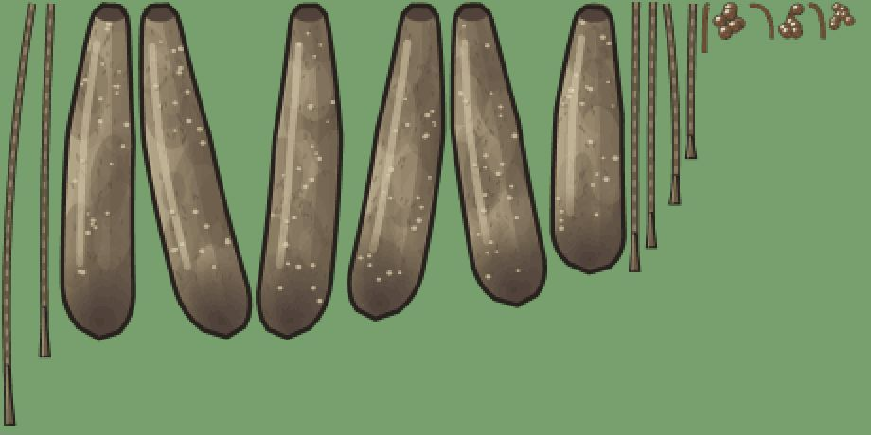
The redrawn sausage-tree fruit, with their stalks drawn separately so the stalk stays on the tree.
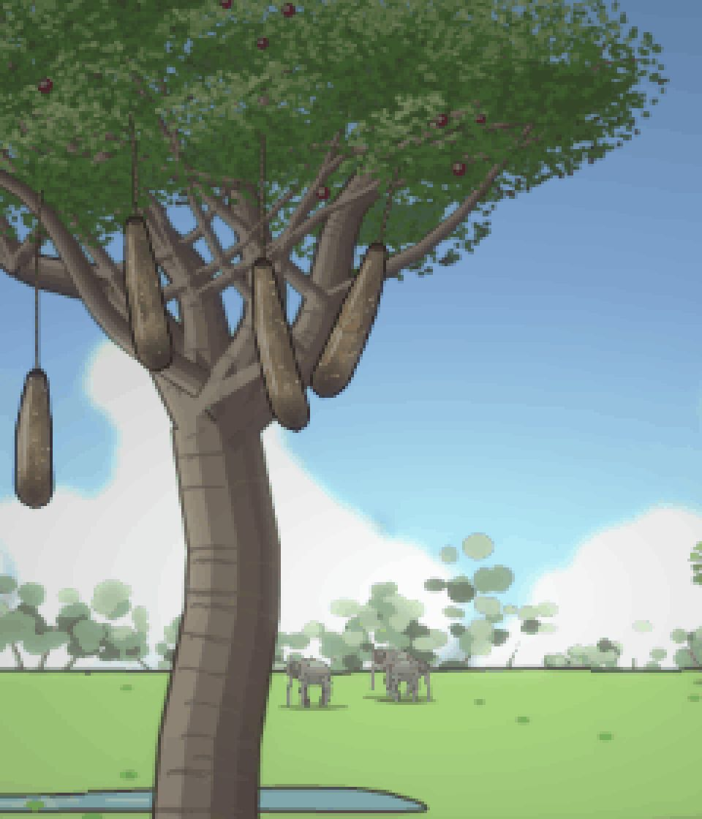
Close-up: a shot sausage swings on its stalk.
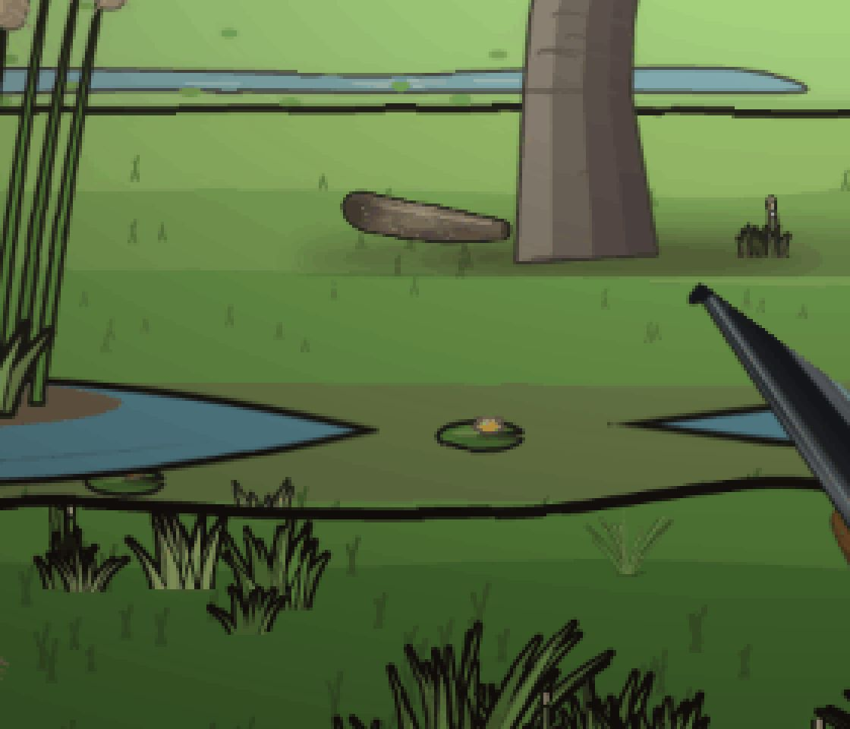
A shot-off sausage lies on the ground, clear of the trunk.
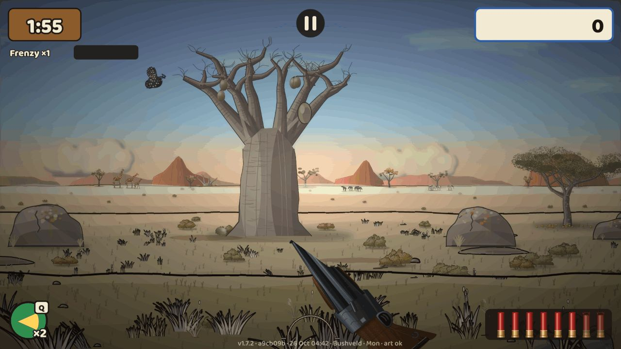
A baobab pod shot off in the Bushveld.

Halloween Spookjag (Feesdae)
When: 26 Oct 2026, 10:32 (started 26 Oct, 04:50) · Pull requests: #80 · Decision: D-048
The product owner chose Halloween from the list of local Daily specials: "Halloween special yes, go ahead".
Reviews and fixes before merging
The first independent review found that the hunt waited for all the Halloween files to download. It now starts as soon as the code is in; the pictures and sounds follow.
Claude’s review round, with screenshots on desktop and Pixel 7, listed 15 points, all fixed: scoring through the same path as every other bonus and penalty, an iPhone-safe Share tap and owl test, witch hats on the head in every frame, carved glowing lanterns placed where they read, a darker dusk, bigger owls on their own band below the HUD, overlaps on the title and the tally, Oupa’s lines loaded only when needed, a message if the Halloween files fail to load, and recorded test hunts (golden replays) that cover the bats, owls and lanterns.
Claude fixed the last overlap of the title badge and the tally test.
An iPhone test still expected the older replay format (replays now record the special day). Claude fixed it before merging.
What it added
- Special days (Feesdae): on a special day (by the UTC date) the Daily Hunt becomes that day’s special, the same for everyone. The special days live in the content files, so more holidays can be added later.
- Halloween’s Spookjag (31 Oct, version 1.7.3): a dusk hunt with its own dark, cool light, under a big low moon with bats circling it.
- Bats are fast bonus targets (+15). The spotted eagle-owl is protected: shooting one costs 10 points, and Oupa scolds you.
- 3–5 carved pumpkin lanterns stand on the tops of props (the reservoir rim, boulders, the bakkie’s roof) or on their own post. Each goes dark when shot. Putting them all out pays "Lanterns out! +25", once.
- About a third of the guineafowl wear small witch hats.
- The title’s Daily button reads Spookjag, with a "Spookjag tonight!" badge. The tally gets a Halloween frame, the title "Spookjag 2026" and a row for bats, owls and lanterns. The share text gets a Halloween frame too.
- Sounds: an organ and kalimba sting, an owl hoot, a bat squeak and a lantern puff. Oupa has five Halloween lines in English, Afrikaans, German and Dutch, voiced in English, Afrikaans and German.
- The Halloween pictures and sounds load in the background, only on the day. The first download stays under 3 MB (3,071 of 3,072 KB).
- How to try it before 31 Oct on the public test build: the admin page → Special days → Spookjag · 31/10 → Play, then Play again on the next card. (The ?feesdag=halloween address only works on developer and test builds.)
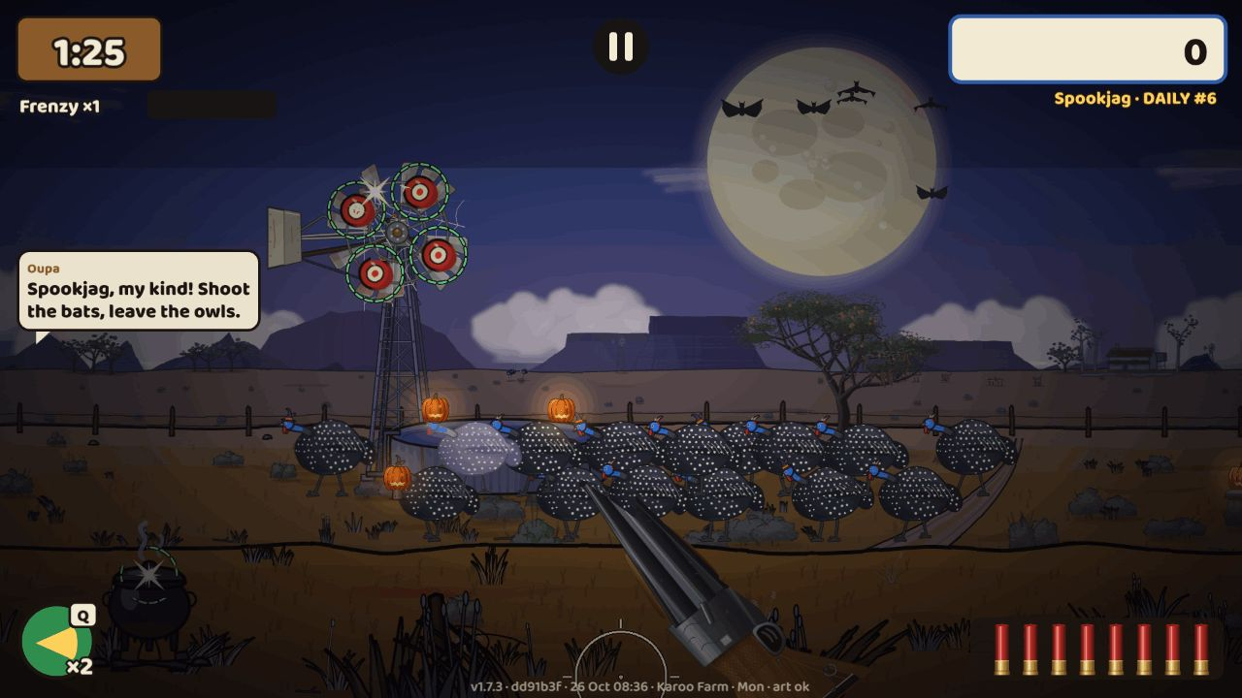
The Spookjag on a desktop: dusk under a big low moon with bats, lanterns on the reservoir rim, guineafowl in witch hats, and Oupa’s opening line.
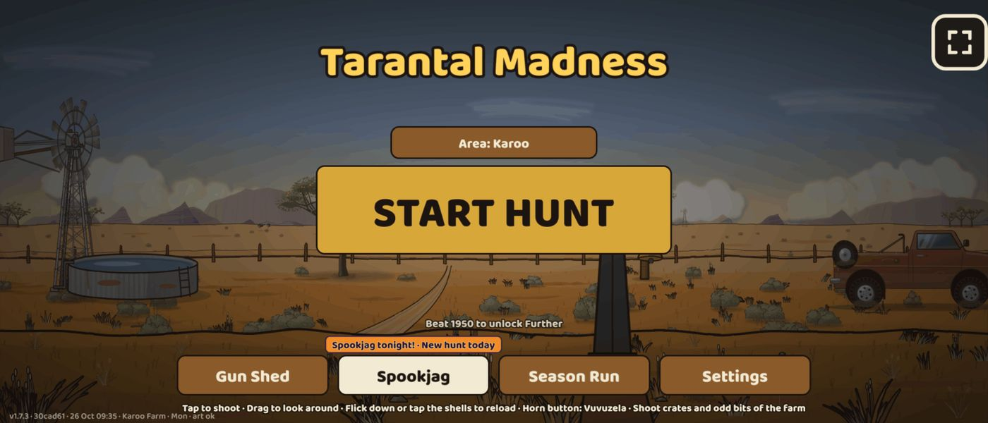
The title on a Pixel 7 on the day: the Daily button reads Spookjag, with the "Spookjag tonight!" badge.
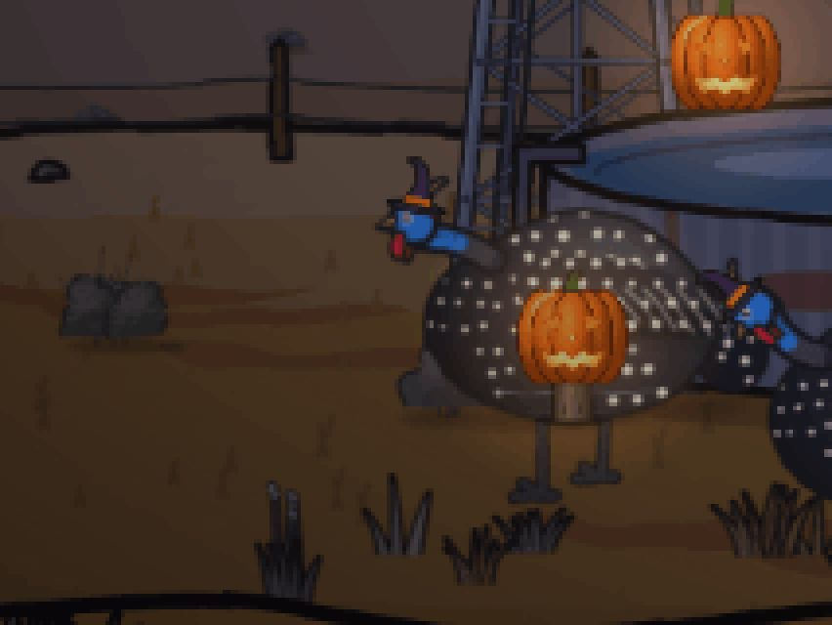
Close-up: the witch hats sit on the guineafowl’s heads; a carved lantern stands on its own post in front of the flock.

Close-up: a lantern on the reservoir rim, lit, and dark with a wisp of smoke after it is shot.
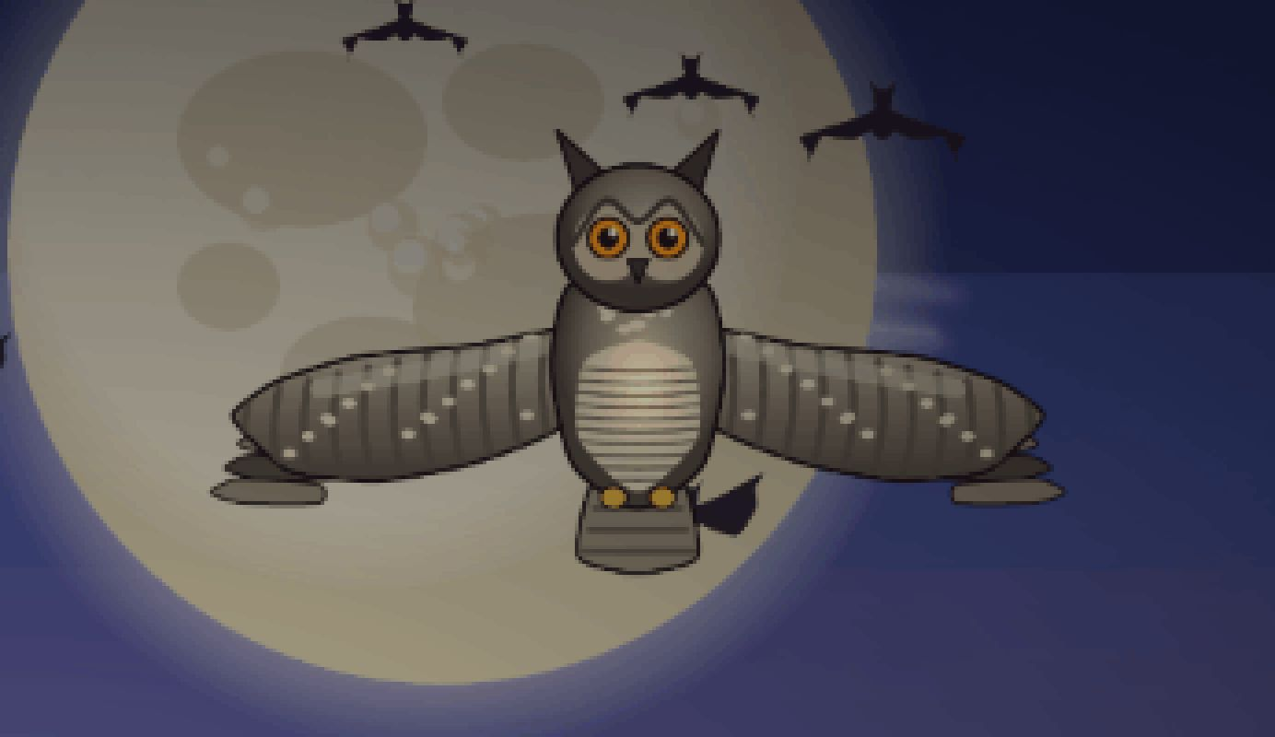
Close-up: the protected spotted eagle-owl crosses the moon among the bats (−10 if shot).
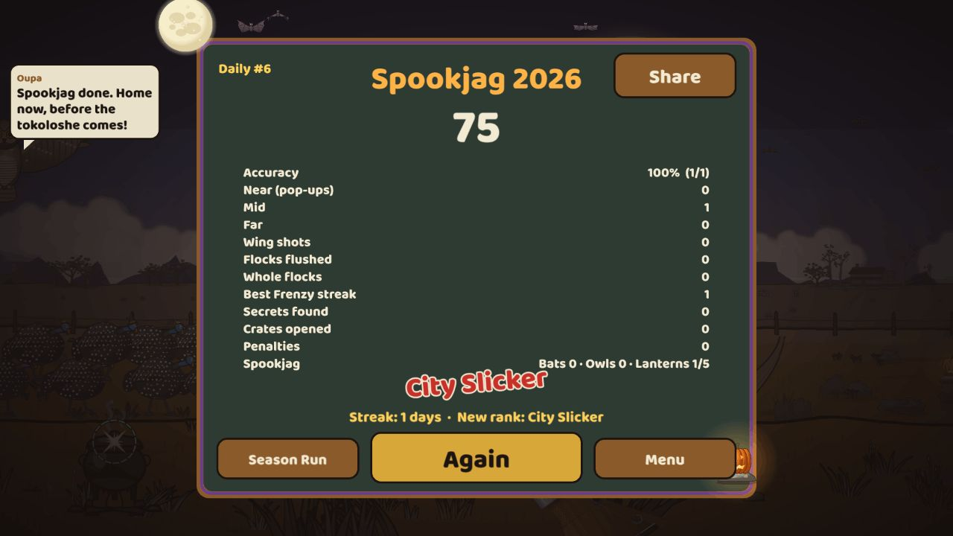
The Halloween tally: "Spookjag 2026", the moon and bats, a row for bats, owls and lanterns, and Oupa’s last line.

Perspective: birds get smaller with distance
When: 26 Oct 2026, 18:34 (started 26 Oct, 08:51) · Pull requests: #82 · Decision: D-049
The product owner, playing the Karoo: "the guineafowl, the further away they are, the smaller they get … the ostriches, because they’re far away, are small, but the guineafowl is even bigger than they are … still in such a way that one can still shoot them … this needs to apply to all the levels."
Reviews and fixes before merging
The independent review found three things: the Halloween bats and lanterns had shrunk without the minimum hit size; the minimum hit size also widened the birds you must not shoot (now it is for targets only); and two difficulty checks failed in the first rough run. The first two were fixed before merging; the full 500-hunt run settled the checks.
Claude’s screenshots showed that the Karoo comparison had no far guineafowl beside the ostriches (the screenshot now uses Monday’s Verder, where a far flock forages by the ostriches), and that the Namibië waterhole animals were shapeless at their new size (redrawn standing head up).
One of Tank’s edits had deleted eleven older entries of the decision log. Tank restored them.
On the final test run two browser tests failed: the seeded test hunts’ shot patterns changed with the content, and the targets were smaller. Claude made both tests robust (more shots, no long waits, a lantern no flock stands in front of), and the full suite passed on all devices.
What it added
- An audit first measured every far animal against the guineafowl. In the Karoo a far bird was about 12× too big beside the ostriches.
- The distance planes got smaller: the middle from 0.5 to 0.42, the far from 0.22 to 0.15, the farthest from 0.1 to 0.07. A standing guineafowl is now 263, 110, 39 and 18 px tall from near to farthest.
- The far herds are shown 3× bigger. The HD animal redraw will later draw them at their true sizes, with the ostriches about 2.7× taller again.
- The Namibië waterhole animals were redrawn 5× taller in the same spots, standing head up.
- Far birds keep a minimum hit size (18 px far, 10 px farthest), so they stay shootable. Only targets get it, never the birds you must not shoot. The Halloween bats and lanterns get it too.
- Feathers, alarm bubbles, score pops and witch hats shrink with the birds.
- The guineafowl pictures were redrawn at their new sizes. That made the first download 106 KB smaller (3,071 → 2,965 KB of 3,072).
- Balance (500 hunts per test): every difficulty check that passed before still passes. Good players score about 1 % more; weaker players about 10 % less (accepted: smaller birds are what was asked). Shotguns score less on the far bonus maps, which are made for rifles. The Langloop was retuned to stay above its minimum.
- Released as version 1.7.4, on every map.
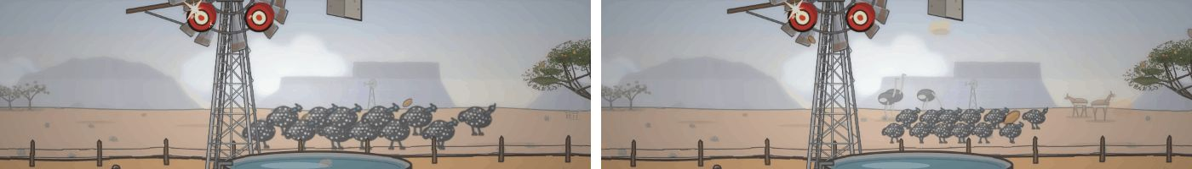
The Karoo, before | after: the far guineafowl used to be bigger than the ostriches; now they are smaller.
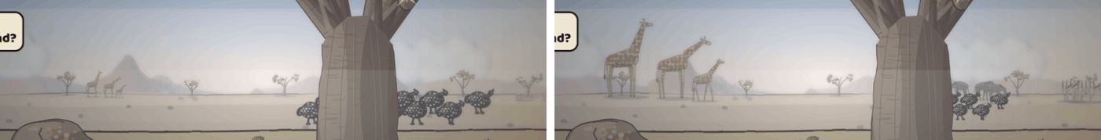
The Bushveld, before | after: the giraffes, elephants and zebras now dwarf the far birds.
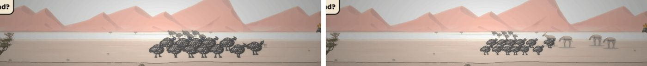
Namibië, before | after: the far flock now stands smaller than the gemsbok beside it.
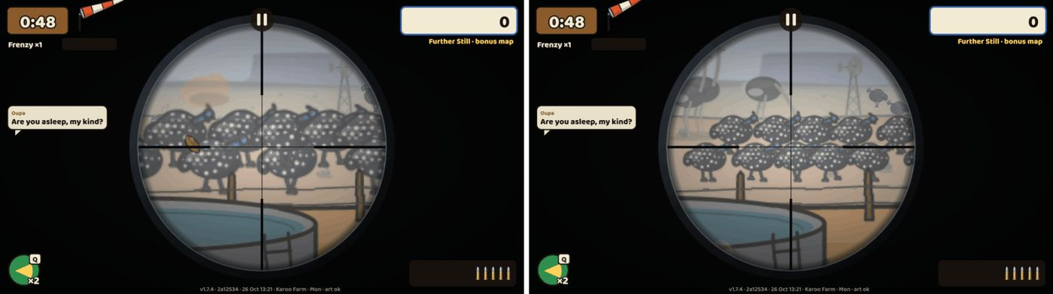
Through the .22’s scope on the Karoo’s Nog Verder, before | after: the far birds are smaller, and the ostriches behind them now stand taller.

v1.8 Blikkies: tin cans on the fence posts
When: 27 Oct 2026, 01:36 (started 26 Oct, 18:39) · Pull requests: #83 · Decision: D-050
The product owner asked for this on 24 Oct and again on 26 Oct: "On maps with fence posts, have some cans standing on them that can be shot off. They somersault when hit … The distance should vary … if you hit them again they continue spinning up and so on till you don’t see them anymore." And: "Faster, higher, more unpredictable."
Reviews and fixes before merging
The independent review found that far cans could be juggled almost forever (a computer shooter kept them up for 16–19 hits, worth more than a whole hunt of birds), and that on the near fence a chain of three was rare because the second hit already threw the can off the top. Tank capped the chain at 10 hits (always ending in Weg!), dropped the minimum hit size for cans in the air, softened the kicks and the sideways drift, and added the apex-juggler bot to prove it.
The review also found that new Skietbaan cans could stand on invisible posts after the view panned. The fence is now rebuilt whenever its posts move.
Claude’s first juggle screenshots reached only two hits, on the middle fence, where the can was tiny. The screenshot now juggles on the near fence and holds the frame while "3× in the air!" is on screen.
The new content changed the seeded test hunts, which broke two Halloween browser tests (the owls, and a lantern at the edge of the map). Claude fixed both on main (#85, #86) before the merge, and the full suite passed on all devices.
Tank’s connection to its model dropped several times during this job, so Claude restarted it as a fresh task with a self-contained brief, as the product owner had asked.
What it added
- A farm fence of 3–6 posts, with a tin can on each (a paint tin, a rusty can, a bean can and others), stands on 3–4 weekday maps of each farm area: the Karoo, the Bushveld, the Kalahari and Namibië. Depending on the day it stands near, in the middle or far away; the bonus maps push it further back.
- Shoot a can and it somersaults off its post, away from the side you hit. Hit it again in the air and it kicks higher, spins faster and wobbles more. The 10th hit in the air always sends it out of the top of the screen: "Weg!" ("gone"). A can that lands lies in the grass for the rest of the hunt.
- Cans are sized for their distance, like the birds. In the air the hit area is 2.5× the drawn can, so near cans are the easiest to juggle and far cans the hardest.
- Points: knocking a can off 5, each hit in the air 8 plus 2 more each time, Weg! 15. Further cans pay more (near ×0.8, middle ×1.3, far ×2, Ver ×2.5). Only the Stampede multiplies them: a can shot neither breaks nor builds your Frenzy, and it does not count as a miss.
- Chain pops on screen ("3× in the air!"), can sounds, Oupa’s lines, a Notaboek challenge and a new secret, the Blikkiesdans (8 hits in the air, once a hunt). The Skietbaan has a Tin Cans target at every distance. Cans are not in the Season Run or the tutorial.
- A new balance bot that shoots a flying can at the top of its arc measured the juggle over 500 hunts per test: a good shot gets 3 or more hits in the air on 98 % of near cans, 47 % of middle cans and none far away. Cans never make up more than 8.7 % of a score, and every difficulty check passes.
- The can art is one small 14.9 KB sheet. The first download grew by 22 KB, to 2,987 of 3,072 KB.
- Released as version 1.8.0.
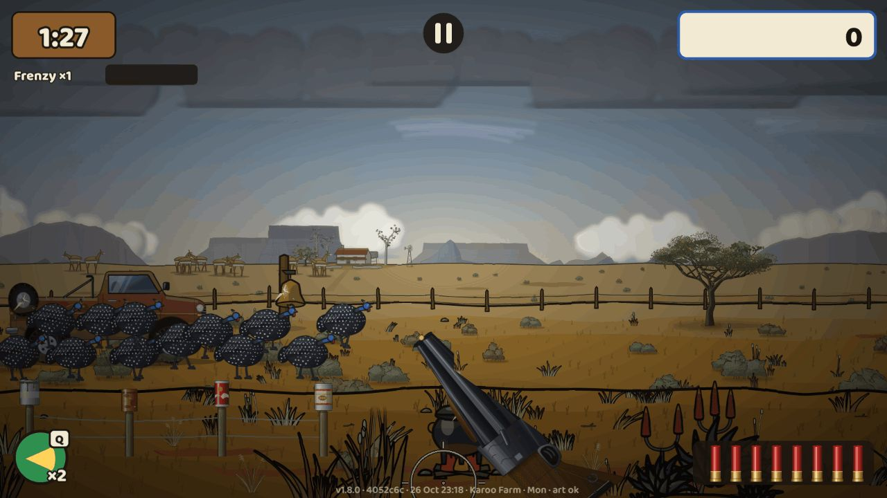
The near fence in the Karoo: four cans on the posts in front of the hunter.
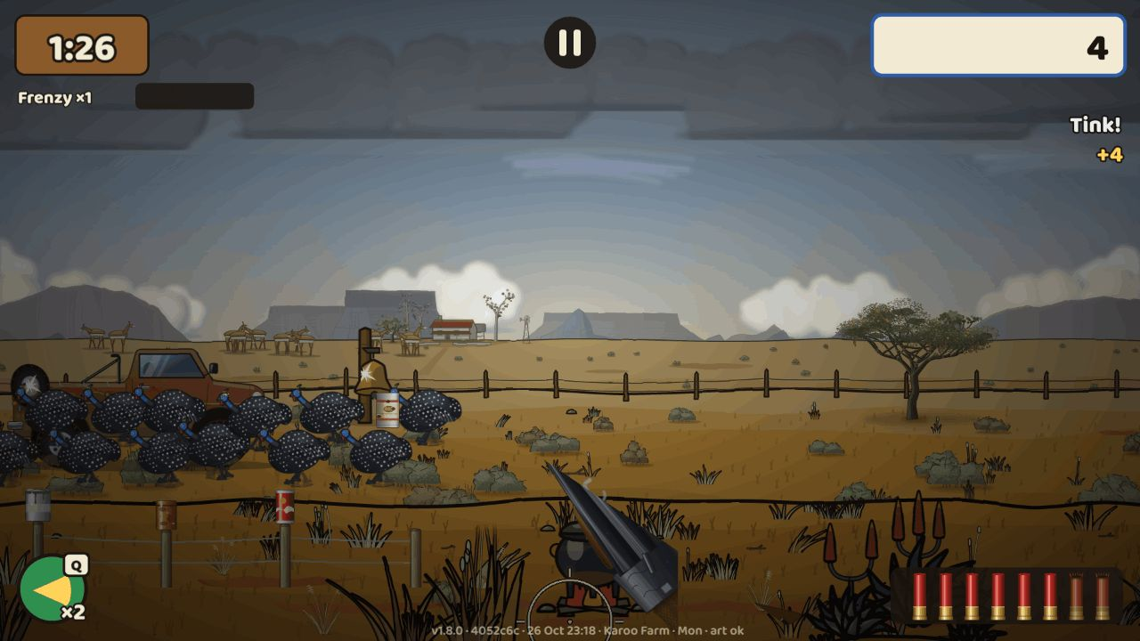
A shot can somersaults off its post ("Tink! +4").
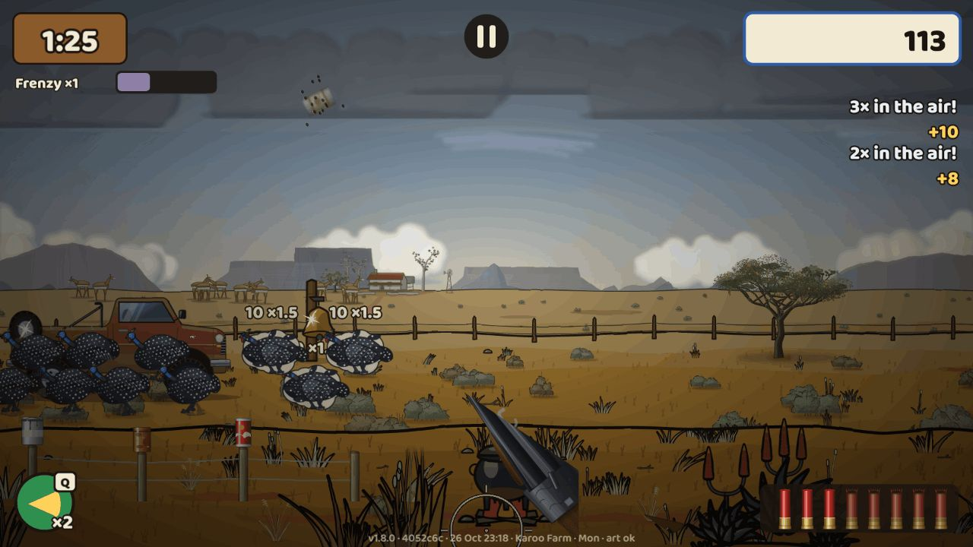
The juggle: a can high in the air after its third hit, with "3× in the air! +10" and "2× in the air! +8".
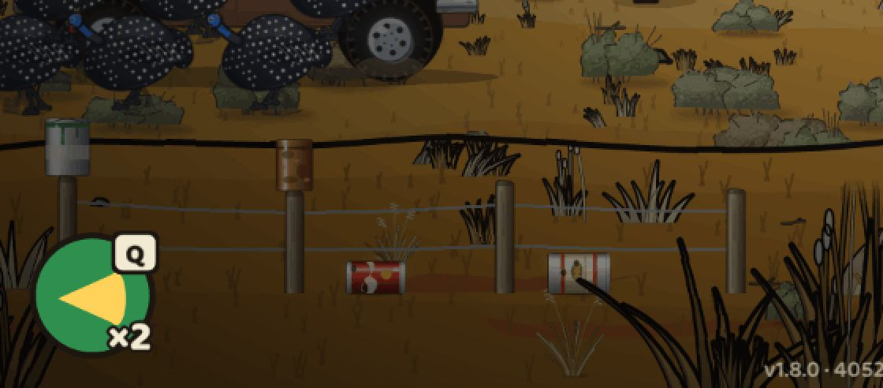
Close-up: two cans lie in the grass below the fence after they were shot off.
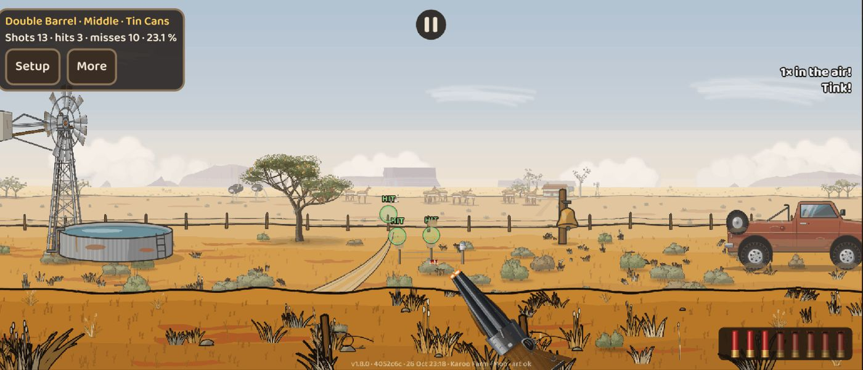
The Skietbaan on a Pixel 7: the Tin Cans target at middle distance, with hit marks and the shot count.

Your requests and what happened
When | What you asked for | What happened
22 Oct | Fix the birds and the gun before merging graphics pass 1 | Done in graphics pass 1 (#35, #36)
22 Oct | Realistic ammo per gun, sound effects, crosshairs per gun, a .22 with far targets, sights and zoom | Plan approved (#40); ammo, crosshairs and sound in v1.1; the .22, sights and zoom in v1.3 (#53, #54); the long rifle in v1.4
22 Oct | Karoo look: fix the grass, bushes and sky | Done in graphics pass 2 (#41, #42)
22 Oct, evening | "Karoo approved … keep pushing, 24/7" | Claude checks in every 10 minutes, with an hourly backup check
23 Oct, 11:40 | Farmhouse cut off, flat mountains, bakkie, guns and birds too cartoony, a bird with no texture | Graphics pass 3, merged at 17:58 (#49) after two look rounds and a code review
23 Oct, 11:50 | An admin URL to test every level and give feedback | Live at 13:32 (#48)
23 Oct, 12:00 | A document of what is built, what is not, estimates and who does what | The Build Status doc, updated at every change
23 Oct, 15:05 | A training ground to test different guns, near and far | Done: the Skietbaan on the admin page (#58)
23 Oct, 15:20 | A Word document with the build pictures and history | This document
23 Oct, 20:50 | Let GitHub record the screenshot baselines | Done (#55)
23 Oct, 21:15 | Keep the build file updated with an infographic every 2–3 hours; keep Tank building overnight | The build board and the status doc, refreshed every 2–3 hours and after each merge; v1.3 merged overnight
24 Oct, 05:45 | More targets in the training ground: mixed targets at all distances, every distance for every gun, a sound or blink on every hit | Done (#61), with screenshots sent at the merge
24 Oct, 12:05 | Better graphics for the trees, bushes and fruit on every map; camelthorn trees in Namibia; a far more detailed weaver nest ("increase quality by 500%") with angry birds flying out when it is shot | Camelthorn and nest first in v1.4 part B, with close-ups for approval; the plants on every map done in v1.6 (#70)
24 Oct, 12:18 | Meerkat burrows on the desert maps: meerkats peek out and run from one burrow to another ("be creative") | Done in v1.7 (#72)
24 Oct, 16:00 | Languages: game, voice and text in German, English and Afrikaans, with names adjusted for each audience | Done in v1.5 (#68)
24 Oct, 17:45 | Clean steel gongs in the training ground, with every shot mark staying visible for the session; tin cans ("blikkies") on fence posts that somersault and can be juggled in the air | Gongs done (#66); Blikkies done in v1.8 (#83)
24 Oct, 18:55 | Five more ideas to keep the African feel (meerkats, a soundscape, a rain storm, a braai, a farm dog, veld cameos) and Daily specials on local days (Heritage Day braai, Christmas in summer, Halloween, New Year) | All queued as v1.6–v1.13; a list of Daily specials sent for the product owner to choose from (Halloween chosen on 26 Oct and done in #80)
24 Oct, 20:35 | Distant animals (like the giraffe) look rough; consider a bow and arrow later | Done in v1.6 (#70); bow and arrow noted as an idea for later
25 Oct, 06:50 | The windmill: more detail, a wheel with missing blades, turning with the wind and spinning | Done in v1.6 (#70)
25 Oct, 07:00 | The dassie "needs to be increased a lot" | Done in v1.6 (#70)
25 Oct, 07:05 | The giraffes’ "detail needs to become more realistic" | Done in v1.6 (#70)
25 Oct, 07:10 | The far trees look like blobs | Done in v1.6 (#70): far trees per species
25 Oct, 07:10 | Placeholder art on a MacBook Air in Brave until a hard reload | Fixed in v1.6 (#70): the art waits to load and retries; no stale cache after a deploy
25 Oct, 07:20 | Map version numbers | Done in v1.6 (#70): a build stamp on every map
25 Oct, 07:25 | The Kalahari dead tree "needs a lot of work"; the clouds "need to be more realistic" | Done in v1.6 (#70)
25 Oct, morning | The windmill redrawn from the reference photos: no outer ring, more missing blades in random order, old and rusted | Approved ("looks great, implement it") and done in v1.6 (#70)
25 Oct | A button to force a fresh map load after a deploy | Done in v1.6 (#70): the Fresh load button in the Skietbaan (test builds)
25 Oct, early morning | An automatic reload and a fast reload as power-ups | Done in v1.6b (#71): Blitslaai and Oupa Laai
25 Oct, 14:45 | When shooting the fruit (sausage tree), make it swing or drop | Done in v1.7c (#79)
25 Oct, 17:45 | The meerkats "a little bit more hairy … a tick more furry, and a little bit nicer faces" | Done in v1.7 (#72), look round 3
25 Oct, 17:48 | Namibië: at least two ostriches with a nest, oryx far away in a mirage, hot-air balloons drifting by; the grass and landscape much more detailed | Queued as v1.7d (Namibië veld life)
25 Oct, 17:51 | A Project overview page in the admin: what is done and outstanding with dates and expected builds, open questions and decisions, what is built and what will be, suggestions, and the history with its pictures, kept up to date | Done (#76), live at 20:06
25 Oct, 18:03 | A Gun Shed section that explains every power-up with pictures, and clearer power-ups in the hunt | Done in v1.7b (#77)
25 Oct, 18:03 | A Settings option to switch Oupa’s comments off | Done in v1.7b (#77): Oupa’s comments On / Text only / Off
25 Oct, 18:03 | The Bushveld rocks and middle distance look childish; replace the star glint on secrets with something else, such as a unique animal | Queued as v1.7e, with mock-ups first
25 Oct, 18:03 | Baboons on the maps that pop up and do something naughty | Queued as v1.8b; they are shot down like guineafowl (the product owner’s choice)
25 Oct, 18:03 | "The Harvest": 30 seconds to shoot the animals raiding the crops while farm workers fix the fence | Queued as v1.8c, a new mode on the title screen (the product owner’s choice)
25 Oct, 20:58 | Keep building overnight on the recommended options; retry Tank, and start a new session if it hangs again | Built overnight: v1.7, v1.7b and the history chapters merged; v1.7c finished in the morning
26 Oct, 04:50 | Halloween special yes, go ahead | Done (#80); live for everyone on 31 Oct
26 Oct, 05:05 | Karoo: HD aloes; the potjie should steam and boil a little and its lid fall off when shot; guineafowl must get smaller the further away they are, on every map, but stay shootable | Perspective done (#82, 1.7.4); Karoo polish (HD aloes, the boiling potjie) being built
26 Oct, 05:15 | Bushveld and Kalahari: the far zebras, giraffes, elephants and other animals look like stick figures; the baobab needs more detail and better fruit, with holes where small animals look out (research what lives in it); little birds around the weaver nest | Planned: far animals in HD (true sizes) and tree life
26 Oct, 05:24 | Okavango: add makalani palms with their hard nuts, which fall or burst when hit; the tin cans and the meerkats were not seen yet; the Project overview looked stale; idea: offer Standard or HD graphics | Blikkies done (#83, 1.8.0); makalani palms and HD graphics planned
26 Oct, 08:10 | Send the Halloween screenshots when the fixes are done; keep backups and the latest version of the project in Dropbox /ai-dev/ | Screenshots sent; Dropbox backup set up (/AI-DEV/Tarantal-Madness: a dated status file at every merge, the job briefs, the board state)
26 Oct, 11:05 | I tried the Halloween URL, but I don’t think it is live? | It was live; the ?feesdag address only works on test builds. Use the admin page: Special days → Spookjag · 31/10 → Play
26 Oct, 19:16 | Send the tin-can screenshots when ready | Sent: the fence near, middle and far, a somersault, landed cans and the Skietbaan target, on desktop
26 Oct, 20:07 | A time outline: when does each build finish, and is there enough to do for the whole night? | Sent: Blikkies by about 03:00 Namibia time, then Karoo polish, far animals in HD and the rest of the queue (more than a day of work)
26 Oct, 21:00 | Send a short WhatsApp when a job finishes, hits a blocker or needs a decision; can you use my new WhatsApp gateway? | Tested: the gateway works, but this cloud session can’t reach it (network policy) or load the .mcpb. Recommended: run it on the server in HTTP mode as a custom connector. Meanwhile Tank’s WhatsApp alert is on for every job
26 Oct, 21:00 | Send the juggle screenshots when ready | A chain of two sent that night; the final near-fence chain of three is in this chapter
26 Oct, 22:05 | Going to bed: keep Tank building, committing and merging overnight; a detailed report with screenshots in the morning; GitHub properly merged and the web build showing it | Blikkies merged at 01:36 (#83) and deployed to the test build; Karoo polish started at 01:37; the morning report follows

What’s next
Approved and queued, in this order. Estimates are Claude’s rough guesses from how long earlier jobs took. The live plan is in the Build Status document.
Item | What it brings | Built by | Estimate
Karoo polish | HD aloes; the potjie steams, simmers and loses its lid when shot | Tank | building now (started 01:37 on 27 Oct); about 6 h
Far animals in HD | Realistic far herds on every map instead of stick figures, drawn at their true sizes beside the birds | Tank | about 6 h
Makalani palms | Okavango palms by the water with nuts that crack off, juggle and pop | Tank | about 5½ h
Tree life | A detailed baobab with residents in its hollows, a better sausage tree, weavers flying around their colony nest | Tank | about 6 h
HD graphics | An optional sharper art pack: Settings → Graphics Auto / Standard / HD | Tank | about 5 h
v1.7d: Namibië veld life | Detailed grass and sand, ostriches at their nest, an oryx herd in the mirage, hot-air balloons | Tank | about 6 h
v1.7e: Bushveld rocks, middle distance and the secret cue | Realistic rocks and middle distance; a unique animal at each secret instead of the star glint (mock-ups first) | Tank, then the product owner | about 6 h
v1.8b: baboons | Baboons that pop up and get up to mischief, shot down like guineafowl | Tank | about 5 h
v1.8c: The Harvest | A new mode on the title screen: 30 seconds to keep the animals off the crops while farm workers fix the fence | Tank | about 6 h
v1.9–v1.13 | Soundscape, the rain storm (reënbui), the braai, the farm dog (brakkie) and veld cameos | Tank | about 4–5 h each
Other holiday specials (Feesdae) | Christmas, New Year, Heritage Day and others can be added on the Halloween system; waiting for the product owner to pick | Product owner, then Tank | after the choice
Final voices | Replace the interim text-to-speech voices with real or premium voices per language | Product owner | when chosen
Suggestion | Bring the scoped .22 back under the long-range cap on the Kalahari’s Nog Verder and Die Verste | Claude | not planned yet
Idea for later | A bow and arrow | Product owner | not planned yet

Appendix A — Decision log
Every rule change is recorded in docs/05-DECISIONS-AND-RESEARCH.md. The entries by number:
Entry | Topic
D-001–D-016 | Before code: engine, the sim/render split, data-driven content, landscape only, mobile input, no fullscreen on iPhone, monetisation, art direction, budget, name, flock tempo, charm order, build order
D-017 | M0 toolchain and scaling
D-018 | M1 game rules in the engine
D-019 | M2 game-layer rules
D-020 | M3 flock rules and balance
D-021 | M4 Karoo rules
D-022 | M5 saves, menus, tutorial
D-023 | M6 Season Run
D-024 | M7 Daily Hunt, share card, challenge links
D-025 | M8 remaining areas and arsenal
D-026 | M9 platform, performance, accessibility, languages
D-027 | M10 final art and audio integration
D-028 | v1.0.1 clean-up
D-029 | Graphics pass 1
D-030 | Faster delivery: CI lanes and working rules
D-031 | Graphics pass 2
D-032 | v1.1 gun feel
D-033 | v1.2 day-of-week maps and Verder
D-034 | Playtest admin page
D-035 | Art direction: semi-realistic (graphics pass 3)
D-036 | v1.3 long range: the Ver plane, sights and zoom, the .22, Nog Verder and Die Verste
D-037 | Training ground (Skietbaan): admin and test build only, never touches the save, left out of the content fingerprint
D-038 | v1.4 part A: the faster scope view (#56) and Die Langloop
D-039 | v1.4 part B: the Namibië pack, camelthorn trees and the family nest, angry weavers, per-plane points
D-040 | Skietbaan gongs: clean plates, lasting hit marks on steel and paper, mark size from the gun data
D-041 | v1.5 Languages: separate text and voice languages, names per language with an "Afrikaans names" option, interim voices per language
D-042 | v1.6 Veld art pass: plants, far animals, clouds, the windmill and dassie, art that waits to load, the build stamp
D-043 | v1.6b Reload power-ups: Blitslaai and Oupa Laai
D-044 | v1.7 Meerkat colonies: living colonies in the game rules, the Familiefoto secret, a shared desert download
D-045 | The Project overview page in the admin, fed from its own branch
D-046 | v1.7b Power-ups explained: icons, the Gun Shed tab, crates that show their item, the pickup card, countdown chips, Oupa’s comments On / Text only / Off
D-047 | v1.7c Fruit reactions: fruit as separate sprites that swing and drop on shots, view only
D-048 | Feesdae (special-day Dailies) and Halloween’s Spookjag on 31 Oct: bats, protected owls, pumpkin lanterns, witch hats
D-049 | Perspective: birds get smaller with distance on every map, far animals in proportion, a minimum hit size for far targets
D-050 | v1.8 Blikkies: tin cans on the farm fences that somersault and can be juggled until Weg!; × Stampede only, the chain ends at 10 hits

Appendix B — Glossary
Word | Meaning
Tarentaal | Helmeted guineafowl, the game’s quarry
Dubbelloop | Double-barrelled shotgun
Plaas-Pomp | Farm pump-action shotgun
Windbuks | Air rifle
Kettie | Catapult (slingshot)
Voorlaaier | Muzzle-loader
Mielie-Masjien | A home-made gun that fires maize kernels
Die Twee-Twee / Die Langloop | The .22 rifle / the long rifle (v1.3, v1.4)
Skiet-Skuur | Gun shed: pick and unlock guns
Padstal | Farm stall: the shop between Season Run hunts
Skietbaan | Shooting range: the training ground on the admin page
Oupa | Grandpa, who comments on your hunt
Bakkie | Pickup truck
Koppie | Small rocky hill
Verder | "Further": the bonus map
Feesdae | Special days (holidays): on such a day the Daily Hunt becomes that day’s special
Spookjag | "Ghost hunt": the Halloween special, 31 Oct
Blikkies | Tin cans
Weg! | "Gone!": a can juggled out of sight
Blikkiesdans | "Tin-can dance": the secret for keeping a can up for 8 hits
Kwêvoël | Grey go-away-bird
Generaal, Ou Grys, Kuifkop Koning, Die Stormvoël | Boss birds

