This hack will add a timer to Euclid’s 24 items menu. Used sram is 7e/f339 and 7e/f33a to save the time.

Apply 24_menu_timer.ips

Now use zcompress and scroll to the first half of the inventory

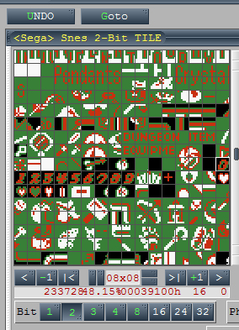

Now change the “Pendants” to numbers with a black background. Change the upper half of the “Crystals” to a double point:

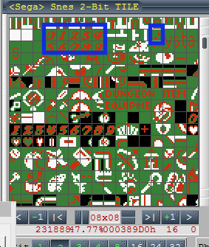

Note: the timer will first show up after having collected your first item!

