Title Page

By: Lucy Coates

Table of Contents

# Contents

Contents 2

Story 3

Reference 4

Program 5

# Story

* An idea for the story is the **witch Marigold Le Fae** whose **cabin sits at the bottom of a mountain**. The outside of the house looks like a beautiful cabin with a garden on the side meant to lure stray travelers in.
* The cabin features an area built into the mountain where the witch does her magic, a small alchemy lab, a library, and a hidden panic room if her creations get out of control with a magic disruption field that can expand to the size of the whole cabin.
* The theme for this is a mix of fantasy with horror elements with a beautiful outside and a horrifying inside which represents the witches hidden area of her cabin.
* The witch uses souls of travelers to enchant and create golems and other magical creations as well as keep her young appearance up, but this over ambitious witch created a construct she couldn’t control, and she had to hide within her panic room

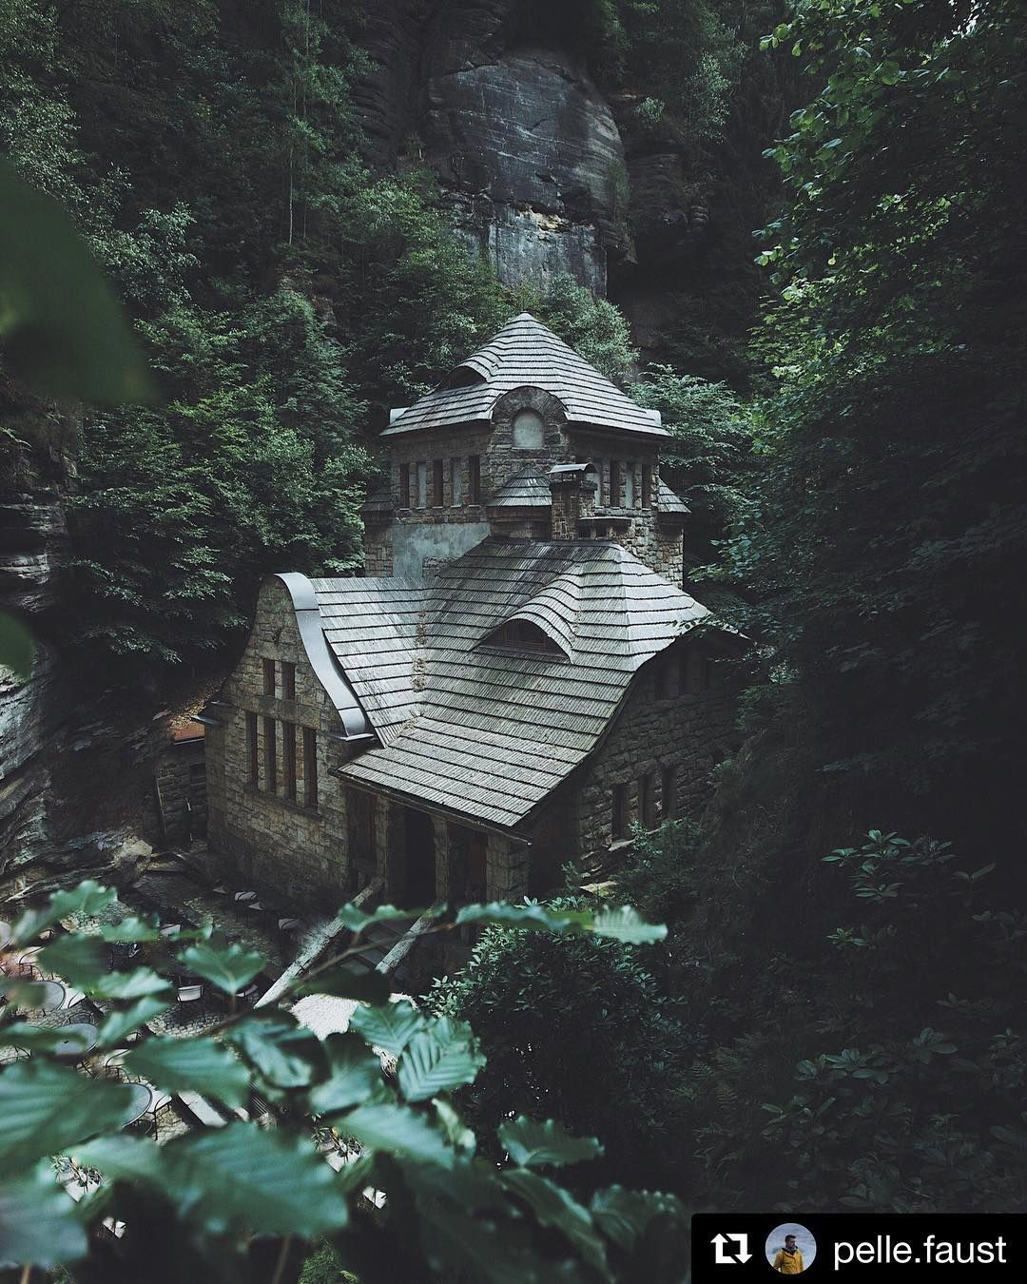

Figure -Outside of the cabin

# Reference

# Program