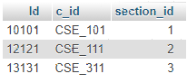**”teaches”**  
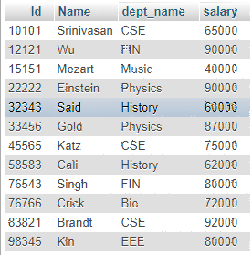

**“ Instructor”**

Q1.Perform Cartesian Product Operation between these two relation.

Select *from Instructor,teaches;

Q2. Find those instructors who teaches any of the courses.

Select name, C_id from instructor INNER JOIN teaches where Instructor.ID=teaches. ID;

Q3. Find only instructor names and course id for instructors in the Computer Science department.

Select name, C_id from instructor INNER JOIN teaches where Instructor.ID=teaches. ID AND dept_name= “CSE”;

Q4. Find the total no. of tuples in “Instructor” relation.

Select count(*) from Instructor.

Q5. Answer Q2 using Natural Join.

Select name, C_id from instructor NATURAL JOIN teaches;

Q6. Perform Left Outer Join.

Select *from instructor NATURAL LEFT OUTER JOIN teaches;

Q7. Perform Right Outer Join.

Select *from instructor NATURAL LEFT OUTER JOIN teaches;