“Employee” Table

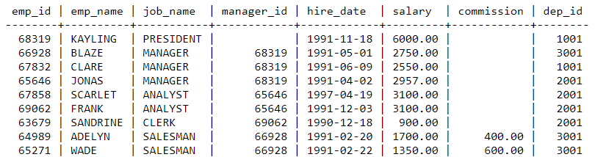

“Department” Table

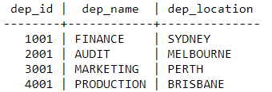

Q1.  From the following table, write a SQL query to find employees along with their department details. Return employee ID, employee name, job name, manager ID, hire date, salary, commission, department ID, and department name.

Q2. From the following table, write a SQL query to identify those employees who earn 60000 or more per year or do not work as ANALYST.

Q3. Find the third highest salary of the employee.

SELECT salary FROM Employee ORDER BY salary DESC LIMIT 2, 1