
Program: B.Sc. Engg. in Computer Science and Engineering
Summer 2026
Level-Term: L3-T1
Course Code: CSE 325 Course Title: Microprocessor and Microcontroller
Credit Value: 3
Course Type: Core Course
Credit Hours: 3.00
Prerequisite: 0612-215
Total Marks: 100
COURSE TEACHER:

Bangladesh University of Business and Technology (BUBT)
Faculty of Engineering & Applied Sciences (FEAS) Department of Computer Science and Engineering (CSE)

Name : | Fahima Khanam | Classroom Code : | 67ctmj4q
Designation : | Assistant Professor | Contact : | +8801686661369
Email : | fahima@bubt.edu.bd | Specialization : | AI, Machine Learning ,Data Mining,
 |  |  | IoT.

CLASS SCHEDULE: |  |  | COUNSELING HOURS:
Class Day | Class Hours | Room | Day | Counseling Hours | Room
Wednesday | 11.15 am - 12.45pm | B2/317 | Monday | 11.15 am – 12.45 pm | B1/310
Thursday | 1.15 pm – 2.45 pm | B2/905 | Tuesday | 11.15 am – 12.45 am | B1/310
 |  |  | Thursday | 9.45 am – 11.00 am | B1/310

Course | Rationale | This course will build up student’s ability to understand fundamental concepts of microprocessor and microcontroller based embedded systems. Also, discuss about architecture and programming concepts of 8086 based microprocessor family as well as different microcontrollers (8051, Arduino, etc.). Analyze different tools for integrating hardware and software components in micro-controller based embedded systems. This course will emphasize different techniques & tools and how to apply them as a solution of  real-life problem.
Course | Objectives | This course will build up student’s ability to understand fundamental concepts of microprocessor and microcontroller based embedded systems. Also, discuss about architecture and programming concepts of 8086 based microprocessor family as well as different microcontrollers (8051, Arduino, etc.). Analyze different tools for integrating hardware and software components in micro-controller based embedded systems. This course will emphasize different techniques & tools and how to apply them as a solution of  real-life problem.
Course Outcomes (COs) |  | Upon completing this course students will be able to:  CLO1: Understand different microprocessor and microcontroller’s internal architecture, pin diagram and its operation in the area of embedded system.  CLO2: Explain the 8086 based assembly & 8051 Microcontroller assembly language program, data movement instructions, different addressing modes, register bank, arithmetic logic instructions and various other functions etc.  CLO3: Analyze the knowledge of microprocessor and microcontroller fundamentals and different components of embedded system to design a solution for a given problem.  CLO4: Apply microcontroller fundamentals to solve the real-world problems with Microcontrollers based Embedded system.

Page | 1



CO PO1PO2PO3PO4
PO5PO6PO7PO8
PO9PO10 PO11 PO12
CO
PO
CO1 PO1
CO2 PO1
CO3 PO2
CO4 PO3
CO1 | √
CO2 | √
CO3 |  |  | √
CO4 |  | √

apping to POs
COs

Bloom’s |  | Delivery Methods / Activities | Assessment Tools
Domain / Level
Cognitive/Understanding |  | Class Lecture & Discussion | Midterm
Cognitive/Understanding |  | Class Lecture & Discussion | Midterm & Final
Cognitive/Analyzing |  | Class Lecture & Problem Solving | Midterm & Final
Cognitive/Applying |  | Problem Solving | Final

LECTURE PLAN (WEEKLY SCHEDULE)

 |  | Teaching | Assessment | Corresponding
Week | Selected Topics | Learning
 |  |  | Strategy | CLOs
 |  | Strategy
1-2 | Overview of the course, Introduction to the 8086 | Lecture, |  | CO1
(Week | microprocessors, the 8051 Microcontrollers: 8051 | Video
1) | assembly language programming | Presentation
3-4 | Internal architecture of 8086 microprocessor, real & |  |  | CO2
 | protected mode addressing, physical address calculation
(Week
 | both real and protected mode operation of
2)
 | microprocessor
5-6 | Different data addressing mode operation of 8086 based |  |  | CO2
 | microprocessors, data movement instructions (machine
(Week
 | language to assembly & assembly to machine | Lecture | Class Test,
3)
 | conversion) for 16-bit and 32-bit | discussion | Assignment,
7-8 | 8086 based assembly language: arithmetic and logic | with White | Written | CO3
(Week |  | Board and | Examination
 | instructions, flow control operation (IF-ELSE, Loop)
4) |  | Multimedia,
9-10 | Understand assembling and running an 8051 program, | Problem |  | CO2
 | The program counter and ROM spaces in the 8051, data | Solving
(Week
 | types and directives, 8051 flag bits and the PSW register,
5)
 | 8051 register banks and stack
11-12 | 8051 Assembly programming using Loop, Jump |  |  | CO2,CO3
 | (conditional & unconditional), Call instructions, time
(Week
 | delay calculation for various 8051 chips, I/O port
6)
 | programming of 8051
13-14  (Week 7) | Case Study & Review class for Mid Term Examination. | Lectures, Questions  and answers | Problem Solving  & Viva Voce | CO4

Midterm Examination (13 Feb – 20 Feb 2026)
15-16 | 8051 Addressing Modes: Immediate and register |  |  | CO2
(Week  8) | addressing modes, accessing memory, bit addressing I/O  and RAM
Page | 2

16)

answers

& Viva Voce

Final Exam (23 April – 30 April 2025)
17-18 | Arithmetic Logic instructions and programming |  |  | CO1, CO2
 | Logic, rotate instruction & data serialization, BCD,
(Week
 | ASCII and other application programs
9) |  | Lecture | Class Test,
19-20 | Hardware connection and INTEL HEX file, Timer | discussion | Assignment, | CO3
(Week |  | with White | Problem Solving
10) | programming in Assembly and C | Board and | Ability and
 |  | Multimedia, | Written
 | 8086 Hardware, De-Multiplexing operation of 8088/8086 |  |  | CO2, CO4
21-22 |  | Problem | Examination
 | Buffering, basic BUS timing, read & write operation of
(Week |  | Solving
11) | microprocessor, I/O interfacing with microprocessor:
 | LCD, Keypad etc.
23-24 | Memory interfacing with microprocessor for RAM & |  |  | CO4
(Week
 | ROM
12)
25-26 | 8051 serial port programming in Assembly and C, Basic |  |  | CO2, CO3
(Week | interrupt processing, hardware interrupt. Basic DMA
13) | operation, DMA controller
27-28 | LCD and Keyboard interfacing, motor control: Relay, | Discussion and Problem Solving | Problem Solving Ability and Written Examination | CO3, CO4
(Week
 | PWM, DC and stepper motors with 8051 microcontrollers
14) | Introduction to Arduino and Arduino based application |  |  | CO3, CO4
27-28 | like keypad, PIR sensor interfacing, servo motor, LCD
(Week 15) | display interfacing with Arduino. Mapping between  languages and hardware; Embedded Systems Hardware/
 | Software Co-design
27-28  (Week | Case Study & Review class for Semester Final Examination. | Lectures, Questions and | Problem Solving | CO3, CO4

Page | 3

Teaching Strategy
Maximum topics will be covered from the textbook. For the rest of the topics, reference books will be followed. Some class notes will be uploaded on the web. White board will be used for most of the time. Multimedia projector and a PC will be used for the convenience of the students to understand codes practically. Students must participate in classroom discussions for case studies, problems solving and project developments.

Assessment and
Summative Continuous

Marks

Assignment / Presentation Class Test
Class Participation
≥ 80

5%

10%

15%

Grading
A+

Distribution
Midterm Examination 30%

Policy

Final Examination

40%

< 40
F
A | 75-<80
A- | 70-<75
B+ | 65-<70
B | 60-<65
B- | 55-<60
C+ | 50-<55
C | 45-<50
D | 40-<45

Additional Information
- Academic Calendar: https://www.bubt.edu.bd/Home/page_details/Academic_Calender_
- Rules & Regulations: https://www.bubt.edu.bd/Home/page_details/Rules_and_Regulations
- Grading & Evaluation: https://www.bubt.edu.bd/Home/page_details/Evaluation_Grading_System
- Proctorial Rules: https://www.bubt.edu.bd/Home/page_details/Office_of_the_Proctor
Assessment methods of COs are given below:

Overall CO Assessment Criteria

Assessment Area
Class Participation
Assignment/Presentation
Class Test
Midterm Exam
Final Exam

Total Mark
CO Assessment

CO2 CO3 CO4 Area Mark
CO1
- | -
- | -  -  10  10  20
-
10
-
10

- | -
- | -
- | -
- | 30
20 | 40
20 | 70

-
-
- 10
10

20

Additional Course Policies
There will assignment. No late homework will be accepted. Any kind of copy/manipulation in assignment will carry zero mark. Two or more copied assignments will carry zero mark in all assignments. Zero tolerance will be shown in this regard. Solutions to assignment problems will be provided through web and on hand.
There will be at least three class tests (CT). Best two of three or best three CTs will be counted. Both of regular and surprise CTs can be conducted.
CT, Mid-term and final exam will be closed book, closed notes. Mobile phone is strictly prohibited in exam hall. Students are insisted to carry their own watch and synchronize time during exam hours.
If a student is absent from class test anyway and made no report to the class teacher personally beforehand, his/her score for that test will be zero. No make-up for the class test will be allowed as 2 of 3 CTs are being considered. No make-up for Mid-exam will be entertained without physical presence and recommendation of the guardian along with written permission of the department. Make-up of Mid-exam may be much harder than the regular one.

Rubrics

Answer is complete and sufficient detail provided to support issues related to the question. And also deals fully with the entire question.
rstanding CO1
COs Excellent | Good | Satisfactory | Poor | Unsatisfactory | Marks
(Bloom’s (80%-100%)  Level) | (70%-79%) | (60%-69%) | (40%-59%) | (0-39%) | (70)
 | Answer is brief

with sufficient detail provided to support issues were introduced. And most of the basic details are included but some are missing.

Answer is brief with insufficient detail provided to support issues were introduced.

Answer is incomplete and excessive discussion of unrelated issues.
And serious gaps in the basic details.

None of the relevant details
were included or 10
didn’t answer.

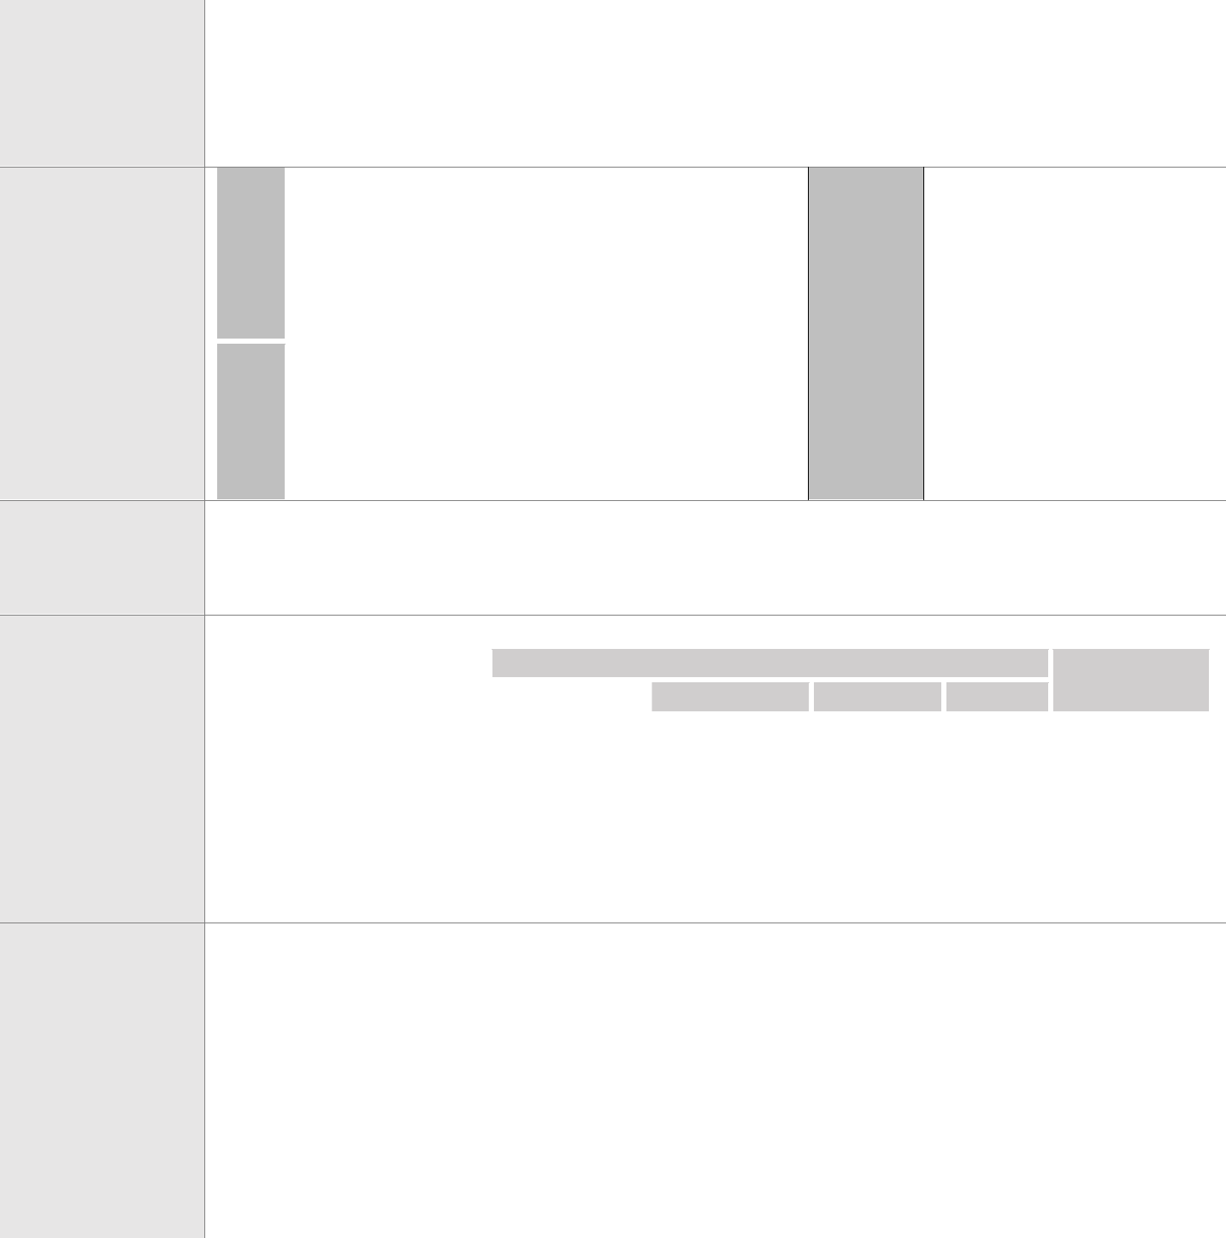Page | 4

The question is answered appropriately explaining the problem solving strategy to a specific programming problem described in the question.
CO2
Understanding

A clear, complete, and properly ordered chain of analyzing steps (i.e. perceive the problem
Analyzing
The question is answered briefly explaining the problem solving strategy to a specific programming problem described in the question.

The chain of analyzing steps
The question is answered correctly by the problem solving strategy to a specific programming problemdescribed in the questionbut some points are missing.

One or more intermediate analyzing steps are

The question is answered incompletely explaining the problem solving strategy to a specific programming problemdescribed in the question but some points are correct.

One or more intermediate analyzing steps are

No attempt to explain the problem solving
strategy to a 20
specific
programming problem described in the questionmethod.

The stated chain of analysis does not

scenario, relate the
CO3
problem to the programming perception, explore the programming strategy to solve it) is followed to answer the question.

The answer shows the complete and appropriate application of conceptual programming strategies to solve a problem.
CO4
Applying
is complete and correctly ordered but lack of some expectedplods.

The answer shows appropriate application of conceptual programming strategies incompletely to solve a problem.
missing or unclear,
but the correctness of the analysis is not compromised.

The answer shows partially appropriate butcomplete application of conceptual programming strategiesto solve a problem.
missing or unclear to answer the question.

The answer shows partially appropriateapplication of conceptual programming strategies incompletely to solve a problem.
lead to the stated 20
question.

The answer shows the incomplete and inappropriate
application of 20
conceptual programming strategies to solve a problem.

Text

Book
- Assembly language programming and Organization of the IBM PC- Ytha Yu, Charles Marut
- The 8051 Microcontroller and Embedded Systems -Muhammad Ali Mazidi , Janice Gillispie Mazidi
- The Intel Microprocessors architecture, programming and interfacing – Barry B. Brey

Reference | 1. Programming and Customizing the AVR Microcontroller
Book | - D. V. GADRE

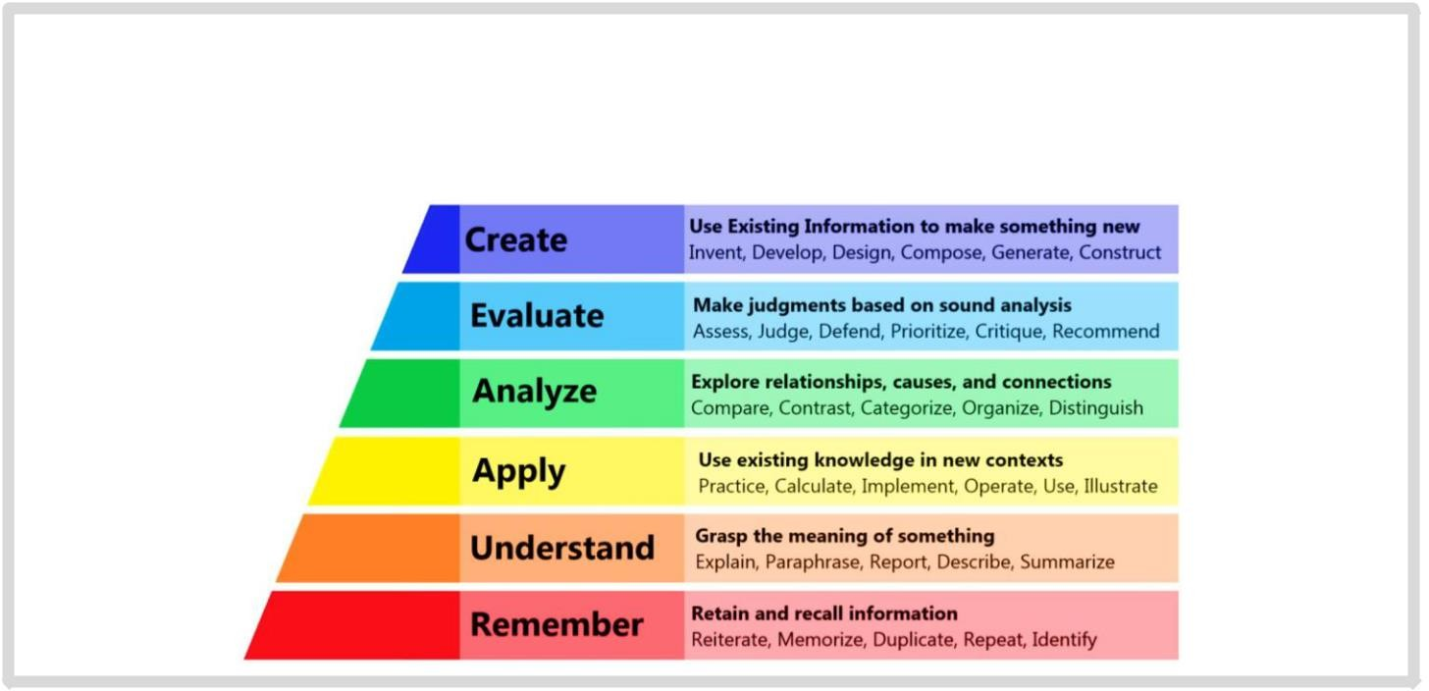
Bloom’s Taxonomy for Teaching-Learning
Bloom's Taxonomy is a set of three hierarchical models used to classify educational learning objectives into levels of complexity and specificity. The three lists cover the learning objectives in Cognitive, Affective and Psychomotor domains. The Cognitive domain list has been the primary focus of most education and is frequently used to structure curriculum learning objectives, assessments and activities. The three domains and respective levels are illustrated below.

Page | 5


Descriptions of Cognitive Domain (Anderson and Krathwohl’s Taxonomy 2001)
The cognitive domain involves the development of our mental skills and the acquisition of knowledge.
Level | Category | Meaning | Keywords
C1 | Remembering | Recognizing or recalling knowledge from memory. Remembering Define, describe, draw, find, identify, is when memory is used to produce or retrieve definitions, facts, or label, list, match, name, quote, recall, lists, or to recite previously learned information. recite, tell, write  Constructing meaning from different types of functions be they Classify, compare, exemplify, conclude, written or graphic messages or activities like interpreting, demonstrate, discuss, explain, identify, exemplifying, classifying, summarizing, inferring, comparing, or illustrate, interpret, paraphrase, predict, explaining. report  Carrying out or using a procedure through executing, or Apply, change, choose, compute, implementing. Applying relates to or refers to situations where dramatize, implement, interview, prepare, learned material is used through products like models, produce, role play, select, show, transfer, presentations, interviews or simulations. use  Breaking materials or concepts into parts, determining how the parts  relate to one another or how they interrelate, or how the parts relate Analyze, characterize, classify, compare, to an overall structure or purpose. Mental actions included in this contrast, debate, deconstruct, deduce, function are differentiating, organizing, and attributing, as well as differentiate, discriminate, distinguish, being able to distinguish between the components or parts. When examine, organize, outline, relate, one is analyzing, he/she can illustrate this mental function by research, separate, structure  creating spreadsheets, surveys, charts, or diagrams, or graphic  representations.  Making judgments based on criteria and standards through checking Appraise, argue, assess, choose, and critiquing. Critiques, recommendations, and reports are some of conclude, critique, decide, evaluate, the products that can be created to demonstrate the processes of judge, justify, predict, prioritize, evaluation. prove, rank, rate, select, Monitor  Putting elements together to form a coherent or functional whole;  reorganizing elements into a new pattern or structure through Construct, design, develop, generate, generating, planning, or producing. Creating requires users to hypothesize, invent, plan, produce, put parts together in a new way, or synthesize parts into something compose, create, make, perform, plan, new and different creating a new form or product. This process is produce  the most difficult mental function.
C2 | Understanding
C3 | Applying
C4 | Analyzing
C5 | Evaluating
C6 | Creating
Graduate Attributes (Program Outcomes) for B.Sc. in Engineering Program based on Washington Accord Program Outcomes (POs) are narrower statements that describe what students are expected to know and be able to do by the Time of graduation. These relate to the knowledge skills and attitudes that students acquire while progressing through the program. The students of the B.Sc. in CSE
program are expected to achieve the following graduate attributes or program outcomes at the time of graduation.
PO1–Engineering knowledge (Cognitive): Apply the knowledge of mathematics, science, engineering fundamentals and an engineering specialization to the solution of complex engineering problems.
PO2–Problem analysis (Cognitive): Identify, formulate, research the literature and analyze complex engineering problems and reach substantiated conclusions using first principles of mathematics, the natural sciences and the engineering sciences.
PO3–Design/development of solutions (Cognitive, Affective): Design solutions for complex engineering problems and design system components or processes that meet the specified needs with appropriate consideration for public health and safety as well as cultural, societal and environmental concerns.
PO4–Investigation (Cognitive, Psychomotor): Conduct investigations of complex problems, considering design of experiments, analysis and interpretation of data and synthesis of information to provide valid conclusions.
PO5–Modern tool usage (Psychomotor, Cognitive): Create, select and apply appropriate techniques, resources and modern engineering and IT tools including prediction and modeling to complex engineering activities with an understanding of the limitations.
PO6–The engineer and society (Affective): Apply reasoning informed by contextual knowledge to assess societal, health, safety, legal and cultural issues and the consequent responsibilities relevant to professional engineering practice.
PO7–Environment and sustainability (Affective, Cognitive): Understand the impact of professional engineering solutions in societal and environmental contexts and demonstrate the knowledge of, and need for sustainable development.
PO8–Ethics (Affective): Apply ethical principles and commit to professional ethics, responsibilities and the norms of the engineering practice. PO9–Individual work and teamwork (Psychomotor, Affective): Function effectively as an individual and as a member or leader of diverse teams as well as in multidisciplinary settings.
PO10–Communication (Psychomotor, Affective): Communicate effectively about complex engineering activities with the engineering community and with society at large. Be able to comprehend and write effective reports, design documentation, make effective presentations and give and receive clear instructions.
PO11–Project management and finance (Cognitive, Psychomotor): Demonstrate knowledge and understanding of the engineering and management principles and apply these to one’s own work as a member or a leader of a team to manage projects in multidisciplinary environments.
PO12–Life-long learning (Affective, Psychomotor): Recognize the need for and have the preparation and ability to engage in independent, life-long learning in the broadest context of technological change.

Prepared By: Checked by: Approved By:

