Feng, Jingrui Jul 7, 2026
NYU ID: jf4446
Database System Section 001
Project Part 1: Enterprise Data Architecture Modeling

Total in points: _____________
Professor’s Comment:

Statement of Independent Effort
I, Jingrui Feng, certify that the work submitted with this application is my own independent effort.
Signature: Jingrui Feng
Date: Jul 7, 2026

1. Introduction and Purpose

This report focuses on Part 1 of the project, which is the modeling step for building an Enterprise Data Architecture, or EDA, for an insurance company. According to the project brief, the full EDA work is divided into three major parts: first creating the data model, then building the Operational Data Store, and finally developing the roadmap. Part 1 is mainly about the first step, which is designing the data model.

For this part, my main goal is to review the reference materials, identify the core business objects in the insurance company, and create an entity relationship diagram based on them. After building the initial ER diagram, I also need to compare it with the business cases from the support slides. If a business case is not properly supported by the diagram, then the design needs to be adjusted until the model can cover the required scenarios.

Another important requirement for this part is that the model can include no more than 20 entities. Because of this limit, I did not try to copy every detail from the original source model. Instead, I focused on selecting the most important entities that are necessary to represent the insurer’s core business process.

The model is designed for the Operational Data Store, or ODS. The ODS works as an integrated data layer that brings together data from the insurer’s separate legacy systems, such as GroupMaster, Flex, Policy Master, and Claims. The purpose is to organize these different sources into one cleaner and more consistent schema that can support later analysis and system integration.

2. Source Material Analyzed
There are three types of material that were provided, and I used each one for a different purpose.
The architecture diagrams, including the current state, future state, and future state v2 diagrams, show how the company is moving from many separate transactional data stores toward one enterprise-level store. That enterprise store then supports the data warehouse, data marts, and business objects. These diagrams helped me understand the major subject areas in the business and also confirmed that the target of my model is the enterprise ODS.
The Enterprise Data Model, which is the large colored diagram, is the most complete reference model. It contains around one hundred tables, with colors showing which legacy system each table came from. I used this diagram as the main detailed source. I abstracted a cleaner and smaller model from it so that my ER diagram could stay within the 20 entity limit.
The Cases Supporting Design Decisions slides, including the slides for Account, Associate, Contract, and Customer, provide business rules in the format of entity, cardinality, entity.

3. Modeling Approach and Notation
Relationship lines:
The legend defines two line styles, both one to many. A solid line is identifying, which means the child depends on the parent and the parent key becomes part of the child key. A dashed line is non-identifying, which means the child can exist on its own and the parent key is a foreign key but not part of the child key. The many-to-many cardinalities I use later come from the case slides, which write relationships like Account n..n BillingAccount, not from the page 5 legend.
Color coding:
The source colors every table by the legacy system it came from, and I used those colors as my subject areas. Red is Customer, blue is Group Master and Flex accounts, which is my Account and Billing area, yellow is Agent information, which is my Associate area, orange is Flex Agreements, which is my Contract area, brown is Payments, purple is Ratebook, which is my Product area, and green is Claims.
The -h suffix:
Some source entities end in -h, such as Account-h and Contract-h. This marks history entities that keep dated versions of a record instead of overwriting them, which is why many of them carry start and end dates. History is required by one of the cases, so I kept effective dates where they are needed.

Keys:
The source uses natural composite keys. For example a customer is identified by the name fields plus date of birth, and that same group of fields reappears as a foreign key on every entity that points at the customer. I kept the natural keys so my model stays faithful to the source and can be checked against the cases, and I note where a surrogate key would be cleaner in Part 2. One case also requires CompanyCode to be part of the Account key, and I kept that.

4. Entity Selection and the 20 Entity Constraint

The source model is much larger than the limit for this part, so I did not copy it directly. Instead, I reviewed each box and classified it into one of four outcomes.

“Keep” means the item is a real business object with its own identity and lifecycle, so it should remain as an entity in my model.

“Merge” means the item is a variation of another object, so I combined it into a broader parent entity. For example, the Life, A and H, and Flex policy tables are folded into one Contract entity rather than modeled as separate entities.

“Attribute or relationship” means the item works more like a lookup table, code table, or linking table. In that case, it is better represented as an attribute or a relationship line instead of a separate entity. For example, the coordinator tables are simplified into one relationship showing that an associate is assigned to an org unit in a specific role.

“Defer” means the item is outside the scope of this model and should be handled later in Part 2. This includes the image tables for unstructured data, detailed pricing records, and data cleansing records.

Based on this process, the entities I kept are Customer, Account, BillingAccount, AccountMember, Administrator, Invoice, Claim, Product, Contract, ContractBenefit, ContractPremium, ContractParty, Associate, WritingNumber, ManagerContract, OrgUnit, and Contest. The main reductions are that the multi-level product catalog is folded into one Product entity, the sales geography hierarchy is folded into one self-referencing OrgUnit entity, and the different policy types are folded into Contract as subtypes.

5. Final Entity List
After selection and the two add backs from case checking, the model has 18 entities.
No. | Entity | Definition
1 | Customer | An insured person or legal party. A trust is treated as a Customer.
2 | Account | An employer or group that offers coverage to its members.
3 | BillingAccount | A billing destination for an account's invoices. An account can have more than one.
4 | AccountMember | A person's employment at an account, with start and end dates.
5 | Administrator | A person who handles an account's or billing account's paperwork.
6 | AccountAlias | The original legacy records kept for review after they are merged into Account.
7 | Invoice | A bill sent to a billing account. It carries payment and remittance detail.
8 | Claim | A claim filed against a contract's coverage.
9 | Product | A catalog offering made of line of business, series, plan, and rider, folded into one entity.
10 | Contract | The policy. Life, A and H, and Flex variations are folded into it.
11 | ContractBenefit | A benefit provided under a contract.
12 | ContractPremium | A premium charged under a specific benefit.
13 | ContractParty | A customer playing a role on a contract or benefit, such as owner, payer, or beneficiary.
14 | Associate | A sales agent of the company.
15 | WritingNumber | A license authorized number an associate writes business under.
16 | ManagerContract | A SitCode selling position under a writing number. It points at itself for the up-line.
17 | OrgUnit | A node in the sales geography, from territory down to district, pointing at itself.
18 | Contest | A sales contest used to score associates by production credit.

6. Entity Specifications
This section gives each entity a primary key and its main attributes from the source. Foreign keys that carry the relationships are left for the diagram. Where the source uses a natural key, I note where a surrogate key would be cleaner in Part 2.
Customer
Primary key: CustLastName, CustFirstName, CustMiddleInitial, CustSuffix, CustDOB.
Attributes: CustSalutation, CusteMailAddress, Gender, SSN_TIN, SSNType, CustomerLegacyID, WithholdingCode, PreferredLanguage, StartDate, EndDate.
Note: Natural composite key from the source. A surrogate CustomerID would be cleaner in Part 2. SSN_TIN can be an alternate key but it is not always present.
Account
Primary key: AccountName, AccountName2, LocationAddress1, LocationAddress2, LocationCity, LocationState, LocationZip, CompanyCode.
Attributes: TaxIDNumber, NumberOfEmployees, ActivityStatus, GroupNumber, LegacyFlexID, PlanYearStartDate, PlanYearEndDate, StandardIndustryCode, HSAFlag, HRAFlag, AnnualizedPremium.
Note: CompanyCode is part of the key because of the XYZ Corp case. A surrogate AccountID would be cleaner in Part 2.
BillingAccount
Primary key: BAcctName, BAcctName2, BillingAddress1, BillingAddress2, BillingCity, BillingState, BillingZip.
Attributes: GroupNumber, TaxIDNumber, GeoCode, OnlineBillingFlag, ActivityStatus, BillingPhone.
Note: Kept separate from Account so one account can have many billing accounts and one billing account can serve many accounts.
AccountMember
Primary key: The Account key plus the Customer key plus StartDate.
Attributes: EndDate, FSAContributionAmount, CustBAcctDepartmentName.
Note: This is the link between Customer and Account. The dates satisfy the 13 month history and the moonlighting cases.
Administrator
Primary key: AdminID, a surrogate key.
Attributes: AdminAddress1, AdminAddress2, AdminCity, AdminState, AdminZip, Phone, FaxNumber, Gender, EMailAddress.
Note: Merges the AcctAdmin and BAcctAdmin tables. A surrogate AdminID is recommended since a name alone is weak.
AccountAlias
Primary key: The Account key plus AliasSource and AliasID.
Attributes: AliasName, AliasAddress1, AliasAddress2, AliasCity, AliasState, AliasZip, AliasPhone, AliasEMailAddress, AliasFax.
Note: Keeps each original legacy record after consolidation, as the AccountAlias case requires.
Invoice
Primary key: InvoiceNumber.
Attributes: PaidDate, DueDate, RunDate, and folded in remittance detail such as PaymentMethod, PaymentDate, RemittanceFreq.
Note: Payment and remittance are folded in here for the conceptual model. They could become their own entity in Part 2.
Claim
Primary key: ClaimNumber.
Attributes: ClaimDate, SettlementDate, WellnessEligibilityDate.
Note: Links to Customer through a claimant relationship and to ContractBenefit through a coverage relationship.
Product
Primary key: LineOfBusiness, SeriesName, PlanName.
Attributes: RiderName, PlanCode, RatebookLocationCode, Description, Benefit, AnnualizedPremium.
Note: This collapses the Product, Series, Plan, and Rider levels into one entity. Rider is held as detail.
Contract
Primary key: ContractNumber.
Attributes: ActivityStatus, CoverageType, BillingMethod, ModalPremium, InForceFlag, PayUpDate, Duration, Language, and banking and card fields.
Note: Life, A and H, and Flex are represented within Contract rather than as separate entities. Their type specific fields can be split out in Part 2.
ContractBenefit
Primary key: The Contract key plus the Product key including RiderName. Identifying.
Attributes: PolicyCountContribution.
Note: A benefit cannot exist without its contract, so this is an identifying child. One contract has many benefits.
ContractPremium
Primary key: The ContractBenefit key plus PremiumCode. Identifying.
Attributes: AnnualizedPremium, ProcessDate, AppSignDate.
Note: A premium cannot exist without its benefit, so this is an identifying child. One benefit has many premiums.
ContractParty
Primary key: The Contract key plus the Customer key plus Role.
Attributes: A benefit reference for benefit level roles, StartDate, EndDate.
Note: Stores which customer plays which role, such as owner, payer, or beneficiary, on a contract or benefit.
Associate
Primary key: AssocLastName, AssocFirstName, AssocMiddleInitial, AssocSuffix, AssocDOB, or a surrogate AssociateID.
Attributes: TenureDate, ConsolAssocID, CorpEMailAddress, AssocPhone, AssocAddress1, AssocAddress2, AssocCity, AssocState, AssocZip, DBAName.
Note: Natural composite key from the source. A surrogate AssociateID is recommended.
WritingNumber
Primary key: CompanyCode, WritingNumber.
Attributes: IssueDate, Status, VestedFlag, TerminationDate, LicenseState, LicenseNumber, LineOfBusiness.
Note: This is the link between an associate and a manager contract. The license detail is folded in here.
ManagerContract
Primary key: SitCode, CompanyCode, WritingNumber, Level, IssueDate.
Attributes: ContractType, CommissionCode, Role, a parent SitCode for the up-line, StartDate, EndDate.
Note: It points back at itself through the parent SitCode. SitCode0 is the formal chain and other SitCodes are side deals.
OrgUnit
Primary key: A surrogate OrgUnitID. The natural key is the level name plus StartDate.
Attributes: OrgLevel from territory down to district, Name, a parent OrgUnit, StartDate, EndDate, StateCode.
Note: This one entity replaces the five source levels and their coordinator tables and points back at itself.
Contest
Primary key: ContestName, StartDate.
Attributes: Prize, PrizeAmount, EndDate, Criteria, Threshold.
Note: Associates enter contests through a participation relationship, and results are scored by OrgUnit.

7. Relationships
Each relationship shows its cardinality and whether it is identifying or non-identifying, and ties to the business meaning. Many-to-many relationships are shown at the conceptual level and would become link entities later.
Relationship | Cardinality | Type | Meaning and case
Account, AccountMember, Customer | 1 to many each side | Identifying | Employment. Resolves Customer and Account. Carries the 13 month history and moonlighting.
Account, BillingAccount | Many to many | Non-identifying | Many accounts to many billing accounts. Three PO box and shared paperwork.
Account, Account | Many to many, self | Non-identifying | Master and sub group links with a relationship type. Archdiocese.
Account, Administrator | Many to many | Non-identifying | Several admins per account and an admin serving several accounts. WalMart admins.
Account, AccountAlias | 1 to many | Identifying | Each account keeps several original legacy records. Gene's Auto Parts.
BillingAccount, Invoice | 1 to many | Identifying | A billing account receives many invoices.
Product, Contract | 1 to many | Non-identifying | A contract is an instance of a product plan.
Contract, ContractBenefit | 1 to many | Identifying | One contract has many benefits. First half of the Contract case.
ContractBenefit, ContractPremium | 1 to many | Identifying | One benefit has many premiums. Second half of the Contract case.
Customer, ContractParty, Contract | Many to many by role | Non-identifying | Owner and payer roles. Daddy Warbucks owner, trust payer.
Customer, ContractParty, ContractBenefit | Many to many by role | Non-identifying | Beneficiary role. Son and family are beneficiaries.
Customer, Customer | Many to many, self | Non-identifying | Family and trust ties. Daddy Warbucks and son.
Contract, Claim | 1 to many | Non-identifying | A contract can generate many claims.
Claim, Customer | Many to many | Non-identifying | Who the claim is for.
Claim, ContractBenefit | Many to many | Non-identifying | Which coverage the claim draws against.
Associate, WritingNumber | 1 to many | Identifying | An agent has many license authorized numbers. License case.
WritingNumber, ManagerContract | 1 to many | Identifying | Each writing number has many SitCodes. License case.
ManagerContract, ManagerContract | 1 to many, self | Non-identifying | The up-line chain. SitCode0 versus side deals. Keith's side deal.
Account, ManagerContract | Many to many by role | Non-identifying | Servicing, assisting, and broker roles. Account to manager contract case.
Associate, Associate | Many to many, self | Non-identifying | Broker and recruiter links. Associate to associate case.
ContractPremium, ManagerContract | Many to many | Non-identifying | Commission accounting along the SitCode chain.
ContractPremium, OrgUnit | Many to many | Non-identifying | Production credit accounting along the geography.
Associate, OrgUnit | Many to many by role | Non-identifying | Coordinator and assistant assignment. Replaces the coordinator tables.
OrgUnit, OrgUnit | 1 to many, self | Non-identifying | The territory down to district hierarchy.
Associate, Contest | Many to many | Non-identifying | Contest participation, scored by OrgUnit.
Customer, Associate | Many to many | Non-identifying | Inherited commissions. Walt and Dave.

8. Case Verification
This is the required step. I go through every case on the four support slides and check whether the model supports it. Supported means the structure can already store the scenario. Amended means I changed the model so it could.

Account cases
Case | Status | How the model supports it
Account n..n BillingAccount. WalMart uses 3 PO boxes. | Supported | Many to many between Account and BillingAccount lets one account reach several billing accounts.
Keith's Garage does paperwork for Cliff's and Scott's. | Supported | The same many to many in reverse lets one billing setup serve several accounts.
Account n..n Account. Archdiocese with St. Jude, St. Mary, and Pepsi. | Amended | Self referencing link on Account with a relationship type, so one account can be a GroupMaster master and another a Flex master at once.
Account n..n AccountAdmin. 3 admins, one admin serves many accounts. | Supported | Many to many between Account and Administrator handles both directions.
Account 1..n AccountMember. 13 month history, moonlighting, quit and return. | Amended | Added start and end dates to AccountMember and made Customer to Account many to many through it.
AccountAlias. Gene's Auto Parts keeps 3 originals plus a duplicate. | Amended | Added the AccountAlias entity back so each original legacy record is kept.
Account key includes CompanyCode. Two XYZ Corps. | Supported | CompanyCode is part of the Account key, so same name and address groups are told apart.

Associate cases
Case | Status | How the model supports it
Account n..n ManagerContract. One SitCode services many accounts, several service roles. | Amended | Many to many between Account and ManagerContract with a role for servicing, assisting, and broker.
Associate 1..n ManagerContract. License to writing numbers to SitCodes, SitCode0 versus side deals. | Amended | Added WritingNumber back so the chain runs Associate to WritingNumber to ManagerContract, and ManagerContract points at itself.
Commissions versus Production Credit. | Supported | ContractPremium to ManagerContract carries commission, and ContractPremium to OrgUnit carries production credit.
Associate n..n Associate. Broker and recruiter. | Supported | Self referencing link on Associate with a relation type.

Contract cases
Case | Status | How the model supports it
Contract 1..n, 1..n ContractPremium. Many benefits, each with many premiums. | Supported | The chain Contract to ContractBenefit to ContractPremium stores this.
Years 1 to 3. Adding a wife then twins on the same policy. | Supported | Each addition is a new benefit and premium on the existing contract, and each premium ties to the selling manager contract.

Customer cases
Case | Status | How the model supports it
Customer n..n Customer. Warbucks, son, and trust, rider for son only. | Supported | Self referencing link on Customer, and the son only rider is a benefit scoped to the son through ContractParty.
Customer n..n Contract. Owner versus payer, plus Daddy's life policy. | Supported | ContractParty with a role of owner or payer.
Customer n..n ContractBenefit. Beneficiaries, son's accident cover. | Supported | ContractParty carries a beneficiary role at the benefit level.
Customer n..n Account. Dana's employees, Keith moonlights. | Supported | Customer to Account many to many through AccountMember.
Customer n..n Associate. Walt and Dave bequeath commissions. | Amended | Added a many to many between Customer and Associate for inherited commissions.

9. Amendments, Assumptions
Amendments from verification
Case tracing exposed gaps that required these changes.
AccountAlias added as an entity to retain original GroupMaster and Flex records post consolidation, per the AccountAlias case.
WritingNumber added as an entity to support the Associate to WritingNumber to ManagerContract chain, per the license case.
RelationshipType attribute added to the Account to Account relation, so one account can act as GroupMaster master and Flex master concurrently.
Role added to the key of the Account to ManagerContract servicing link and the Customer to Contract party link, allowing multiple roles per pair, servicing versus assisting, owner versus payer versus beneficiary.
Customer to Associate relation added for bequeathed commissions, per the Walt and Dave case.
StartDate and EndDate added to AccountMember for the 13 month history and quit and return case.
Assumptions
Model target is the ODS, so entities consolidate legacy sources rather than mirror any single system.
A trust or non person payer is modeled as a Customer instance, not a separate entity.
The five level sales geography, Territory through District, is collapsed into one self referencing OrgUnit with OrgLevel as a discriminator.
The four level product catalog, Product through Rider, is collapsed into one Product entity keyed at plan level, with RiderName as an attribute.
Natural composite keys are retained for source fidelity, surrogate keys recommended at the Part 2 logical stage.
Payment, remittance, and image data are deferred to Part 2, represented here as folded attributes or documented hooks.
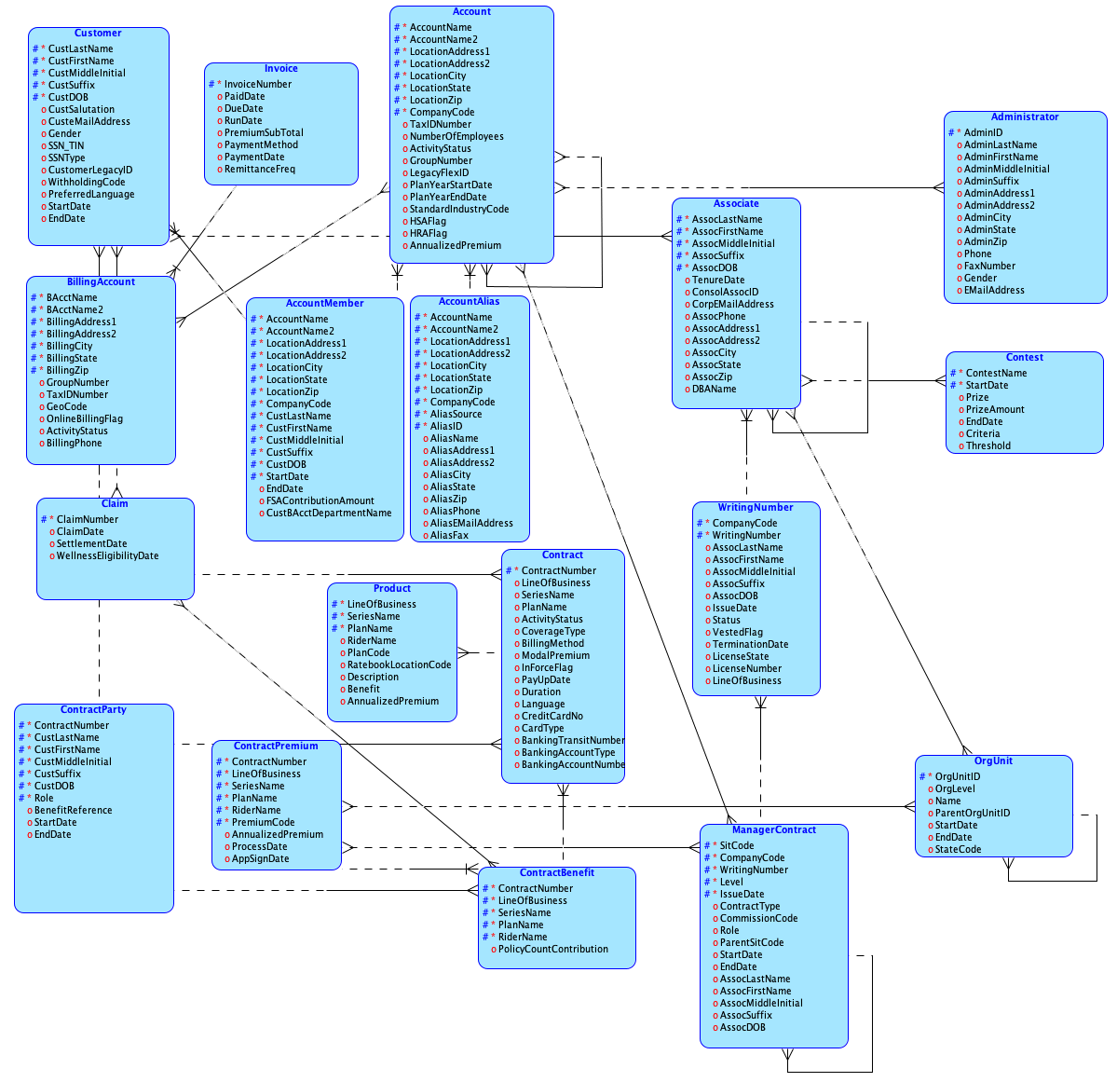
Tool: Oracle SQL Developer Data Modeler (free, cross platform), used as the equivalent to Erwin allowed by the brief. Logical model built and exported for submission.

