Feng, Jingrui Jul 21, 2026
NYU ID: jf4446
Database System Section 001
Database Systems Project Part 2
Logical Schema Optimization and Unstructured Data Collection

Total in points: _____________
Professor’s Comment:

Statement of Independent Effort
I, Jingrui Feng, certify that the work submitted with this application is my own independent effort.
Signature: Jingrui Feng
Date: Jul 21, 2026

1. Introduction
This report covers the second part of my project for the life insurance company. Part 1 produced a conceptual entity relationship model with 18 entities and 26 relationships. This part takes that model, turns it into an optimized logical database schema, collects a set of external health datasets into a small data lake, and designs the bridge that inter-relates the two so the company can use population health data to price its policies.

1.1 Project direction
The original idea from the brainstorming session was a health insurance product that would price premiums based on diabetes risk. When I looked into it I found that does not work legally. Under the ACA, health insurers in the US cannot set premiums based on health status or pre-existing conditions. Health premiums can only vary by age, location, family size, and tobacco use, so a product that prices diabetes risk directly is not permitted.
I proposed a pivot to life insurance instead, where medical underwriting on conditions like diabetes is legal and is standard industry practice. Professor Franchitti approved this direction. Life insurance also makes the data story stronger, since life insurance prices mortality risk and diabetes is a well documented driver of mortality, so the external datasets map directly onto what the company needs to know.
The product is a life insurance company with a transactional website. An applicant provides a medical profile with age, gender, smoking status, diabetes status, and BMI, and receives a quote. A wellness program lets policyholders join participating gyms, and participation reports back to the company so premiums can be credited at renewal.

1.2 Required pricing mechanisms
When approving the direction, the professor confirmed three behaviors the design should cover. These drove much of the bridge schema design and I have noted throughout the report where each one is satisfied.
- An asynchronous mechanism that revises policy pricing based on information collected from the datasets.
- Pricing changes must not affect the premiums of members who already hold policies, while new applicants are subject to the current rates.
- Policy renewals are affected by the new rates, with offsets from participation in the wellness program.

2. Data Lake
The data lake holds the external health data the company uses to understand mortality risk. All of it is public and government sourced, which keeps the sourcing transparent and avoids any licensing or privacy problem.

2.1 Datasets collected
Source | Content | Format | Scope
CDC BRFSS 2024 | Diabetes prevalence and changeable risk factors by demographic band | SAS XPT converted to CSV | 50,000 record sample of 457,670
CDC NHANES 2021 to 2023 | Measured biometrics, diabetes questionnaire, body measures | XPT converted to CSV | 11,933 demographics records, full extract
CDC WONDER, all cause | Deaths, population, and crude rate by age band and sex | TSV | Full query result
CDC WONDER, diabetes | Same breakdown filtered to ICD-10 E10 to E14 | TSV | Full query result
SSA period life table 2023 | Death probability and life expectancy by age and sex | CSV | Ages 0 to 119, both sexes
NIDDK diabetes statistics | Prevalence and acute complications summary tables | CSV | Published summary tables

2.2 Fields that matter
For BRFSS 2024 the variable names I need are DIABETE4 for diabetes status, _SMOKER3 for smoking status, EXERANY2 and _TOTINDA for physical activity, _BMI5 and _BMI5CAT for body mass index, _AGEG5YR for the age band, and _SEX for sex. Variable names change between survey years so these were read from the 2024 codebook rather than assumed.
For NHANES the August 2021 to August 2023 release uses the _L file suffix. The diabetes fields are DIQ010, DID040, DIQ160, DIQ180, DIQ050, DID060, DIQ060U, and DIQ070, and measured body mass index is BMXBMI.
I had planned to use A1C as the diabetes biomarker, but A1C is not present in the three NHANES files I collected and the diabetes questionnaire documentation states that A1C knowledge questions were not collected for this cycle. Measured BMI from BMXBMI serves as the biometric instead, with DIQ010 supplying the diabetes status.

2.3 Lake structure
The lake is organized so the raw downloads stay separate from the cleaned extracts. Raw folders hold the original files exactly as they were downloaded, one folder per source. A curated folder holds the cleaned CSVs containing only the columns the project needs. Keeping both means the lineage from a curated number back to its original file is never lost, which matters for the governance side of the architecture.
Where a raw file was too large to carry whole, I took a curated slice rather than the complete dataset and recorded that in the metadata. BRFSS is the main case, where the 2024 annual file holds 457,670 records and the curated extract is a deterministic 50,000 record sample. NHANES was small enough to keep in full.

2.4 How the lake feeds the EDA
The path from a raw file to a quoted premium runs through the bridge schema described in section 5. In short, curated slices of the lake files load into staging tables inside the relational database. An asynchronous job reads those staging tables and derives a mortality multiplier for each combination of age band, gender, smoking status, diabetes status, and BMI band. Those multipliers become rates, and the rates are what an applicant is quoted.
The two CDC WONDER exports are what make this accurate. The all-cause query gives the baseline mortality rate for each age and sex band, and the diabetes filtered query gives the diabetes attributed rate for the same bands. Comparing the two produces the risk signal the product prices on. In the 45 to 64 age range, which is the core life insurance market, diabetes accounts for roughly four percent of deaths, and the rate for men runs consistently above the rate for women in every band.

3. Logical Schema Generation

3.1 Generating from the Part 1 model
I generated the logical schema from the Part 1 conceptual model using Oracle SQL Developer Data Modeler, which is the same tool I used to build the model. In this tool the assignment idea of a logical schema corresponds to what the tool calls a relational model, and the process of producing it is forward engineering.
The target database matters here. The handout asks that the target correspond to the product the project will actually run on, which is Azure SQL Database. The SQL Server target I used is SQL Server 2012, and since Azure SQL Database uses the SQL Server dialect, that target produces valid types for it.
The generation took the 18 entities and 26 relationships in, and produced 29 tables and 38 foreign key constraints out. The extra 11 tables are junction tables the engine created for the many to many relationships, since a relational database cannot represent those directly.
The generated relational model is shown below and is included in the archive as relational_model.png.
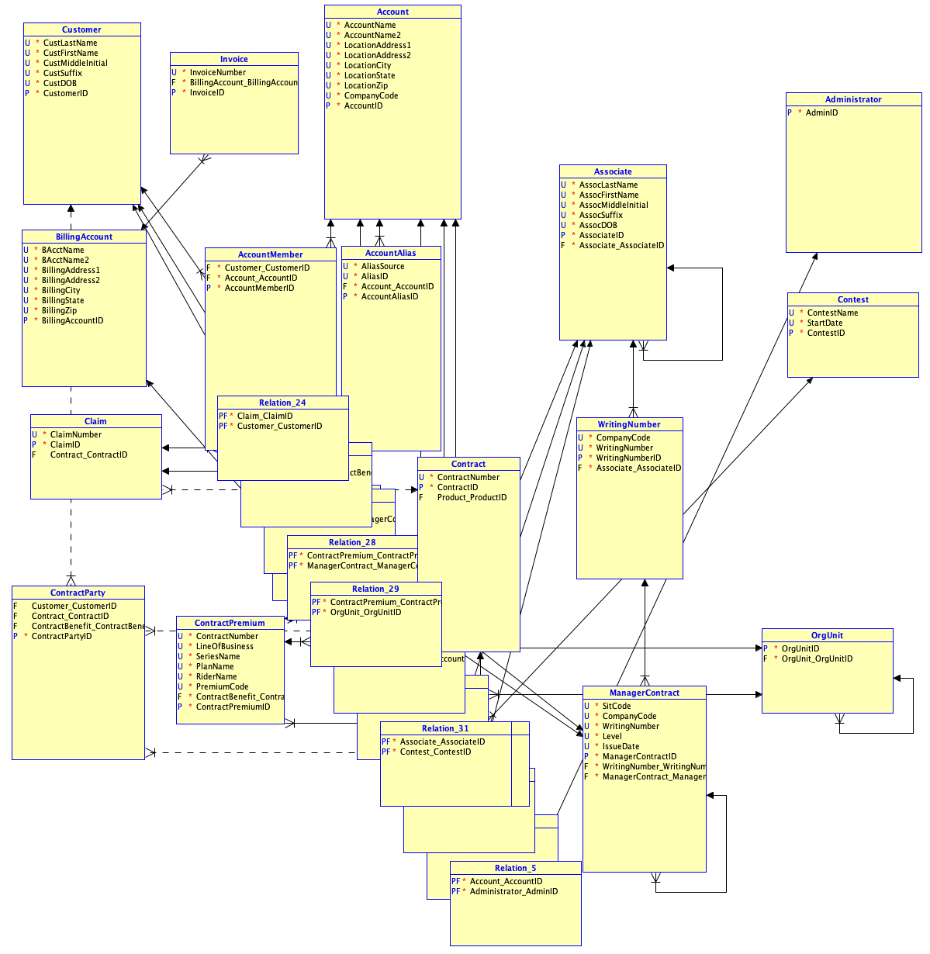

3.2 How each relationship type translated
One to many relationships became foreign key columns, with the primary key of the parent copied into the child. Where a relationship was identifying, that foreign key also became part of the child primary key, and where it was non-identifying it stayed an ordinary column. Mandatory relationships produced NOT NULL foreign keys and optional ones produced nullable columns.
Many to many relationships each generated a junction table holding the keys of both sides. These arrived with generated names like Relation_3 and Relation_39 that carry no meaning, which is a naming problem I address in the optimization section.
The three self-referencing relationships became columns pointing back at their own table primary key. OrgUnit is the clearest example, where a parent organization unit identifier references OrgUnit itself. These are the relationships that let the model represent a hierarchy.

4. Schema Optimization
The handout defines optimization for this project as covering normalization as well as the extensions needed to the data. This section covers the first part, and the change log for the created schema. Section 5 covers the extensions.
The generated schema is included in the archive as schema_v0_generated.sql and the final optimized version as schema_final.sql, so the before and after can be compared directly.

4.1 Change log

1. Assigned datatypes to all attributes. The first generation produced 621 errors, all saying datatype UNKNOWN is not allowed, because the Part 1 model carried no physical types.

2. Corrected 13 reversed relationship directions. The generated DDL put foreign keys on the parent tables, so Contract held a key to Claim rather than the reverse. The cause was my click order when drawing the relationships, since the first entity clicked becomes the source and the source key is what gets copied into the target. The Part 1 cardinalities were correct throughout, only the recorded direction was wrong, and nothing surfaced it until the model had to generate something.

3. Made three self-references optional. OrgUnit, Associate, and ManagerContract generated with a mandatory parent, which makes the root of a hierarchy impossible to represent.

4. Converted all entities to single column surrogate keys. Natural composite keys chained through identifying relationships absorbed each other, producing a 97 column primary key on AccountMember and a 64 column junction key. Every base table now has a one column key, with the original natural keys preserved as UNIQUE constraints so the business rules they encoded still hold.

5. Applied 15 reusable domains. Defining types once and reusing them avoids inconsistency across the model. The choices carry meaning: money is NUMERIC(12,2) rather than floating point because premiums must be exact to the cent, and ZIP is VARCHAR because a leading zero matters.

6. Removed 326 redundant propagated columns. These were untyped copies of natural key columns left behind by the surrogate conversion, superseded by the surrogate foreign keys and carrying no independent data.

4.2 Normalization check

I checked each table for repeating groups, partial dependencies, and transitive dependencies. The first two are resolved structurally by the surrogate key conversion, since a single column primary key leaves no partial key for an attribute to depend on. Repeating groups were already absent from the Part 1 model.

The redundant propagated columns from change 6 were the one real violation. A customer last name sitting inside AccountAlias depends on the customer, reachable through the relationship chain, not on the alias. Removing those columns resolves it.

4.3 Result
Measure | Generated schema | Optimized schema
Datatype errors | 621 | 0
Largest primary key | 97 columns (AccountMember) | 1 column
Largest junction key | 64 columns | 2 columns
Redundant untyped columns | 326 | 0
Foreign keys | 38 | 38
Tables | 29 | 29

The table count and foreign key count are unchanged because the optimization did not alter what the model represents. It changed how the model is physically expressed.

5. Extensions for the Hybrid Model
This section covers the optimization, which is the extensions required to interrelate structured and unstructured data. I added 12 tables that connect the relational schema to the external health data in the lake. Together they are what makes the model hybrid rather than just relational.
The bridge is organized in layers that follow the DIKW pyramid, which is the framing the handout uses throughout.

5.1 Data layer: staging tables
Three staging tables mirror curated slices of the lake files into the database so the rest of the system can work with them. STG_BRFSS holds prevalence and changeable risk factors by demographic band. STG_NHANES holds the measured biometrics. STG_MORTALITY holds the mortality rates and life expectancy from the WONDER exports and the SSA life table.
Each staging row carries a LoadDate and a SourceFile reference. That reference is the lineage back to the specific blob in the lake, so any number in the system can be traced to the file it came from.

5.2 Information layer: risk factors
RISK_FACTOR turns the raw bands into a pricing signal. Each row combines an age band, gender, smoking status, diabetes status, and BMI band, and attaches a mortality multiplier where one means baseline risk and anything above one means elevated risk. Each row also records which refresh run derived it, so the provenance of a multiplier is never ambiguous.

5.3 Knowledge layer: rates
RATE_VERSION records a set of rates with an effective date, an expiry date, and a status, so the company can have one active rate book while keeping the history of previous ones. RATE ties a risk factor and a product to a base premium, which is the number an applicant is actually quoted.

5.4 The asynchronous mechanism
DATA_REFRESH_RUN is the first of the professor requirements made concrete. Each row is one scheduled run that reads the staging tables, rebuilds the risk factors, and publishes a new rate version. It records when the run started and finished, whether it succeeded, and which datasets it read.
The important property is that this is decoupled from anything a user is doing. The website reads whichever rate version is currently active. The refresh job is what changes which version is active. Because they are separate, a rate revision never interrupts a live application and never silently reprices a policy in force.

5.5 Freezing existing policies
The second requirement is that a pricing change must not affect people who already hold a policy. I satisfied this with a single column added to the existing Contract table, IssuedRateVersionID, which pins each policy to the rate version that was active when it was issued.
When a new version is published, existing contracts keep pointing at their original version so their premium does not move. A new applicant is quoted against whatever version is active at that moment. This is the only change the bridge makes to the 18 base tables. Everything else is new.

5.6 Renewals and the wellness loopback
The third requirement is that renewals are affected by new rates with an offset for wellness participation. POLICY_RENEWAL is a separate record that points at the current rate version rather than the frozen one, so a renewal reprices against the newest rates. It carries a wellness discount percentage and the final premium after that discount is applied.
The wellness side supplies the discount through four tables. WELLNESS_PROGRAM describes the programs and their participating gyms. WELLNESS_ENROLLMENT records which policyholder joined which program. WELLNESS_ACTIVITY records the participation events reported back by the gym. RISK_IMPROVEMENT records measured change over time in the changeable factors, comparing a measurement against a baseline to produce an improvement percentage.
That last table is what closes the loop. The changeable factors it measures, body mass index and smoking status and exercise frequency, are the same factors that appear in RISK_FACTOR. So the wellness program is not just a marketing discount, it measures improvement in the exact variables the company prices on. There is real market precedent for this in interactive life policies, and the evidence base is the NIH Diabetes Prevention Program, which found that lifestyle intervention reduced progression to type 2 diabetes more than medication did.

5.7 How the three key requirements are met
Requirement | Where it is satisfied
Asynchronous revision from datasets | DATA_REFRESH_RUN reads STG tables, rebuilds RISK_FACTOR, issues a new RATE_VERSION
Existing policies unaffected, new applicants get current rates | Contract.IssuedRateVersionID pins each policy to its issue time rate book
Renewals repriced with wellness offset | POLICY_RENEWAL points at the current version and subtracts a discount derived from RISK_IMPROVEMENT

6. Reference Architecture
The architecture spans four domains.
The business domain covers what the company is trying to do, which is quote and renew life insurance policies, and it includes the wellness program and the participating gyms that report participation back.
The application domain has two pieces. The transactional website is what applicants and policyholders use, and it reads and writes the structured tables. The asynchronous refresh job is separate from any user session and is what revises pricing on a schedule.
The knowledge domain is the DIKW pipeline described in section 5, running from staging tables through risk factors to rates. This is the center of the architecture, because it is where external data becomes something the company can price on.
The infrastructure domain is the cloud platform. The structured tables live in a managed relational database and the raw external files live in object storage acting as the data lake. Splitting them this way matches how each is used, since the relational database suits structured transactional data and object storage is a simple and cheap home for large raw files.
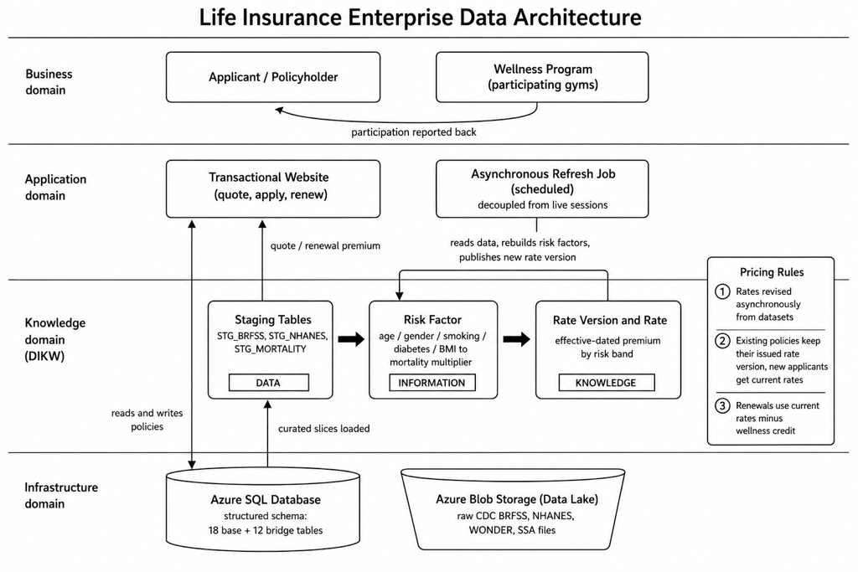

6.1 Governance
Governance is what keeps a data lake from becoming a data swamp as more datasets flow in. Several things in this design serve that.
Every staging row keeps its source file reference, so any number traces back to the dataset it came from. Every refresh run is logged with its status and the datasets it read. And because rates are versioned and each version records the run that produced it, the company can explain why a particular policy was priced the way it was. That matters for accountability, since a model that prices people on health data should be able to show its work.
The company-side data is synthetic rather than drawn from real policyholders, and the external health data is public and aggregated with no individual records, so nothing in the system holds identifiable personal health information.

7. Cloud Implementation
7.1 Cloud platform
The handout asks that a cloud platform be leveraged to store and manage all or part of the hybrid data, and gives Microsoft Azure as the example. I used Azure SQL Database for the structured schema and Azure Blob Storage for the data lake, and set the schema generation target to SQL Server 2012 so the DDL would be valid for Azure SQL.
The deployment runs on a personal Azure free account, since NYU tenant policy restricts enrollment in Azure for Students. The database uses the Azure SQL Database free offer, 100,000 vCore seconds of compute and 32 GB of storage per month, with overage billing disabled. The data lake uses roughly 2.7 MB of the 5 GB of always free blob storage.
7.2 Data lake in Blob Storage
The seven curated dataset files are stored in a blob container named datalake under a curated folder, mirroring the local structure described in section 2.
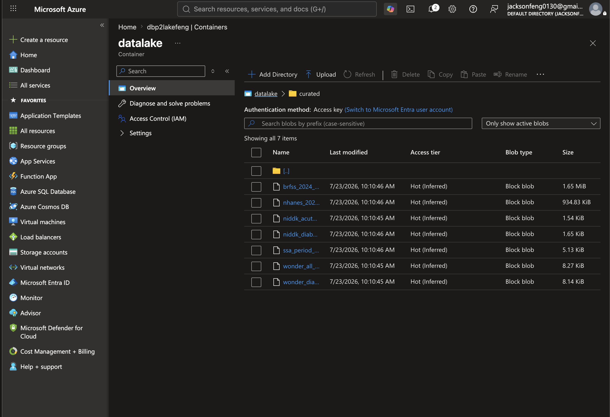

7.3 Schema deployment
I deployed the schema in three steps against the Azure SQL database. First the optimized base schema, which created 29 tables. Then the bridge schema, which created the 12 tables described in section 5. Then the post deployment statements that wire the two together, adding the IssuedRateVersionID column to Contract and creating the four cross schema foreign keys.
The query below confirms the third step landed, returning the added column and all four foreign keys.
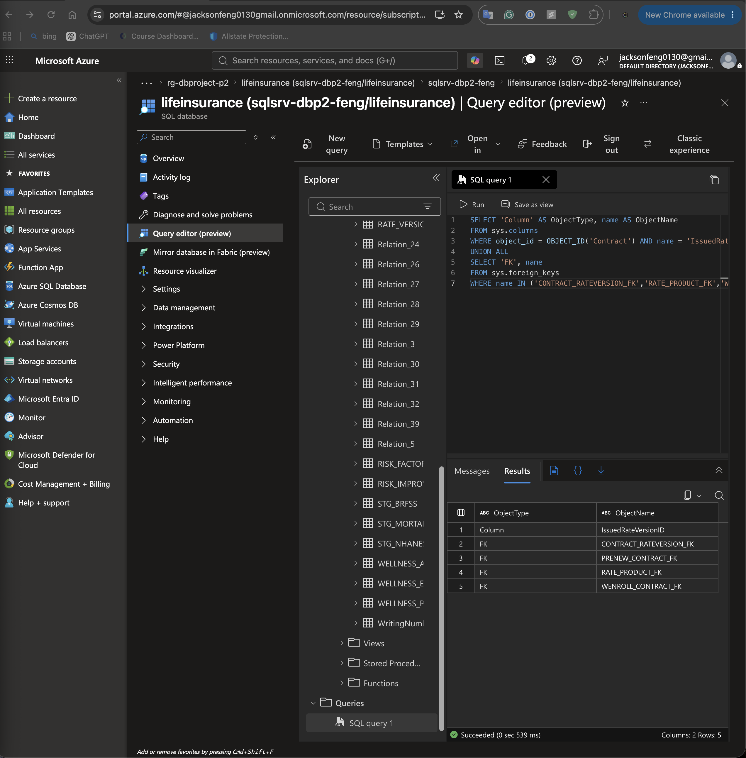

7.4 Synthetic data for the structured tables
The relational tables are populated with synthetic data generated in Mockaroo, since real policyholder records obviously cannot be used. I built a schema per table matching the column names, types, and lengths in the optimized schema, and generated the following.
Table | Rows
Customer | 1,000
Product | 15
BillingAccount | 300
Contract | 500
Claim | 200
ContractParty | 500
Invoice | 600
WELLNESS_PROGRAM | 5
WELLNESS_ENROLLMENT | 200
WELLNESS_ACTIVITY | 800
RISK_IMPROVEMENT | 400

The surrogate keys behave differently between the two halves of the schema. The base tables use plain integer primary keys, so their CSV files carry the identifier column explicitly. The bridge tables use IDENTITY columns, so the database generates their keys and the CSV leaves the column out. Getting this wrong in either direction fails the load.
The generated data also had to be validated against the schema before loading, and it did not pass on the first attempt. The generator produced malformed dates across most tables, emitted error text where custom lists were left empty, and produced values that overflowed their columns. Contract had card type values like diners-club-carte-blanche at 25 characters against a 10 character column. Product violated its own natural key UNIQUE constraint, since three columns randomized independently will collide, and only 12 of 15 rows came out distinct.
I checked every file for NOT NULL coverage, length overflow, unique constraint violations, foreign key integrity, and date ordering, then corrected the data and kept the originals. This is ordinary ETL cleansing, and it shows something the schema alone cannot, which is that constraints only prove their worth when real data meets them.

7.5 Data loaded into the deployed database
The Azure portal query editor has no CSV import wizard, so I loaded the corrected data as INSERT statements. Product and Customer are loaded, which is enough to demonstrate the deployed schema accepting real rows and enforcing its constraints. Both are parent tables with no foreign keys of their own, so they load before anything that references them.
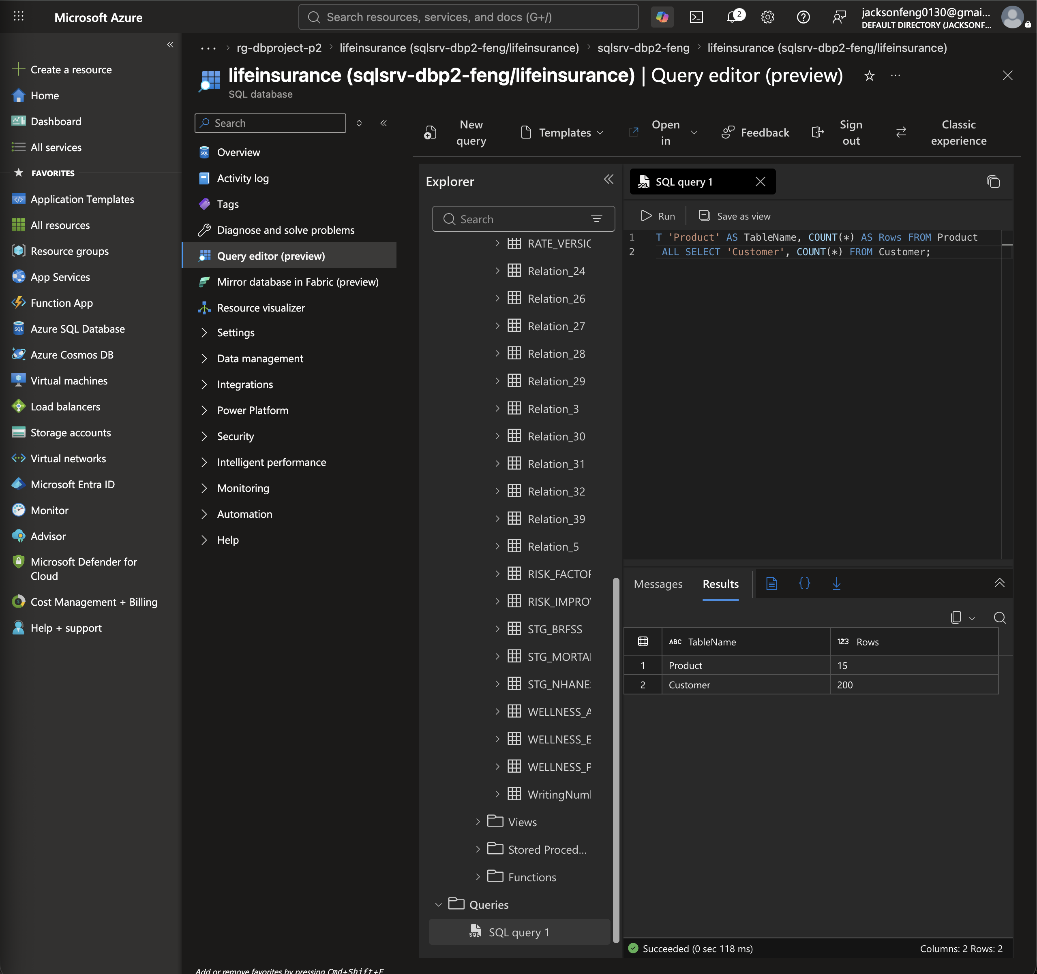
Selecting from Customer returns the loaded rows with the corrected data, including the CustSuffix values that had to be filled because the column is NOT NULL.
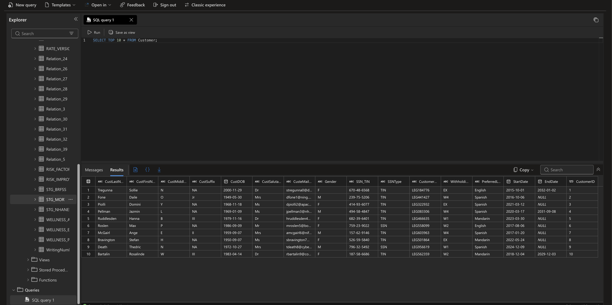

7.6 Load order
Foreign key constraints require parents to exist before children. The load order is Customer, Product, and BillingAccount first, then Contract, then Claim, ContractParty, and Invoice, then WELLNESS_PROGRAM, then WELLNESS_ENROLLMENT, and finally WELLNESS_ACTIVITY and RISK_IMPROVEMENT.
8. Roadmap
The handout describes three efforts that make up an enterprise data architecture. Modeling is covered in sections 3 and 4, and the operational data store is covered in sections 5 and 7. This section covers the third, which is how the company moves its existing applications and operations onto the architecture.
8.1 Current state and target state
The relational schema described in section 4, together with the transactional website, is the transactional data store. It holds the current state of every policy and it is what applicants and customer service work against directly. The bridge tables in section 5 sit beside it and hold the derived pricing data.
The target state adds an operational data store, which is a daily snapshot of the transactional tables used for reporting. The point of separating them is that reporting queries stop competing with the tables the website is writing to. Beyond that, a data warehouse tracks how values change over time and data marts hold the aggregates that specific reports need. Rate versions are already effective dated, so the warehouse has a history to track from the first day it runs.
8.2 Migration steps
Deploy the optimized schema and the bridge schema to the cloud database. This step is done and is described in section 7.
Load the remaining synthetic tables in the order given in section 7.6, so the deployed database holds a complete set of related rows rather than two parent tables.
Move the wellness feed onto a scheduled load, so gym participation arrives through ETL rather than being entered by hand.
Stand up the operational data store as a nightly snapshot of the transactional tables, and point all reporting at it.
Move the asynchronous refresh job onto a managed schedule, so rate versions publish on a fixed cadence instead of being run manually.
Add the data warehouse and a first data mart once there is enough rate and renewal history for trend reporting to be worth building.
8.3 Retention
Data retention is the other architectural objective the handout lists. Staging rows are replaced on each refresh and do not need to be kept, since the curated files in the lake are the durable copy and each staging row already carries a reference back to its source file. Rate versions are the opposite case and must be kept indefinitely, because a policy issued years ago is still pinned to the version it was priced under, and removing that version would make the premium impossible to explain.
9. Archive Contents
File | Contents
Feng_p2_report.docx | This report
model/ | Oracle SQL Developer Data Modeler design, logical and relational models
relational_model.png | Exported relational model diagram
schema_v0_generated.sql | DDL as first generated, before optimization
schema_final.sql | Optimized schema, 29 tables
schema_final_portal.sql | Version deployed through the Azure portal
bridge_schema.sql | The 12 bridge tables
bridge_schema_design.txt | Bridge schema design notes
load_customer.sql, load_product.sql | Insert statements for the loaded tables
build_curated.py | Builds the curated extracts from the raw downloads
validate_mockaroo_csvs.py | Validates generated data against the schema
mockaroo_csv_validation_report.md | Validation findings and corrections
data_lake_metadata.md | Source, format, scope, and lineage for each dataset
raw/ | Original downloads, one folder per source
curated/ | Cleaned extracts
mockaroo/ | Synthetic data for the relational tables
refarch_plain.png | Reference architecture diagram

