Task
Here we have somehow cut-ted and running part of complete project. This mostly don’t do anything useful so need to fix some ;)

1.First part need to fix.
We have DARK/LIGHT theme switch -left bottom button in window.
This somehow take effect on all window background but not on this engine canvas control
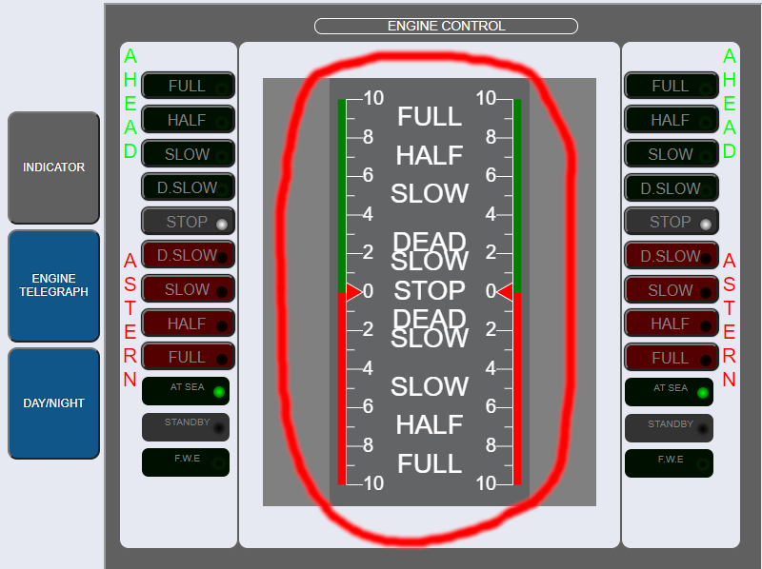
Please make this control background and foreground color follow DARK/LIGHT theme changes.

2. Second part to fix
This control controlled by mouse but don’t change anything, please found how Engine control data sent to C# part and use this data to change pitch indicator. This indicator mast follow engine input changes on C# side.
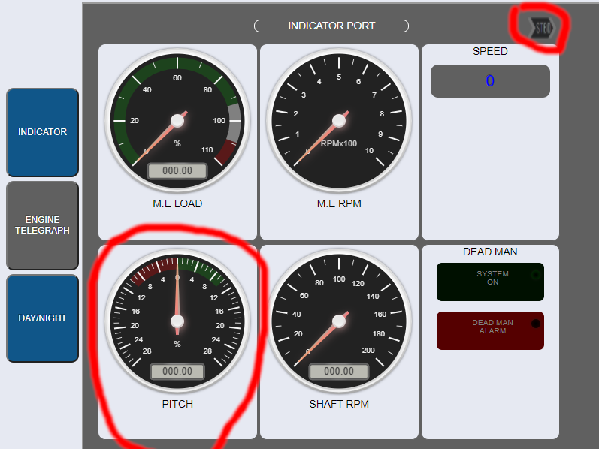

3. Create pull request with all needed changes to initial repository

