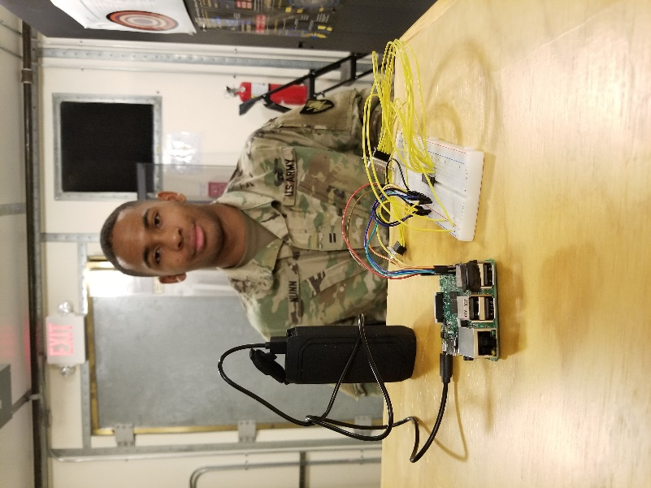

**Name:** Derek Nunn

**Position:** Admin NCO

**Hometown:** Waldorf, MD

**Likes:** Eating and Computers

**Dislikes:** Being tired

**Intended Branch:** Cyber

**Favorite Quote:** “Start by doing what's necessary; then do what's possible; and suddenly you are doing the impossible.”– Francis of Assisi