**Kongsberg EM2040**

**Coverage Map**

**Procedure**

**DOCUMENT CONTROL**

|  |  |  |  |  |  |  |
| --- | --- | --- | --- | --- | --- | --- |
| Revision | Reason for Issue | Issue Date | Originator | Checked by | Approved by | COMPANY  Approval |
| 0 | Review | E | PK | L | DR |  |

**VERSION RECORD SHEET**

|  |  |  |  |
| --- | --- | --- | --- |
| **Version** | **Issue**  **Date** | **Purpose** | **Description of**  **Updated/Modified Sections (if any)** |
| A | 29/01/2019 | Draft | For internal review |
|  |  |  |  |
|  |  |  |  |
|  |  |  |  |
|  |  |  |  |
|  |  |  |  |
|  |  |  |  |

**Table of Contents**

1. Document Scope 4

2. Objective 4

3. References 4

4. Definitions 5

5. Responsibilities 6

5.1. Chief Surveyor 6

5.2. Project Manager 6

5.3. Party Chief 6

5.4. Data Processor 6

6. Coverage Processing Procedure 6

6.1.1. Step 1: Select Mission Folder 7

6.1.2. Step 2: Select the Workflow 8

6.1.3. Step 3: Running the Workflow 9

6.1.4. Step 4: Completion 10

6.1.5. Step 4: QC 10

1. Document Scope

This document describes a series the post-processing phase of the Kongsberg Multibeam Echosounder data in order to create GIS shape files and DGN cad drawings containing the spatial coverage of the MBES sonar data.

1. Objective

This procedure details the steps required to post-process AUV Kongsberg .ALL data files following recovery of the AUV. The intent is to create a small file for easy understanding where MBES data exists without the need to load the MBES data into memory.

The deliverable from this procedure is highlighted below:

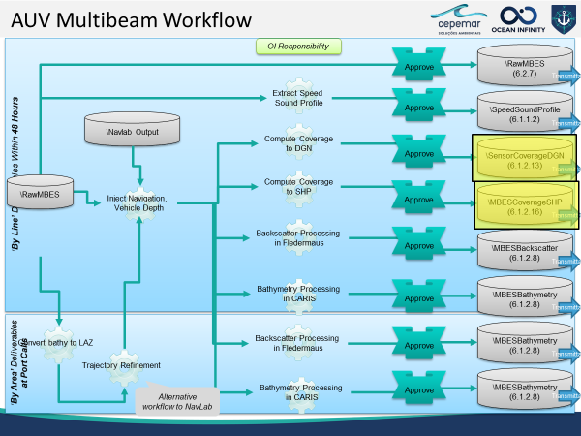

**Workflow for Coverage deliverable**

1. References

|  |
| --- |
| **Document #** |
| None |
|  |
|  |

1. Definitions

|  |  |
| --- | --- |
| **Name** | **Description** |
| AUV | Autonomous Underwater Vehicle |
| FMGT | Fledermaus Geocoder |
| GPS | Global Positioning system |
| MBES | Multi-Beam Echo Sounder |
| MRU | Motion reference Unit |
| HOS | Hugin Operating System |
| NavLab | Navigation Laboratory |
| INS | Inertial Navigation System |

1. Responsibilities
   1. Chief Surveyor

* For ownership of this document and ensuring that this procedure is reviewed on a regular basis and revised where necessary.
* For monitoring the use of this procedure within the company quality system and any non-conformances reports resulting from it.
* For approving this procedure for use.
  1. Project Manager
* For issuing this procedure to the Senior Site Representative. For ensuring that all project personnel are familiar with their responsibilities with regard to this procedure.
* For ensuring that the Chief Surveyor is advised when deviation from the approved procedure is necessary due to inadequacies in the procedure, project specific requirements or improved methods are used.
* Supporting the project and providing liaison with shore-based facilities and agencies.
  1. Party Chief
* For ensuring that this procedure is followed by field personnel.
* For ensuring that the Project Manager is advised when deviation from the approved procedure is necessary due to inadequacies in the procedure, project specific requirements or improved methods are used.
* For allocating personnel to assist in the installation and operation of the system when necessary.
* For checking, approving and accepting the sensor calibration results.
* Notifying the Client Representative of any changes to equipment calibration.
  1. Data Processor
* Ensuring that the procedure is carried out correctly and that all quality control checks are performed as required.
* For ensuring that any non-conformances are recorded and issued to the Party Chief.

1. Coverage Processing Procedure

The tool to create the coverage maps of Kongsberg .ALL files is one of the Infinity Tools. This is used to extract the spatial bounding box from the binary ALL file format and create ESRI shape and Bentley Microstation DGN files.

To start Infinity Tools, go to the install folder, by default c:\infinitytools\bin

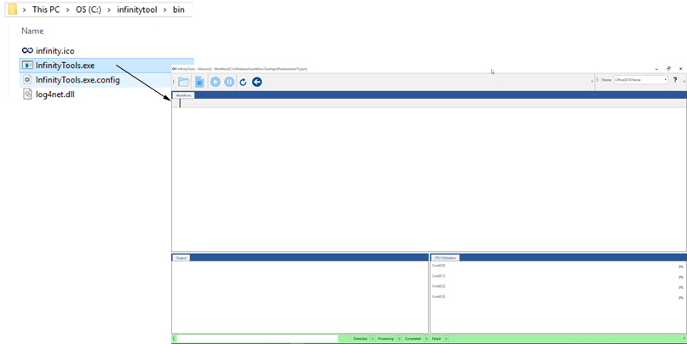

**Infinity Tools, which contains the navigation coverage mapper for *.TIL files.**

A blank project will open the first time as there is nothing to restore from a previous run. Once you configure a project the settings are automatically saved as a settings.xml file.

To configure and run a workflow there are 4 steps as described below.

* + 1. Step 1: Select Mission Folder

In order to set the project, select the root folder of an AUV mission that has already been processed on NavLab (…\Project_Name\A_MBES\2_NAVLAB\1_Mission\Mission_Number). Use the *Select mission Folder* option on the menu to browse. Press ok after choosing the mission folder. Now the path to find the TIL files that will be used to compute coverage maps (…\Mission_Number\pp\em2040) and also where the resultant files will be stored is set.

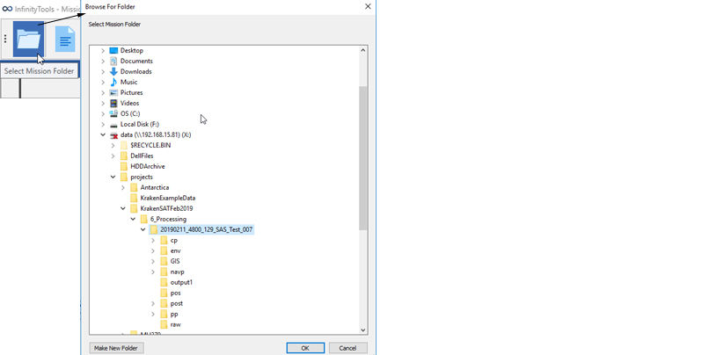

**Selecting the mission folder.**

* + 1. Step 2: Select the Workflow

Select the workflow file which defines the purpose of the tool to be used. In this case it will be the “KongsbergALL2SSDM.json” file.

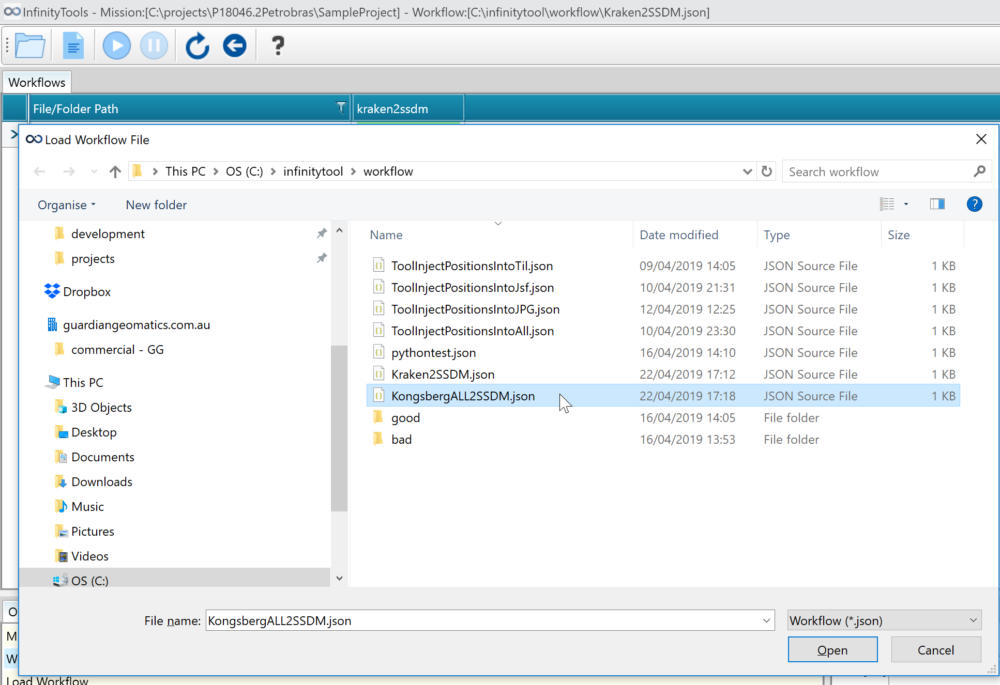

**Selecting the workflow.**

Infinity Tool will decode the various directives of the *.json file and it will use them to configure the and display the scheduler to the user. In the simplest case, a workflow file directive specifies the location and type of files to be processed and the tool to be applied to those files.

In the example below the “KongsbergALL2SSDM.json” file has a directive to process Kongsberg **‘.ALL’** files using the **‘all2ssdm.py’**. Infinity Tool scans for .til files in the mission folder and creates a list in the scheduler and assigns the tool to that file. The list of tasks will then be presented in the workflow tab of Infinity Tools.

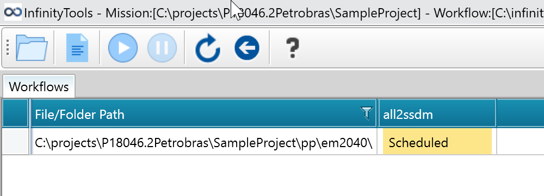

**Infinity Tool “KongsbergALL2SSDM.json” schedule after scanning the *.alll files on the mission folder.**

* + 1. Step 3: Running the Workflow

Once the workflow is loaded a series of files (rows) and tools (columns) will appear on the project and it will be possible to run the workflow.

For each file/tool a status entry will be seen as described below:

* **Scheduled:** yet to be executed;
* **Running:** the tool is active;
* **Complete:** completed without error;
* **Failed:** completed and reported an error on completion;
* **Output view:** provides the feedback as each tool runs.

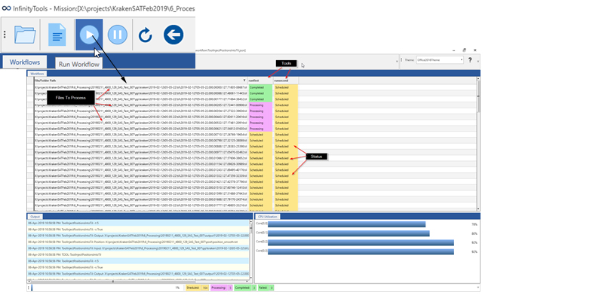

Files to be processed

Status

Tools

**Status for each file and tool whenever the workflow is running.**

* + 1. Step 4: Completion

Infinity Tool status bar displays the following:

**Progress Bar:** displays the ongoing execution of the tools.

**Scheduled:** (number of tools) x (number of files to be processed);

**Currently Running:** number of tools currently being executed;

**Completed:** number of tools which have successfully completed.

**Failed:** number of tools that have failed during the workflow.



**Indicator turns green when the Tool completes without errors.**

* + 1. Step 5: QC

For each .all file, a polygon representing the coverage will be written to the Mission\GIS folder. To accommodate GIS and CAD users, the coverage is written to both ESRI shape files in SSDM schema syntax and to Microstation DGN file format.

To test in DGN file, open the resulting file in Microstation. To better understand the .all file properties, 3 shapefiles are created.

A Polygon shape file contains the outline of the multibeam coverage. The extents of this polygon are defined by the first and last ping in each .all file and the first and last beam within each ping. The outline is a replication of the actual coverage of the raw data.

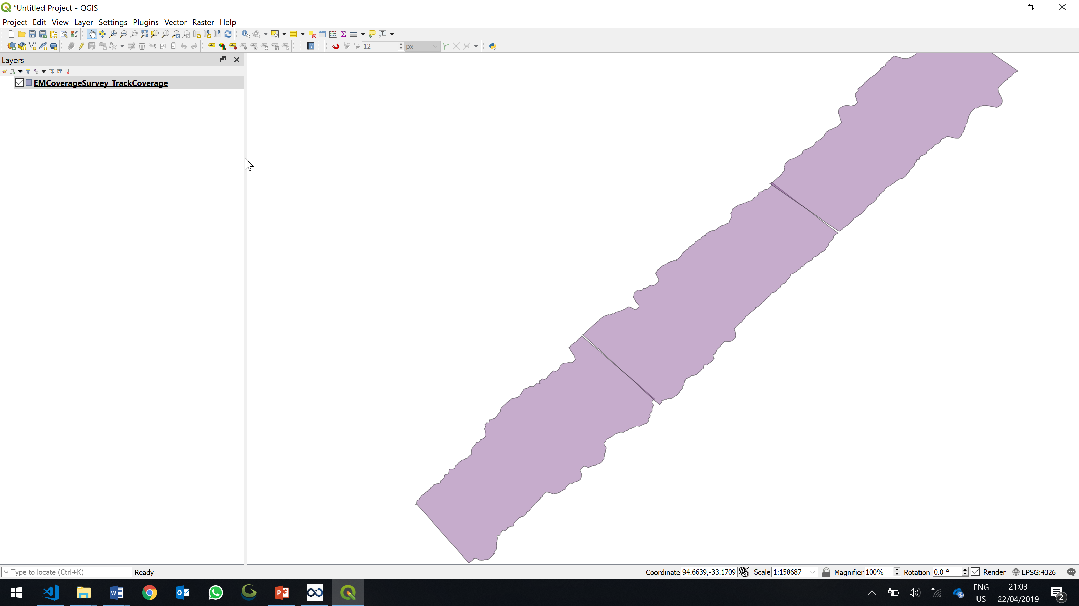

*EMCoverageSurvey_TrackCoverage.shp*

A Polyline shape file contains a track line of the transducer position as it acquired data. The extents of this line are the first and last position updates as recorded to the .all file.

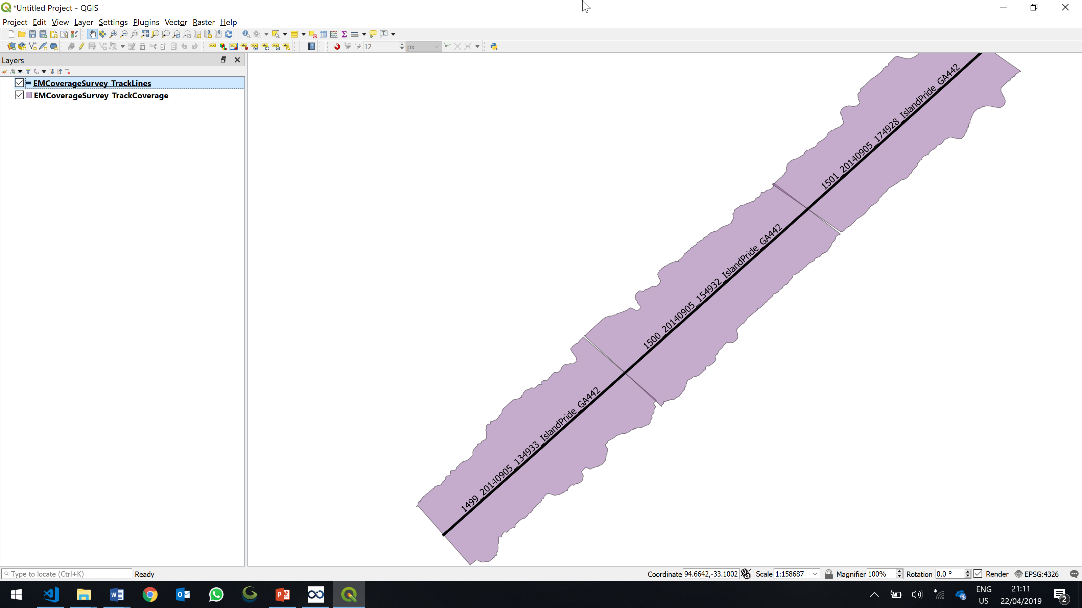

*EMCoverageSurvey_TrackLines.shp*

A Point shape file contains a track line of the transducer position updates and sonar configuration at those updates. The extents of this line are the first and last position updates as recorded to the .all file.

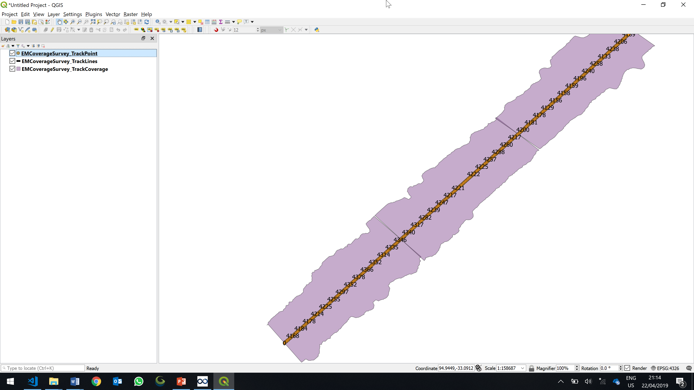

*EMCoverageSurvey_TrackPoint.shp*

END OF DOCUMENT