PROMISE & PRACTICE · UNIT 3 · DEEP DIVE ASSIGNMENT
Four Voices, One Chord
Listening + sort + claim and evidence · Skill: Causation and historical memory
Name _________________________________ Period ______ Date ______________
WHAT I CAN DO TODAY
I can hear the parts of a barbershop quartet, explain where the style came from, and explain who got credit for it.

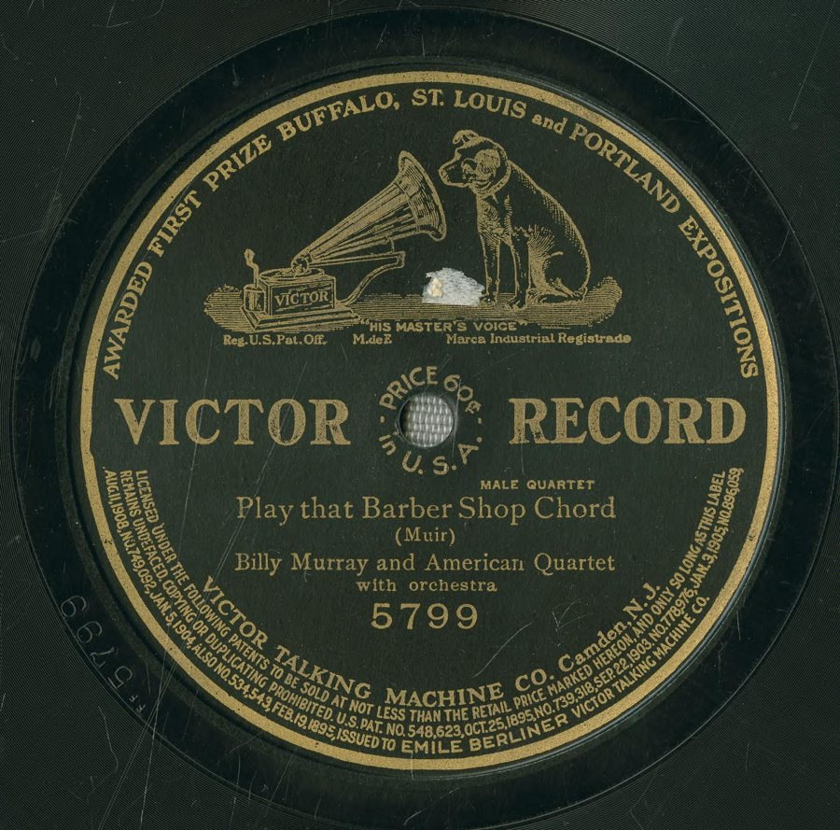  “Play That Barber Shop Chord,” Billy Murray and the American Quartet — Victor record label, 1910, public domain (Library of Congress National Jukebox via Internet Archive) | Directions  Go through the Barbershop Harmony deep dive first. Then play at least one record on the “Listen” slide and answer each part.

1 | Listen closely  Play one of the quartet records in the deep dive.

Which record did you choose?

Do you hear any instruments, or only voices? Describe what you hear.

Find a big held chord. Where in the song is it?

2 | Who sings what?  Match each quartet voice to its job.

A. Sings the lowest notes
B. Sings the melody
C. Fills in the middle of the chord
D. Sings the highest part, above the melody

1 | Lead | ______
2 | Tenor | ______
3 | Baritone | ______
4 | Bass | ______

3 | Check the facts  Choose the best answer.

Where did historians find that barbershop harmony began?
○ A. In European opera houses
○ B. In Hollywood movie studios
○ C. On the radio
○ D. In African American barbershops, churches, and street-corner quartets

Look at the record label at the top of this page. A record cost 60 cents. Why is that important?
○ A. Records were free
○ B. Only rich families could buy them
○ C. A record cost more than a day's pay for many workers, so buying music was a big decision
○ D. Records cost less than a nickelodeon ticket

Why did Bert Williams perform in blackface makeup?
○ A. Theaters and audiences of the time expected it of Black comedians
○ B. He liked the costume
○ C. It was required by federal law
○ D. He was playing a white character

4 | Where does it belong?  Sort each fact into the right part of the story.

 | STATEMENT | WHERE IT BEGAN | HOW IT SPREAD | HOW IT WAS REMEMBERED
1 | Men harmonized while waiting for a haircut | ☐ | ☐ | ☐
2 | Victor sold quartet records across the country | ☐ | ☐ | ☐
3 | A 1938 club in Tulsa set out to save quartet singing | ☐ | ☐ | ☐
4 | Bert Williams sang “Play That Barber Shop Chord” on Broadway | ☐ | ☐ | ☐
5 | Black quartets sang on street corners and in churches | ☐ | ☐ | ☐
6 | For years, the society's chapters admitted only white men | ☐ | ☐ | ☐

5 | Make your case  Why do you think the music's African American roots were forgotten for so long?

Claim

Evidence

Connection

Finished? Turn in this paper the way your teacher asks.

