PROMISE & PRACTICE · UNIT 3 · CHAPTER 1 ASSIGNMENT
Read the Photograph
Photo analysis · Skill: Reading a photograph
Name _________________________________ Period ______ Date ______________
WHAT I CAN DO TODAY
I can describe what a photograph shows, tell who made it and why, and decide how much to trust it.

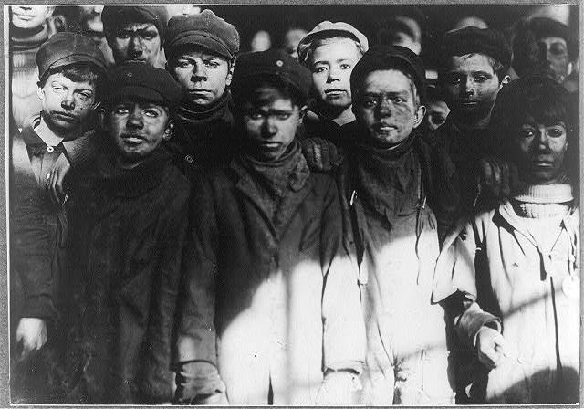  Breaker boys at No. 9 Breaker, Hughestown Borough, Pennsylvania — photograph by Lewis Hine, 1911, public domain (Library of Congress) | Directions  Look closely at Lewis Hine's 1911 photograph of breaker boys in a Pennsylvania coal mine. Answer each part in your own words. Use the sentence starters if they help.

1 | Look closely  Name three things you can actually see in the photo.

I see…

I also see…

One more detail is…

2 | What is happening?  Use the details you found to explain what is going on.

What are the boys doing? How do you know?

How do you think they feel? What in the photo makes you think so?

3 | Who made it and why?  Choose the best answer.

Lewis Hine took this photo while working for the National Child Labor Committee. What did that group want?
○ A. To find more workers for coal mines
○ B. To sell cameras to families
○ C. To end child labor
○ D. To build new schools for miners

Why would a reformer want to photograph children at work instead of just writing about it?
○ A. Photos were cheaper than newspapers
○ B. A photo makes people see real faces, not just numbers
○ C. Writing about children was against the law
○ D. Mine owners asked for photos

4 | Can we trust it?  Hine wanted to change the law, so he chose what to show. Does that make the photo less trustworthy?

Write 2–3 sentences. Use one detail from the photo.

Finished? Turn in this paper the way your teacher asks.

