PROMISE & PRACTICE · UNIT 3 · CHAPTER 10 ASSIGNMENT
Washington or Du Bois? Point of View
Quote analysis + argument · Skill: Accommodation or agitation?
Name _________________________________ Period ______ Date ______________
WHAT I CAN DO TODAY
I can tell two leaders' points of view apart and argue which strategy made more sense in 1900.

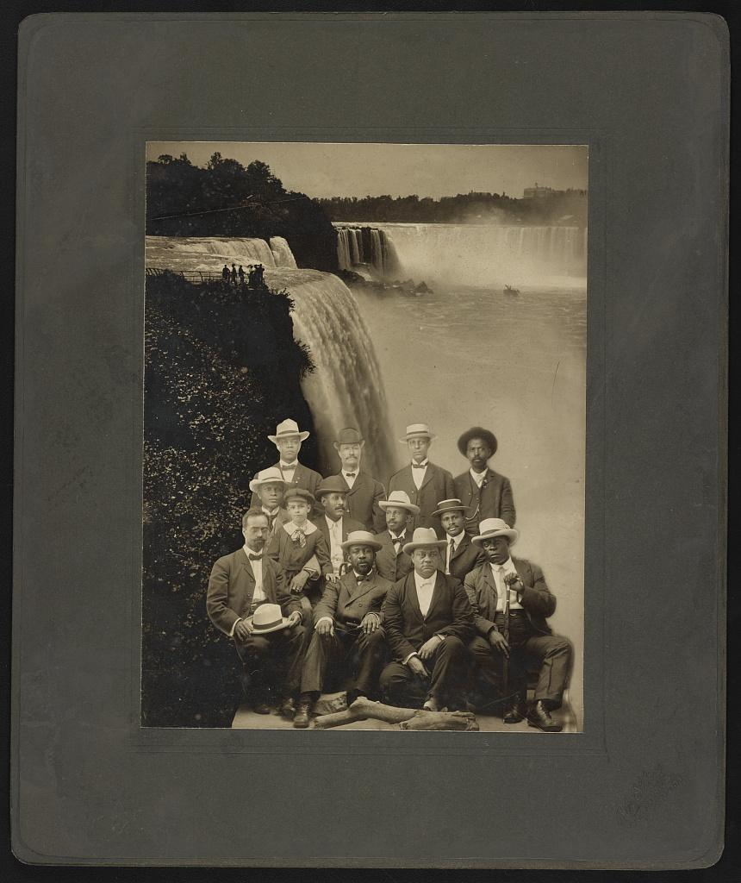  Founders of the Niagara Movement — photograph, 1905, public domain (Library of Congress) | Directions  Booker T. Washington and W. E. B. Du Bois both wanted a better life for Black Americans, but they disagreed about how to get it. Read each quote, decide who said it, and explain what he wanted.

1 | Who said it?  Choose the speaker. Then put the idea in your own words.

“Cast down your bucket where you are.”
Who said it? ☐ Booker T. Washington ☐ W. E. B. Du Bois
In my own words, this means…

“In all things that are purely social we can be as separate as the fingers, yet one as the hand in all things essential to mutual progress.”
Who said it? ☐ Booker T. Washington ☐ W. E. B. Du Bois
In my own words, this means…

“The problem of the Twentieth Century is the problem of the color-line.”
Who said it? ☐ Booker T. Washington ☐ W. E. B. Du Bois
In my own words, this means…

“We claim for ourselves every single right that belongs to a freeborn American, political, civil and social.”
Who said it? ☐ Booker T. Washington ☐ W. E. B. Du Bois
In my own words, this means…

2 | Sort the strategies  Which leader's strategy does each idea match?

 | STATEMENT | WASHINGTON: ACCOMMODATION | DU BOIS: AGITATION
1 | Learn trades and farming skills first | ☐ | ☐
2 | Demand the right to vote now | ☐ | ☐
3 | Accept segregation for now to stay safe | ☐ | ☐
4 | Train a college-educated group of leaders | ☐ | ☐
5 | Build businesses and save money | ☐ | ☐
6 | Protest openly and go to court | ☐ | ☐

3 | Which made more sense in 1900?  Remember: this was the nadir, when lynching and Jim Crow were at their worst.

Claim

Evidence

Counterargument

Finished? Turn in this paper the way your teacher asks.

