PROMISE & PRACTICE · UNIT 3 · CHAPTER 2 ASSIGNMENT
Robber Baron or Captain of Industry?
Evidence sort · Skill: The label is the argument
Name _________________________________ Period ______ Date ______________
WHAT I CAN DO TODAY
I can sort evidence about business leaders and choose a label I can defend.

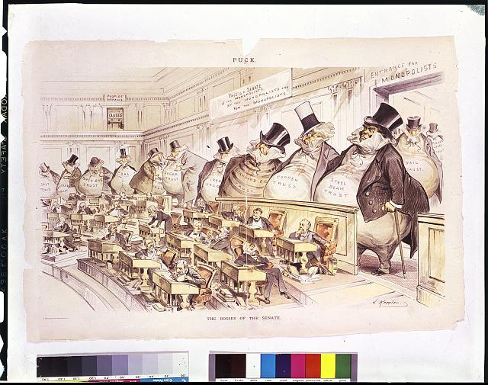  “The Bosses of the Senate” — the trusts loom over the U.S. Senate — cartoon by Joseph Keppler, Puck, 1889, public domain (Library of Congress) | Directions  Historians use two very different labels for the business giants of this era. Sort each fact, then pick a label for one man and defend it.

1 | Sort the evidence  Does each fact support calling the man a robber baron, a captain of industry, or could it be both?

 | STATEMENT | ROBBER BARON | CAPTAIN OF INDUSTRY | COULD BE BOTH
1 | Carnegie's mills made steel cheap enough to build railroads and bridges across the country. | ☐ | ☐ | ☐
2 | Carnegie gave away about 90 percent of his fortune, paying for more than 2,500 libraries. | ☐ | ☐ | ☐
3 | At Carnegie's Homestead mill in 1892, managers cut wages and hired armed Pinkerton guards against strikers. | ☐ | ☐ | ☐
4 | By 1880, Rockefeller's Standard Oil controlled about 90 percent of the nation's oil refining. | ☐ | ☐ | ☐
5 | Standard Oil got secret discounts from railroads that its competitors could not get. | ☐ | ☐ | ☐
6 | Rockefeller's refineries made kerosene cheap, so more families could light their homes at night. | ☐ | ☐ | ☐
7 | George Pullman built a planned town for his workers with brick homes, parks, and a library. | ☐ | ☐ | ☐
8 | In 1893–94, Pullman cut his workers' wages but did not lower the rent in his town. | ☐ | ☐ | ☐

2 | Choose your label  Pick Carnegie, Rockefeller, or Pullman. Which label fits him better?

My choice and my label:

Give two pieces of evidence from the sort.

What would someone who disagrees with you say?

Finished? Turn in this paper the way your teacher asks.

