PROMISE & PRACTICE · UNIT 3 · CHAPTER 3 ASSIGNMENT
Push, Pull, and the Golden Door
Push/pull sort + two-source check · Skill: The myth and the tenement
Name _________________________________ Period ______ Date ______________
WHAT I CAN DO TODAY
I can explain why immigrants came and check the 'golden door' story against the evidence.

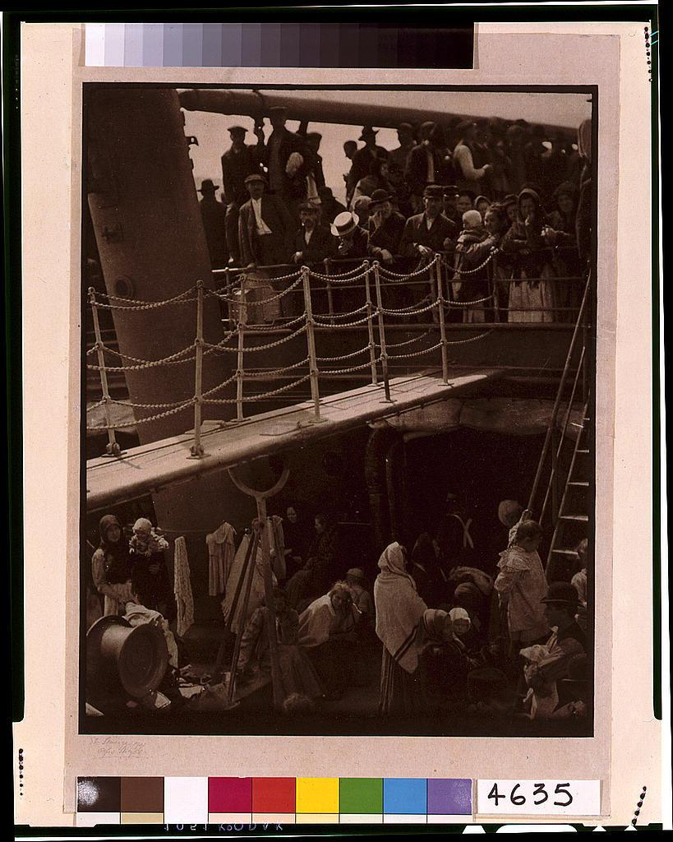  “The Steerage” — photograph by Alfred Stieglitz, 1907, public domain (Library of Congress) | Directions  First sort the reasons people came. Then compare two photographs and decide whether they support the idea of America as a 'golden door.'

1 | Push or pull?  A push factor drives people out of their home. A pull factor draws them to America.

 | STATEMENT | PUSH | PULL
1 | Crop failures and poverty in southern Italy | ☐ | ☐
2 | Violent attacks on Jewish communities in the Russian Empire | ☐ | ☐
3 | Jobs in factories, mines, and stockyards | ☐ | ☐
4 | Letters from relatives already living in America | ☐ | ☐
5 | Cheaper, faster steamship tickets | ☐ | ☐
6 | Being forced into the Russian army for years | ☐ | ☐
7 | Freedom to practice your religion | ☐ | ☐
8 | Too little farmland to divide among children | ☐ | ☐

2 | Two sources  Compare this photo with Alfred Stieglitz's “The Steerage” (1907) at the top of the page.

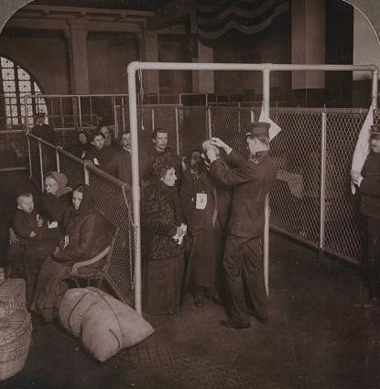
U.S. inspectors examining the eyes of immigrants, Ellis Island — photograph, c. 1913, public domain (Library of Congress)

3 | Check the story  Answer in your own words.

What does “The Steerage” show about how people crossed the ocean?

What does the Ellis Island photo show about arriving?

Do the two photos agree with each other? Explain.

4 | Was it a golden door?  Was America a 'golden door' for these immigrants?

Write 2–3 sentences with one piece of evidence.

Finished? Turn in this paper the way your teacher asks.

