PROMISE & PRACTICE · UNIT 3 · CHAPTER 4 ASSIGNMENT
Read a Law for Its Fear
Close reading in chunks · Skill: A law as evidence of fear
Name _________________________________ Period ______ Date ______________
WHAT I CAN DO TODAY
I can read part of a real law, put it in plain words, and explain what it shows about fear.

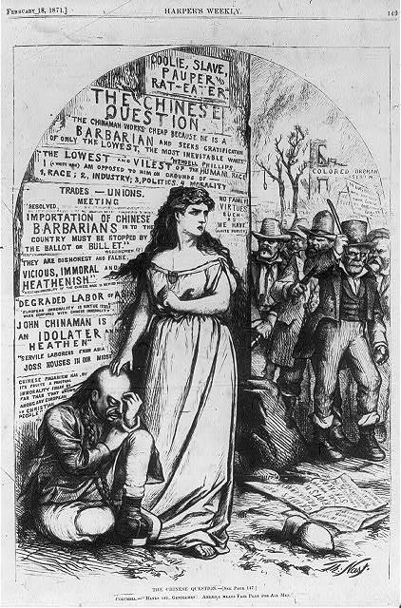  “The Chinese Question” — Columbia shields a Chinese man from an anti-Chinese mob — cartoon by Thomas Nast, Harper’s Weekly, 1871, public domain (Library of Congress) | Directions  Read each chunk of the Chinese Exclusion Act of 1882. Put it in your own words, then answer the questions.

1 | Chunk 1: The reason

Whereas, in the opinion of the Government of the United States the coming of Chinese laborers to this country endangers the good order of certain localities within the territory thereof…
Chinese Exclusion Act, May 6, 1882 (opening)
In your own words, what reason does the law give?

Is this reason a fact or an opinion? How can you tell?

2 | Chunk 2: The rule

The coming of Chinese laborers to the United States is suspended for ten years. (Summary of Section 1.)
Chinese Exclusion Act, 1882, Section 1 (summary of the law's rule)
Who is stopped from coming? Who is not mentioned?

3 | Chunk 3: Citizenship

That hereafter no State court or court of the United States shall admit Chinese to citizenship…
Chinese Exclusion Act, 1882, Section 14
What can Chinese immigrants already living here not do?

Why would a law block citizenship, not just new arrivals?

4 | Compare with the cartoon  Look at Thomas Nast's 1871 cartoon at the top of the page.

In the cartoon, Columbia (a symbol of America) shields a Chinese man from an angry mob. What is Nast's point of view?
○ A. Chinese immigrants are dangerous
○ B. Immigration should be stopped
○ C. The mob is wrong and America should protect him
○ D. Columbia agrees with the mob

5 | What fear does it show?  Finish the claim.

This law shows that some Americans feared…, because…

Finished? Turn in this paper the way your teacher asks.

