PROMISE & PRACTICE · UNIT 3 · CHAPTER 5 ASSIGNMENT
Accident or System?
Cause-and-effect chain · Skill: Accident, or system?
Name _________________________________ Period ______ Date ______________
WHAT I CAN DO TODAY
I can sort causes of the Triangle fire and decide whether it was bad luck or a system that failed.

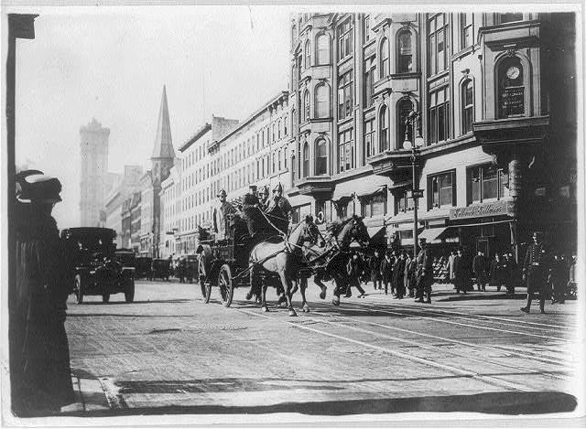  Horse-drawn fire engines race to the Triangle Shirtwaist Company fire, New York City — photograph, 1911, public domain (Library of Congress) | Directions  On March 25, 1911, a fire at the Triangle Shirtwaist factory in New York killed 146 workers, most of them young immigrant women. Sort the facts, build the chain, then make your call.

1 | Sort the causes  Was each fact bad luck, a choice someone made, or a missing rule?

 | STATEMENT | BAD LUCK | A CHOICE SOMEONE MADE | A MISSING RULE
1 | The fire probably started in a bin of cloth scraps on the 8th floor. | ☐ | ☐ | ☐
2 | Owners kept a stairway door locked to stop workers from taking breaks or stealing. | ☐ | ☐ | ☐
3 | No law required the factory to hold fire drills. | ☐ | ☐ | ☐
4 | Firefighters' ladders reached only to about the 6th floor. | ☐ | ☐ | ☐
5 | The building had only one fire escape, and it collapsed. | ☐ | ☐ | ☐
6 | Workers were paid by the piece, so stopping to leave cost them money. | ☐ | ☐ | ☐

2 | Build the chain  Put the events in order from first (1) to last (5).

ORDER | EVENT
______ | Workers die or jump from the windows
______ | A fire starts in a scrap bin
______ | Workers rush to exits and find a door locked
______ | New York creates a commission and passes new safety laws
______ | The fire escape collapses under the crowd

3 | Make the call  Was the Triangle fire an accident or the result of a system?

Claim

Evidence: use two facts from the sort.

Why does it matter which one it was?

Finished? Turn in this paper the way your teacher asks.

