PROMISE & PRACTICE · UNIT 3 · CHAPTER 6 ASSIGNMENT
Who Threw the Bomb? Weigh the Evidence
Evidence weighing · Skill: Who threw the bomb?
Name _________________________________ Period ______ Date ______________
WHAT I CAN DO TODAY
I can tell what is proven, what is not proven, and what is opinion, and use that to judge a trial.

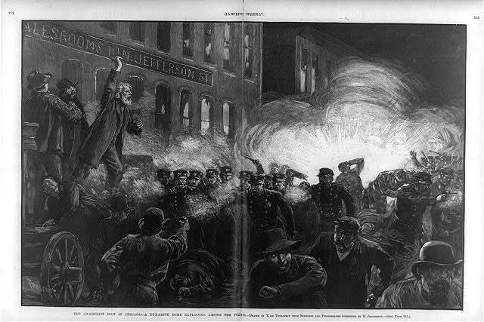  “The Anarchist Riot in Chicago” — the bomb explodes in Haymarket Square — wood engraving, Harper’s Weekly, 1886, public domain (Library of Congress) | Directions  Eight men were convicted after the Haymarket bombing in Chicago on May 4, 1886. Sort each statement, then write your verdict as a historian.

1 | Proven, not proven, or opinion?  Sort each statement.

 | STATEMENT | PROVEN FACT | NOT PROVEN | OPINION
1 | A bomb exploded among police in Haymarket Square on May 4, 1886. | ☐ | ☐ | ☐
2 | Seven police officers died from the bomb and the shooting that followed. | ☐ | ☐ | ☐
3 | One of the eight defendants threw the bomb. | ☐ | ☐ | ☐
4 | Several of the defendants were not in the square when the bomb went off. | ☐ | ☐ | ☐
5 | The anarchists' fiery speeches were to blame for the bombing. | ☐ | ☐ | ☐
6 | Four of the men were hanged on November 11, 1887. | ☐ | ☐ | ☐
7 | The bomb was thrown by someone trying to make the labor movement look bad. | ☐ | ☐ | ☐
8 | In 1893, Governor John Peter Altgeld pardoned three of the men and said the trial was unfair. | ☐ | ☐ | ☐

2 | Your verdict  Write like a careful historian.

Was the trial fair? Use one proven fact.

What can't we know? What is the honest thing to say about it?

Finished? Turn in this paper the way your teacher asks.

