PROMISE & PRACTICE · UNIT 3 · CHAPTER 7 ASSIGNMENT
Match the Muckraker
Matching + argument · Skill: Can journalism change the law?
Name _________________________________ Period ______ Date ______________
WHAT I CAN DO TODAY
I can connect what muckrakers exposed to the reforms that followed and judge how much journalism mattered.

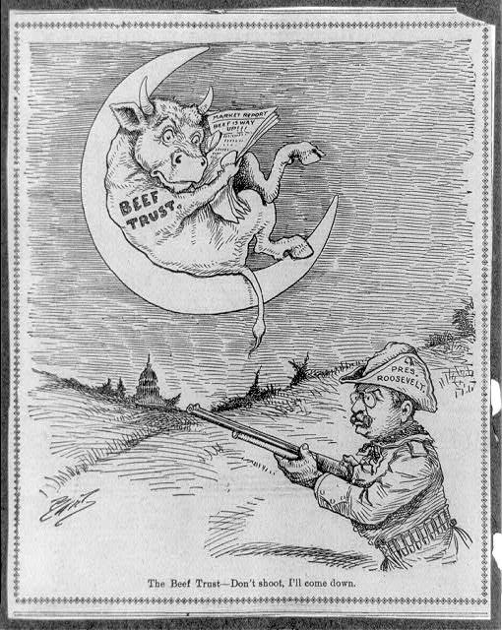  “The Beef Trust — Don’t shoot, I’ll come down” — cartoon, c. 1902, public domain (Library of Congress) | Directions  Match each exposé to the change that followed it. Then decide which one did the most to change the law.

1 | Match the exposé to the change  Choose the change that followed each exposé.

A. Meat Inspection Act and Pure Food and Drug Act (1906)
B. The Supreme Court breaks up Standard Oil (1911)
C. New York Tenement House Act (1901)
D. Keating-Owen Child Labor Act (1916)
E. 17th Amendment: voters elect senators directly (1913)

1 | Upton Sinclair, The Jungle (1906) — Chicago meatpacking | ______
2 | Ida Tarbell, The History of the Standard Oil Company (1904) | ______
3 | Jacob Riis, How the Other Half Lives (1890) — tenement life | ______
4 | Lewis Hine, photographs of child workers (1908–1916) | ______
5 | David Graham Phillips, “The Treason of the Senate” (1906) | ______

2 | Did journalism change the law?  Pick the match you think shows journalism's power best.

Which one, and why?

What else besides the writing helped the law pass?

3 | A muckraker today  If you were a muckraker today, what problem would you expose?

Name the problem and who it hurts.

Finished? Turn in this paper the way your teacher asks.

