PROMISE & PRACTICE · UNIT 3 · CHAPTER 8 ASSIGNMENT
Expanding or Shrinking?
T-chart sort + claim · Skill: Expanding and shrinking at once
Name _________________________________ Period ______ Date ______________
WHAT I CAN DO TODAY
I can sort changes as expanding or shrinking democracy and explain who gained and who lost.

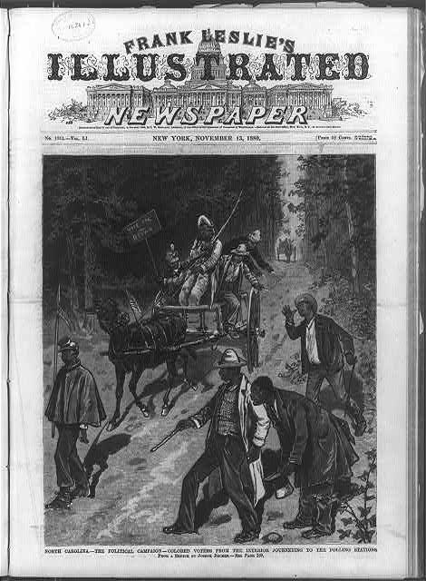  North Carolina — Black voters journeying to the polling stations — wood engraving, Frank Leslie’s, 1880, public domain (Library of Congress) | Directions  Between 1890 and 1920, democracy grew for some Americans and shrank for others. Sort each change, then write your claim.

1 | Sort the changes  Did each change expand or shrink democracy?

 | STATEMENT | EXPANDING DEMOCRACY | SHRINKING DEMOCRACY
1 | 1890: Wyoming joins the Union, and its women keep the right to vote. | ☐ | ☐
2 | 1890: Mississippi's new constitution adds a poll tax and a literacy test for voting. | ☐ | ☐
3 | 1896: In Plessy v. Ferguson, the Supreme Court allows 'separate but equal' segregation. | ☐ | ☐
4 | 1898: Louisiana adds a grandfather clause to its voting rules. | ☐ | ☐
5 | 1902: Oregon lets voters propose and pass laws themselves (initiative and referendum). | ☐ | ☐
6 | Black voters registered in Louisiana fall from about 130,000 in 1896 to about 5,000 in 1900. | ☐ | ☐
7 | 1913: The 17th Amendment lets voters elect U.S. senators directly. | ☐ | ☐
8 | 1913: Illinois women win the right to vote for president. | ☐ | ☐

2 | Who gained? Who lost?  Look at your two columns.

Who gained a voice in these years?

Who lost a voice?

3 | Your claim  Was this an age of more democracy or less?

Write 2–3 sentences. Use one example from each column.

Finished? Turn in this paper the way your teacher asks.

