PROMISE & PRACTICE · UNIT 3 · CHAPTER 9 ASSIGNMENT
Seventy-Two Years: Put It in Order
Timeline sequencing · Skill: Why seventy-two years?
Name _________________________________ Period ______ Date ______________
WHAT I CAN DO TODAY
I can put the women's suffrage movement in order and explain why it took so long.

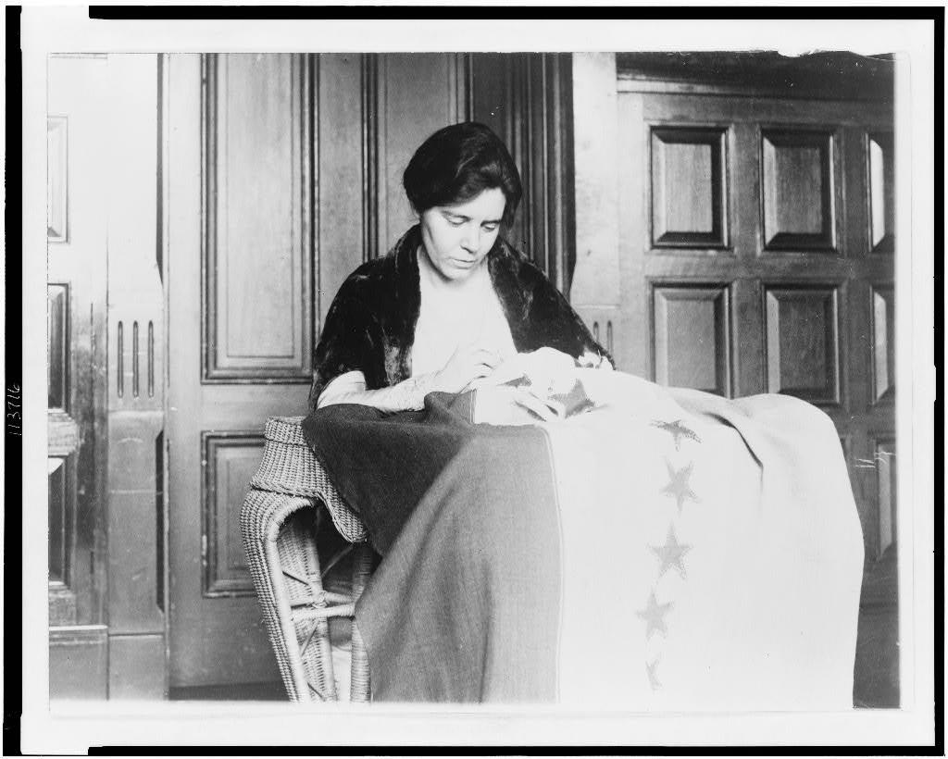  Alice Paul sews the 36th star on the suffrage ratification banner — photograph, 1920, public domain (Library of Congress) | Directions  Women first demanded the vote in 1848 and won it nationally in 1920. Put the events in order, check your work, then explain one turning point.

1 | Put it in order  Number the events from first (1) to last (7). Then check your work to see the years.

ORDER | EVENT
______ | Suffragists march in a huge procession in Washington, D.C., the day before President Wilson takes office
______ | Women meet at Seneca Falls, New York, and sign the Declaration of Sentiments
______ | Tennessee becomes the 36th state to ratify the 19th Amendment
______ | Wyoming Territory gives women the right to vote
______ | The Silent Sentinels picket the White House and many are arrested
______ | Two rival suffrage groups join to form one national association
______ | Illinois women win the right to vote for president

2 | The turning point  Choose the event you think was the biggest turning point.

Which event, and what changed because of it?

3 | Did the 19th Amendment include all women?  Choose the best answer.

After 1920, which group of women still could NOT vote in most places?
○ A. White women in the North
○ B. Black women in the South, who faced poll taxes, tests, and violence
○ C. Women in Illinois
○ D. Women in Wyoming

Finished? Turn in this paper the way your teacher asks.

