PROMISE & PRACTICE · UNIT 3 · DEEP DIVE ASSIGNMENT
What Changed Everything?
Sort + rank + claim and evidence · Skill: Significance and historical credit
Name _________________________________ Period ______ Date ______________
WHAT I CAN DO TODAY
I can explain how inventions changed daily life, rank their importance, and decide who deserves the credit.

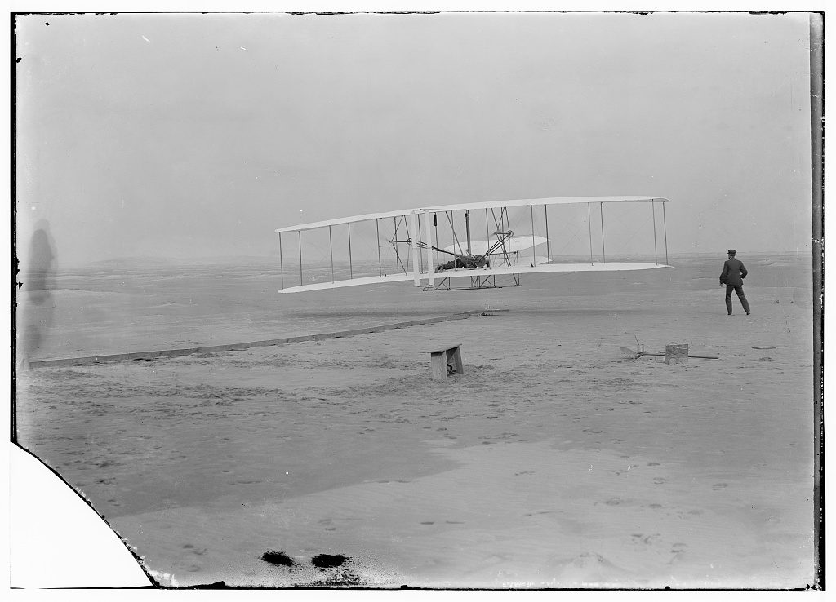  First flight, 120 feet in 12 seconds, Kitty Hawk, North Carolina — photograph, December 17, 1903, public domain (Library of Congress) | Directions  Go through The Age of Invention deep dive first. Then answer each part.

1 | Who made what?  Match each inventor to the invention.

A. Alternating-current (AC) motor
B. Practical electric light system
C. Hair-care products and a sales network
D. Railway telegraph between moving trains
E. Telephone patent
F. First powered airplane flight

1 | Thomas Edison | ______
2 | Alexander Graham Bell | ______
3 | Nikola Tesla | ______
4 | Granville Woods | ______
5 | Madam C. J. Walker | ______
6 | Wilbur and Orville Wright | ______

2 | What did it change?  Sort each invention by the part of life it changed most.

 | STATEMENT | COMMUNICATION | POWER AND LIGHT | TRANSPORTATION | WORK AND BUSINESS
1 | Telephone | ☐ | ☐ | ☐ | ☐
2 | Phonograph | ☐ | ☐ | ☐ | ☐
3 | Electric light | ☐ | ☐ | ☐ | ☐
4 | AC power from Niagara Falls | ☐ | ☐ | ☐ | ☐
5 | Airplane | ☐ | ☐ | ☐ | ☐
6 | Railway telegraph | ☐ | ☐ | ☐ | ☐
7 | Assembly line | ☐ | ☐ | ☐ | ☐
8 | Walker's sales-agent network | ☐ | ☐ | ☐ | ☐

3 | Check the facts  Choose the best answer.

Why is Elisha Gray important to the telephone story?
○ A. He made the first phone call
○ B. He bought Bell's company
○ C. He filed telephone papers the same day as Bell
○ D. He invented the light bulb

Why did Westinghouse's AC system win out over Edison's DC?
○ A. AC could send power much farther and more cheaply
○ B. AC was invented first
○ C. Edison stopped making electricity
○ D. The government banned DC

Where did Ford's engineers say they got the idea for the moving assembly line?
○ A. The Wright brothers' bicycle shop
○ B. Edison's phonograph
○ C. The 1893 Ferris wheel
○ D. Chicago's meatpacking plants

4 | Rank them  Rank the three inventions you think changed daily life the most.

#1 — and why

#2 — and why

#3 — and why

5 | Make your case  Which invention changed daily life the most — and who deserves the credit for it?

Claim

Evidence

Credit

Finished? Turn in this paper the way your teacher asks.

