PROMISE & PRACTICE · UNIT 3 · DEEP DIVE ASSIGNMENT
Listen Like a Historian: Ragtime
Listening + sheet music analysis · Skill: Point of view and significance
Name _________________________________ Period ______ Date ______________
WHAT I CAN DO TODAY
I can describe what I hear in ragtime, read a sheet music cover as evidence, and explain why Joplin's music matters.

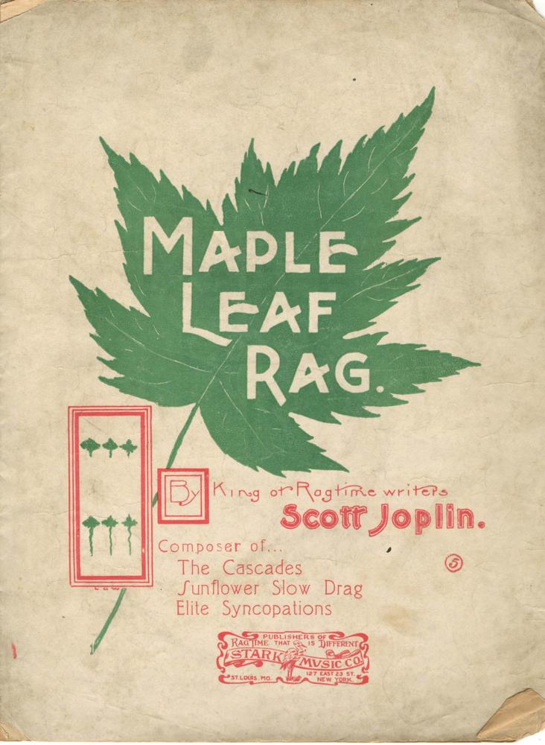  “Maple Leaf Rag” by Scott Joplin — sheet music cover, John Stark & Son, Sedalia, 1899, public domain (Internet Archive / Washington University Gaylord Music Library) | Directions  Go through the Scott Joplin deep dive first. Then pick one of the three Joplin rags on the “Listen” slide, play it, and answer each part.

1 | Listen closely  Play one of the three rags in the deep dive. Answer in your own words.

Which piece did you choose? What instrument do you hear?

Describe the beat underneath. Is it steady or jumpy?

How does the music make you feel? Why?

2 | Check the idea  Choose the best answer.

What is syncopation?
○ A. Playing every note very loudly
○ B. Music played only by banjos
○ C. Melody notes that land off the main beat
○ D. Singing without instruments

How did most Americans in 1900 play ragtime at home?
○ A. On the radio
○ B. On television
○ C. By buying sheet music and playing it on the piano
○ D. By streaming it

3 | Read the cover  Look at the 1899 “Maple Leaf Rag” cover at the top of this page.

What words and pictures do you see on the cover?

The cover calls Joplin the “King of Ragtime Writers.” Why would the publisher put that on the cover?

4 | Why does it matter?  Joplin was famous but could not get his opera staged, and he died nearly forgotten.

Why do you think his serious music was ignored in his lifetime? Use one fact.

Finished? Turn in this paper the way your teacher asks.

