PROMISE & PRACTICE · UNIT 3 · DEEP DIVE ASSIGNMENT
Opening Night at the Nickelodeon
Film viewing + cause-and-effect chain · Skill: Cause and effect
Name _________________________________ Period ______ Date ______________
WHAT I CAN DO TODAY
I can explain why the movies spread so fast, what changed because of them, and why some people wanted to control them.

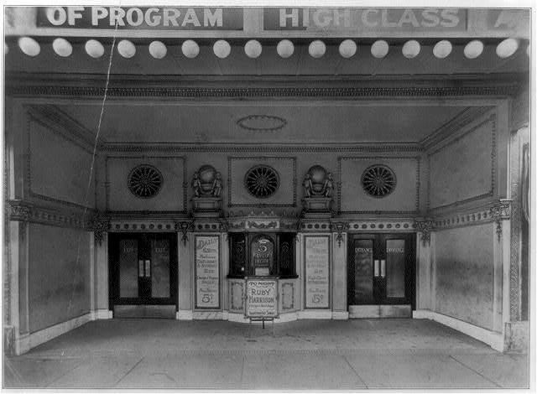  Entrance of the Revelry Theatre, a moving-picture theater, probably Chicago — photograph, c. 1909, public domain (Library of Congress) | Directions  Go through the Nickelodeon deep dive first and watch the three film clips. Then answer each part.

1 | Watch closely  Think about the three film clips in the deep dive.

How is the 1894 Sandow film different from The Great Train Robbery (1903)?

Why could someone who did not speak English still enjoy these films?

2 | Put the movies in order  Number the events from first (1) to last (6). Then check your work to see the years.

ORDER | EVENT
______ | The Great Train Robbery becomes a hit
______ | Edison's Kinetoscope peep-show machines open
______ | Chicago passes the first movie censorship law in the U.S.
______ | Films are projected on a big screen with the Vitascope
______ | Charlie Chaplin makes His New Job at Essanay in Chicago
______ | Storefront nickelodeons start spreading

3 | Cause or effect?  The nickelodeon boom had causes and effects. Sort each statement.

 | STATEMENT | A CAUSE OF THE BOOM | AN EFFECT OF THE BOOM
1 | Tickets cost only five cents | ☐ | ☐
2 | Reformers pushed for censorship laws | ☐ | ☐
3 | Silent films needed no English | ☐ | ☐
4 | Chicago became a center for making and renting films | ☐ | ☐
5 | Workers had a little free time in the evenings | ☐ | ☐
6 | Immigrant families shared American movies and stars | ☐ | ☐

4 | Make your case  Was Chicago right to censor movies in 1907?

Claim

Evidence

Counterargument

Finished? Turn in this paper the way your teacher asks.

