PROMISE & PRACTICE · UNIT 3 · DEEP DIVE ASSIGNMENT
Our Town in the Industrial Age
Photo analysis + timeline + local link · Skill: Contextualization
Name _________________________________ Period ______ Date ______________
WHAT I CAN DO TODAY
I can place Waukegan's history in order and connect our town to the big stories of Unit 3.

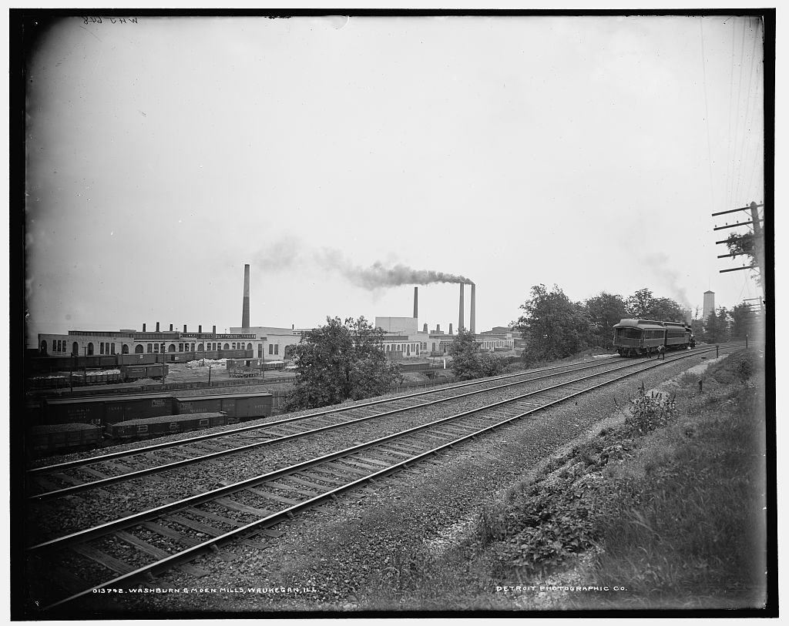  Washburn & Moen Mills, Waukegan, Ill. — photograph, Detroit Publishing Co., c. 1900, public domain (Library of Congress) | Directions  Go through the Waukegan on Stage deep dive first. Then study the photo, put the events in order, and connect our town to Unit 3.

1 | Read the photo  Look at the Washburn & Moen Mills photo at the top of this page (about 1900).

Name three things you can see.

What does the photo tell you about work in Waukegan?

2 | Put Waukegan in order  Number the events from first (1) to last (6). Then check your work to see the years.

ORDER | EVENT
______ | The Genesee Theatre opens on Genesee Street
______ | Benjamin Kubelsky (Jack Benny) is born to immigrant parents
______ | Waukegan's steelworkers join the nationwide steel strike
______ | Ray Bradbury is born in Waukegan
______ | The restored Genesee Theatre reopens
______ | A teenage Benny plays violin in the Barrison Theatre's pit orchestra

3 | Which Unit 3 story?  Match each piece of Waukegan history to the big Unit 3 story it belongs to.

 | STATEMENT | INDUSTRY | IMMIGRATION | LABOR | POPULAR CULTURE
1 | The Washburn & Moen wire mill | ☐ | ☐ | ☐ | ☐
2 | Benny's parents came from Eastern Europe | ☐ | ☐ | ☐ | ☐
3 | The 1919 steel strike | ☐ | ☐ | ☐ | ☐
4 | Vaudeville shows at the Barrison Theatre | ☐ | ☐ | ☐ | ☐
5 | Families from Sweden, Slovenia, Lithuania, and Armenia settle here | ☐ | ☐ | ☐ | ☐
6 | The Genesee movie palace | ☐ | ☐ | ☐ | ☐

4 | Local link  History happened here, too.

Pick one part of Waukegan's story and connect it to a Unit 3 chapter.

Ask someone at home about a Waukegan place they remember. What did they say?

Finished? Turn in this paper the way your teacher asks.

