PROMISE & PRACTICE · GROWTH & CONFLICT · SOURCE ANALYSIS
Nauvoo
A city on a bend in the river
Name: ______________________________ Period: _____ Date: ________________
WHAT I CAN DO TODAY I can read primary sources about Nauvoo, weigh who made each one and why, and use evidence to answer historical questions.

THE SOURCES
THE RULE · 1791
“Congress shall make no law… abridging the freedom… of the press; or the right of the people peaceably to assemble, and to petition the Government for a redress of grievances.”
The First Amendment to the U.S. Constitution.
THE CITY’S CLAIM · 1844
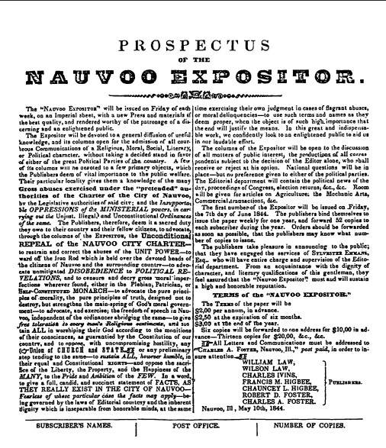
The council declared the Expositor a “public nuisance” whose libels, they argued, would provoke mobs to descend on Nauvoo — so destroying it, they claimed, protected the city’s safety
The Nauvoo city council’s stated reason for destroying the press.

YOUR WORK
A. WHO ORDERED THE DESTRUCTION OF THE EXPOSITOR, AND WHAT WAS THAT SAME PERSON’S RELATIONSHIP TO THE NEWSPAPER? WHY DOES THAT MATTER?
a. Who ordered the destruction of the Expositor, and what was that same person’s relationship to the newspaper? Why does that matter?
____________________________________________________________________________________________
____________________________________________________________________________________________
____________________________________________________________________________________________
B. WHAT REASON DID THE CITY GIVE FOR DESTROYING THE PRESS — IN ITS OWN WORD FOR IT?
b. What reason did the city give for destroying the press — in its own word for it?
____________________________________________________________________________________________
____________________________________________________________________________________________
____________________________________________________________________________________________
A. THE FIRST AMENDMENT PROTECTS “FREEDOM OF THE PRESS.” THE CITY CALLED THE PAPER A “PUBLIC NUISANCE.” PUT THE CONFLICT IN ONE SENTENCE: WHAT DOES EACH SIDE SAY SHOULD WIN?
a. The First Amendment protects “freedom of the press.” The city called the paper a “public nuisance.” Put the conflict in one sentence: what does each side say should win?
____________________________________________________________________________________________
____________________________________________________________________________________________
____________________________________________________________________________________________
____________________________________________________________________________________________
B. IS THERE EVER A POINT WHERE SPEECH BECOMES SO DANGEROUS A COMMUNITY MAY STOP IT? WHERE WOULD YOU DRAW THAT LINE — AND DOES THE EXPOSITOR FALL ON YOUR SIDE OF IT?
b. Is there ever a point where speech becomes so dangerous a community may stop it? Where would you draw that line — and does the Expositor fall on your side of it?
____________________________________________________________________________________________
____________________________________________________________________________________________
____________________________________________________________________________________________
____________________________________________________________________________________________
THE MORMONS HAD THEMSELVES BEEN DRIVEN FROM MISSOURI BY MOBS AND LIES IN THE PRESS. HOW MIGHT THAT HISTORY EXPLAIN — NOT NECESSARILY EXCUSE — WHY THEY FEARED THIS NEWSPAPER ENOUGH TO DESTROY IT?
The Mormons had themselves been driven from Missouri by mobs and lies in the press. How might that history explain — not necessarily excuse — why they feared this newspaper enough to destroy it?
____________________________________________________________________________________________
____________________________________________________________________________________________
____________________________________________________________________________________________
____________________________________________________________________________________________
CLAIM — SHOULD THE CITY HAVE BEEN ALLOWED TO DESTROY THE EXPOSITOR? TAKE A CLEAR POSITION.
CLAIM — Should the city have been allowed to destroy the Expositor? Take a clear position.
____________________________________________________________________________________________
____________________________________________________________________________________________
____________________________________________________________________________________________
EVIDENCE — AT LEAST TWO SPECIFICS FROM THE PRESENTATION AND THE TWO SOURCES THAT SUPPORT YOUR CLAIM.
EVIDENCE — at least two specifics from the presentation and the two sources that support your claim.
____________________________________________________________________________________________
____________________________________________________________________________________________
____________________________________________________________________________________________
____________________________________________________________________________________________
REASONING — A MOB THEN MURDERED JOSEPH SMITH IN JAIL. DOES THAT LATER VIOLENCE CHANGE HOW YOU JUDGE THE CITY’S ORIGINAL DECISION? WHY OR WHY NOT?
REASONING — a mob then murdered Joseph Smith in jail. Does that later violence change how you judge the city’s original decision? Why or why not?
____________________________________________________________________________________________
____________________________________________________________________________________________
____________________________________________________________________________________________
____________________________________________________________________________________________
Promise & Practice · ShadowDog Digital Studios · Unit 2

TEACHER ANSWER KEY — Nauvoo

a. Who ordered the destruction of the Expositor, and what was that same person’s relationship to the newspaper? Why does that matter?: Open response.
b. What reason did the city give for destroying the press — in its own word for it?: Open response.
a. The First Amendment protects “freedom of the press.” The city called the paper a “public nuisance.” Put the conflict in one sentence: what does each side say should win?: Open response.
b. Is there ever a point where speech becomes so dangerous a community may stop it? Where would you draw that line — and does the Expositor fall on your side of it?: Open response.
The Mormons had themselves been driven from Missouri by mobs and lies in the press. How might that history explain — not necessarily excuse — why they feared this newspaper enough to destroy it?: Open response.
CLAIM — Should the city have been allowed to destroy the Expositor? Take a clear position.: Open response.
Look for a response along the lines of: “The city should / should not have …”
EVIDENCE — at least two specifics from the presentation and the two sources that support your claim.: Open response.
REASONING — a mob then murdered Joseph Smith in jail. Does that later violence change how you judge the city’s original decision? Why or why not?: Open response.

