PROMISE & PRACTICE · DEEP DIVE · SOURCE ANALYSIS
Appomattox — A House Divided
A Surrender Without Vengeance
Name: ______________________________ Period: _____ Date: ________________
WHAT I CAN DO TODAY I can read primary sources about Appomattox — A House Divided, weigh who made each one and why, and use evidence to answer historical questions.
Directions. The same moment looks different from each chair in the room. Read the points of view, then judge the choice

THE SOURCES
THE IMAGE · APRIL 1865 — The surrender
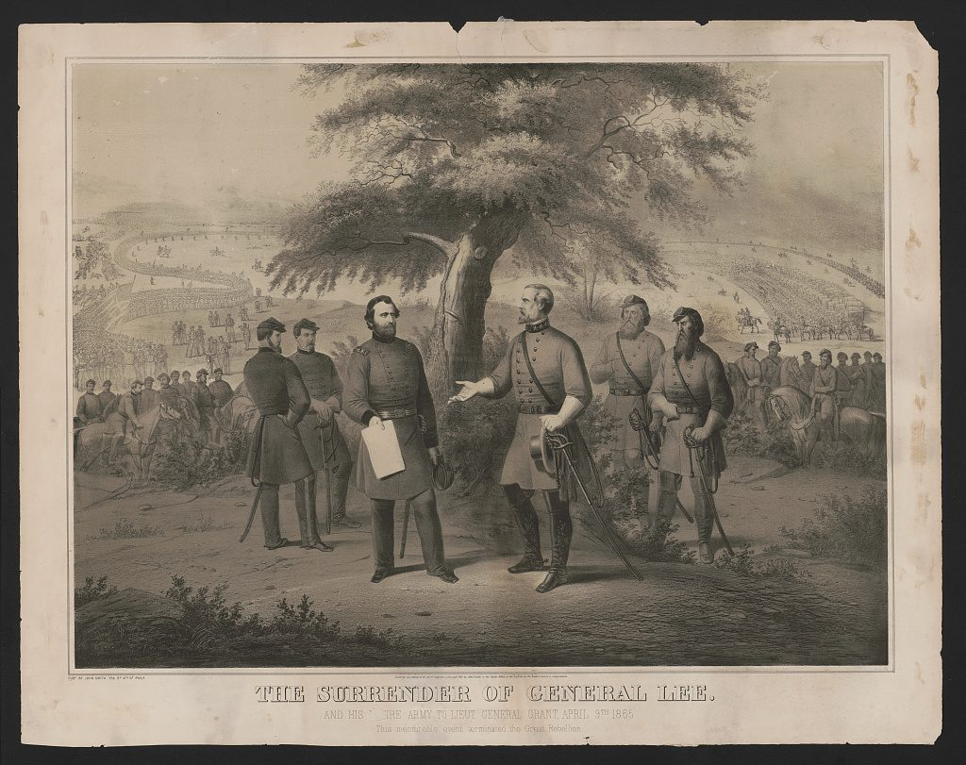
“The Surrender of General Lee, April 9, 1865” — lithograph, public domain (Library of Congress).
SOURCE A · GRANT'S POINT OF VIEW · MEMOIRS — The victor
“I felt … sad and depressed … at the downfall of a foe who had fought so long and valiantly … The much talked of surrendering of Lee's sword and my handing it back, this and much more that has been said about it is the purest romance. … [I told my men] the war is over; the rebels are our countrymen again.”
— Ulysses S. Grant, Personal Memoirs. Public domain
— Ulysses S. Grant, Personal Memoirs. Public domain.
SOURCE B · A UNION OFFICER'S POINT OF VIEW · AT THE STACKING OF ARMS — The salute
“… before us in proud humiliation stood the embodiment of manhood … Was not such manhood to be welcomed back into a Union so tested and assured? … [we gave them] the soldier's salutation, from the 'order arms' to the old 'carry' — the marching salute.”
— Gen. Joshua Chamberlain, remembering the surrender. Public domain
— Gen. Joshua Chamberlain, remembering the surrender. Public domain.

YOUR WORK
QUESTION 1 STEP 1 · THE TERMS
List three specific ways Grant's surrender terms were generous rather than punishing. (Think about parole, sidearms, horses, rations.)
____________________________________________________________________________________________
____________________________________________________________________________________________
____________________________________________________________________________________________
QUESTION 2 STEP 2 · WHY MERCY?
Why would Grant and Lincoln choose generous terms instead of harsh punishment?
☐ A. they were afraid of Lee
☐ B. they wanted the war to continue
☐ C. their goal was to reunite the country, and mercy would help it heal
☐ D. Congress forced them to
QUESTION 3 STEP 3 · TWO POINTS OF VIEW
Using Sources A and B, describe how the Union side viewed the defeated Confederates. Then imagine the Confederate soldiers' point of view as they surrendered. How might the same moment have felt very different to each?
____________________________________________________________________________________________
____________________________________________________________________________________________
____________________________________________________________________________________________
____________________________________________________________________________________________
QUESTION 4 STEP 4 · JUDGE THE CHOICE
Some argue the generous terms helped heal the nation; others argue they let the old Southern order off too easily, setting up the troubles of Reconstruction. In three or four sentences, argue which view you find more convincing.
____________________________________________________________________________________________
____________________________________________________________________________________________
____________________________________________________________________________________________
____________________________________________________________________________________________
____________________________________________________________________________________________
Promise & Practice · ShadowDog Digital Studios · Unit 2

TEACHER ANSWER KEY — Appomattox — A House Divided

QUESTION 1: Open response.
Look for a response along the lines of: “1)… 2)… 3)…”
QUESTION 2: Correct — C. their goal was to reunite the country, and mercy would help it heal
Right. The goal now was to reunite the country. Humiliating the South would deepen the wounds; treating the defeated as “countrymen again” was meant to help heal the nation.
QUESTION 3: Open response.
Look for a response along the lines of: “The Union soldiers saw…; the Confederate soldiers may have felt…”
QUESTION 4: Open response.
Look for a response along the lines of: “I find ___ more convincing because…”

